**Mineral Systems Analysis in the Tasmanides - Looking north from the south through 'Lachlan Orocline' coloured glasses.**

Ross Cayley.

Geological Survey of Victoria.

**Introduction**

Eastern Australia’s easy-to-find giant mineral deposits have already been found. They either stick out of the ground or have characteristic geophysical or geochemical signatures so that their discovery did not depend on a greater systems understanding. There will be other giant deposits here, but buried, cryptic, disrupted. Some will lie beneath regions where few are currently exploring because we don't know any better...yet. Finding these requires explorers to gain sufficient confidence to invest in exploration beneath deep cover, far from regions of outcrop. Confidence will follow greatly enhanced predictive capacity born of lithospheric-scale understanding, a product of greatly improved regional-scale data and modelling integration, and geological – and mineral – systems analysis.

Adapted from the petroleum industry, the mineral systems approach was first proposed for hard-rock systems by Wyborn et al (1994) to provide an exploration framework that considers all the geological processes thought to control the formation of mineral deposits. A critical extension to the approach involves attempting to place mineral systems into context with the broader geodynamic environment and regional tectonic setting operating at the time of their formation (Fraser et al., 2007).

Geodynamics and Tectonics are the fundamental parameters that determine the range of possible mineral system groups, deposit types and metals/fluids associations expected to occur in any given region. These are also the parameters that are most highly interpretive and uncertain, especially in ancient, poorly exposed terranes such as in Australia. They are interpretive and uncertain because they operate at much larger scales, with more diverse, dynamic and complex outcomes, over more protracted timescales, to yield more ambiguous geology, when compared to petroleum systems. This is the research challenge, and the exploration opportunity.

Like Geoscience Australia (see http://www.ga.gov.au/scientific-topics/minerals/mineral-exploration/deposits-events#heading-1), the GSV has adopted the geological systems (and Mineral Systems) approach in an attempt to increase understanding of mineral prospectivity, and to provide maps that depict the predicted extents and styles of different mineral systems developed at different times in a regions geological evolution. Regions of shared mineral prospectivity, defined by a combination of geological and mineral system analysis, are referred to as ‘mineral exploration fairways’ – see Figure 1 and: <http://earthresources.vic.gov.au/earth-resources/geology-of-victoria/geological-survey-of-victoria/mineral-systems-of-victoria>). The Mineral and geological system boundaries depicted are dependent on the geodynamic and tectonic models that are preferred. Change the models, and you change the mineral systems, and potentially the shape and location of the exploration fairways.

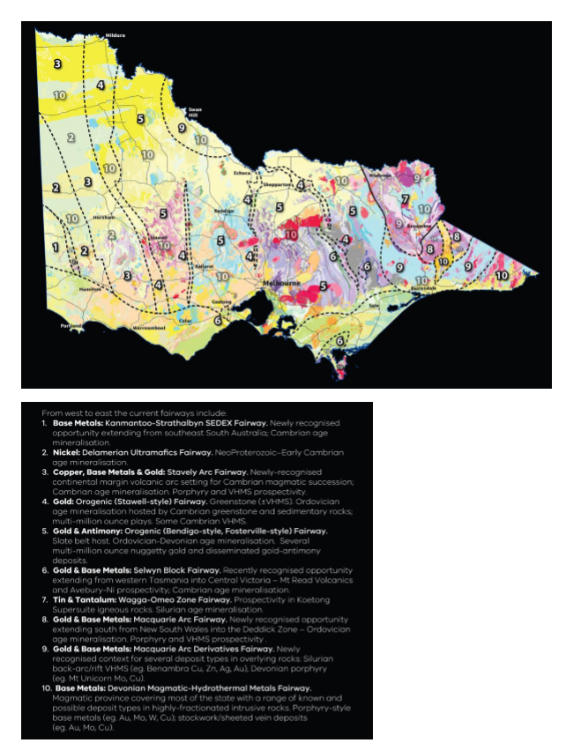

*Figure 1: Mineral exploration Fairways in Victoria. Geological Survey of Victoria.*

To reduce the ambiguity and uncertainty, and for ambitions such as UNCOVER to deliver, methods for remote sensing of geology at regional scales must be deeply integrated with the constraints provided by directly sampled geology. Understanding the ambiguities and limitations inherent in different data types, and understanding the nature of interplays that can operate within active geological systems is critical. The concept of scale-invariance in geology (particularly for stress-mapping) means that robust interpretations developed in discrete areas of excellent data (exposure) might be upscaled to constrain continent-scale geodynamic models, and downscaled to inform province or even mine-scale mineral systems analysis.

Over the last 2 decades, modern geoscience across Eastern Australia and the explosion in understanding of global geodynamics and computing power has combined to put us on the threshold of a true revolution in understanding the geology, tectonic evolution, and therefore mineral prospectivity of the Tasmanides and beyond. Victoria contributes a vital part to this story. Victoria’s physical size is small but, uniquely, the Great Dividing Range is orientated east-west across virtually the whole State, exposing the full width of the Lachlan and eastern Delamerian fold belts to modern detailed geological investigations, now nearly complete (eg. VandenBerg et al., 2000; Cayley et al, 2011a; Rawling et al., 2012). This Victorian Palaeozoic geology transect is a fundamental constraint against which all new tectonic models for the Tasmanides, from far north Queensland to Tasmania, with the Alice Springs Orogen thrown in, can be measured.

The opportunity exists in Victoria to locate deep seismic reflection transects in areas of outcrop, where decades of detailed study have already defined rocktypes, identified faults and other structures, constrained timing and relationships, and developed a range of state-scale tectonic models. The Geological Survey of Victoria, collaborating with Geoscience Australia, universities, the pmd*crc and AUSCOPE made a conscious decision to acquire crustal-scale seismic reflection profiles in these regions of greatest understanding to test existing tectonic models (e.g. the ‘Selwyn Block’ concept), and to allow extrapolation of well-understood surface geology into the mid- and even lower- crust. Tight geological constraints along these transects significantly reduce ambiguities inherent in interpreting seismic data by, for example, allowing faults and rock-types precisely located at surface to be traced directly to depth, and by facilitating recognition and reconciliation of out-of-plane displacements (surprisingly common!) in imaged geology. The increased confidence that results creates a virtuous cycle whereby seismic data and interpretations and field data can be fed back into the reinterpretation of potential field and other datasets (eg. aeromagnetic and gravity) to deliver tightly constrained 3-dimensional models of the subsurface.

This talk explores the complexities of such aspirations and tries to address some of the challenges, using research workflows developed in Victoria that resulted in the Lachlan Orocline concept (Cayley 2010, 2012; Cayley & Musgrave, in review) as an example. The hope is that a less ambiguous geodynamic and tectonic model for the Tasmanides might emerge from this work, reducing the complexity of Mineral Systems analysis, and thus increasing the confidence for exploration investment throughout the Tasmanides.

**Geodynamics and tectonics (and mineral systems analysis) in the Tasmanides.**

Compared to modern subduction-accretion systems which are generally elongate, the Lachlan Orogen is unusually wide, squat, composite and complex, seemingly comprising an amalgamation of multiple linear, orogen-parallel Early Paleozoic accretion and/or rifting events and coeval arc complexes (Figure 1). Because of this, multiple, often contrary, tectonic and geodynamic models have been proposed for the Tasmanides of Eastern Australia by many different researchers over many decades (see Glen, 2013 for a recent review).

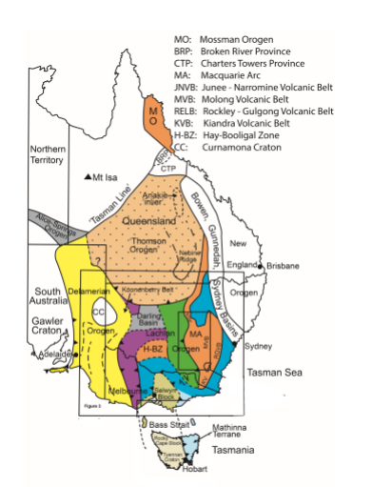

*Figure 2. Tasmanides of Eastern Australia – main elements. Square depicts the region of the Tasmanides restored in the Lachlan Orocline retrodeformation and discussed in the text (see Figure 3, including for key for colours).*

Different models proposed for the Tasmanides include a range of subduction-related geodynamic scenarios: arc-continent collision(s) with subduction polarity reversals; long-term continent-dipping subduction; multiple coeval – but-separate – arcs/subduction zones; arc-rotations; arc modification/disruption across strike-slip faults; multiple cycles of arc trench ‘advance’ and ‘roll-back’ events. Other scenarios suggest rift-related and/or ‘intraplate’ and/or continental-fragment or ‘inlier’ origins for different parts of the belt. Competing oceanward- and continent-dipping subduction zone and rift interpretations make models for key mineral systems (eg. Macquarie Arc, Cobar) ambiguous. The different models variously predict back-arc, arc, and fore-arc environments operating in completely different locations within the terrane at different times (ie: to the west – or east – of fault-belts of ‘Macquarie Arc’ rocks, depending on interpretations of subduction polarity), or even entirely absent (in intraplate and rift-dominated scenarios). Different parts of the Tasmanides are separated into entirely different ‘fold belts’, presumably each with separate mineral systems, based on age (eg. ‘Delamerian’ vs. ‘Lachlan’ vs. ‘New England’) and/or on location and geophysical appearance (eg. ‘Lachlan’ vs ‘Thomson’), or because of the incorporation of seemingly unrelated rocks (eg. the Anakie ‘Inlier’). There is a lot of ambiguity and uncertainty, which leads to a range of contradictory minerals system models, confusion for mineral explorers, difficulty in extending exploration models from the known into the unknown, and a justifiable reluctance to invest, particularly under cover.

**The Lachlan Orocline – towards a unified mineral systems analysis for the Tasmanides.**

The Lachlan Orocline model seeks a unifying explanation for much of the observed complexity, particularly within the ‘Lachlan’ and ‘Thomson’ parts of the Tasmanides. Curious Ordovician palaeogeography that appears impossible in its current configuration (eg. Fergusson et al., 1986; Fergusson et al, 1989; Willman et al., 2002), and regions of Ordovician accretionary, back-arc and intra-plate character juxtaposed across younger (Siluro-Devonian) faults/rifts exposed in Victoria (eg. the cold ‘accretionary’ Tabberabbera Zone juxtaposed against the hot ‘back-arc’ Omeo Zone across the sub-vertical Kiewa Fault) hint at profound Silurian structural modification superimposed over a simpler, larger, Ordovician subduction-accretion system.

The presence of a Precambrian microcontinent (Vandieland- Tasmania and the Selwyn Block; Cayley et al., 2002, 2011b; Cayley, 2011) embedded within the orogen interior at a time when regions of similar-age Early Palaeozoic oceanic strata on either side appear to have developed contrasting accretionary (Tabberabbera) and intra-plate (Bendigo Zone) structural and stratigraphic characters proximal to the eastern seaboard of Gondwana, suggests a west-Pacific-style system where a microcontinent has disrupted and modified the development of a continent-fringing subduction system. Mirroring of Ordovician geology, also in Victoria (in blue, Figures 2, 3), reveals the presence of large scale, subvertical Silurian-age oroclinal (mega) folds, including a fold limb – the Tabberabbera Zone – apparently wrapped clockwise around the northern margin of Vandieland. These oroclinal fold limbs appear to have formed at the exact same time that large sub-vertical strike-slip faults and rifts were active within the Tasmanides. Combined, the Silurian oroclines and strike-slip faults have completely rearranged pre-Silurian Victorian geology, and thus form the foundation of the Lachlan Orocline concept.

The huge amplitude of the oroclines and the large magnitude of strike-slip fault displacements mapped along northerly-trending Silurian-age faults in Victoria implies that these influences must extend interstate. Geophysics now constrains these influences.

Aeromagnetic data extends the Victorian constraints into NSW to provide regional context and support for previous models that independently proposed Silurian sinistral strike-slip fault disruption of a simpler, larger Macquarie Arc system into separate, subparallel segments (eg. Packham, 1987; Fergusson, 2009). The sinistral faults proposed by Packham to separate the Parkes-Junee-Narromine and Molong-Kiewa-Rockley-Gulgong belts in NSW fit neatly within the Lachlan Orocline structural framework as conjugate to larger-scale dextral faults of the same age, exposed in Victoria as the Kiewa and Kancoona faults and imaged beneath the Murray Basin as the Bootheragandra Fault.

The overall pattern is of southeast-directed dextral transtension, involving clockwise rotations (*Figure 3*). The timing of Lachlan Orocline formation coincides with a pulse of magmatism and rifting that progresses as an easterly wave across the entire central and eastern Lachlan Fold Belt. This event has been related to trench retreat driven by slab roll-back, following a period of trench advance (Collins, 2002a, b). Asymmetric slab rollback, pinned at the northern apex of the Vandieland microcontinent is a credible geodynamic driver for the continent-scale dextral rotations and southerly translations needed to form the Lachlan Orocline (Cayley, 2012). It has gained support and geodynamic context from independent studies at Monash University, led by Prof. Louis Moresi (Moresi et al., 2014).

The precise same pattern of Silurian fault-disruption accompanying clockwise rotations can be extended even further north. For example, it can explain the east-west strike and convex-south shape of the southern Thomson Fold Belt as yet another instance of clockwise rotation and sinistral strike-slip offset of an Ordovician Macquarie Arc segment, within the same single system *(see Figures 2, 3)*.

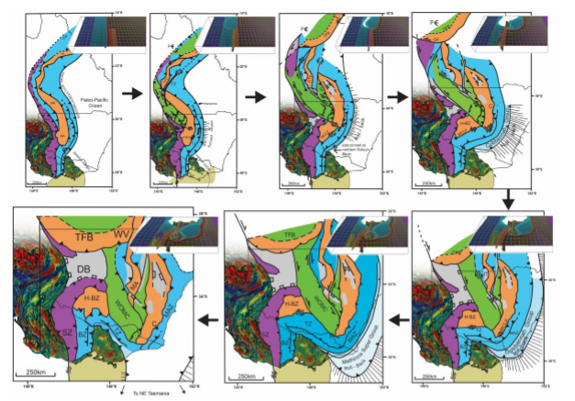

*Figure 3: Palinspastic map sequence depicting the evolution of the mainland Lachlan Fold Belt from the culmination of the Benambran Orogeny at 440 Ma to the end of the Bindian Orogeny at ~405 Ma. Tilt-filter aeromagnetic data= Proterozoic-Cambrian craton and northern Vandieland. SZ=Stawell Zone, KZ=Kayrunnera Zone, BZ=Bendigo Zone, TZ=Tabberabbera Zone, MAZ=Mallacoota Zone, MA=Macquarie Arc, H-BZ=Hay-Booligal Zone, TFB= (southern) Thomson Fold Belt, WOMZ=Wagga-Omeo Metamorphic Complex/Zone, DB=Darling Basin. Purple= Cambrian accretionary wedge. Orange=Ordovician Macquarie Arc. Blue= deformed Ordovician marine siliciclastic successions. Green= Silurian (back-arc) metamorphic terranes. Grey= Siluro-Devonian back-arc rifts. Numerical modelling results of Moresi et al. (2014) depicted for geodynamic context.*

**A simplified model for the Tasmanides.**

This research has resulted in a cascade of radical new understandings that have now grown to incorporate the furthest reaches of the Tasmanides (*Figure 4*). This new understanding has huge implications for mineral prospectivity across Victoria, NSW, Queensland, Tasmania and parts of SA and the NT, some of which are briefly reviewed.

The Lachlan Orocline model advocates for a single, active, relatively simple continent-dipping subduction zone in eastern Australia, active continuously throughout the Ordovician-Early Devonian.

This subduction system developed subsequent to, and outboard of, a preceding subduction system that was also relatively simple and also apparently continent-dipping and culminated to form the Delamerian Orogen in the Late Cambrian (the Stavely/Mt Wright Arc – Crawford, 1978; Cayley & Taylor, 2000; Kemp, 2003; Miller et al., 2005; Foden et al., 2006; Cayley, 2011; Greenfield et al., 2011, Cayley et al., 2011a and in prep.). Culmination of the Cambrian subduction system in Victoria apparently involved a change from a marine-dominated Japanese- to an uplifted Andean-style geometry, probably a consequence of shallowing and congestion of the underlying subduction zone in response to the oblique arrival and collision of an exotic micro-continent just to the south – Vandieland (Cayley, 2011). This is important, as the modern Andes host giant metals systems, and the geological setting suggests similar mineral prospectivity may exist in the Stavely Arc in western Victoria in the Cambrian.

Extinguishment of Cambrian subduction proximal to the eastern Gondwana margin coincided with the appearance of a brand new continent-dipping subduction system a little farther outboard that was able to take up the ongoing Pacific-Gondwana sinistral-oblique plate-boundary convergence – this ‘new’ system was the intra-oceanic Ordovician Macquarie Arc system – a single, linear arc when active. Its position outboard of the Gondwana margin in a marine-dominated setting is consistent with initiation as a Japan-style system, with a broad, submarine back-arc. Throughout the Ordovician a narrow, linear Macquarie Arc formed above this subduction zone during a protracted period of trench-stability. Although the Macquarie Arc appears to have not extended as far south as Victoria at this time, it appears to have extended into Queensland as the Thomson Orogen and beyond.

Restoration of the Lachlan Orocline places the proto-Wagga-Omeo Zone in a back-arc position west of the Macquarie Arc throughout the Ordovician (Figure 3). Restoration of the Lachlan Orocline places the Tabberabbera and Mallacoota Zones in a fore-arc/accretionary wedge position east of the Macquarie Arc throughout the Ordovician. Throughout the Ordovician, the back-arc and fore-arc positions of the proto-Lachlan Fold Belt both accumulated vast volumes of deep marine siliciclastics, deposited in huge submarine turbidite fans that encircled the active Macquarie Arc (Fergusson, 2009). Some parts of the turbidite fan accumulated in an intraplate setting south of the arc (eg. the Bendigo Zone; Gray et al., 2006; Cayley, 2011; Cayley et al, 2011b). The Lachlan Orocline model advocates for different paleogeographic contexts for each of these regions throughout the Ordovician, explaining important distinctions in depositional history and structural character, and some other curious aspects of Late Ordovician sedimentology, in a way that previous models proposed for the region have been unable to.

Silurian clockwise rotation is advocated for the southern Thomson Fold Belt during Lachlan Orocline development. With these effects retrodeformed (Figure 3), the southern Thomson restores to a north-south alignment directly north along-strike from the restored Macquarie Arc. The inference is that the southern Thomson Fold Belt is a segment of the Macquarie Arc, explaining the arc-affinity of Early Paleozoic rocks incorporated within it. The evidence for clockwise rotations allows interpretation of the overall facing of this arc segment, and implies that the region that now lies just to the north, buried beneath southern Queensland, was equivalent to, and continuous with, the Wagga-Omeo Zone in the Ordovician, and in a back-arc position. These relationships can be extended into Far North Queensland, to place the Charters Towers and Broken River provinces, and others, into the same context – basically, all the Ordovician elements restore into a single arc system aligned north-south along the eastern Gondwana margin (Figure 4). This is a much simpler Ordovician scenario to any other previously proposed for the Tasmanides, and so has important implications for developing a unified, greatly simplified template for predicting the distribution and style of Ordovician-age mineral systems in the Tasmanides, including under cover.

At the end of the Ordovician, a simple, linear, marine-dominated Macquarie Arc and associated rocks was accreted and uplifted against the outboard edge of the preceding Delamerian fold belt/Stavely Arc to form the Lachlan Orogen during a period of trench advance. This is the Benambran Orogeny. The Benambran Orogeny represents a change from a low-relief, marine-dominated Japanese-style arc system to a higher-relief, uplifted Andean-style arc system. Upper plate shortening at this time was likely precipitated by sinistral-oblique ingestion of the Vandieland microcontinent into the southern end of the Macquarie Arc subduction zone near the Victoria-NSW border. This is a similar scenario as envisaged for the preceeding Delamerian Orogeny, and appears to have involved the same Vandieland microcontinent, drawn out from its previous site of Delamerian collision in a form of ‘tectonic escape’ (Cayley, 2011), after which it travelled inexorably northwards towards the southernmost end of the Macquarie Arc system, to eventually – and inevitably – collide at the end of the Ordovician. Once again Vandieland, including western Tasmania, appears to have been the ‘wrecking ball’ disrupting an otherwise meta-stable convergent plate-boundary system.

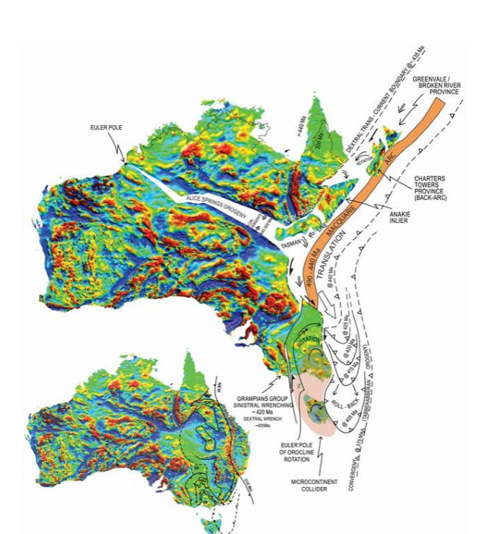

***Figure 4:*** *The Lachlan Orocline in Eastern Australia. Tracking evolution of the convergent East Gondwana-Paleopacific plate margin from the ~440Ma collision of Vandieland (Tasmania plus the Selwyn Block - SB), to it’s folded arrival in NE Tasmania around ~405 Ma. Persistent southerly asthenospheric flows in the parts of the upper plate orogen most distal to the foundering, retreating and folding slab explain the longer duration of southerly convergence in the Alice Springs Orogen and beyond. AI = Anakie Inlier, NR=Nebine Ridge, CTP = Charters Towers Province, GP = Greenvale/Broken River Province.*

Beyond the southern limits of the Macquarie Arc, parts of the oceanic system adjacent to the approaching microcontinent were squeezed in an intraplate vice-scenario to form greatly oceanic crust with world-class orogenic gold deposits – these are the Bendigo and Stawell zones. Similar thickening occurred in the Macquarie Arc back-arc, particularly to the south, to form the proto-Wagga-Omeo Zone and to rework the Cambrian Kayrunnera Zone and equivalents in Queensland.

The culmination of microcontinental collision and upper-plate Benambran Orogeny compression and congestion of the southern Macquarie Arc subduction zone appears to have occurred around 440 Ma – the start point represented in Figure 3. This is the time of a second dramatic tectonic mode switch within the Tasmanides (Collins, 2002a; Moresi et al., 2014; Cayley, 2015a). This switch was from trench advance and associated upper plate shortening during the Benambran Orogeny, to asymmetric trench retreat and upper plate extension and collapse – the Silurian Bindian Orogeny. The upper plate of the system, containing the Macquarie Arc and associated Lachlan rocks, began to collapse and translate into a gravitational potential well that was chasing the uncongested portions of the stalled lower plate slab adjacent to Vandieland in rapid asymmetric rollback into the Paleopacific Ocean. The trigger for the tectonic mode switch is interpreted to be collision of the microcontinent, which effectively stalled the lateral advance of the Paleopacific slab. The mode-switch is important for understanding mineral prospectivity, because it provides a geodynamic context for the pulse of mineralised porphyries that intruded the Macquarie Arc at ~440Ma, following on from a hiatus in Macquarie Arc magmatism. This change is explained as compressive stress-related suppression of magmatism, followed by a ‘release’ coincident with the mode-switch.

Throughout the Binidan Orogeny, slab rollback became increasingly asymmetric. This was a direct consequence of the buoyant Vandieland Microcontinent which remained embedded into the lower plate, and effectively pinned the southern end of the retreating slab. With the remainder of the slab uncongested and in free roll-back, a clockwise rotation developed farther outboard, progressively forming the Lachlan Orocline (Cayley, 2012; Figure 1). The once-linear Macquarie Arc – and all the mineral systems developed within it up to ~440 Ma – was torn into a number of segments at this time. Some parts were internally rifted (for example the Hill End Trough), while other parts were juxtaposed across strike-slip faults (Packham, 1987). Most of the arc segments were drawn southwards into the translating core of the Lachlan Orocline as its amplitude continued to grow. Dextral mega-folds wrapped Vandieland’s northern margin, the southern Lachlan Orogen reoriented into a Z-shaped 400-1200 km amplitude orocline. The southernmost Macquarie Arc segment – the Hay-Booligal Zone adjacent to the site of Vandieland collision – remained trapped behind the microcontinent. Well-defined orocline limbs in Victoria enclose a fault-disrupted and extended core in NSW and central Queensland (Thomson Orogen - unified with the Lachlan in this model) with continent-scale reorientations, overall southerly transport of the Tasmanides, doubled orogen width, systematic disruption and redistribution of all pre-400 Ma rocks and mineral systems, and introduction of new mineralisation, all of it in an extending and translating back-arc environment.

Today, simple cross-sections are constructed east-west across the Lachlan Orocline give the appearance of ‘multiple’ coeval accretionary systems of opposing dip (eg. Gray & Foster, 1998). This is simply a function of the large-scale of oroclinal folding. Today, simple cross-sections constructed east-west across the Macquarie Arc give the appearance of ‘multiple’ subparallel and/or end-juxtaposed (in the case of the southern Thomson Fold Belt) belts of arc volcanics separated by belts of oceanic rocks with no clear arc-associations. This is simply a function of large-scale of fault-segmentation of a single arc into a series of side-by-side segments, which were variously translated and rotated relative to one another throughout the Silurian, while also being translated south relative to Gondwana.

The new Lachlan Orocline model explains: patterns in aeromagnetic data; long-standing paleomagnetic data complexity; palaeogeography; provenance and stratigraphic relationships; apparent structural vergence ‘reversals’; the transition to Silurian crustal extension and rejuvenated marine sedimentation, onset of high-T back-arc metamorphism, and the wave of Silurian/Early Devonian arc- and back-arc magmatism that swept the LFB.

The model delivers insight into the dynamics of the transfer of continental colliders from the lower to upper plate of a persistent subduction system and provides a new geodynamic model for the Cambrian-Devonian evolution of Tasmania in the process - final transfer of the microcontinent Vandieland onto the upper plate of the Gondwana-Pacific plate active margin is preserved in the rock record as a tight Early Devonian orocline – the Dundas-Fossey Orocline – and associated crustal fragmentation that has imparted enormous apparent complexity into the Proterozoic-Ordovician geology. The Lachlan Orocline model provides the regional context for retro-deformation of this Tasmanian complexity, revealing a new simplified pre-Silurian configuration which has huge implications for the (re)interpretation of Cambrian and pre-Cambrian tectonics and associated mineral systems (Cayley, 2015b). The model provides a geodynamic link that links the long-lived Alice Springs Orogeny directly to Lachlan Orocline geodynamics.

It’s a brand new conceptual template for predicting the location of buried mineral systems in all of Australia’s eastern States, with a 3-fold+ increase in the area of potentially prospective rocks that are directly comparable to those already known, from beneath the vast plains of southern Queensland to the highlands of Tasmania.

New locations predicted beneath younger cover are now available for targeted regional mineral exploration – a stimulant for the search for the next generation of mineral deposits in Australia. This result illustrates the power of deep integration of geodynamic modelling with other strands of geoscience. The proven concept of scale invariance – the multi-scale manifestation of process and structure in geology – means that this continent-scale structural solution can be down-scaled for use as a structural template to solve, or test complex geological scenarios at province, camp- and the mineral-deposit scale. Eastern Australia is now the global type-locality for a new geodynamic model that rethinks the mantle processes that drive continental collisions.

**Revisiting Mineral Systems in the Tasmanides.**

The Lachlan Orocline model shows how it is possible for long, linear, narrow and simple magmatic arc systems active in the Cambrian (Stavely Arc (Victoria); Mt Wright Arc (NSW); Mount Read Volcanics (Tasmania) and in the Ordovician (Macquarie Arc) to have been mineralised and then subsequently dismembered and refolded during formation of the Siluro-Devonian Lachlan Orocline.

Restoration of the Lachlan Orocline suggests that the Macquarie Arc subduction-accretion system was simple and linear and ‘text-book’ at the time it formed in the Ordovician, and extended into the so-called Thomson Fold Belt, and into Far North Queensland. Thus the distribution of Ordovician mineral systems expected in arc, back-arc and fore-arc terranes was likely to be similarly simple and linear, and text-book. The Lachlan Orocline also allows restoration of complexity in adjacent Cambrian rocks, thus yielding similar, simpler results for the preceding Delamerian magmatic arc just to the west (Stavely / Mt Wright Arc). Constraints from the Lachlan Orocline model provide a structural template that can be used to restore disrupted and folded Stavely Arc segments in western Victoria to reveal a much simpler Cambrian configuration. Timing constraints for Lachlan Orocline deformation of the Cambrian rocks here are given by the Silurian Grampians Group cover succession, which was also deformed (Cayley & Taylor, 1997).

The Lachlan Orocline concept can therefore underpin a much simpler – and surprisingly text-book - mineral systems analysis for both Cambrian and Ordovician magmatic arc successions in the Tasmanides. This is the basis for a new mineral systems analysis presented in Huston et al., 2015.

Today the simple Cambrian and Ordovician Tasmanide mineral systems are disrupted, so that their distributions appear chaotic (Figure 5). This is where past uncertainty has arisen for mineral explorers. Formation of the Lachlan Orocline involved eastwards and southwards subduction trench-retreat (Figure 3, 4), so that arc-magmatism migrated east and south across the eastern Lachlan Fold Belt. A key prediction of the Lachlan Orocline model therefore is that Silurian mineral systems will also be easterly-migrating, dominated by systems characteristic of a back-arc environment since, by ~410Ma, the arc component had migrated east to near, or beyond, the present-day eastern Australian seaboard. The super-position of Silurian back-arc systems over Ordovician arc and fore-arc / accretionary complex systems has given rise to complex combinations of mineral system characteristics that, while sometimes co-located, are likely to be separated in time.

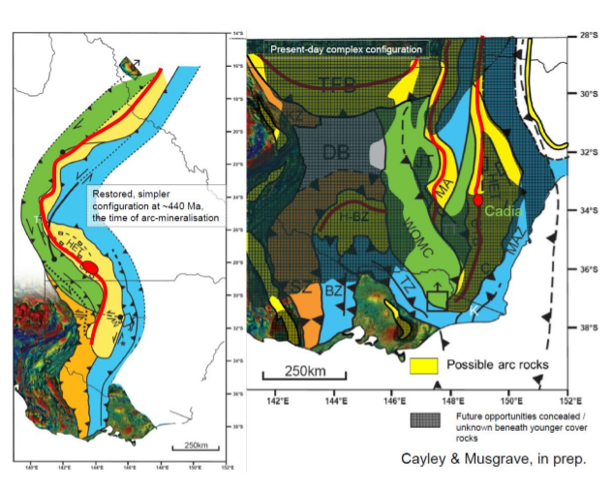

***Figure 5:*** *The Macquarie Arc (in yellow) in Eastern Australia, at ~440Ma (at left). This was the time of mineralised porphyry emplacement (note position of Cadia deposit cluster as red ellipse), and probable axis of porphyry-related arc magmatism (red line). The region to the west of the simple, linear, continuous Macquarie Arc at this time is the back-arc, the entire region prone to back-arc style mineral systems. The region to the east of the Macquarie Arc is the fore-arc and accretionnary wedge, prone to accretionary and fore-arc mineral systems. South of the Macquarie Arc lies an interesting ‘intraplate’ region, with mineral systems related to crustal thickening in the absence of magmatism, including for orogenic gold. The geometry of Eastern Australia from ~405Ma to the present day is depicted at right. Note that the previously simple, linear Macquarie Arc is now disrupted into a number of segments. Consequently, the simple Ordovician ‘Mineral Systems’ boundaries have also been disrupted, and appear quite chaotic. Most of the disrupted arc segments are buried beneath younger cover (grey shading), and some (eg. Hay-Boolical Zone and so-called Thomson Fold Belt) are virtually completely covered and untested. The older and narrower Stavely/Mount Wright Arc is also depicted in yellow in the right-hand diagram. This has also been disrupted by Lachlan Orocline deformation.*

The largest-scale disruption has occurred to the Macquarie Arc, with fragments dispersed widely throughout the radically-reshaped Orogen. The fragments that crop out at surface – Rockley-Gulgong, Molong-Kiandra and Parkes-Narromine Belts – have long been recognised as highly prospective. The new model shows how these may have been configured adjacent (Rockley-Gulgong-Molong-Kiandra) and along-strike (RGMK – Parkes-Narromine) to one-another at their time of formation, and highlights several other fragments that have (a) not previously been recognised as parts of the Macquarie Arc (eg. the Hay-Booligal Zone), or (b) have been (eg. Burton, 2010), but with significant uncertainty to context or mineral prospectivity (eg. Southern Thompson Fold Belt) or (c) extensions into regions not previously able to be explained (eg. beneath the Deddick Zone of NE Victoria) – see Figure 3.

The Lachlan Orocline model and multiple tectonic mode-switch models provide a rationale for persistent mineral exploration beneath cover for Stavely, Mount Read, and Macquarie Arc systems, and even helps decide where within these belts to explore (for example, the western flank of the restored Macquarie Arc appears the most prospective; the locus of extensional collapse and related magmatism – figure 5). Clock-wise rotation of the Southern Thomson fold belt implies that the northern margin of this belt is the back-arc region, and therefore likely to be most prospective for Macquarie-arc style porphyries.

**References**

Burton, G.R., 2010. New structural model to explain geophysical features in northwestern New South Wales: Implications for the tectonic framework of the Tasmanides. Australian Journal of Earth Sciences 57, 23-49.

Cayley, R.A., 2010. South-directed oroclinal folding in the Lachlan Fold Belt: unravelling mid-late Silurian fold belt assembly to solve apparent Ordovician–early Silurian complexity. Geological Society of Australia, 2010 Australian Earth Sciences Convention (AESC) 2010, Earth systems: change, sustainability, vulnerability. Abstract No 98 of the 20th Australian Geological Convention, National Convention Centre, Canberra, Australian Capital Territory. July 4-8 July, 59-60.

Cayley, R.A., 2011. Exotic crustal block accretion to the eastern Gondwanaland margin in the Late Cambrian – Tasmania, the Selwyn Block, and implications for the Cambrian-Silurian evolution of the Ross, Delamerian and Lachlan Orogens. Gondwana Research 19, 628 – 649.

Cayley, R.A., 2012. Oroclinal folding in the Lachlan Fold Belt: consequence of southeast-directed Siluro-Devonian subduction rollback superimposed on an accreted Ordovician arc assemblage in eastern Australia. In: The Great East-Australian Arm-Wave of 2012: Tectonics, Modern Analogues/Events, Mineralisation (GAGA 2012) (ed. White, S.) 34–43 (Selwyn Symposium of the GSA Victoria Division, Geological Society of Australia Extended Abstract 103, 2012).

Cayley, R.A., 2015a. The giant Lachlan Orocline – a powerful new predictive tool for mineral exploration under cover across eastern Australia. In: Lewis, P.C. (compiler) Mineral exploration in the Tasmanides. Australian Institute of Geoscientists Bulletin 62. 29 – 38.

Cayley, R.A., 2015b. A new geodynamic model for Cambrian Tasmania/Australian East Gondwanaland – continent-continent collision above doubly divergent Dundas Trough subduction zones. In: Siegel, C., Verdel, C. & Rosenbaum, G. (Eds.). Riding the Wave: GSA Specialist Group in Tectonics and Structural Geology Conference, November 2015. Geological Society of Australia, Abstract 113, 21-22.

Cayley, R.A., & Musgrave, R.J., (in review). The giant Lachlan Orocline – a new geodynamic model for the Ordovician-Devonian evolution of Australia. Earth Science Reviews.

Cayley, R.A., Korsch, R., Kennett, B, Skladzien, P., Jones, L, Morand, V.J., Gibson, G. & Rawling, T.J., & Betts, P. G., 2011a. Results of deep seismic reflection imaging of the eastern Delamerian Orogen, South Australia and western Victoria, Australia. Data CD version: 4 March, 2011. GeoScience Victoria, Department of Primary Industries.

Cayley, R.A., Korsch, R.J., Moore, D.H., Costelloe, R.D., Nakamura, A., Willman, C.E., Rawling, T.J., Morand, V.J., Skadzien, P.B. & O’Shea, P.J., 2011b. Crustal architecture of central Victoria: results from the 2006 deep crustal reflection survey. Australian Journal of Earth Sciences 58, 113 – 156.

Cayley, R. A. & Taylor, D. H. 1997. Grampians special map area geological report. Geological Survey of Victoria Report 107.

Cayley, R. A., Taylor, D. H., VandenBerg, A. H. M & Moore, D. H., 2002. Proterozoic–Early Palaeozoic rocks and the Tyennan Orogeny in central Victoria: the Selwyn Block and its tectonic implications. Australian Journal of Earth Science 49, 225–254.

Collins, W.J., 2002a. Hot Orogens, tectonic switching and creation of continental crust. Geology 30, 535-538

Collins, W.J., 2002b. The nature of extensional accretionary orogens. Tectonics 21, 6-1 to 6-12.

Crawford, A.J. and Keays, R.R. 1978. Cambrian greenstone belts in Victoria: marginal sea-crust slices in the Lachlan Fold Belt of southeastern Australia. Earth and Planetary Science Letters, 41, 197-208.

Fergusson, C.L., 2003. Ordovician-Silurian accretion tectonics of the Lachlan Fold Belt, southeastern Australia. Australian Journal of Earth Sciences. 50. 475-490.

Fergusson, C.L., 2009. Tectonic evolution of the Ordovician Macquarie Arc, central New South Wales: arguments for subduction polarity and anticlockwise rotation. Australian Journal of Earth Sciences 56, 179–194.

Fergusson, C.L., Cas, R.A.F., & Stewart, I.R., 1989. Ordovician turbidites of the Hotham Group, eastern Victoria: sedimentation in deep –marine channel-levee complexes. Australian Journal of Earth Sciences 36, 1 – 12.

Fergusson, C. L., Gray, D. R. & Cas, R. A. F., 1986. Overthrust terranes in the Lachlan Fold Belt, southeastern Australia. Geology 14, 519–522.

Foden, J. D., Elburg, M.A., Dougherty-Page, J., & Burtt, A., 2006. The Timing and Duration of the Delamerian Orogeny: Correlation with the Ross Orogen and Implications for Gondwana Assembly. The Journal of Geology, 114, 189 – 210

Fraser, G.L., Huston, D.L., Gibson, G.M., Neumann, N.L., Maidment, D., Kositcin, N., Skirrow, R.G., Jaireth, S., Lyons, P., Carson, C., Cutten, H. & Lambeck, A. 2007. Geodynamic and metallogenic evolution of Proterozoic Australia from 1870 to 1550 Ma: a discussion. Geoscience Australia Record 2007/16.

Glen, R.A., 2013. Refining accretionary orogen models for the Tasmanides of eastern Australia. Australian Journal of Earth Sciences 60, 315 - 370.

Gray D.R. & Foster D.A., 1998. Character and kinematics of faults within the turbidite-dominated Lachlan Orogen: implications for tectonic evolution of eastern Australia. Journal of Structural Geology 12, 1691–1720.

Gray, D. R., Willman, C. E. & Foster, D. A. 2006. Crust restoration for the western Lachlan Orogen using the strain-reversal, area balancing technique: implications for crustal components and original thicknesses. Australian Journal of Earth Sciences 53, 329–341.

Greenfield, J.E., Musgrave, R.J., Bruce, M.C., Gilmore, P.J. & Mills, K.J., 2011. The Mount Wright Arc: A Cambrian subduction system developed on the continental margin of East Gondwana, Koonenberry Belt, eastern Australia. Gondwana Research 19, 650 – 669.

Huston, D.l., Mernagh, T.P., Hagemann, S.G., Doublier, M.P., Fiorentini, C., Champion, D.S., Lynton, J.A., Czarnota, K., Cayley, R.A., Skirrow, R., & Bastrakov, E., 2015. Tectono-metallogenic systems – the place of mineral systems within tectonic evolution, with an emphasis on Australian examples. Ore Geology Reviews (2015), doi:10.1016/j.oregeorev.2105.09.005Kemp, A.I.S., 2003. Plutonic boninite-like rocks in an anatectic setting: tectonic implications for the Delamerian Orogen in southeastern Australia. Geology, 31, 371 - 374.

Kemp, A.I.S. (2003) Plutonic boninite-like rocks in an anatectic setting: tectonic implications for the Delamerian orogen in southeastern Australia. Geology, 31 (4). pp. 371-374.

Miller, J. Mc. L. & Gray, D.R., 1997. Subduction related deformation and the Narooma anticlinorium, eastern Lachlan Fold Belt. Australian Journal of Earth Sciences 44. 237-251.

Miller, J. McL., Phillips, D., Wilson, C.J.L. & Dugdale, L.J., 2005. Evolution of a reworked orogenic zone: the boundary between the Delamerian and Lachlan fold belts. Australian Journal of Earth Sciences, 52, 921 - 940.

Moresi, L., Betts, P.G., Miller, M.S. & Cayley, R.A., 2014. Dynamics of continental accretion. Nature. 10.1038/nature13033

Packham, G.H., 1987. The eastern Lachlan fold belt of southeast Australia. A possible Late Ordovician to Early Devonian sinistral strike slip regime. IN: Leitch E.C. & Scheibner, E. eds. Terrane Accretion & Orogenic Belts,, 67 – 82, AGU Geodynamic Series 19.

Rawling, T.J., Osborne, C.R., McLean, M.A., Skladzien, P.B., Cayley, R.A. & Williams, B., 2011. 3D Victoria Final Report. GeoScience Victoria 3D Victoria Report 14. Department of Primary Industries.

Taylor D. H. & Cayley R. A., 2000. Character and kinematics of faults within the turbidite-dominated Lachlan Orogen: implications for tectonic evolution of eastern Australia. Discussion. Journal of Structural Geology 22, 523–528.

VandenBerg, A. H. M., Willman, C. E., Maher, S., Simons, B. A., Cayley, R. A., Taylor, D. H., Morand, V. J., Moore, D. H. & Radojkovic, A. 2000. The Tasman Fold Belt System in Victoria. Geological Survey of Victoria Special Publication.

Willman C.E., VandenBerg A.H.M. & Morand V.J., 2002. Evolution of the southeastern Lachlan Fold Belt in Victoria. Australian Journal of Earth Sciences 49, 271–289.

Wyborn, L.A., Heinrich, C.A., Jaques, A.L., 1994. Australian Proterozoic mineral systems: essential ingredients and mappable criteria: Australia Institute of Mining and Metallurgy Annual Conference, Melbourne. Proceedings, 109-115.