**CONTROLS TO TASMANIDE EPITHERMAL-PORPHYRY Au-Cu- MINERALISATION**

**– EXPLORATION IMPLICATIONS**

Greg Corbett, Consultant [greg@corbettgeology.com](mailto:greg@corbettgeology.com) [www.corbettgeology.com](http://www.corbettgeology.com)

**Key words**: Epithermal Au, porphyry Cu-Au, host rocks, structure

**ABSTRACT**

An improved understanding of Tasmanide Cu-Au ore deposits is derived from recent exploration aided by comparisons with less deformed, more youthful magmatic arc ore systems within Pacific rim and Tethyan arcs. The early correct identification during an exploration program of the epithermal-porphyry mineralisation style present in any prospect facilitates data analysis and timely prioritisation of targets within exploration portfolios. Some deposit types are preferred at varied cultural and geological settings. An understanding of the controls to mineralisation expedites the exploration process from target selection to resource definition. The analyses of buried intrusion architecture and regional structure might help target mineralisation concentrated in the apophyses to buried magmatic source rocks while the identification of the triggers for ore formation might extend prospecting beyond a known resource. Best ores, commonly as ore shoots, develop at the coincidence of as many as possible of the controls to mineralisation which include:

* Style of mineralisation broadly grading from lower metal grade bulk mineable porphyry to bonanza Au grade epithermal veins mined as underground operations.
* Host rocks control ore formation as competent rocks fracture well as vein hosts while permeable rocks promote hydrothermal fluid flow.
* Structures localise buried magmatic source bodies and at prospect scale dilatant fractures govern ore shoot geometry.
* Effective mechanisms of Au deposition, such as fluid mixing provide bonanza grade epithermal ores.
* Post-mineral effects include vein in-fill such as calcite or supergene near surficial Au and deeper level Cu enrichment
* Repeated activation of the porphyry (as multiple intrusions) or epithermal (as banded veins) mineralisation process are required to form economic ores.

**INTRODUCTION**

Explorationists utilise an understanding of the controls to epithermal-porphyry Au-Cu mineralisation in order to identify quality ores in exploration programs extending from the target generation to resource definition stages.

Exploration benefits from the correct classification of ore types, as the application of geological models derived from studies of youthful, less deformed, Pacific rim and Tethyan subduction-arc complexes, has contributed to the reclassification of many Tasmanide ores, which were formerly (1960’s era) described as volcanic hosted syngenetic, but might now be interpreted as intrusion-related (Mt Morgan Au-Cu, Burraga Cu, Mineral Hill Au-Cu-Bi-Ag-Pb-Zn, Commonwealth Au-Ag-Pb-Zn and more in progress). Correct recognition of the ore type (figure 1) has profound implications upon the exploration models and techniques used, styles of targets identified and expeditious evaluation of any project (Corbett, 2013a, & 2013b). Nevertheless, geological exploration models should be considered as constantly evolving and not rigid (Corbett and Leach, 1998).

Best ores of different deposit types, extracted as bulk low grade open pit mines or bonanza grade underground mines, develop at the coincidence of as many as possible multiple controls to mineralisation, such that the activation of fewer controls provides only lower metal grade or smaller mineral occurrences/ore deposits (Corbett, 2013b).

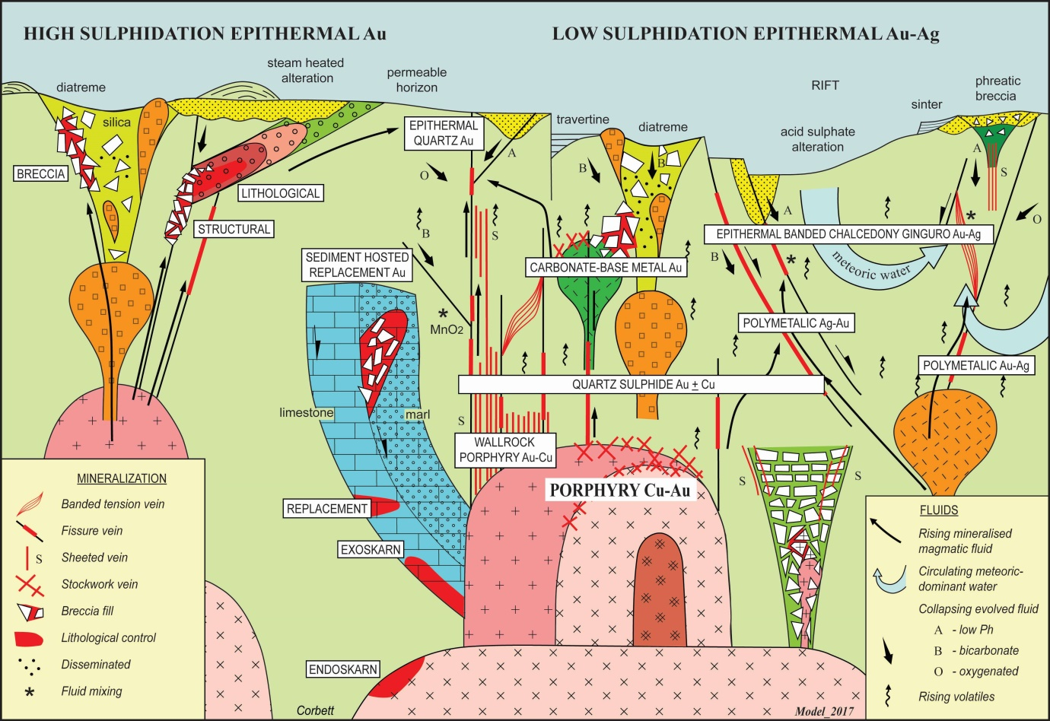

Figure 1. Styles of epithermal Au-Ag + Cu and porphyry Cu-Au mineralisation (modified from Corbett, 2013). Subduction-related magmatic arcs host porphyry, high sulphidation and some low sulphidation epithermal deposits, while banded chalcedony-ginguro quartz veins dominate in extensional settings such as back arcs or rifts.

**CONTROLS TO MINERALISATION**

The controls to mineralisation which combine to provide high quality ore systems include:

* Ore fluids
* Styles of mineralisation
* Host rocks
* Structure
* Mechanism of Au deposition
* Post-mineral effects
* Triggers for intrusion emplacement and hydrothermal fluid evolution

**ORE FLUIDS**

Epithermal-porphyry ore systems host metals concentrated by subduction-related magmatic arc processes within mostly compressional collision settings, grading into more extensional back arc environments for some epithermal deposits. Although considerable debate remains for the origin of the older and more deformed portions (Glen, 2013; Cayley, 2015), the Tasmanides vary from Palaeozoic linear belts of accreted arc fragments in New South Wales, to wider back-arc segments in north Queensland, and in many cases the arcs are far less deformed than the enclosing often younger sediments. The subduction process features the rise and progressive differentiation of intermediate composition magmatic material which is associated with varying deposit types at different crustal levels, exposed by diverse degrees of uplift and erosion. Higher crustal level epithermal deposits associated with felsic magmatism (Drummond Basin & Kidston region, Queensland) contrast with the diorite-monzonite (intermediate-alkaline) compositions of many NSW porphyry deposits. Crustal processes such as the remelting of oceanic crust to provide Pacific rim Au-rich alkaline intrusions (Lihir & Porgera, Papua New Guinea; Emperor, Fiji) might be extended to Tasmanide magmatic arcs (Cadia Valley, Goonumbla).

Very low metal concentrations within buried cooling batholitic source intrusions at depth concentrate within capping apophyses or cupolas, where regional throughgoing structures intersect the buried magma and facilitate upward ore fluid flow. Exploration might then focus upon sub-surface intrusion architecture and the intersection of major structures. Deep erosion to batholith levels (Yoeval, Goonumbla, NSW) exposes equigranular rocks with features such as metal anomalous miarolitic cavities, but below any level of sufficient metal concentration. At Goonumbla spine-like porphyry bodies occur above the upper portions of buried BQM (biotite quartz monzonite) intrusion source rocks, which are discernible from the gravity low provided by the contrast between the differentiated batholith and more dense andesite host rocks (Heithersay et al., 1990; Owens et al., in press). Here, ore systems with NS trending sheeted veins aligned along a NS trend, are interpreted to have been emplaced during transient events of extension (Corbett, 2017). Similarly, the Cadia Valley deposits are aligned within the Lachlan Transvers Zone, long identified as a mineralised trend (Scheibner and Stevens, 1974), and now defined as a deep crustal fracture (Glen and Walshe, 1999), underlain by an interpreted deep magmatic source apparent on regional magnetic and gravity data. The Kidston Au breccia pipe erupted at about 3.5 km depth (Baker and Andrews, 1991) was localised where regional conjugate fractures cut a buried magmatic source discernible as an arch of gravity low linking two felsic Palaeozoic complexes below more dense outcropping Proterozoic metamorphic rocks (Corbett and Leach, 1998). Breccia clasts with Mo porphyry veins provide a window into the intrusion source. The nearby outcropping sub-economic Mt Borium flow dome complex lacked ability to focus ore fluids provided at Kidston. The Mt Leyshon breccia pipe is also interpreted to have been localised by regional structures which tap an underlying batholith (Wormald et al., 1991; Wormald, in press). At Cowal emplacement of fracture/vein carbonate-base metal Au mineralisation within folded volcanic rocks above an interpreted magmatic source apparent on magnetic and gravity data was triggered by a change in the nature of convergence.

Some ore systems are clearly derived from magmatic source rocks but lack a quality structural focus. At Drake, NSW, a collapse caldera with resurgent felsic magmatism focused ore fluids within high level domes and structures, many formed by bedding plane shear during caldera collapse (Cumming et al., 2013). Similarly, at nearby Tooloom, although there is abundant evidence of a magmatic source at depth (collapse breccias), but in the absence of structural focus, Au mineralisation is widely dispersed as stockwork veins and breccias (www.malachite.com.au).

Banded epithermal veins (Cracow, Drummond Basin deposits) deposited from mixed magmatic-meteoric ore fluids feature variable episodic input from mineralised magmatic components and near-barren meteoric-dominated fluids (Corbett, 2008). Explorationists would be wise to take these differences into account during vein sampling and evaluation.

An exploration implication is apparent as regional scale target selection might benefit from a model which synthesises buried intrusion architecture with cross-cutting regional structures which may localise spine-like intrusion and tap mineralised hydrothermal fluids.

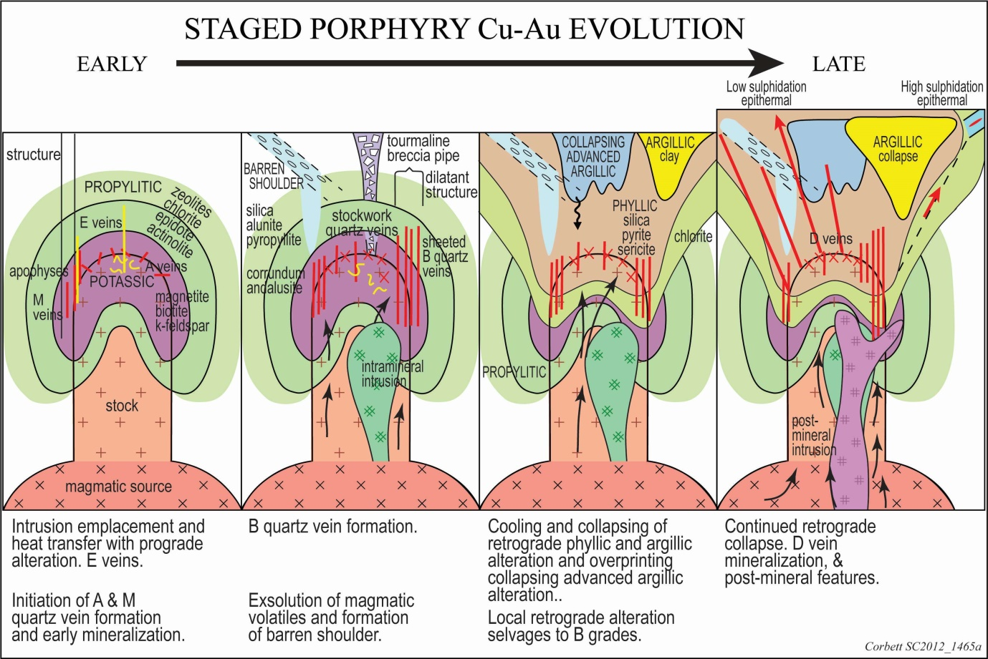

Figure 2. Model for the staged development of porphyry Cu-Au deposits which accounts for overprinting relationships and near porphyry features (from Corbett, 2017 modified from Corbett and Leach, 1998; Corbett, 2008).

**STYLES OF MINERALISATION**

Studies of many ore systems provide a classification of deposit types which accommodates variations in metal grade, metal ratios, metallurgical responses, form of deposits and many other features (figure 1).

Porphyry Cu-Au deposits develop at a deep crustal level as caps to more major magmatic source rocks, commonly as vertically attenuated spine-like polyphasal intrusions (Goonumbla, Ridgeway) with well documented overprinting stockwork and sheeted quartz-sulphide veins, related to repeated porphyry emplacement, in which host sulphide ore commonly post-dates quartz vein formation (Copper Hill). The host dilatant structural settings also facilitate the evolution of ore fluids from magmatic source rocks at depth to apophyses, commonly within dilatant sheeted quartz-sulphide veins. Elevated Au grades in some Tasmanide porphyry deposits are associated with the greater ability of bornite than chalcopyrite to host Au (Corbett, 2017 and references therein). The use of the staged model for porphyry development (figure 2; Corbett and Leach, 1998, Corbett, 2008, & 2017) aids in the application to exploration of the complex overprinting relationships of hypogene prograde and later retrograde hydrothermal alteration followed by supergene processes, and accounts for many near-porphyry settings features such as: pebble dykes, D veins, zoned alteration and geochemistry (figure 3) which are used as exploration tools to vector towards hidden porphyry targets.

The potassic core of zoned prograde potassic-propylitic hydrothermal alteration (figure 2) hosts initial Cu-Au mineralisation with magnetite creation and silicification discernible on geophysical data. Later retrograde hydrothermal alteration hosts additional mineralisation and overprints prograde minerals as destruction of magnetite and deposition of pyrite and variable silica or clays, all discernible on geophysical data. In the supergene environment this pyrite oxidises to provide acidic ground waters responsible for the development of leached caps and remobilisation of Au and Cu, the latter to form buried Cu-rich chalcocite blankets. One of the most profound controls to porphyry Cu-Au remains repeated mineralisation provided by multiple intrusion events, while late barren intrusions may also stope out earlier ore. Explorationists can easily identify features in the field which provide encouragement of a polyphasal intrusion system provides a quality porphyry such as: cross cutting intrusions, sharp alteration contacts, residual early quartz veins not absorbed by later intrusions, xenoliths of early intrusions in later intrusions, prograde magnetite overprinting retrograde sericite and early style quartz veins (A or M style) overprinting later style quartz veins (B, C or D style). Intrusion categorisation may provide domains to aid to resource estimation.

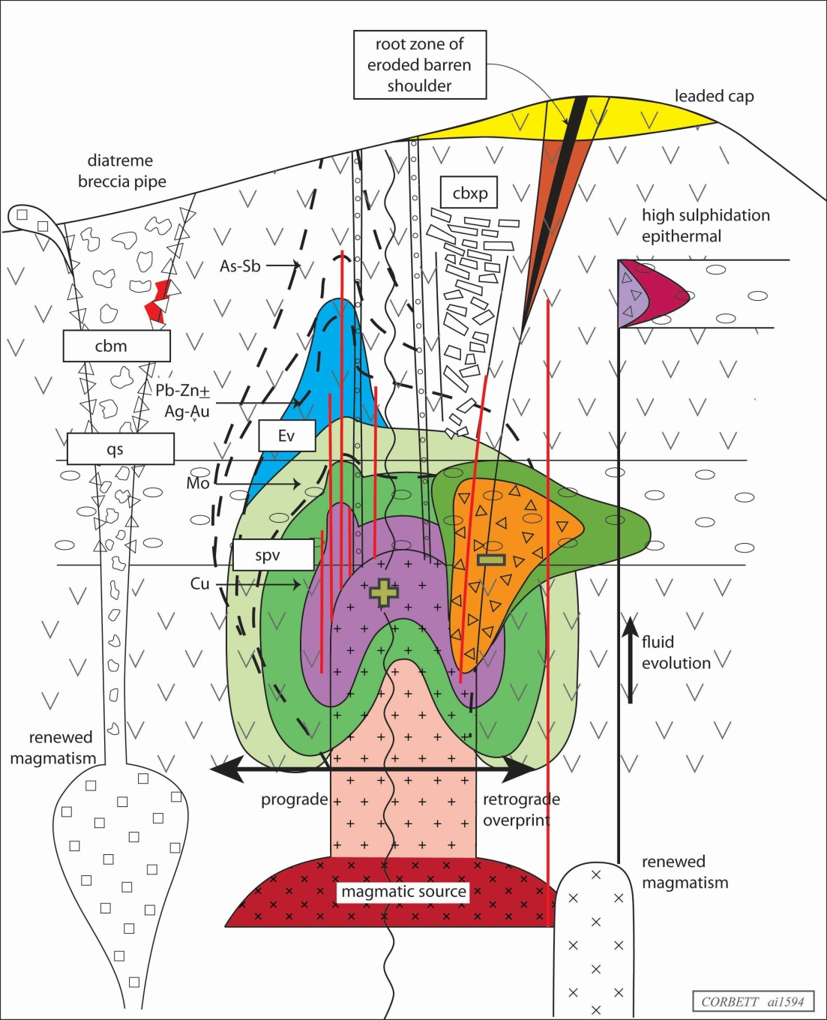

Figure 3. Model to account for many near-porphyry features which might be used as vectors towards mineralisation (from Corbett, 2017).

Preserved buried porphyry deposits localised by the intersection of regional structures and competent host rocks may retain volatiles and metals, including within the adjacent host rocks, that might otherwise have been vented to the surface from porphyries developed below stratovolcanoes and so represent quality exploration targets.

Skarns form by the metasomatic alteration by magmatic derived fluids of typically, but not always, carbonate-bearing wall rocks. Stages of skarn alteration are likened to events recognised in porphyry systems in sequence as: isochemical, prograde, retrograde skarn and later epithermal Au, while mineralisation varies from Cu closest to intrusion source rocks, outwards as Pb-Zn, to marginal epithermal Au. Highest Cu-Au grade ores are associated with marble or skarn fronts at the contact between ore fluids and marble host rocks. An exploration vector in porphyry exploration is provided by magnetite formed within the prograde and retrograde alteration stages identified as: float of resistant rocks (Ok Tedi, Papua New Guinea), characteristic magnetic rocks which are resistant to erosion and identified during reconnaissance geology or airborne geophysical exploration programmes (Ertsberg, West Papua; Constancia, Peru), or that have often formerly been mined as sources of FeO (Cadia Hill). There are many cases (Cadia and Goonumbla, Australia; Grasberg, Indonesia; Ok Tedi, Papua New Guinea; Bingham Canyon, USA) where skarns were recognised and locally mined prior to the porphyry discovery. Skarns therefore represent ores in their own right, including bonanza epithermal Au, and also act as vectors to porphyry mineralisation by analysis of structural and lithological fluid flow paths.

Epithermal Au-Ag deposits are distinguished as high and low sulphidation styles, here based upon the ore fluid which provides characteristic wall rock alteration and ore mineralogy, while low sulphidation deposits evolve as two fluid flow trends best developed within magmatic arcs or extensional intra-arc rifts or back-arcs.

Low sulphidation epithermal Au deposits developed within magmatic arcs (Tasmanides, Papua New Guinea, Chilean Andes) are derived from near neutral, dilute fluids, which have evolved in an open system to grade from magmatic to meteoric-dominant, in order to deposit ores in a continuous transition from porphyry to wallrock porphyry, grading upwards from deep epithermal quartz sulphide Au + Cu, to carbonate-base metal Au and at shallowest crustal level epithermal quartz Au ores (Corbett, 2013b & 2017). Au grades progressively rise in these three deposit types, with changes in metallurgy. In more extensional settings (Sierra Madre of Mexico, southern Peru, Argentine Patagonia) the polymetallic Ag-Au ores (as the Ag-rich equivalent carbonate-base metal Au) evolve to chalcedony-ginguro Au-Ag veins with the progressive addition of silica-dominated gangue from meteoric waters (Corbett, 2013b & 2017). This latter group also hosts Au grades with elevated Ag. Sediment host replacement (Carlin) Au deposits develop by reaction of a quartz-sulphide Au fluid with impure limestones at an elevated crustal setting and so host anomalous As, As and Sb.

High sulphidation epithermal Au + Ag + Cu deposits are derived from a magmatic-dominated fluid which evolves during the rise from porphyry levels as a closed system to become strongly acidic, and then at epithermal crustal levels, becomes cooled and neutralised by wall rock reaction to produce characteristic zoned alteration, overprinted by mineralised sulphides (Corbett, 2013b & 2017). Consequently, there is generally gap of many hundreds of metres between the causative intrusion and any associated high sulphidation epithermal Au deposits, notwithstanding telescoping outwards by dilatant structures or inwards by rapid uplift and erosion. The permeability controls (structure, lithology and breccias) guide ore distribution and many deposits are mined only in the oxide zone because of the problematic sulphide metallurgy. Explorationists need to understand the varying advanced argillic alteration elements (described separately in Corbett, 2008 & 2017) which are lumped as lithocaps, in order to use these rocks as exploration tools.

Whereas high sulphidation epithermal Au deposits typically display modest Au grades and complex sulphide metallurgy, high Au grade good metallurgy ores are recognised in the rare instances where the ore fluid evolves to lower sulphidation carbonate-base metal Au and epithermal quartz Au styles described above, (El Indio, Chile; Mt Carlton, Australia, Link Zone, Wafi, Papua New Guinea; Corbett, 2017). The term intermediate sulphidation should only be used for ores which overprint high sulphidation mineralisation and advanced argillic alteration and the original (Leach and Corbett, 1994, 1995; Corbett and Leach, 1998) carbonate-base metal Au terminology should be utilised for sulphide-rich low sulphidation mineralisation with near neutral wall rock alteration developed as part of low sulphidation fluid flow trends, often wrongly described as intermediate sulphidation in the geological literature.

There are many exploration implications in the staged model for porphyry development (figure 2) such as alteration vectors towards mineralisation hosted within core potassic alteration, the understanding of geophysical responses, and the importance of polyphasal intrusion and vein emplacement. The early recognition of the style of epithermal mineralisation also guides exploration programmes and the discovery of best ore within ore shoots. Lithocaps, although not a control to mineralisation must be correctly interpreted as different elements ore styles display variable relationships to mineralisation (Corbett 2008 & 2017).

**HOST ROCKS**

Host rocks, which enhance and retard ore formation in porphyry and epithermal systems, change character with hydrothermal alteration and may obscure underlying mineralisation (figure 4; Corbett, 2013b, 2017).

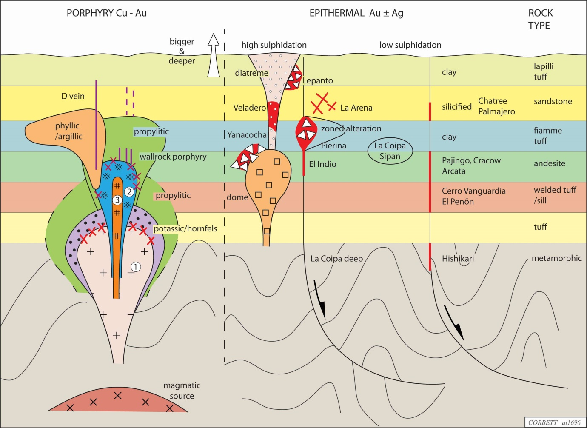

Figure 4. Summary of host rock control to the emplacement of porphyry intrusions and epithermal vein/breccia mineralisation.

Competent host rocks required for the propagation of throughgoing fractures in which epithermal veins might develop include metamorphic basement, andesite, welded tuffs and some intrusions. Non-reactive permeable rocks such as sandstone become silicified to form competent host rocks (Chatree, Thailand; Palmarejo, Mexico). Low sulphidation epithermal veins may be obscured by clay alteration of overlying reactive volcanic rocks such as breccia, lapilli tuffs and fiamme tuffs (Chatree, Thailand; Hishikari, Japan; El Peñón, Chile), some syn- to post-mineral (Frute del Norte, Ecuador). By contrast, while some structurally controlled high sulphidation epithermal Au vein deposits are hosted within andesite and metamorphic rocks (El Indio, La Coipa deep, Chile), an ideal setting for these deposits is at the intersection of feeder structures and permeable rocks such as fiamme tuffs (Pierina, Sipan, Peru; El Guanaco, Chile), or breccias (Lepanto, Philippines; Yanacocha, Peru; Mt Kasi, Fiji). Silicification within the advanced argillic alteration associated with high sulphidation epithermal Au deposits also renders permeable host rocks competent for mineralised fracture formation.

Porphyry deposits are also well developed within competent host rocks such as metamorphic (Grasberg, West Papua; Golpu, Papua New Guinea) and sedimentary (Bingham Canyon, USA) basement rocks, while Titley (1982) notes the alteration of overlying volcanic rocks by early porphyry intrusions may render volcanic rocks more competent and amenable to host intrusions and marginal veins which extend into the wall rocks. Similarly, wall rock porphyry deposits (Cadia East) require competent host rocks for sheeted vein formation.

The exploration implications of host rock control centre on the requirement for competent host rocks which fracture to facilitate epithermal vein formation (Hishikari, Japan; El Peñón), while clay altered permeable rock restrict fracture/vein formation and may obscure mineralisation at depth (Chatree, Thailand; Frute del Norte, Ecuador).

**STRUCTURE**

Major structures which are classified as arc-parallel (Gilmore Suture, Chilligoe Fault, Parkes Thrust), arc-normal (Lachlan Transverse Zone) and conjugate (Gilberton lineament) localise intrusion-related ore systems in the Tasmanides and other ore systems ((Corbett, 1994, 2009, 2102, 2017; Corbett and Leach, 1998). At prospect scale dilatant structures including sheeted veins bleed magmatic ore fluids from intrusion source rocks at depth to higher crustal level settings of porphyry mineralisation, and control the shape of epithermal ore shoots (Corbett, 2012). Structural intersections represent sites of ore shoot formation by fluid mixing Corbett 2017). The pitch of ore shoots varies from sub-horizontal in the steeper dipping portions of listric faults (Lihir, Papua New Guinea; Palmarejo, Mexico; Corani, Peru), to steep within flexures formed by components of strike-slip fault movement (Vera Nancy, Australia) and moderate pitches where there are mixtures of deformation styles (Viento vein, El Indio, Chile). Ore shoots host high sulphidation epithermal Au ores at the intersection of steep dipping feeder structures and reactive permeable lithologies, including breccias (Nena, Papua New Guinea; Papua New Guinea; Lepanto, Philippines; Sipan, Peru).

Arc-parallel fractures (Domeyko Fault, Chile; Gilmore Suture and Chilligoe Fault, Australia) commonly represent steep-dipping terrain boundaries in which ore systems are hosted by dilatant sites developed by transient changes from the general reverse movement typical of compressional magmatic arcs. Arc-normal fractures segment arcs, account for changes in dip or rate of subduction, locally provide linear groups of ore systems (Cadia Valley in the Lachlan Transverse Zone, Australia), may tap mantle-derived melts (Porgera, Papua New Guinea) and focus repeated hydrothermal events (Wafi-Golpu, Papua New Guinea). Conjugate fractures localise intrusion-related mineralisation at intersections with arc-parallel and arc-normal structures within arcs especially within back-arc settings (Kidston in the back arc of north Queensland; Cerro Negro, Cerro Moro and others in the Deseado Massif of Argentine Patagonia).

Exploration implications include the recognition of dilatant sites on major regional as settings for ore system formation and structural control to epithermal ore shoots.

**MECHANISMS OF AU DEPOSITION**

Porphyry deposits mostly deposit metals from cooling fluids, although later stage high grades, especially Au, are noted by the mixing of rising ore fluids with low pH waters related to phyllic alteration. Similarly, high sulphidation epithermal Au deposits mostly feature metal deposition from cooling fluids. In low sulphidation epithermal Au deposits, while cooling, boiling and sulphidation reactions deposit lower grade Au mineralisation, it has been argued (Leach and Corbett, 2008; Corbett, 2017) that highest (bonanza) Au grades result from the mixing of rising pregnant ore fluids with evolved oxidising ground waters, as the most efficient mechanism for the destabilisation of the bisulphide complexes which transport Au. Carbonate-base metal Au deposits (Cowal, Drake, Kidston, Mt Leyshon, Mt Rawdon) form by the mixing of sulphide-bearing ore fluids with oxidising bicarbonate waters and host better Au grades in association with Mn carbonate (rhodochrosite). Highest Au grade result from the mixing of acid sulphate waters with ore fluids as evidenced by kaolin in the ore assemblage (Cracow, Australia; Frute del Norte, Ecuador; Palmarejo, Mexico), and form ore shoots at structural intersections (COSE, Argentina). Low pH waters may collapse to 1 km blow the near surficial environment of formation to promote Au deposition at depth.

An exploration implication is the potential for the development bonanza Au grade epithermal Au deposits by fluid mixing and discovery of blind high grade epithermal ore deposits below barren acid sulphate caps (Guadalupe, Palmarejo, Mexico). Careful field examination of gangue mineralogy provides a valuable exploration tool.

**POST-MINERAL EFFECTS**

Supergene Au and Cu represent the most prominent post-mineral effect in porphyry and epithermal deposits. Explorationists have long used characteristics of leach caps to explore for buried supergene Cu-rich chalcocite blankets (Chávez, 2000; Blanchard, 1968). In the Tasmanide porphyry deposits leached caps and chalcocite blankets are only well developed where pyrite within phyllic alteration oxidises as a source of acid ground waters. Consideration must also be given to the behaviour of gold and silver in the supergene environment.

Low sulphidation epithermal quartz-sulphide Au + Cu mineralisation, which commonly features Au on fractures and grain boundaries within coarse cubic pyrite, weathers in the supergene environment to liberate Au and acid ground waters. In these settings, elevated Au concentrates within Fe oxides at the surface, base of oxidation and collapsing down structures and so explorationists must be mindful that elevated Au in these settings, especially evidenced by boxworks after leached pyrite, commonly does not pass downwards to significant Au grade within hypogene sulphide material at depth. At Mt Morgan, Australia, the gossan cap provided spectacular (to 62,000 g/t) Au near surface Au (Jones and Golding, 1994), which passed down to an oxide resource of 30.6 g/t Au (for 2.7M oz Au) (Taupe, 1990), and deeper hypogene ore of 3.4 g/t Au with 0.8% Cu (Cornelius, 1969). Supergene Au enrichment locally forms ore systems (Ciraniu, Fiji; Taylor et al., 2013), or sub-horizontal zones of high Au grades at the base of oxidation have ben extracted early in the mine life (Cowal, Australia; Ok Tedi, Papua New Guinea). Silver is readily leached from oxide zones and concentrates within sulphosalts overprinting sulphides below the base of oxidation, much like Cu.

An exploration implication in the Tasmanides suggests explorationists to treat elevated surficial Au grades associated with boxworks after pyrite with caution, as supergene enriched Au derived from the oxidation of quartz-sulphide Au style mineralisation, does persist to depth in sulphide ore.

**TRIGGERS TO ORE FORMATION**

A mechanism is required to provide the space for the emplacement of porphyry intrusions within compressional magmatic arcs. The geometry of veins marginal to porphyry deposits and also within many epithermal deposits is not consistent with regional compressional deformation. Consequently, models have been proposed (Corbett and Leach, 1998; Corbett, 2012 & 2017) that tectonic triggers facilitate the rapid emplacement of ore systems from fluids concentrated within intrusion source rocks at depth include:

* Reduction in confining pressure by thrust erosion (Porgera Zone VII, Papua New Guinea), sector collapse (Ladolam, Lihir Is., PNG), rapid uplift and erosion (the transition from the Wafi high sulphidation epithermal to Gulpu porphyry Cu-Au and also Ok Tedi in Papua New Guinea, Copper Hill, Australia).
* Transient changes in the nature of convergence trigger the formation of veins in with kinematic indicators contrary to the regional geology. Examples include the change from orthogonal to oblique compression (in the Tasmanides of NSW, Browns Creek, Peak Hill, Mineral Hill, Cowal and the Cobar district; in Chile, Chuquicamata, L Escondida, El Peñón, El Indio, La Coipa) or relaxation of convergence (Goonumbla in the Tasmanides, Pascua-Lama on the Chile-Argentina frontier, many in Turkey such as the Mastra epithermal veins or thrust-related Himmetdede). Dilatant structures (sheeted veins) activated at these stages most effectively bleed ore fluids from deeper to higher crustal levels of ore deposition.

An exploration implication is that in individual districts (Andes of Chile-Argentina) there are patterns of better ore systems associated with transient changes to extension rather than compression, locally apparent at district scale such as Goonumbla (Corbett, 2017).

**CONCLUSIONS AND EXPLORATION IMPLICATIONS**

Metals extracted from epithermal-porphyry deposits are ultimately derived from magmatic source rocks at considerable depth concentrated at more shallow crustal levels while some epithermal veins include minerals deposited from meteoric waters. Target selection might consider controls to metal concentration such as: architecture of the buried magmatic source, dilatant portions of regional structures which transport fluids within brittle host rocks and methods of metal deposition at elevated crustal settings. Ore shoots develop where several controls to mineralisation coincide. Whereas traditional models have placed porphyry deposits below stratovolcanoes, these might be supplemented by localisation porphyry and intrusion-related epithermal deposits by major structures. Non-eroded blind porphyry targets are favoured as metals, which did not vent form stratovolcanos, may be hosted in the uppermost portions of porphyry intrusions and the adjacent wall rocks. An understanding of the staged development of porphyry deposits allows near-porphyry features within the wall rocks at prospect scale to vector towards blind porphyry intrusions. ‘Lithocaps’ incorporate many features which should be considered separately as guides to exploration (Corbett, 2008, 2017), especially as hydrothermal alteration may spread for considerable distances within in permeable host rocks.

Triggers for dynamic mineralisation events in generally compressional magmatic arcs are provided by transient changes in the nature of convergence to provide extension, evidenced by vein kinematics. Deposits initiated by localised extensional conditions are typically larger than those formed in compressional environments and easily identified early in any exploration program by vein mapping.

Different styles of mineralisation display dramatically different metal grades, metal ratios, wall rock alteration and responses to geophysical techniques during exploration or metallurgical processes during later extraction. Early categorisation of mineralisation style can better guide exploration programmes. Linkages between deposit types are well documented and can guide discovery, such as the use of skarns as vectors towards porphyry deposits, although the term intermediate sulphidation is commonly wrongly applied. Epithermal Au deposits host best ore within ore shoots localised at the coincidence of several factors which can be considered within regional and prospect scale exploration programmes.

Lastly, Corbett and Leach (1998) stressed that geological models represent a snapshot in time based upon the data to hand and should be modified for each prospect (to become prospect specific) and as new data comes to hand. Peer review of exploration programs helps to maintain quality control.

**ACKNOWLEDGEMENTS**

Denese Oates continues to proofread the text and draft these figures as she has willingly done for many years. Doug Menzies and Jason Cunliffe aided with geological discussion while recently University of NSW has provided access to library facilities and Bob White and Mark Arundell helped with the supply and analysis of imagery.

**REFERENCES CITED**

BAKER E.M. & ANDREW A.S. 1991. Geologic, fluid inclusion, and stable isotope studies of the gold-bearing breccia pipe at Kidston, Queensland, Australia: Economic Geology. 86, 810-830.

BLANCHARD R. 1968. Interpretation of leached outcrops: Nevada Bureau of Mines, Bulletin 66, Mackay School of Mines, University of Nevada.

CAYLEY R. 2015. The Giant Lachlan Orocline – a powerful new predictive tool for mineral exploration under cover across Eastern Australia: AIG Bulletin 62, 29-38.

CHÁVEZ W. 2000. Supergene oxidation of copper deposits: zoning and distribution of copper oxide minerals: SEG newsletter, April 2000, 1 & 10-21.

CORBETT G.J. 1994. Regional structural control of selected Cu/Au occurrences in Papua New Guinea. In: Rogerson R. ed. Geology, exploration and mining conference, June 1994, Lae, Papua New Guinea, proceedings: Parkville, The Australasian Institute of Mining and Metallurgy 57-70.

CORBETT G.J. 2008. Influence of magmatic arc geothermal systems on porphyry-epithermal Au-Cu-Ag exploration models: Terry Leach Symposium, Australian Institute of Geoscientists, Bulletin 48, 25-43.

CORBETT G.J. 2009. Tectonic/structural control to Papua New Guinea Au-Cu mineralisation: Macquarie Arc Conference, Geological Society of Australia Abstracts, 92, 48-49.

CORBETT G.J. 2012. Structural controls to, and exploration for, epithermal Au-Ag deposits: Australian Institute of Geoscientists Bulletin 56, 43-47.

CORBETT G.J. 2013a. Tasmanides arc-style Au-Cu mineralisation, in a Pacific rim context: AIG Bulletin 55, 23-32.

CORBETT G.J. 2013b. Pacific rim Epithermal Au-Ag: World Gold Conference Brisbane, Proceedings, Australasian Institute of Mining and Metallurgy, Publication Series 9/2013, 5-13.

CORBETT G.J. 2017. Epithermal gold-silver and porphyry copper-gold exploration – Short course manual [www.corbettgeology.com](http://www.corbettgeology.com)

CORBETT G.J. & LEACH T.M. 1998. Southwest Pacific gold-copper systems: Structure,

CORNELIUS K.D. 1969. The Mt Morgan Mine Queensland – Massive Gold-Copper pyritic replacement deposit: Economic Geology 64, 885-902.

CUMMING G. WORLAND R. & CORBETT G. 2013. The collapse caldera environment for Au-Ag mineralisation within the Drake Volcanics, New England: Implications for exploration: Proceedings, Mineral Exploration in the Tasmanides, AIG Bulletin 25, 33-40.

GLEN R. A. 2013. Refining accretionary orogen models for the Tasmanides of eastern Australia: Australian Journal of Earth Sciences, 60, 315-370.

GLEN R.A. & WALSHE J. L. 1999. Cross structures in the Lachlan Orogen: the Lachlan Transverse Zone example: Australian Journal of Earth Sciences, 46, 641-658.

HAYWARD S. CORIANIZ G. FERRIC B. & CORBETT G. 2015 Copper Hill Project; Integration of traditional geology and new technologies to build a deposit model: Mines and Wines 2015 Conference Proceedings, AIG Bulletin 62, 111-121.

HEITHERSAY P.S. O'NEILL W.J. VAN DER HELDER P. MOORE C.R. & HARBON P.G. 1990. Goonumbla porphyry copper district - Endeavour 26 North, Endeavour 22 and Endeavour 27 copper-gold deposits. In: Hughes F.E. ed. Geology of the mineral deposits of Australia and Papua New Guinea: Australasian Institute of Mining and Metallurgy Monograph 14, 1385-1398.

JONES I.W.O. & GOLDING S.D. 1994. The Mount Morgan Mine Central Queensland: Three dimensional relationships of the mineralisation in the Mount Morgan gold-copper deposit: Geological Society of Australia Conference 1994, Capricorn Region. Ed. Holcombe R.J. Stephens C.J. & Fielding C.N. 64-78.

LEACH T.M. & CORBETT G.J. 1994. Porphyry-related carbonate base metal gold systems: Characteristics, *in* Rogerson, R., ed., Geology, exploration and mining conference, June 1994, Lae, Papua New Guinea, proceedings: Parkville, The Australasian Institute of Mining and Metallurgy, p. 84-91.

LEACH T.M. & CORBETT G.J. 1995. Characteristics of low sulphidation gold-copper systems in the southwest Pacific. In: Pacific Rim Congress 95, 19-22 November 1995, Auckland, New Zealand, proceedings, Carlton South, The Australasian Institute of Mining and Metallurgy, 327-332.

LEACH T.M. & CORBETT G.J. 2008. Fluid mixing as a mechanism for bonanza grade epithermal gold formation: Terry Leach Symposium, Australian Institute of Geoscientists, Bulletin 48, 83-92.

OWENS J. PRIEST D. JAGO C. & PACE D. in press. Northparkes copper-gold deposits: AusIMM Monograph on Australian Ore Deposits.

SCHEIBNER E. & STEVENS B.P.J. 1974. The Lachlan River Lineament and its relationship to metallic deposits: Quarterly Notes, Geological Survey of New South Wales, 8-18.

TAUPE A. 1990. Mount Morgan gold-copper deposit, in Geology of the Mineral Deposits of Australia and Papua New Guinea (Ed F.E. Hughs) 1499-1504., Australasian Institute of Mining and Metallurgy, Melbourne.

TAYLOR G. CORBETT G. & CUMMING G. 2013. Cirianiu Epithermal Au, Vanua Levu, Fiji: Australian Institute of Geoscientists Bulletin 56, 89-90.

TITLEY S. R. 1982. The style and progress of mineralisation and alteration in porphyry copper systems.In: Titley, S.R., Ed., Advances in geology of the porphyry copper deposits, Southwestern North America, University of Arizona Press, Tucson, Arizona, 93-116.

WORMALD P. J. ORR T. O. H. & HODKINSON I P. 1991. The Mount Leyshon Gold Mine (NE Queensland), an intrusive breccia and igneous complex. Proceedings World Gold ’91, 223-232 (Cairns). Reprinted in: Henderson, R A, ed., 1993. Guide to economic geology of the Charters Towers region, northeast Queensland: Brisbane, Geological Society of Australia, Queensland Division, 61−74.

WORMALD P.J. in press, The Mount Leyshon gold deposits *in* Monograph on Australian Ore Deposits, Ed. GN Phillips, Australian Institute of Mining and Metallurgy.