**COWAL GOLD MINE; DISTRICT GEOLOGY AND EXPLORATION OVERVIEW**

**Christopher Leslie1, Paul Balind2, Ned Howard3, and Geoff Heidemann2**

1 ARC Centre of Excellence in Ore Deposits, University of Tasmania, Private Bag 79, Hobart, TAS, 7001

2 Evolution Mining Limited, Cowal Operations, Lake Cowal Road, Lake Cowal, NSW, 2671

3 Evolution Mining Limited, Level 30, 175 Liverpool Street, Sydney, NSW, 2000

**Key Words:** Cowal Igneous Complex, Macquarie arc, mineralization, gold, copper

**INTRODUCTION**

The Cowal Gold mine, operated by Evolution Mining Limited, is approximately 38 kilometres north-northeast of the town of West Wyalong, central New South Wales. The open pit mine commenced production in 2005 by Barrick Gold Corporation and was subsequently purchased by Evolution in 2015. The mine is currently exploiting the Endeavour 42 (E42) gold deposit, which comprises a series of shallow to steep dipping auriferous veins and vein-breccias cutting volcanic, volcaniclastic and intrusive rocks of the Cowal Igneous Complex (CIC; Crawford et al., 2007). The approximately 40 by 15 kilometre fault-bounded CIC, largely defined on the basis of geophysical and widely spaced drill data, hosts numerous polymetallic deposits in two dominant mineralization types; 1) structurally controlled, epithermal related gold +/- silver mineralization and, 2) bulk-tonnage porphyry related copper +/- gold, molybdenum mineralization. For a comprehensive overview of the CIC, the reader is referred to the forthcoming Balind et al. (2017, in press).

**GEOLOGICAL SETTING**

The CIC is part of the Junee-Narromine belt, the westernmost of four discrete volcanic belts within the prospective Early Ordovician to Early Silurian Macquarie arc, eastern Lachlan Orogen (Glen et al., 1998). Early Ordovician submarine volcaniclastic rocks, andesite flows and diorite to granodiorite intrusive rocks comprise the dominant host rock lithologies to mineralization within the CIC (Fig. 1). Besides through-going, property scale, domain-bounding faults (e.g., Booberoi Fault) and deposit scale, grade-controlling north, northwest and northeast trending faults, the CIC is also cut by a poorly defined west-northwest trending structure termed the Marsden lineament. This structure broadly juxtaposes volcanic and sedimentary strata and lesser diorite host to structurally controlled epithermal systems to the north with polyphase, dominantly equigranular granodiorite to monzonite host to porphyry systems to the south.

The structurally controlled gold systems in the western CIC, define a 7.5 by 2 kilometre trend of local gold mineralization termed the ‘Gold Corridor’ (Fig. 1). We refer to these systems as low-sulphidation epithermal-type as suggested by Cooke et al. (2007), Henry et al. (2014) and Zukowski et al. (2014), however, as noted by Miles and Brooker (1998) and Forster et al. (2015), these systems also have some characteristics typical of mesothermal shear-hosted deposits. Considerable exploration efforts in the Gold Corridor have identified numerous centres of gold mineralization (e.g., E46, E41, E40, Galway, Regal) which together, with E42 (proven and probable mineral reserve of 3.2 million ounces gold1), contain a measured, indicated and inferred mineral resource of 177.7 million tonnes at 0.88 grams per tonne (g/t) gold for a contained 5.04 million ounces of gold1. All Gold Corridor mineralized centres are along strike, and/or slightly offset from E42 and collectively fall into Evolution’s long-term pipeline of advanced stage assets. Mineralization characteristic of Gold Corridor systems comprise quartz +/- carbonate veins mineralized with pyrite +/- galena, sphalerite, chalcopyrite with local tellurides and sulphosalts. Veins are either, 1) narrow (up to 10cm), dilatational, with sharp crustiform quartz vein walls, and local sericite + pyrite +/- ankerite halos or, 2) shear hosted, carbonate rich, with irregular vein walls, locally up to 50cm in width. A third, less common, gold mineralization type are quartz-rich breccia zones, up to a few meters in width, which locally contain bonanza grade gold mineralization. All vein sets cut variably chlorite +/- carbonate, epidote, quartz, sericite, hematite, potassium feldspar, magnetite and pyrite altered host rocks of the CIC. The distribution of pre-mineral alteration assemblages and mineralized vein types is fundamentally controlled by host rock lithology (e.g., Miles and Brooker, 1998).

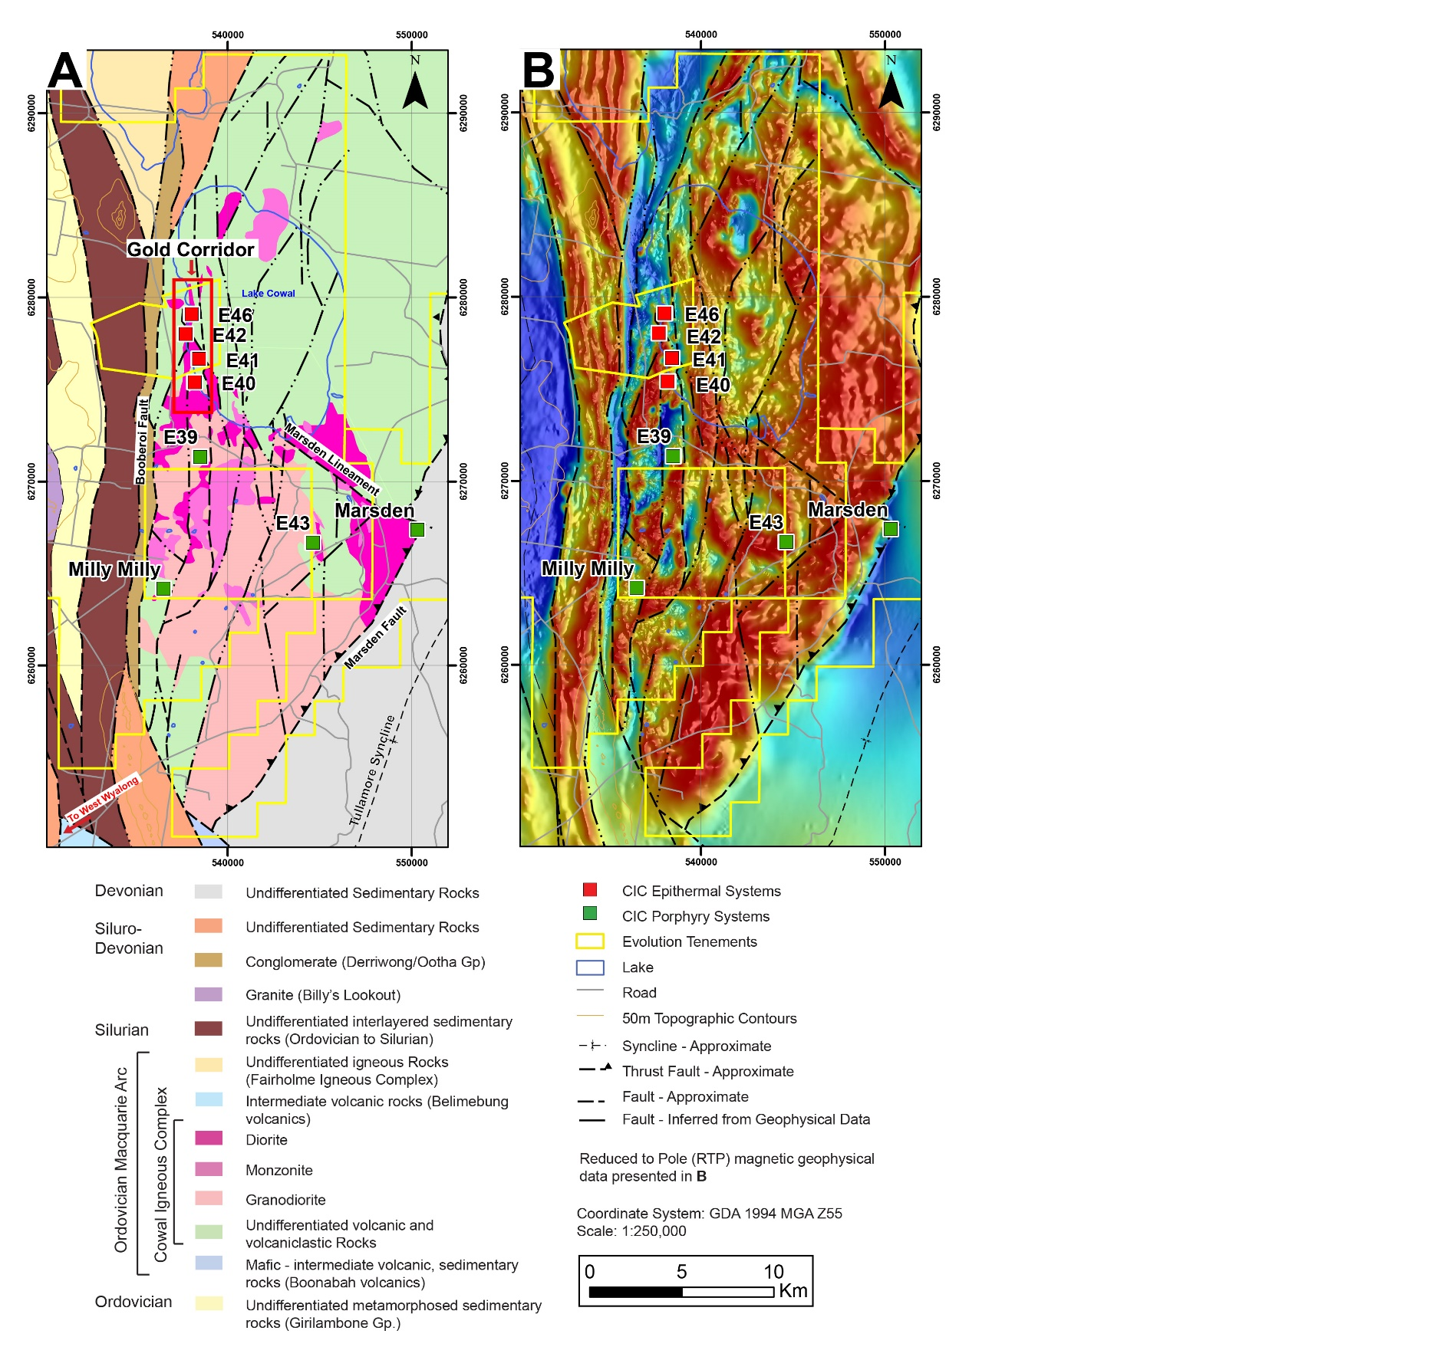

Figure 1.Geological map (A) and Reduced to Pole magnetic map (B) for the Cowal Igneous Complex. Bedrock geology modified from Henry et al. (2014) and Zukowski et al. (2014) using top of bedrock lithology data from Evolution’s drill hole database. Note - Galway and Regal deposits (not shown) are between E42 and E46.

Mineralized calc-alkalic porphyry systems occur over an area approximately 12 by 8 kilometres south of the Marsden lineament (Fig. 1). Drilling is widely spaced and due to lack of outcrop, targets were initially generated based predominantly on airborne magnetic geophysical data. The best-known system is the recently acquired Marsden porphyry deposit. Marsden is 16 kilometres southeast of E42 and has an indicated and inferred mineral resource of 180 million tonnes at 0.38% copper with 0.20 g/t gold2. The core of the Marsden ore body is characterized by quartz + magnetite + chalcopyrite stockwork veins cutting biotite + magnetite altered quartz monzonite to quartz diorite (Rush, 2013). Biotite + magnetite altered porphyritic diorite and intermediate to mafic volcanic and volcaniclastic rocks and lesser magmatic breccias, host local stockwork controlled chalcopyrite mineralization at the nearby E43 porphyry target, five kilometres west of Marsden. Seven kilometres northeast of E43, at E39, widespread low-grade copper mineralization (e.g., ~0.1 to 0.2% copper) consists of chalcopyrite hosted in quartz + magnetite +/- potassium feldspar stockwork veins with local potassium feldspar alteration halos cutting equigranular granodiorite. Clotted chalcopyrite as replacements after mafic phenocrysts overprinted by pervasive sericite alteration is observed at Milly Milly, seven kilometres south of E39. Many of these porphyry systems are only tested to shallow depths, lack significant drill hole density and are therefore considered underexplored and represent long-term exploration assets.

Fluid inclusion and isotopic studies focused on defining the composition and formation temperatures of magmatic-hydrothermal fluids responsible for gold deposition at E41 suggest that low-sulphidation epithermal mineralization is possibly related to an alkalic porphyry system, now concealed at depth (Zukowski, 2010; Zukowski et al., 2014). This interpretation has profound implications for exploration in the CIC, specifically for alkalic porphyry mineralization. Significant alkalic porphyry systems within the Macquarie arc are currently minded 100 kilometres north of Cowal in the Parkes district and 145 kilometres east of Cowal in the Cadia district.

**TIMING OF MINERALIZATION**

Constraining the age of epithermal and porphyry related mineralization in the CIC has proven to be difficult (Forster et al., 2015). For example, sericite associated with a mineralized vein at E42 was dated using radiometric argon-argon techniques and yielded a regionally important hydrothermal alteration and related mineralization age of 439 +/- 1 Ma (Perkins et al., 1995). This age is significantly younger than uranium-lead zircon and monazite ages from interpreted syn-mineral dykes at E42, E41 and E46 and from a post-mineral dyke at E42, which collectively suggest gold mineralization occurred at ~455 Ma (Zukowski, 2010; Henry et al., 2014). Both interpreted ages of gold mineralization are younger than known porphyry related mineralization south of the Marden Lineament. Porphyry related mineralization of the southern CIC is currently constrained to ~463 – 458 Ma based on rhenium-osmium molybdenite ages from the Marsden, E43 and the Milly Milly systems (Zukowski, 2010; Rush, 2013; Forster et al., 2015). This apparent age discrepancy between known CIC epithermal and porphyry systems is further supported by lead isotopic data which suggest different mineralizing events were responsible for each system type (Forster et al., 2015). The spatial and temporal relationships between known CIC mineralized systems will be further addressed in current research undertaken by the first author.

**EXPLORATION**

Based on a systematic evaluation of structurally controlled mineralization in E42, deep exploration drilling was conducted on the southwest side of the E42 pit in 2016. This program was designed to investigate the extension of mineralization below the current E42 mine-plan mineral reserve. An area, informally termed the ‘Stage H cutback,’ was identified and added 1.2 million ounces of gold to the E42 mineral resource2. Mineralization characteristic of the Stage H cutback is similar in nature to all Gold Corridor systems, discussed above. Geotechnical studies and mine site development for future production from the Stage H cutback are ongoing.

Evolution’s current exploration focus is on investigating gold mineralization continuity between the main target areas south of E42 (e.g., E40 and E41) and the potential extension of the Gold Corridor north of E46. Data from these programs will greatly refine the geological model for the entire Gold Corridor and will enhance Evolution’s ability to systematically explore this area of significant gold endowment.

1. Evolution Mining Limited, The Future of Cowal Presentation, December 2016 Mineral Resources table; www.evolutionmining.com.au

2. Evolution Mining Limited, Quarterly Report – For the period ending 31, March 2017, www.evolutionmining.com.au

**REFERENCES**

Balind, P., Booth, J., and McInnes, P., 2017, in press, Cowal gold deposits, Lake Cowal: AusIMM Mongraph Series, Australian Ore Deposits, In Press, p. 4.

Cooke, D. R., Wilson, A. J., House, M. J., Wolfe, R. C., Walshe, J. L., Lickfold, V., and Crawford, A. J., 2007, Alkalic porphyry Au-Cu and associated mineral deposits of the Ordovician to Early Silurian Macquarie Arc, New South Wales: Australian Journal of Earth Sciences, v. 54, p. 445-463.

Crawford, A. J., Cooke, D. R., and Fanning, C. M., 2007, Geochemistry and age of magmatic rocks in the unexposed Narromine, Cowal and Fairholme Igneous Complexes in the Ordovician Macquarie Arc, New South Wales: Australian Journal of Earth Sciences, v. 54, p. 243-271.

Forster, D., McInnes, P., Downes, P. M., Maas, R., Norman, M., and Blevin, P. L., 2015, New lead isotopic and geochronologic constraints on mineralisation in the Macquarie Arc — insights from the Lake Cowal district, New South Wales: Quarterly Notes, Geological Survey of New South Wales, August 2015, v. 144, p. 21.

Glen, R. A., Walshe, J. L., Barron, L. M., and Watkins, J. J., 1998, Ordovician convergent-margin volcanism and tectonism in the Lachlan sector of east Gondwana: Geology, v. 26, p. 751-754.

Henry, A. D., McInnes, P., and Tosdal, R. M., 2014, Structural Evolution of Auriferous Veins at the Endeavour 42 Gold Deposit, Cowal Mining District, NSW, Australia: Economic Geology, v. 109, p. 1051-1077.

Miles, I. N., and Brooker, M. R., 1998, Endeavour 42 deposit, Lake Cowal, New South Wales: A structurally controlled gold deposit: Australian Journal of Earth Sciences, v. 45, p. 837-847.

Perkins, C., Walshe, J. L., and Morrison, G., 1995, Metallogenic episodes of the Tasman fold belt system, eastern Australia: Economic Geology and the Bulletin of the Society of Economic Geologists, v. 90, p. 1443-1466.

Rush, J. A., 2013, Geology of the Marsden Cu-Au Porphyry, NSW: Unpub. B.Sc. (Hons) thesis, University of Tasmania, 110 p.

Zukowski, W., 2010, Geology and mineralisation of the Endeavour 41 gold deposit, Cowal district, NSW, Australia: Unpub. Ph.D. thesis, University of Tasmania, 287 p.

Zukowski, W., Cooke, D. R., Deyell, C. L., McInnes, P., and Simpson, K., 2014, Genesis and Exploration Implications of Epithermal Gold Mineralization and Porphyry-Style Alteration at the Endeavour 41 Prospect, Cowal District, New South Wales, Australia: Economic Geology, v. 109, p. 1079-1115.