WHAT IS DOWN PLUNGE OF THE DOBROYDE HILL HIGH-SULPHIDATION EPITHERMAL DEPOSIT, near Junee, Nsw?  
AN EMERGING CARBONATE-BASE METAL EPITHERMAL SYSTEM

*Glen Diemar1*, Kyle Hughes2  
New South Resources Pty Ltd, gdiemar@newsouthresources.com.au1*

*Geological Survey NSW, kyle.hughes@industry.nsw.gov.au2*

**Key Words:** Dobroyde Hill, High sulphidation, carbonate base-metal gold, epithermal, shoshonitic andesite volcanics, NSW cooperative drill funding

**SUMMARY**

Discovered by Getty Oil in 1983, the outcropping Dobroyde Hill 77k Oz gold high-sulphidation epithermal prospect is now known to telescope into a carbonate base-metal epithermal gold system down plunge. The project is 50km north of Wagga Wagga and 10km north of Junee which is the far southern toe of the Junee-Narromine Volcanic Belt. It is hosted within a 4km long package of middle Ordovician andesitic to basaltic sub-marine volcanic rocks and early Silurian plagioclase and hornblende phyric shoshonitic andesite sub-marine breccias (Crawford 2014, 2017). The “Hill” was the focus of episodes of near surface exploration between the mid-1970s and 1990 employing shallow very tightly spaced drilling resulting in a small uneconomic gold deposit.

Revival of the prospect was driven by field mapping armed with a TerraSpec Halo, ground magnetics and 3D IP and magnetic inversions (by Chris Moore, Moore Geophysics). This lead to the recognition of widespread and surficial dickite ± pyrophyllite ± kaolinite ± illite ± silica alteration in shoshonitic andesite breccias. Follow up drilling which targeted a zone 700m down plunge of the Dobroyde Hill resource was completed in partnership with the NSW Government through the cooperative drill funding scheme. This hole, NDD005, intersected a far larger system than expected, with 280m of intense dickite + pyrophyllite + kaolinite + pyrite ± illite ± silica alteration then 200m of unmistakable carbonate base-metal style alteration as presented in Corbett & Leach (1998). Both alteration styles have associated broad low-grade gold and silver mineralisation with individual 1m intervals to 9.5g/t gold. NDD005 is interpreted to have stepped over the top of the main epithermal gold zone, hence the target remains open to further exploration. Additionally, this 700m down plunge gap between the new and historic drilling is completely untested and if mineralised could extend the strike length of the deposit to one kilometre.

In another hole collared 1.5km to the north west of NDD005, drilling intersected a volcanosedimentary polymictic pebble-conglomerate containing angular to sub-rounded clasts of mineralised quartz-monzonite porphyry indicating possible porphyry mineralisation within the source district. These clasts are petrographically described by Crawford (2017) as unroofed Phase 3 Copper Hill suite monzonites.

Dobroyde is now known to contain at least two styles of mineralisation. A high sulphidation epithermal characterised by dickite, pyrophyllite, kaolinite, pyrite, enargite and a carbonate base-metal gold epithermal system. These large alteration systems have been defined by low cost ground and SWIR alteration mapping and have vastly increasing the size and potential of the project.

Numerous other shallow targets within the alteration system have been defined. These include the Dobroyde West Target defined by a 1km long magnetic low with only three historic RAB holes containing strong bleached siliceous and pyritic andesite. The Far North prospect is another hill 2km north of Dobroyde which contains abundant chalcedonic to colloform silica (Crawford 2014) float boulders within a large Mg- and K-illite altered zone.

The Dobroyde project has valid exploration potential. It has a JORC 2012 gold resource which outcrops at surface, a large preserved dickite pyrophyllite kaolinite alteration halo, an emerging carbonate base-metal epithermal story, potential for mineralised monzonites, additional near surface camp scale exploration targets and great land holders.

**GEOLOGICAL SETTING**

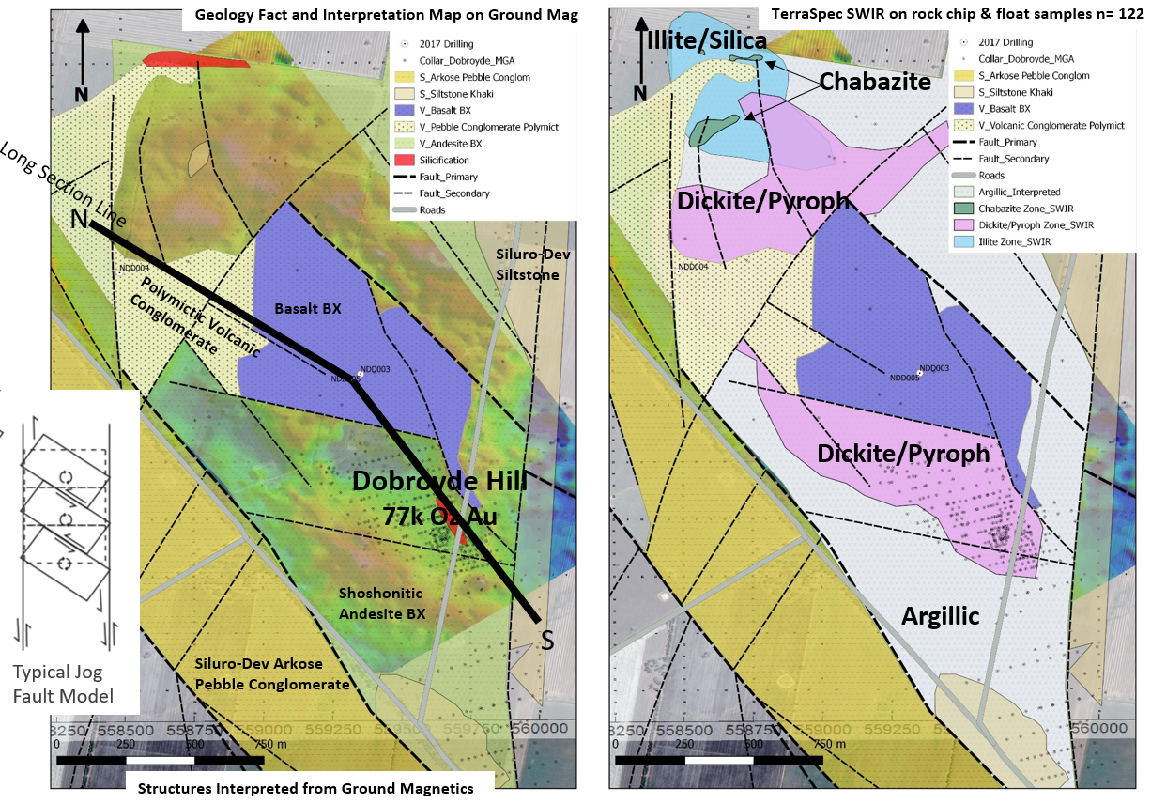

Figure 2. (Left) Surface lithology and structural map of the immediate Dobroyde area only. The image does not include argillic alteration continuing another 1km further south. The map is interpreted from outcrop, float, historic drilling and the ground magnetics partly shown. (Right) The same geology with an alteration map replacing the andesite breccias. The alteration map is derived from TerraSpec SWIR data (n=122) from outcrop and float. Note the northern cooler temperature alteration assemblage of Mg- and K-illite and chabazite (cool temperature zeolite) also has intense chalcedonic and colloform silica (Crawford 2014) boulders. The North-South long section line marks the location of figure 3.

Interpretation of GSNSW regional magnetic data highlights a 5km wide dilational jog in the Gilmore Fault Zone which is filled with Macquarie Arc volcanic and volcanosedimentary rocks that span from the earlier stages of the Arc to its termination. The Dobroyde Volcanics are defined by a 5km long, 3km wide magnetic high containing three main lithologies. Descriptions below (Crawford 2014, 2017 and field work) start from south Dobroyde to north as illustrated in the long section in figure 3.

1. The Dobroyde Andesite: *ca*435-437 Ma hydrothermally altered shoshonitic plagioclase + hornblende phyric glassy quenched lava breccias, flows, dykes and pyroclastics and associated volcano-sedimentary facies including the occasional monzonite clast. Large zircons and apatite phenocrysts are common in the andesites. Petrographic correlations with these lavas are the Nash Hill and Bushman volcanics from the Parkes district (Crawford et al,. 2007).

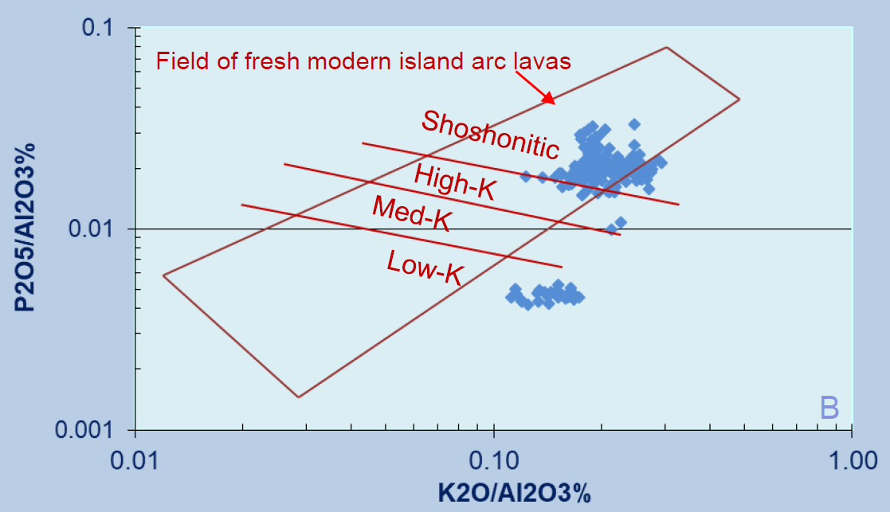

Figure 1. The andesitic breccias hosting both mineralisation styles are clearly shoshonitic while post mineral but still carbonate altered dykes are low-K (Crawford 2017).

1. The Bloody Basalt: *ca*460 Ma medium-K calk-alkaline plagioclase olivine augite phyric basaltic quenched lava breccias which show strong petrographic similarities to the Basal Goonumbla Volcanics from the Parkes district.
2. A polymict volcanosedimentary clast-supported pebble conglomerate. This facie is dominantly made up of Phase 3 Copper Hill suite 450Ma shallow intrusive porphyritic monzonites and various volcanic facies reworked with quartz turbidite/arenites and fresh to altered fossiliferous limestones. The conglomerate is generally poorly sorted however in localised zones has well graded sand to silt beds. The matrix is a fine mud/silt cemented and in part replaced by pale carbonates, pyrite to 5%, barium to over 1000ppm and irregular patches of chalcopyrite in quartz-epidote-chlorite. Hydrothermal alteration has demagnetised wide zones within this conglomerate. The deposition age is *ca*435Ma.

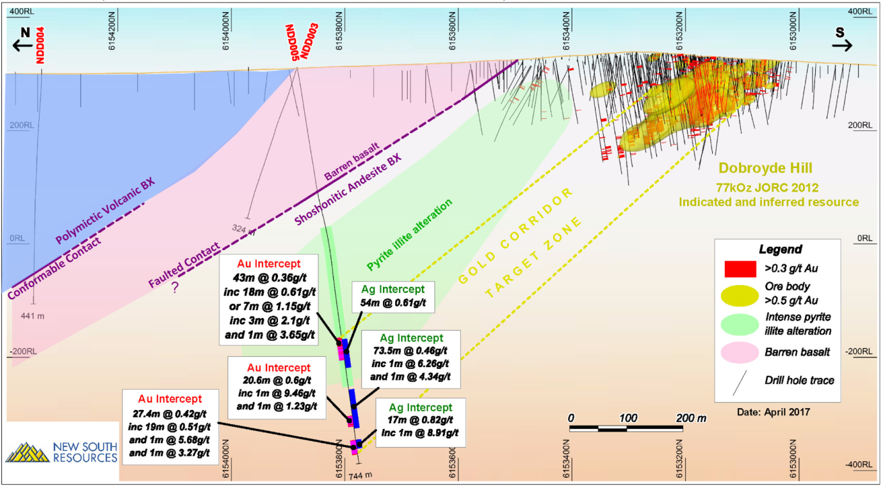

**Dickite pyrophyllite**

Figure 3. Dobroyde north to south long section showing the main lithologies dipping moderately to the north. The three cooperatively funded drill hole collars are highlighted in red. NDD005 was planned to test 700m down plunge of the Dobroyde Hill mineralisation and no other drilling exists in this 700m gap, now termed the gold corridor target zone. The dickite pyrophyllite pyrite illite zone (green) has experienced magnetite destruction and has also been intercepted in shallow drilling 500m to the south and in historic RAB 1km to the west at the Dobroyde West magnetic low prospect. The carbonate base-metal assemblage is located below the green dickite pyrophyllite pyrite illite zone and also has the potential to extend up plunge.

**ALTERATION AND MINERALISATION – Down Plunge Opportunity from Dobroyde Hill**

The high sulphidation ore body is 200m in length, strikes 330o coincident with the Gilmore fault, has a sub vertical dip and plunges 30o to the north. Similarities in alteration and mineralisation have been drawn between this system and the Gidginbung and Peak Hill high sulphidation deposits (Allibone, 1997) mined by Gold Mines of Australia and Alkane respectively. Two main differences are apparent. Firstly, Dobroyde has not seen the widespread precipitation of alunite, which is thought to be due to the high concentration of barium, which scavenges sulphate and then preferentially precipitates low solubility barite instead of alunite (Leach, 1987). This is also evident at the Mount Kasi high sulphidation gold deposit in Fiji (Turner, 1986). The second is that Gidginbung and Peak Hill have not demonstrated strong carbonate zones like Dobroyde. In this case similarities are drawn to the large Lake Cowal E42 deposit, 120km to the north (Henry et al., 2014).

The high sulphidation epithermal gold style outcrops in a road cutting over Dobroyde Hill. From 1984 to 1990 the “Hill” was the focus of 25km of drilling with average depth of 69m and a max depth of 250m, this shallow and very tightly spaced drilling resulting in a small uneconomic gold deposit. The recently drilled NSW government cooperatively funded drill hole NDD005 targeted mineralisation 700m down plunge of this resource. Below the faulted Bloody Basalt-Andesite lithology contact at 260m, this hole intersected the 280m thick package of advanced argillic and argillic altered andesitic volcanics. In the base of this alteration was increased silica and high sulphidation style gold mineralisation grading 43m at 0.36g/t Au and 0.6g/t Ag, including 7m at 1.15g/t Au. This grade of intercept is similar to the low-grade gold halo around the Dobroyde Hill resource and is hence considered a near miss. The gold is in association with silica, pyrite, enargite and minor chalcopyrite (up to 0.7% Cu). This intercept in NDD005 has extended the outcropping high sulphidation epithermal for another 700m taking the down plunge strike length to nearly one kilometre.

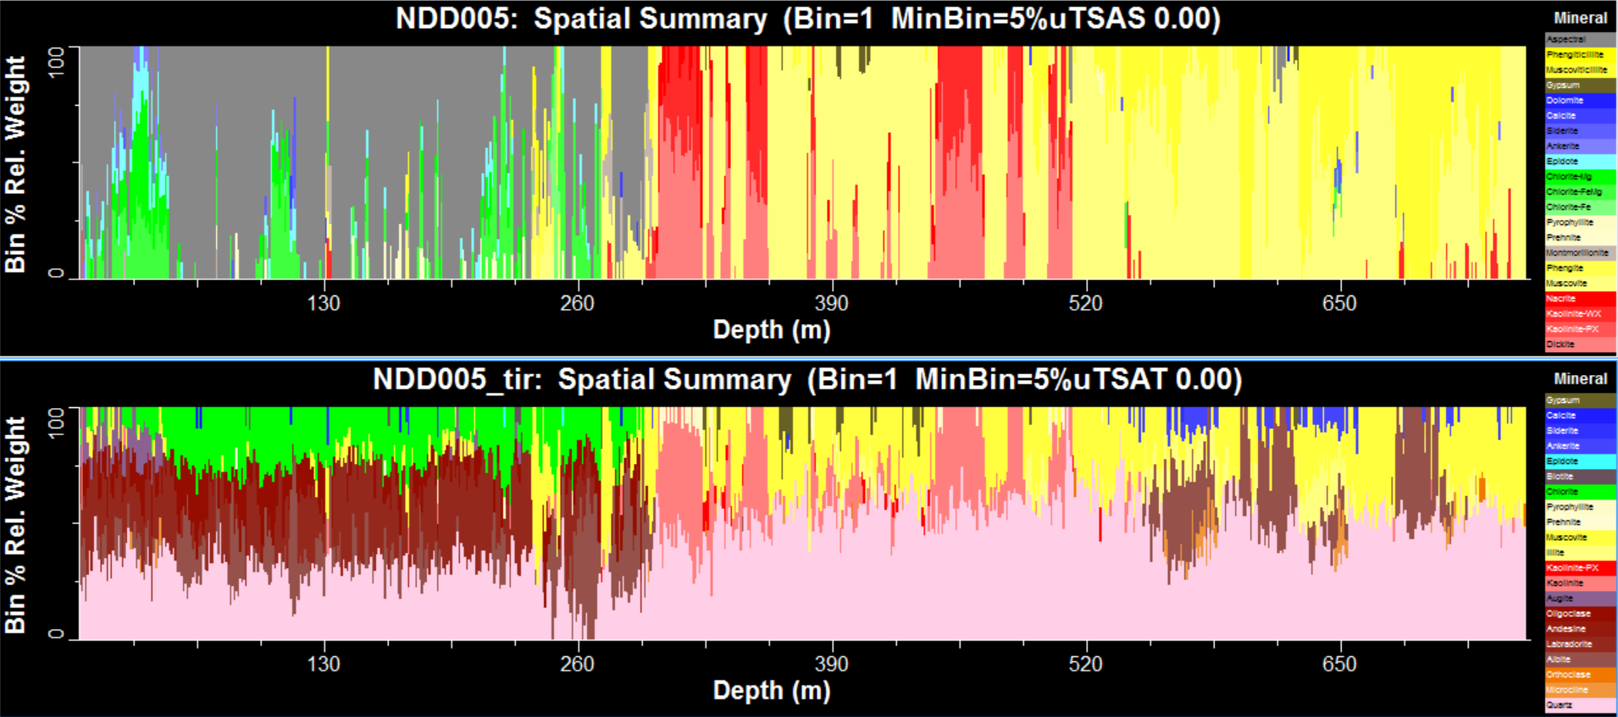

**SWIR TIR**

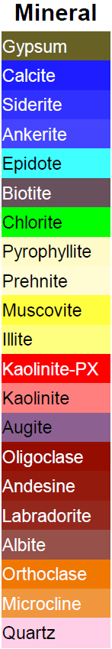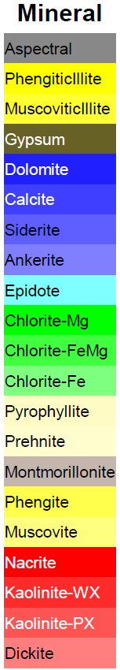

Figure 4. CSIRO’s Hylogger (courtesy GSNSW) of NDD005 downhole summary. Short wave infra-red SWIR (top) and thermal infra-red TIR (bottom). Three main zones of alteration emerge: 0-260m the basalt with low grade metamorphic chlorite, 260-510m alternating advanced argillic (red) and argillic (yellow) and 510-744.2m argillic (yellow) and ankerite (blue). The TIR below 550m shows four zones of albite in brown.

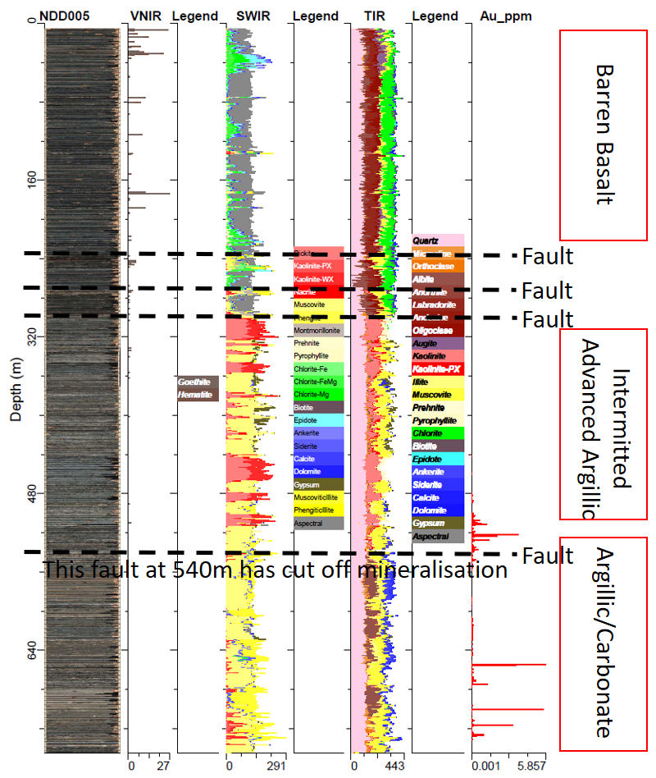

Figure 5. Hylogger summary of NDD005 with Au ppm in the right-hand column and major geological features in red boxes on the right hand side. Fault locations are highlighted for reference.

Below a syngenetic fault at 540m downhole in NDD005, the alteration style immediately changed to kaolinite, muscovite, illite with a late strong ankerite overprint. Below the fault a second mineralisation style intersected over a 200m zone includes local zones of quartz carbonate veins bearing gold, galena, chalcopyrite with minor pyrite and sphalerite (figure 6).

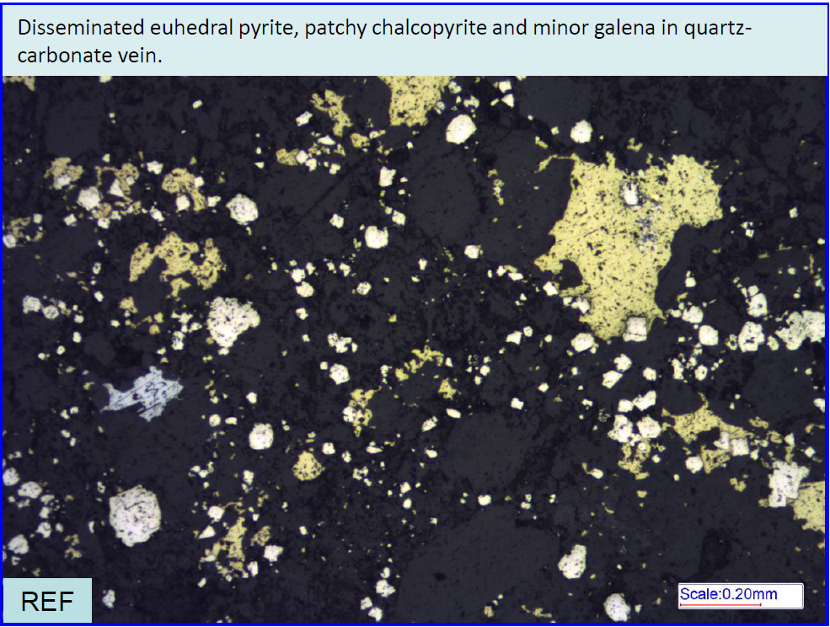

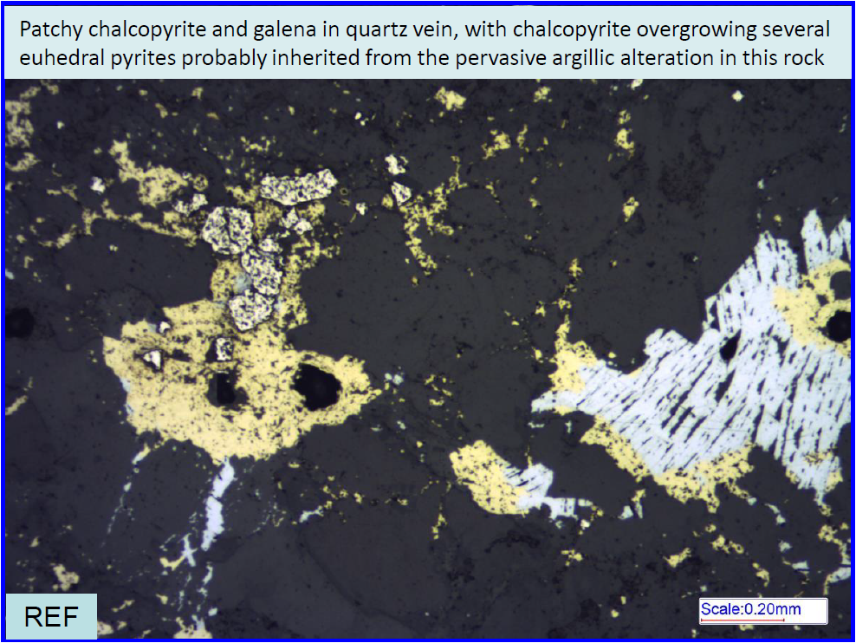

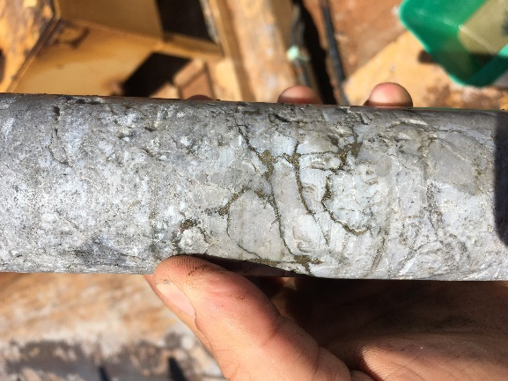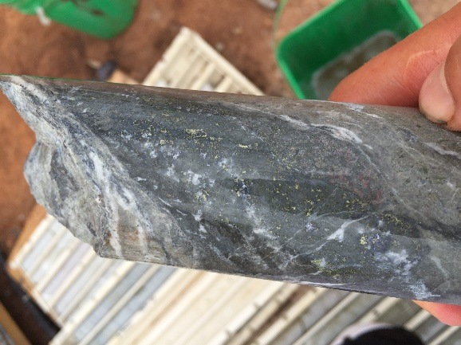

Figure 6. NDD005 from left to right. Drill core (510m) from the high sulphidation zone of fine grained volcaniclastic completely replaced by vuggy quartz with enargite, chalcopyrite, pyrite veins and disseminations grading 0.7g/t gold over 1m. The silica zone is surrounded by dickite pyrophyllite kaolinite pyrite alteration. Drill core (700.7m) from the carbonate base metal zone of a 3cm wide quartz-carbonate vein bearing gold grains (in thin section), galena, chalcopyrite with minor pyrite and sphalerite. This one vein over a 1m assay returned 5.68g/t gold. Petrography from Crawford (2017) of the same vein at 700.7m showed the base metal and carbonate associations are late with respect to argillic alteration which is a common feature of carbonate base metal systems (Corbet and Leach, 1996). Figure 7 and 8 highlight the relationship between gold and base metals and manganese.

The species of carbonate in a carbonate base metal deposit depends on the proximity to a magmatic heat source, depth and fluid mixing (Corbet and Leach, 1996). A typical carbonate zonation from distal to proximal is Fe, Mn, Mg and Ca however this can vary greatly. The thermal hylogger data for carbonate species in NDD005 is generally ankerite with siderite, but calcite and dolomite do occasionally persist. Despite the quantity of manganese rhodochrosite has not been observed.

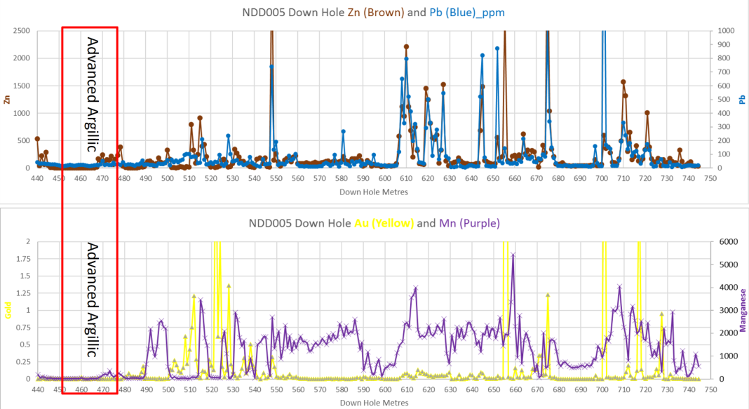

Figure 7. Downhole graphs Top: zinc (top cut to 2500ppm) and lead (top cut to 1000ppm) and Bottom: gold (top cut to 2g/t) and manganese (ppm) showing anomalous and coincident base metals, gold and manganese in the carbonate zone. The manganese is taken up by ankerite as demonstrated in the hylogger data.

As seen in the surface geology/alteration map in figure 3, the dickite pyrophyllite kaolinite alteration is prolific over a wide area within the andesite. This assemblage has experienced magnetite destruction where the alteration intensity ranges from strong to intense. The Bloody Basalt on the other hand is not hydrothermally altered and is strongly magnetic so the contrasting magnetic intensities between the andesite and the basalt can be a useful tool when modelling in 3D. This lithology contact is interpreted to dip northward with the plunge of the deposit so directly beneath the footwall contact is an exploration target.

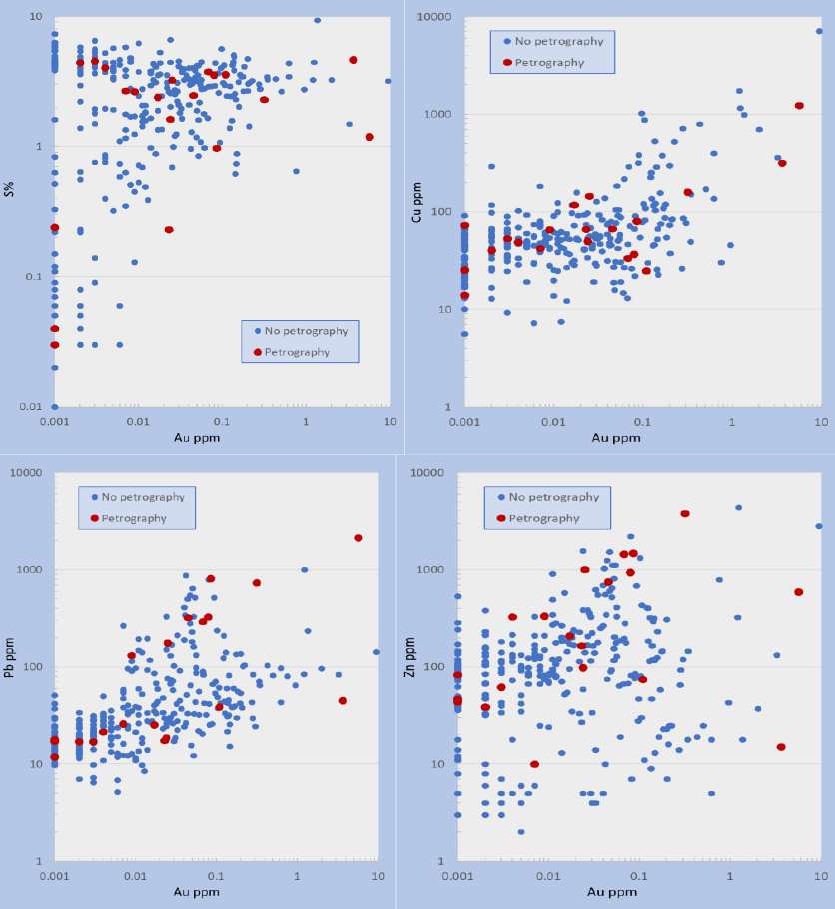

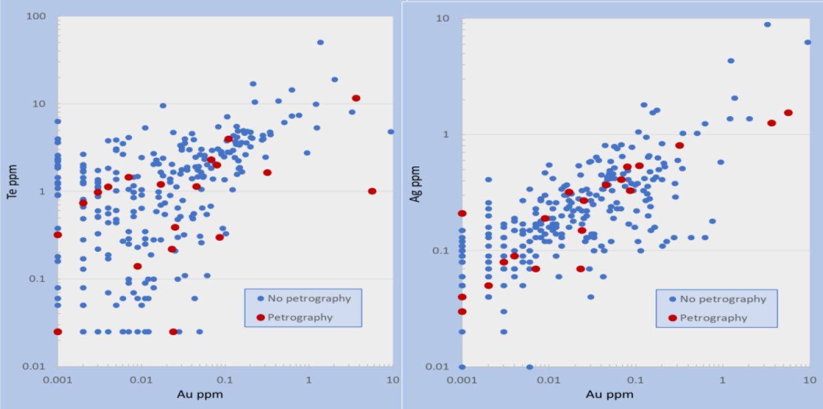

Figure 8. Plots from Crawford, (2017) of Au abundance vs S, Cu, Pb, Zn, Te and Ag. No correlation exists between Au and S or As (Arsenic graph not shown here), but above 0.01ppm Au there is a correlation for Cu, Pb, Zn, Te and Ag. Pb has two clear populations highlighted by the green ovals.

**POST MINERAL STRUCTURES – Understanding the Post Mineral Fault Regime**

The regional dextral stress along the Gilmore fault has impacted the shoshonitic andesite post mineralisation. The Dobroyde deposit does not exhibit regional foliation but moderately NE and SW dipping faults have offsets in the range of tens of metres. Block faulting is interpreted to have dextral rotations within the Dobroyde Jog and this has implications for exploration. The post mineral faulting is not seen to have offset mineralisation enough to affect the potential economics.

**SURROUNDING PROSPECTS – All Shallow and within the Camp**

**Dobroyde West**

The advanced argillic and argillic alteration around the Dobroyde Hill deposit has created 500m wide magnetic low which plunges northward underneath the Bloody Basalt. Another magnetic low has formed 750m west of the Hill in an area named Dobroyde West. This magnetic low strikes north south and has a larger footprint. Only three RAB holes have tested this magnetic low, they were drilled in 1992 to 60m depth. Logging described grey argillic altered andesite averaging 2-5% pyrite in the base of all three holes and in one hole, strong silica with up to 10% pyrite over 4 metres.

The Dobroyde West magnetic low feature is interpreted to be an extension of the argillic alteration and is further evidence for a large degassing fertile gold system. Drill testing Dobroyde West is a high priority.

**Far North Prospect**

Two kilometres along the typical 330o strike to the north of Dobroyde Hill is another albeit smaller hill interpreted to be a low-temperature epithermal silica zone. The prospect was first recognised during field mapping by the presence of 50cm float boulders of white chalcedonic to colloform silica (Crawford 2014), limonite and rare fresh pyrite completely replacing a plagioclase phyric protolith. SWIR data (n=53) on float samples from this hill demonstrate a large Mg- and K-illite zone with three distinct zones of the cool temperature epithermal zeolite chabazite.

Limited gold and barium float assays (n=5) are anomalous, with the highest being 0.24g/t Au and 1000+ppm Ba. In 2006, sub audio magnetics completed over Dobroyde extended to the Far North prospect. The EQMMR response for both the Dobroyde and Far North prospects are strongly coincident and hence enhance the prospectivity of this area.

**Southern Magnetic High**

Five kilometres south along strike to the of Dobroyde Hill is a large magnetic high response. This feature is known from regional government magnetic data and extends 5km in length and 2km in width. The feature is similar in appearance to the Dobroyde Magnetic High and also appears to have magnetic destruction zones however the area has had no modern exploration or drilling. The area is under shallow pastoral cover and no outcrop has been found however illite altered float samples have been found. This very large magnetic feature will be the focus of regional exploration moving forward.

**CONCLUSION**

The small but well defined historic gold resource at the Dobroyde Hill high sulphidation epithermal deposit has provided confidence that the Dobroyde volcanics are fertile with gold and that further exploration is warranted. The historic drilling did not test the current resource deeper than 200m down plunge. This large mineralised alteration system intercepted in NDD005, has extended the outcropping high sulphidation epithermal for another 700m, taking the down plunge strike length to nearly 1km as well as discover carbonate base-metal epithermal gold mineralisation.

Traditional low-cost ground work with modern spectral technology, a 20th century understanding of magmatic related alteration systems and the NSW Government cooperative drill funding has led to the recognition of a much larger alteration system and is unlocking a bigger story. This project has the potential to lead to the discovery of New South Wales second large carbonate base-metal gold epithermal deposit.

**ACKNOLOWEDGEMENTS**

The NSW Geological Survey are thanked for their partnership with New South Resources Pty Ltd in the form of the Cooperative Drill Funding, as well as being a supplier of public geological information which has greatly helped advance the Dobroyde Project. The Dobroyde landholders are thanked for not just allowing access to explore but also for their attitude towards the coexistence of mining and farming. Many others are thanks for their contribution to this project and those people know who they are.

**REFERENCES**

ALLIBONE A., 1997. Gold mineralisation and advanced argillic alteration at the Dobroyde prospect, central New South Wales. Australian Journal of Earth Science, 44, 727-742.

BLAYDEN I. D., 2013. Statement of resources, Murphys and Dobroyde Gold Deposits. For Arc Exploration Ltd Sydney. 26p.

CORBETT G. J. & LEACH T. M., 1998. Southwest Pacific gold-copper systems: Structure, alteration and mineralisation: Special Publication 6, Society of Economic Geologists, 238 p.

CRAWFORD A. J., MEFFRE S., SQUIRE R. J., BARRON L. M. & FALLOON T. J., 2007. Middle and Late Ordovician magmatic evolution of the Macquarie Arc, Lachlan Orogen, New South Wales. Australian Journal of Earth Science, 54, 181-214.

CRAWFORD A. J. 2014. Petrographic Report, 11 rocks from the Dobroyde prospect, and Adelong-Temora-Birnaseer Areas, SE NSW. For Arc Exploration Ltd Sydney. 50 p.

CRAWFORD A. J. 2017. Petrographic Report, 28 rocks from drill holes NDD004 and NDD005, Dobroyde Project, For New South Resources Pty Ltd. 174 p.

HENRY A.D., MCINNES P. & TOSDAL R., 2014. Structural evolution of auriferous veins at the endeavour 42 gold deposit, Cowal Mining District, NSW, Australia. Economic Geology. 109. 1051-1077.

LEACH T. M. 1987. Petrological evaluation of cores from the Dobroyde gold deposit, NSW. For Little River Goldfields NL. 135p.

TURNER, S. J. 1986. Fluid Inclusion, alteration and ore mineral studies of an epithermal, mineralised vein system: Mount Kasi, Vanua Levu, Fiji. 157p.