Pathfinder exploration techniques TArgeting porphyry and epithermal alteration systems in the Temora Copper-Gold Belt

*Bruce Hooper1*, Damien Stephens2 and Mathew Peacock 3  
Sandfire Resources NL, bruce.hooper@sandfire.com.au1, Sandfire Resources NL, damien.stephens@sandfire.com.au2 Sandfire Resources NL, mathew.peacock@sandfire.com.au*

INTRODUCTION

Sandfire Resources NL (Sandfire) considers the Lachlan Fold Belt to be a key target area for discovery of a significant economic deposit masked by recent sediments. Sandfire has built up a significant 100% owned tenement holding to target porphyry Copper-Gold and Epithermal Gold within the Ordovician volcanic complexes under less than 100m of cover (Figure 1).

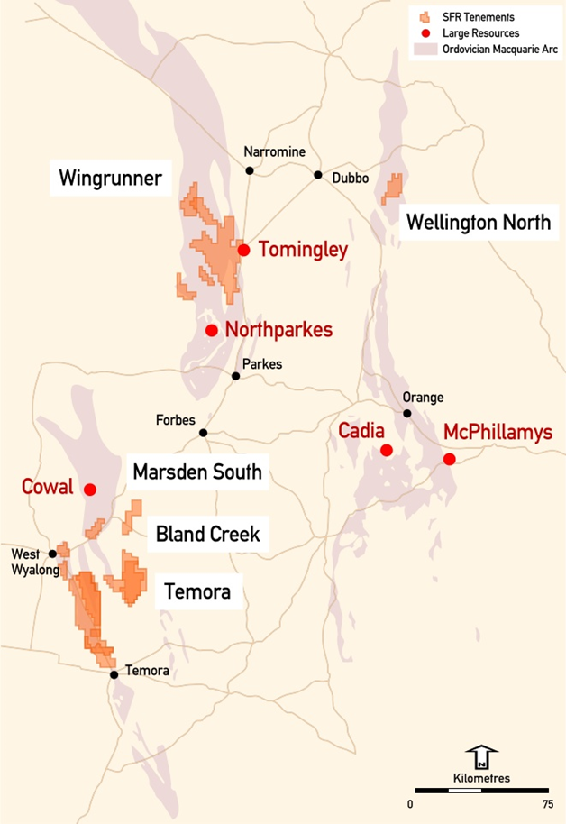

Figure 1. Lachlan Fold Belt Sandfire Tenements

The Temora project lies in the Lachlan Fold Belt south of West Wyalong and was targeted by Sandfire as a mineralized district with potential for new and higher grade deposits that could be unlocked with modern exploration techniques. The tenements were purchased outright in 2015.

A number of mineralised systems are defined within the Late Ordovician Gidginbung Volcanic Complex (Figure 2), including the historical Gidgingbung high sulphidation gold mine and a number of mineralised porphyry prospects including Yiddah, Mandamah, Cullingerai, Estoril and the Dam deposits. Mineralisation is related to narrow intrusive dykes within a coeval volcanic pile of volcaniclastics, sediments and lavas. Quartz-magnetite-feldspar-pyrite-chalcopyrite veins are associated with a chlorite-magnetite-carbonate alteration. A later quartz-sericite-pyrite alteration postdates the mineralisation.

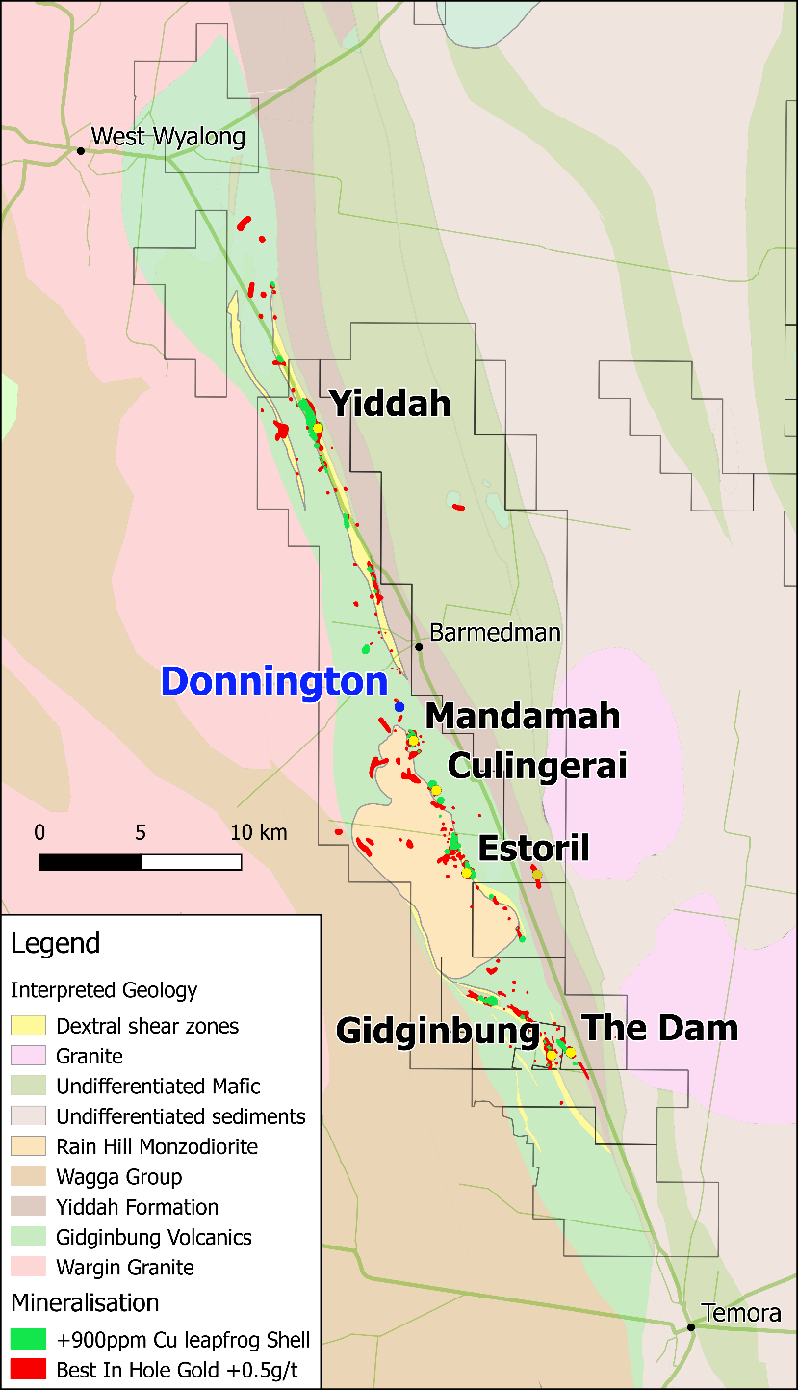

Figure 2. Temora interpreted geology, geochemical anomalies defined from Aircore drilling

EXPLORATION ANALYSIS

The substantial previous exploration work including over 4,000 drill holes was compiled, holes were re-logged and geophysics re-interpreted. Time was allowed to collect all previous holes and available pulps in the West Wyalong yard for re-logging and resampling to incorporate new data in detailed re-analysis of the geology and alteration systems. The availability of these historical drill pulps, chip samples and core enabled the first comprehensive multi-element geochemistry and Short Wave Infrared (SWIR) analysis of many of these samples. This provided a good understanding of the project prior to commencing drilling campaigns.

Interpretation of the SWIR hydrous minerals’ (e.g. micas, clays, hydrous sulphates) spectra identified their individual crystallinity, (the higher the temperature of formation the higher the level of crystalline order). The illite crystallinity is measured by calculating the depth of 2200mm absorption peak divided by the H2O absorption peak at ~1900nm. The less water in the matrix the higher the crystallinity. The 2200nm Al-OH absorption peak in white micas is a proxy for Ph gradients in the paleo fluid with acid paleo fluids giving lower wavelengths (Figure 3) (Chang et al, 2014).

In combination with trace element compositions, petrology, whole rock geochemistry the crystalline structure variations provide an alteration zonation and vectors towards higher temperature (acid) fluids based on stability diagrams and distributions around known deposits (Halley et al, 2015).

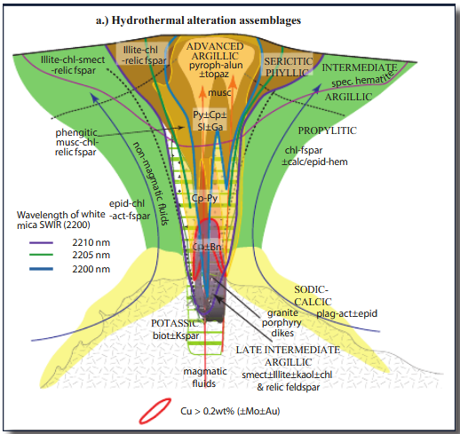

Figure 3. Vertical cross section of a typical porphyry Cu deposit showing distribution of hydrothermal alteration and sulﬁde minerals. Also shown are generalized contours of the 2,200-nm peak measured in SWIR instruments- from Halley et.al. 2015.

INTERPRETATION AND TARGET DEFINITION

The hydrothermal alteration assemblages, multi-geochemical zonation patterns from aircore drilling combined with the known geophysical signatures associated with porphyry deposits (Hoschke, 2011) enabled the prioritisation of modern IP and gravity surveys with infill aircore and diamond drilling.

This work confirmed high temperature, low Ph alteration at Yiddah and Yiddah North (untested), The Dam, MagH1, Fields North, Punch and Mandamah. One of the most intense zones of this alteration was highlighted between Punch and Mandamah defined as the Donnington prospect (Figures 4 and 5).

Priority targets were highlighted across the belt, including targets at depth associated with the Gidginbung high sulphidation epithermal gold system and the northern and eastern margins of the Rain Hill monzodiorite intrusive centre (Internal reports, Kitto 2016).

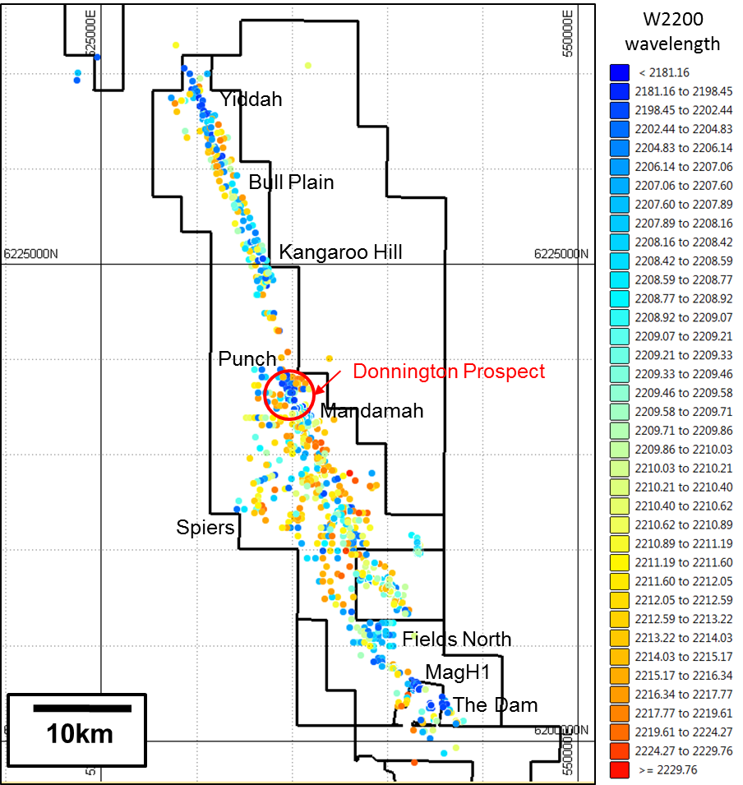

Figure 4. Plan showing spatial distribution of the 2200nm wavelength absorption peak associated with white micas over Temora tenements

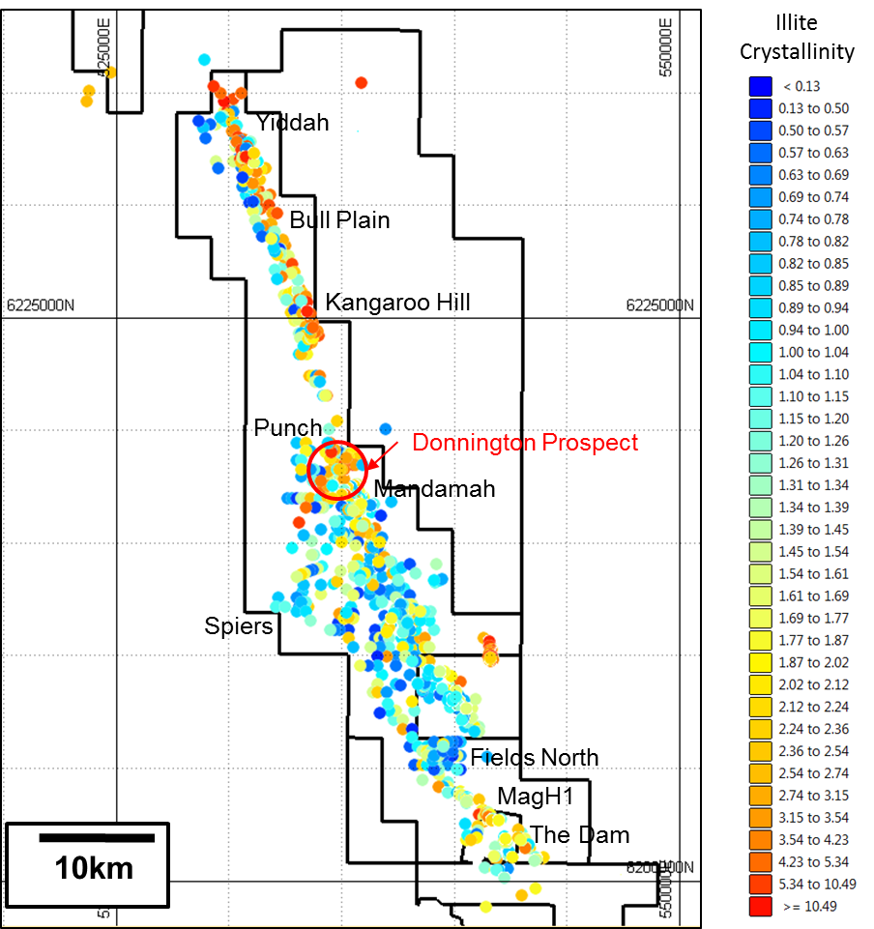

Figure 5. Plan showing Illite Crystallinity over Temora tenements.

EXPLORATION PROGRAM

Drilling during the 2016-2017 field season included deep diamond holes targeted at MagH1, Gidginbung and on the margins of the Rain Hill monzodiorite.

The Donnington prospect was defined within a 12 km long magnetic depletion zone, the Mandamah Alteration Zone (MAZ), on the eastern margin of the Rain Hill monzodiorite. The entire extent of the depletion zone shows a consistent, best in hole, aircore copper result of +500ppm with a peak to the north at Punch of 1,630ppm Cu with a peripheral zinc anomaly. Infill aircore drilling further defined the anomaly. The geological, geochemical and SWIR anomaly defined at Donnington is associated with a 2nd order weak magnetic signature within this large alteration zone (Figure 6).

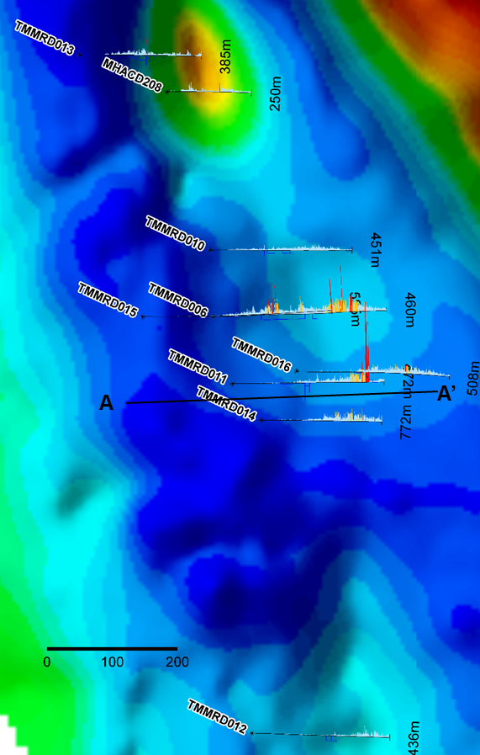

**Punch**

**Donnington**

**Figure 6**. Donnington magnetic image showing copper mineralization intersected in drilling associated with a 2nd order magnetic high.

A Diamond hole was drilled to test the anomaly and was successful in discovering porphyry style mineralisation in the first hole, with an intercept of 125m @ 0.32% Cu and 0.46g/t Au. Mineralisation is associated with narrow porphyry dykes with potassic alteration and quartz-magnetite-chalcopyrite and pyrite mineralization (Figure 7).

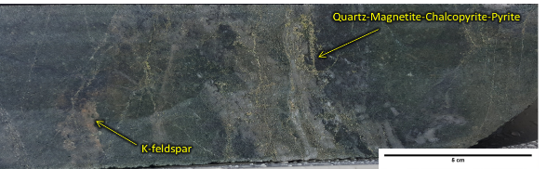

**Figure 7**. Donnington mineralization in core from TMMRD011

Follow up drilling has intersected 77m @ 0.44% Cu and 0.65g/t Au including 24m @ 0.89% Cu and 1.39 g/t Au. Drilling has encountered mineralization over 200m along strike, 700m depth and is still open (Table 1, Figure 8). (Sandfire Quarterly Report June 2017).

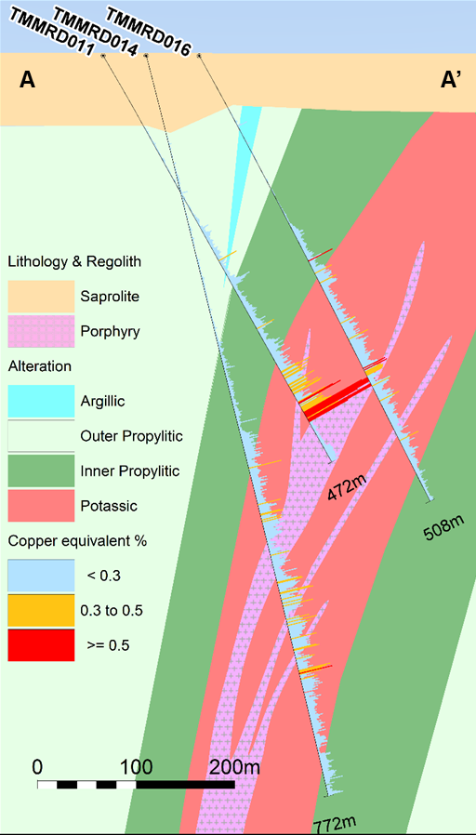

**Figure 8**. Donnington cross section showing copper anomalism associated with porphyry intrusives.



**Table 1**. Drill hole results for Donnington Prospect Sandfire Quarterly June 2017.

**CONCLUSION**

Selection and acquisition of the highly mineralised Temora belt is key in the plan for Sandfire to discovering a major economic deposit in New South Wales. Utilising modern understanding of porphyry systems with new exploration techniques such as low level multi element geochemistry, SWIR, high power IP and reprocessed geophysics has defined a new mineralised system at Donnington in a mature exploration belt. It is hoped this is one of many new discoveries in the region.

**REFERENCES**

CHANG Z CLAPIN G, WILSON A, MCKNIGHT S, BOTTRILL R, WOOLLEY R, LISOWIEC N, ANDREWS W 2014. Illite crystallinity by short wavelength infrared spectral techniques and its application in exploration. SEG conference 2014.

HALLEY S., DILLES J., TOSDAL R., 2015, Footprints: hydrothermal alteration and geochemical dispersion around Porphyry Copper Deposits, SEG newsletter Jan 2015

HOSCHKE T., 2011 Geophysical Signatures of copper-gold porphyry and epithermal gold deposits, and implications for exploration. ARC Centre of Excellence in Ore Deposits, June 2011

KITTO J., 2016. Miscellaneous internal reporting of exploration targeting at Temora.

SANDFIRE RESOURCES NL June 2017 Quarterly Report: Competent Person Hooper, B. RPGeo AIG