**OROGENIC GOLD SYSTEMS IN VICTORIA**

**Andy Tomkins1, Chris Voisey1, Roland Maas2, and Stefan Vollgger1, Steven Micklethwaite1, Chris Wilson1**

1. School of Earth, Atmosphere & Environment, Monash University

2. School of Earth Sciences, University of Melbourne

**Key Words:** orogenic gold, Victoria, sediment-hosted gold, silver isotopes, ore genesis

**INTRODUCTION**

Gold is a key strategic commodity for Australia; we are the world’s 2nd largest gold producer, and we survived the Global Financial Crisis better than any other developed nation because we have a strong resources industry with ties to China. Orogenic gold deposits have contributed over 75% of the gold recovered globally through history (when placers are included; Phillips & Powell 2015), and Victoria contains one of the richest orogenic gold regions ever discovered. Victoria therefore represents an important piece in the puzzle of understanding this deposit type.

Orogenic gold deposits mainly form in metamorphic rocks in the mid- to shallow crust (5–15 km depth), at or above the brittle-ductile transition, in compressional settings that facilitate transfer of hot gold-bearing fluids from deeper levels (Goldfarb et al. 2005). The term “orogenic” comes from the envisaged accretionary tectonic setting for these deposits (Groves et al. 1998). A key aspect of this setting is that earthquakes and aftershocks control transfer of weakly oxidised, low-salinity gold-bearing fluids to the sites of ore accumulation (e.g. Micklethwaite et al. 2010). This concept implies that fluids are able to rapidly traverse large thicknesses of crust, but the consequences have not been properly investigated from a geochemical or thermodynamic perspective. This rapid rise takes the fluids out of equilibrium with their surroundings, promoting destabilisation of the gold-carrying hydrosulfide complexes. However, the chemical cause of gold precipitation is highly debated, and mechanisms such as fluid-rock reaction (Evans et al. 2006), phase separation (Weatherley & Henley 2013), fluid mixing (Bateman & Hagemann 2004), and chemisorption onto the surfaces of pyrite and arsenopyrite (e.g. Möller & Kersten 1994) have been proposed.

Although the question of the cause of gold deposition is approachable because we sample the rocks where precipitation occurred, there remains a remarkable disconnect between our understanding of fluid flow and that of the geochemistry controlling metal precipitation. Researchers focusing on structural controls tend to invoke pressure and temperature change as the dominant control on metal localisation (Weatherley & Henley 2013; Bateman & Hagemann 2004), whereas geochemists tend to focus on local scale changes in fluid chemistry driven by interaction between fluids and rocks (Evans et al. 2006; Möller & Kersten 1994). To our knowledge, no research group has ever examined how the scale of fluid migration influences the chemistry of the fluid, with the goal of explaining the observed mineralogical controls on metal deposition. It is important to close this first-order gap in understanding because it occurs exactly at the scale of mineral exploration – explorers want to know where metal is concentrated within a known structural system; the structure alone does not explain this, and nor does geochemistry.

To approach this problem we need to examine a natural system where a range of significant gold deposits are exposed at different crustal levels in a relatively simple structural setting. The best natural system in Australia for this is the Victorian Goldfields because there are significant variations in mineralisation style exposed at different crustal levels, most deposits have simple structural histories, and there is no debate as to whether fluids are igneous or metamorphic; they are clearly metamorphic because there are no intrusions of comparable age (Phillips et al., 2012). By using the Victorian goldfields as a type example, we hope to develop new insights into gold deposit formation in slate belts globally. Our team is currently undertaking an ARC Linkage project supported by the Geological Survey of Victoria and Kirkland Lake Gold Ltd, to improve the understanding of gold deposit genesis across a range of scales in Victoria, with the aim of improving mineral exploration success. This paper reports on part of our work to date, focusing on new silver isotope data for a range of deposits across Victoria, which informs the larger scale view of gold deposit genesis across the Victorian Goldfields.

**SILVER ISOTOPES AS A TOOL FOR INVESTIGATING REGIONAL GOLD SYSTEMS**

Since 2010, the most exciting advancements in orogenic gold genesis have come in the area of understanding the source region processes responsible for generation of gold-bearing fluids. The question of where the gold comes from is difficult to answer because the potential sources are distant to the gold deposits that we sample. Although other possibilities have been debated, there are now considered to be two plausible sources for the gold in these deposits: (1) metamorphic rocks, from which gold-bearing fluids are liberated as temperatures increase; and (2) felsic-intermediate magmas, which release fluids as they crystallise (Tomkins, 2013). Gold-bearing magmatic-hydrothermal deposits are characterised by significant enrichments in a range of elements as well as gold, including variable proportions of S, Cu, Mo, Sb, Bi, W, Pb, Zn, Te, Hg, As, and Ag (e.g. Goldfarb et al., 2005). Such deposits have been referred to as gold-plus deposits and likely inherit much of the metal budget from magmatic sources (e.g. Phillips & Powell 2015). In comparison, most orogenic gold deposits fall into the alternative gold-only grouping, and are considered to be more enigmatic in origin; they are characterised by elevated S and As, and have only minor enrichments in some of the elements listed above. Most gold deposits in central Victoria fall into the gold-only grouping and are thought to have formed from metamorphic fluids (Thomas et al. 2011; Wilson et al. 2013). However, there are some deposits (such as Fosterville and Costerfield) that have a gold-arsenopyrite association overprinted by a later generation of gold-stibnite-bearing quartz veins.

Amongst proponents of the metamorphic source model there has been vigorous debate over the last five years on the ideal source rock. Some suggest that hydrated, pyrite-bearing mafic rocks are the best source for fluids and gold (Phillips & Powell 2009; Wilson et al. 2013), whereas others suggest that pyritic carbonaceous sedimentary rocks can generate much more fertile fluids than mafic rocks (Large et al. 2009; Tomkins 2010; Pitcairn et al. 2015). For both mafic and metasedimentary source regions, the most fertile fluids are generated during low-pressure metamorphism at the transition between greenschist and amphibolite grade metamorphism, which constrains the tectonic settings where gold deposits are likely to form (Tomkins 2010), and thus exploration models. The deposits in the Victorian goldfields are underlain by ~15 km of carbonaceous turbidites, which sit above a ~20 km thick package of mafic volcanic/sedimentary rocks (Willman et al. 2010; Cayley et al. 2011). Because of these factors, and there are no intrusions of equivalent age to the deposits, Victoria is an ideal place to investigate the source rock question. One way to solve this problem is to identify a geochemical tracer that identifies the source of gold beyond doubt, and we have investigated the potential of Ag isotopes for solving this problem.

We have investigated variations in silver isotope compositions in Ag-bearing gold grains from 10 deposits across Victoria (Figure 1). The conceptual basis for this research was as follows. In turbidites, the sequestration of gold, silver and arsenic into diagenetic pyrite involves bacterial sulfate reduction in a deep-sea setting, and this biogenic process may fractionate silver isotopes (107Ag and 109Ag) to produce a distinct isotopic range, as it does in other isotopic systems. In contrast, metabasalts should contain mantle-derived Ag, with relatively little variability in isotopic signature. Currently available data imply a mantle value for ε107 of -2.2 (Schönbachler et al., 2007), but there are no data yet for meta-turbidites. A key aim of this study was to determine whether source isotopic signatures could be preserved during ore metal transport and deposition.

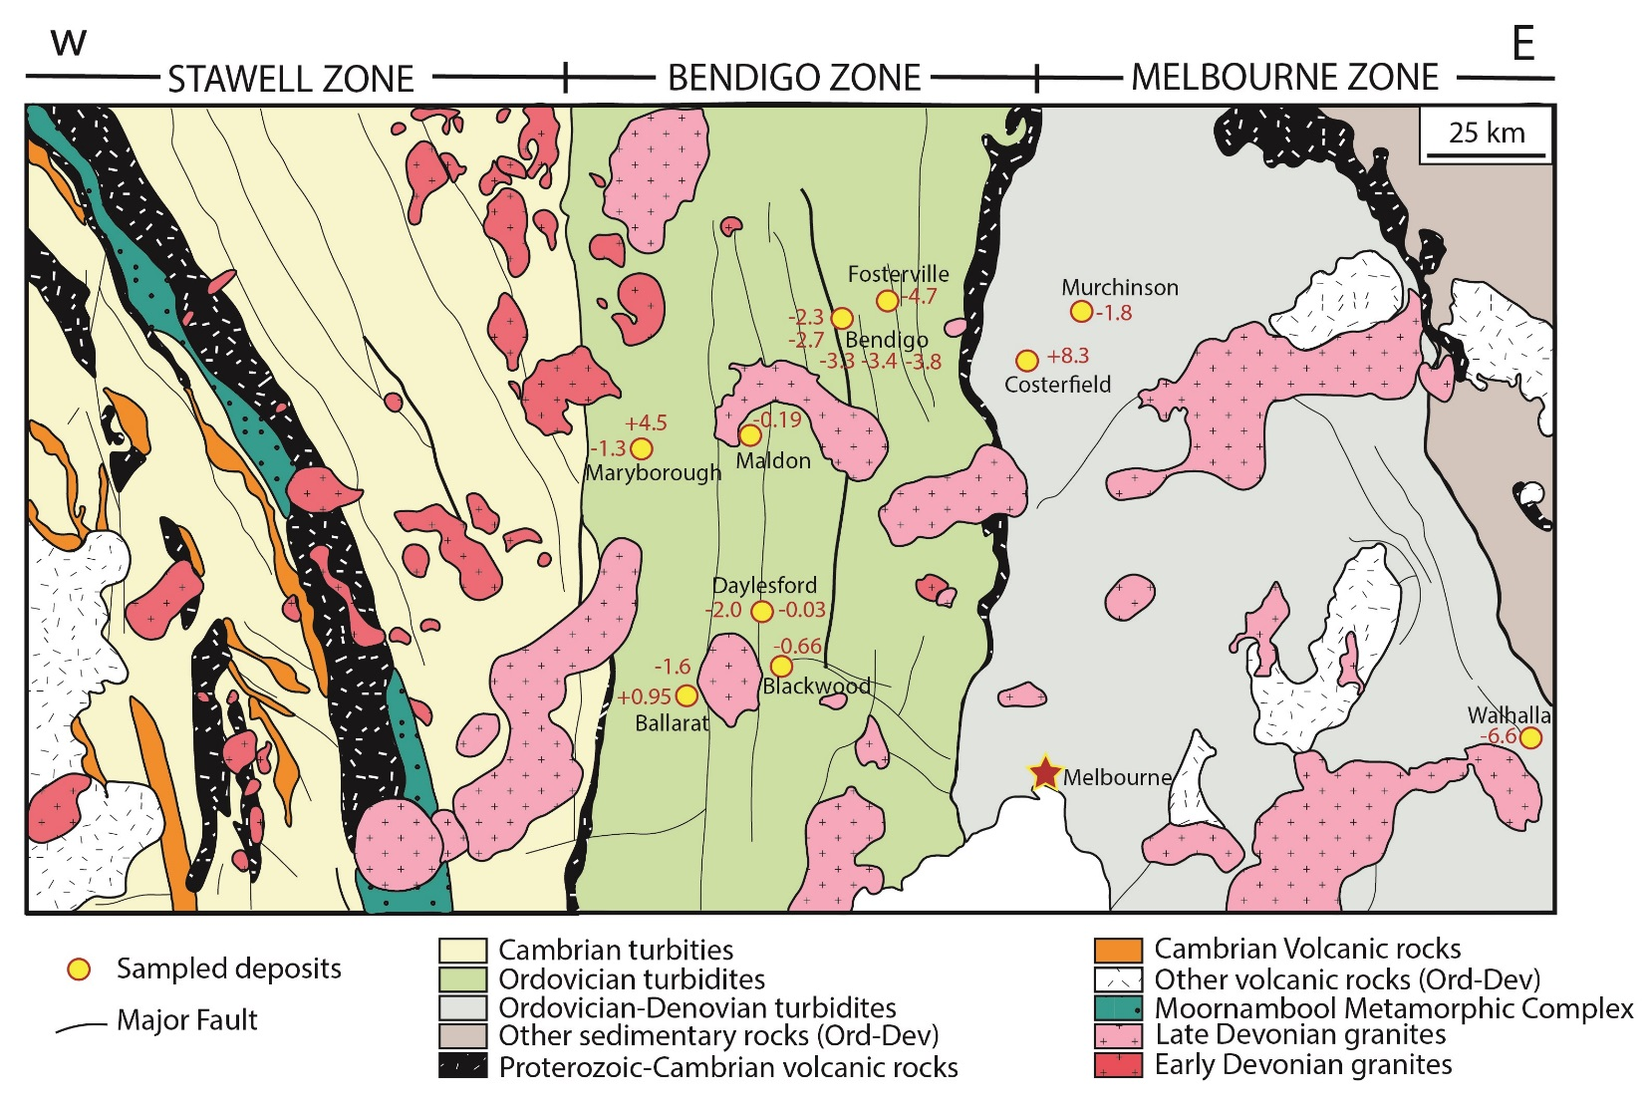

**Figure 1** Geological map of the primary gold producing belts in Victoria, showing the locations of mines that gold samples were selected from. 107Ag/109Ag ratios are shown in red numbering associated with each deposit.

Eighteen gold samples from the 10 Victorian deposits were prepared by sectioning specimens with a steel scalpel. Dissolution and ion exchange chemistry were conducted at the Curt-Engelhorn-Zentrum Archäometrie (CEZ) located in Mannheim, Germany. A detailed summary of these procedures can be found in Brauns et al. (in prep). Ag isotope analyses were carried out on a ThermoFinnigan Neptune Plus MC-ICP-MS. 107Ag/109Ag ratios were corrected for instrumental mass bias by normalising to 108Pd/105Pd = 1.18899. The mass bias-corrected 107Ag/109Ag in unknowns were normalised to the average of the 107Ag/109Ag in bracketing runs of NIST SRM 978a. Typical in-run precisions were <20 ppm (2σ), and external precision for Ag standards run as unknowns was ± 20 ppm (2σ).

**LARGE VARIATION IN SILVER ISOTOPES IN VICTORIAN GOLD**

An unexpected large range in silver isotope values resulted from the above analyses. Silver concentration in the gold samples varied from 0.43 to 13.35 wt%, Pd/Ag ratios were effectively zero for all specimens, and Cu concentration was 9 to 400 ppm. 107Ag/109Ag ratios range from -6.6 to +8.3 ԑ107Ag for the entire sample suite (14.9 ԑ units). These data, despite being from a single geologic terrane, deposit type, age, and host rock composition, exhibit the largest spread in ԑ107Ag recorded in an ore deposit study; the value of +8.3 ԑ107Ag for one sample is higher than any previously reported terrestrial sample.

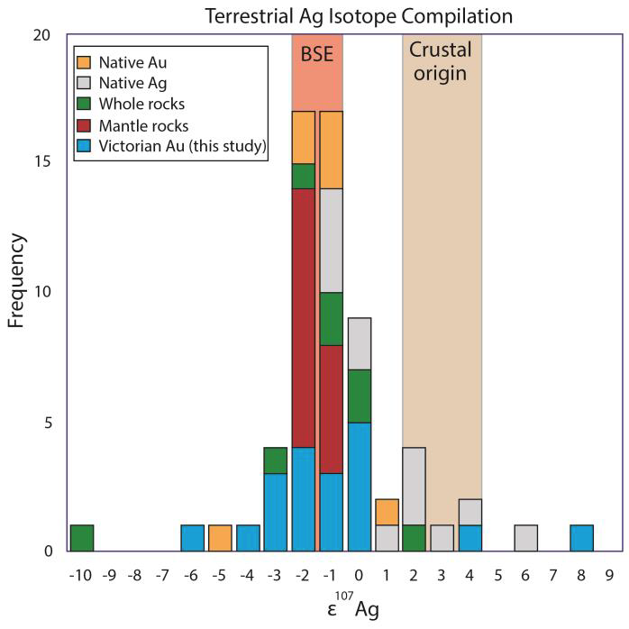**Figure 2** Ag isotope data for the Victorian Goldfields compared with the global database.

**USING Ag ISOTOPES TO UNDERSTAND THE TRANSPORT PATHWAY**

There are essentially two main end-member gold deposits in the Victorian Goldfields in terms of mineralisation style. The Fosterville deposit has most of its gold contained in the crystal structure of very fine-grained arsenopyrite (“refractory gold” in 0.5 – 2 mm crystals) that is disseminated throughout fault-bounded sandstones and shales (with increasing depth more visible gold appears), whereas the Bendigo deposit has coarse nuggetty gold that is only found in quartz veins, with little gold in coarse disseminated arsenopyrite (1-2 cm crystals). Ballarat and the Castlemaine goldfields have characteristics that sit between these end-members, with some visible gold in veins and some refractory gold. Stawell is more structurally complex and sulfide rich, with gold particles commonly attached to moderately coarse arsenopyrite. All are hosted within a thick sequence of variably graphitic turbidites. Fosterville formed at shallow crustal level and is hosted in sub-greenschist facies rocks, whereas Stawell formed at the deepest crustal level of all deposits in Victoria, hosted in upper greenschist facies rocks; a series of thrust stacks has created a regional system that shallows in blocks from Stawell in the west to Fosterville in the east Bendigo Zone (Fig. 3).

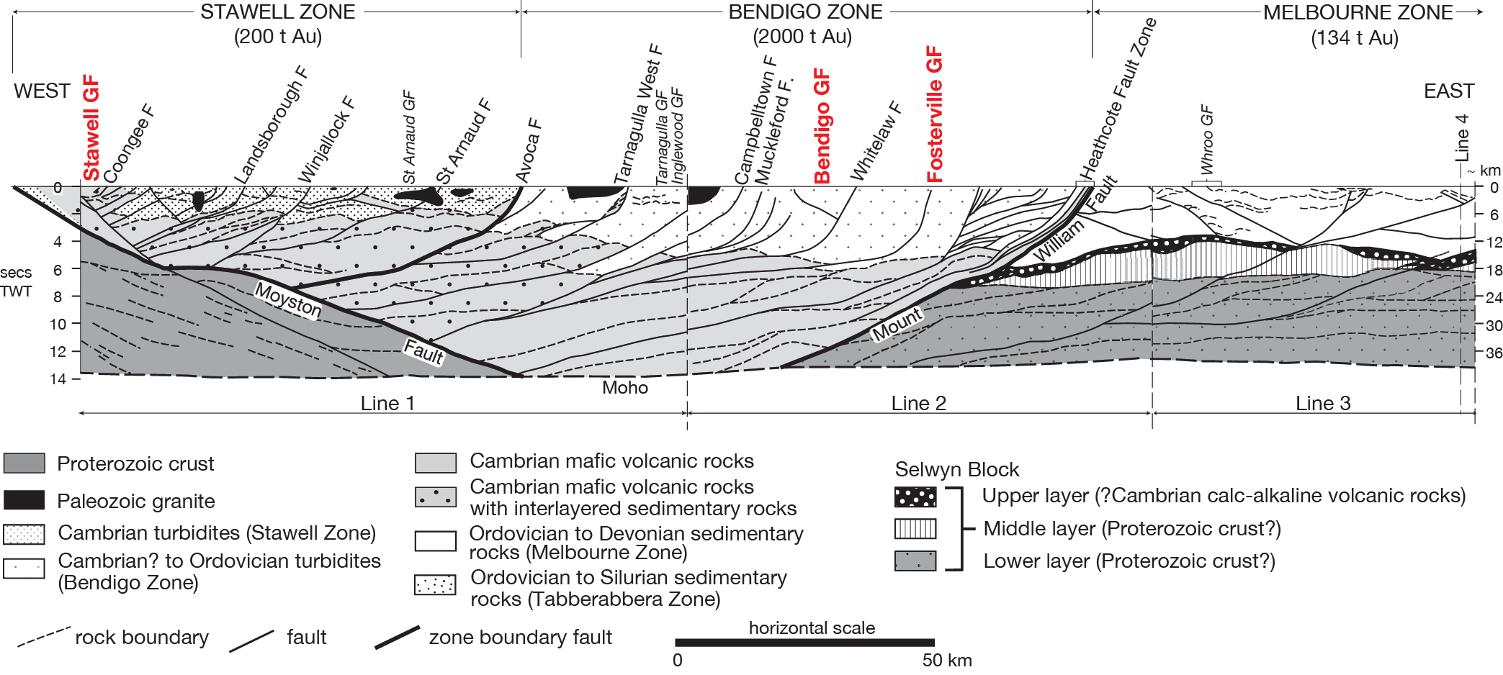

**Figure 3** Interpretation of a seismic section through western Victoria, showing the thrust stack system that comprises the Stawell and Bendigo zones (from Willman et al. 2010).

The deposits in the Bendigo Zone all formed from metamorphic fluids (there are no granites of equivalent age; Phillips et al., 2012) above the same package of source rocks (Fig. 3), in structurally similar settings, and within host rocks that are geochemically the same. Thus, if source region isotopic signatures are preserved during ore metal transport and deposition this is one of only a few places in the world where the same isotopic signatures would be expected in each deposit. The fact that there is large variability in silver isotope values for gold within this district (Figs. 1, 2) therefore implies that silver isotopes are fractionated on the transport pathway and/or at the sites of deposit formation. By extension, gold is also likely to be affected by whatever process is controlling this fractionation, since Au and Ag are intimately associated in these deposits.

The small mass difference between 107Ag and 109Ag means that extensive isotopic fractionation in this system is unlikely to result from mass-dependent processes. In the absence of mass-dependent fractionation, the most likely mechanism capable of driving the observed fractionation is known as the nuclear volume effect; essentially, this is fractionation associated with switching between oxidation states of an element, in this case between Ag0 in gold and Ag+ in hydrothermal fluids. Greater fractionation is seen when more stages of dissolution and precipitation occur. If Ag0 is dissolved from native gold into a fluid where Ag+ is complexed with Cl– or HS– (Seward et al., 2014), some fractionation will occur, and the inverse fractionation occurs during the reverse, as metal is precipitated from fluids. In addition, silver can be incorporated into sulfide and particularly sulfosalt minerals as Ag+, where it is more commonly found than gold; Au+ can occur in trace quantities in arsenopyrite and As-rich pyrite, whereas Ag+ occurs at percent levels in many sulfosalts. Where Ag+ from a fluid complex is incorporated into a sulfide or sulfosalt as Ag+, there is no fractionation associated with the nuclear volume effect. In the natural system where native gold coprecipitates with sulfides, some Ag0 will have been precipitated in gold and some Ag+ in sulfides in a given fluid infiltration event, creating variability in the extent of isotope fractionation. At Fosterville gold was coprecipitated with a range of minerals that typically incorporate minor Ag+ (e.g., Fig. 4), so variable extents of Ag isotope fractionation must have occurred during ore formation. However, if deposit formation was a simple process of extraction of metal from a source, transport with no modification, and precipitation of ore minerals, the extent of Ag isotope fractionation would be small, perhaps not detectable. Instead, the strong variability in isotopic signature across the Bendigo Zone requires that Ag, and by extension gold, are precipitated, redissolved, and reprecipitated multiple times during the processes leading to ore accumulation. This must happen on the fluid transport pathway, but the question of whether it occurs over a large crustal depth range, or through remobilisation proximal to the deposits, is still open. One might expect, however, that Ag isotope variation would be greater in deposits like Fosterville where the Ag budget is contained in gold + sulfides, relative to Bendigo, where native gold dominates; this is an area of our ongoing research.

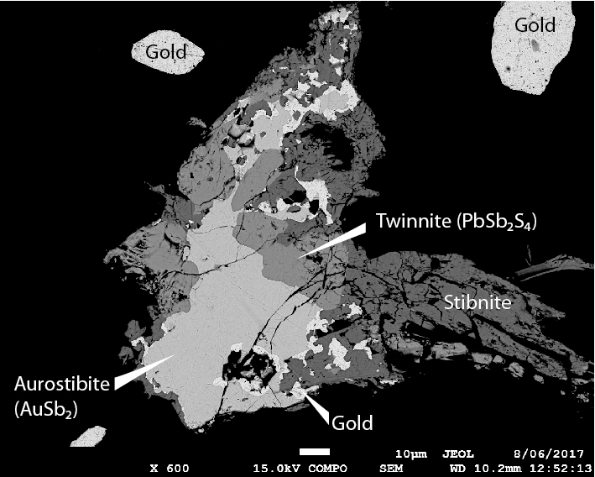

Fig. 4 Gold associated with a range of other ore minerals in a Fosterville quartz vein (BSE image).

**REFERENCES**

BATEMAN R. & HAGEMANN S. 2004. Gold mineralisation throughout about 45 Ma of Archaean orogenesis: Protracted flux of gold in the Golden Mile, Yilgarn craton, Western Australia. Mineralium Deposita 39, 536–559.

CAYLEY R. A. 2011. Exotic crustal block accretion to the eastern Gondwanaland margin in the Late Cambrian – Tasmania, the Selwyn Block, and implications for the Cambrian-Silurian evolution of the Ross, Delamerian and Lachlan Orogens. Gondwana Research 19, 628-649.

EVANS K. A., PHILLIPS G. N. & POWELL R. 2006. Rock-buffering of auriferous fluids in altered rocks associated with the Golden Mile-style mineralization, Kalgoorlie gold field, Western Australia. Economic Geology 101, 805-818.

GOLDFARB R. J., BAKER T., DUBE B., GROVES D. I., HART C. J. R & GOSSELIN P. 2005. Distribution, character, and genesis of gold deposits in metamorphic terranes, *in* Hedenquist J. W., Thompson J. F. H., Goldfarb R. J., Richards J. P., eds., Economic Geology 100th Anniversary Volume, p. 407-450.

GROVES D. I., GOLDFARB R. J., GEBRE-MARIAM M., HAGEMANN S. G. & ROBERT F. 1998. Orogenic gold deposits: a proposed classification in the context of their crustal distribution and relationship to other gold deposit types. Ore geology Reviews 13, 7-27.

LARGE R. R., DANYUSHEVSKY L., HOLLIT C., MASLENNIKOV V., MEFFRE S., GILBERT S., BULL S., SCOTT R., EMSBO P., THOMAS H., SINGH B. & FOSTER J. 2009. Gold and trace element zonation in pyrite using a laser imaging technique: Implications for the timing of gold in orogenic and carlin-style sediment-hosted deposits. Economic Geology 104, 635-668.

MICKLETHWAITE S., SHELDON H. A. & BAKER T. 2010. Active fault and shear processes and their implications for mineral deposit formation and discovery.  Journal of Structural Geology 32, 151-165.

MÖLLER P. & KERSTEN G. 1994. Electrochemical accumulation of visible gold on pyrite and arsenopyrite surfaces. Mineralium Deposita 29, 404-413.

PHILLIPS D., FU B., WILSON C. J. L., KENDRICK M. A., FAIRMAID A. M. & MILLER J. M. 2012. Timing of gold mineralisation in the western lachlan orogen, SE australia: A critical overview. Australian Journal of Earth Science 59, 495-525.

PHILLIPS G. N. & POWELL R. 2015. A practical classification of gold deposits, with a theoretical basis. Ore Geology Reviews 65, 568-573.

PHILLIPS G. N. & POWELL R. 2009. Formation of gold deposits: Review and evaluation of the continuum model. Earth-Science Reviews 94, 1-21.

PITCAIRN I. K., CRAW D. & TEAGLE D. A. H. 2015*.* Metabasalts as sources of metals in orogenic gold deposits. Mineralium Deposita 50, 373-390.

SCHONBACHLER M., CARLSON R. W., HORAN M. F., MOCKA T. D. & HAURI E. H. 2007. High precision Ag isotope measurements in geologic materials by multiple-collector ICPMS: An evaluation of dry versus wet plasma. International Journal of Mass Spectroscopy 261, 183-191.

SEWARD T. M., WILLIAMS-JONES A. E. & MIGDISOV A. A. 2014. The chemistry of metal transport and deposition by ore-forming hydrothermal fluids. *In:* Scott, SD, ed. Treatise on Geochemistry 2nd Edition, Vol. 13, Geochemistry of Mineral Deposits, p. 29-57.

THOMAS H. V., LARGE R. R., BULL S., MASLENNIKOV V., BERRY R. F., FRASER R., FROUD S. & MOYE R. 2011. Pyrite and pyrrhotite textures and composition in sediments, laminated quartz veins, and reefs at Bendigo gold mine, Australia: Insights for ore genesis. Economic Geology 106, 1-31.

TOMKINS A. G. 2010. Windows of metamorphic sulfur liberation in the crust: Implications for gold deposit genesis. Geochimica et Cosmochimica Acta 74, 3246-3259.

WEATHERLEY D. K. & HENLEY R. W. 2013. Flash vaporization during earthquakes evidenced by gold deposits. Nature Geoscience 6, 294-298.

WILLMAN C. E., HORSCH R. J., MOORE D H., CAYLEY R. A., LISITSIN V. A., RAWLING T. J., MORAND V. J. & O'SHEA P. J. 2010. Crustal-scale fluid pathways and source rocks in the Victorian Gold Province, Australia: Insights from deep seismic reflection profiles. Economic Geology 105, 895-915.

WILSON C. J. L., SCHAUBS P. & LEADER L. D. 2013. Mineral precipitation in the quartz reefs of the Bendigo gold deposit, Victoria, Australia. Economic Geology 108, 259-278.