**gold mineralisation in the woods point district, victoria – REGIONAL AND LOCAL CONTROLS**

**Rick Valenta1, Tom Evans2, Nick Oliver3, Vic Wall4, Hassan Baghian5,   
and Ron Cunneen5**

1W H Bryan Mining and Geology Research Centre, University of Queensland and Mantle Mining Corporation (Non-exec Director)

2Evans Geological Consulting

3HCOV Global

4Vic Wall and Associates

5Independent Consultant

**Key Words:** gold, vein, dyke, granite, fault, reverse, Melbourne zone, Devonian

**INTRODUCTION**

Gold mineralisation in the Woods Point District occurs primarily in quartz veins associated with late Devonian intermediate dykes which intrude deformed turbidites of the early Devonian Walhalla Group (VandenBerg et al, 2006). Historical production from the region is estimated to be approximately 5 million ounces (Goodz et al, 2008). Geochronological studies suggest that dyke intrusion, intrusion of regionally associated granites, and gold mineralisation were virtually synchronous at approximately 375Ma (VandenBerg et al, 2006; Fu et al, 2009). Mantle Mining Ltd holds mining licenses over the Morning Star and Rose of Denmark mine areas, as well as a group of exploration licenses covering approximately 650 km2 covering a strike length of approximately 60km of the main belt of gold occurrences (Fig 1). An understanding of the processes controlling the localisation of dykes and associated mineralisation as well as the factors which could potentially lead to the development of the more economically attractive mineralisation end members in the district is important to guide targeting and exploration in this remote and relatively inaccessible part of Victoria.

**REGIONAL SETTING**

Mineralisation in the Woods Point District is hosted in the Walhalla Synclinorium – a fault-bounded zone of folded Devonian turbidites bounded to the east and west by west-dipping reverse faults (Vandenberg et al, 2006, McLean et al, 2010) interpreted to have formed during the 390 to 400 Ma Tabberabberan Orogeny (VandenBerg et al, 2006) (Fig 1). Both the Morning Star and Rose of Denmark mines are interpreted to lie on the west-dipping eastern limb of the main Walhalla syncline (Fig 2). The folded and faulted metasediments are intruded by swarms of felsic to ultramafic dykes which predominantly follow the NNW-trending structural grain of the district. Post-Tabberaberan granites outcrop in various parts of the belt, including the Baw Baw granodiorite to the south of Woods Point and the Strathbogie granite, which truncates the northern end of the belt. Published dates place the ages of both the dykes and the Strathbogie granite within error of each other at approximately 375Ma (VandenBerg et al, 2006).

Magnetic and gravity images show a marked transition from NW to SE within the Walhalla Synclinorium (Fig 1). The northern end of the belt is a zone of moderate magnetic intensity with subtle linear magnetic units. Terrain-corrected bouguer gravity is a relative high in this part of the belt. There are very few recorded gold occurrences in this part of the belt. Starting from a distance of approximately 50km to the SSE of the Strathbogie granite, the synclinorium warps and becomes slightly wider, and is also characterised by the presence of a series of ovoid subtle magnetic lows which appear to be related to deeper sources, on the basis of their long wavelength. This area has a much lower gravity signature, despite the fact that the same rocks are outcropping at the surface. This southern area is also characterised by a much higher density of gold occurrences and dykes. One possible explanation for this pattern is that the southern part of the belt is intruded by a NNW-trending granitic batholith, producing the observed gravity low and less linear magnetic pattern.

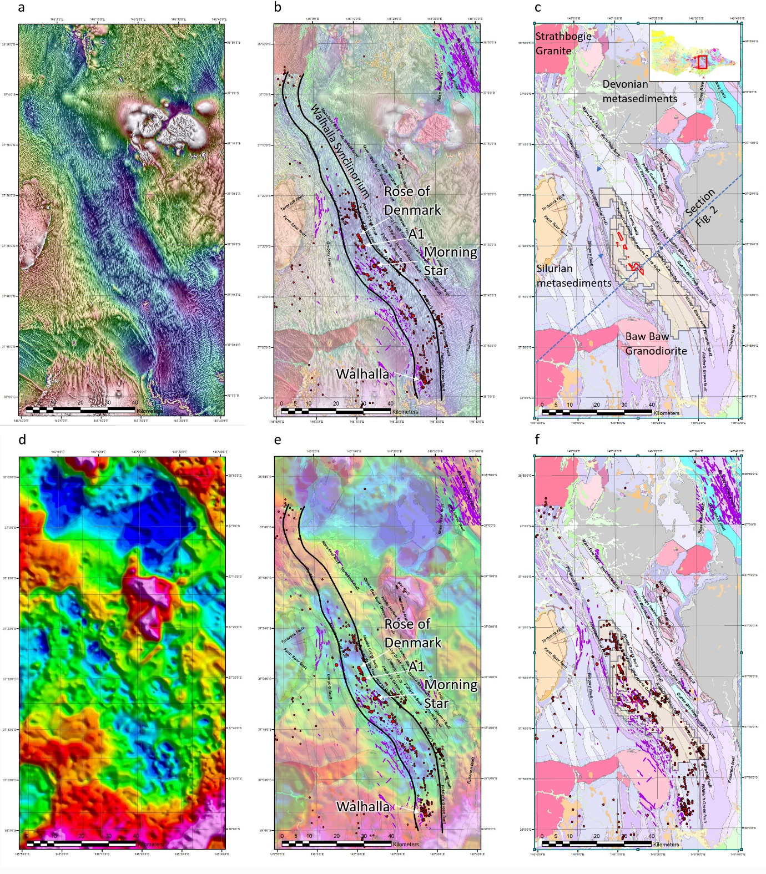

*Fig. 1. a. Tilt-processed image of state aeromagnetics. b. Aeromagnetics with overlays of gold occurrences (red dots) and mapped dykes (purple), along with locations of mines mentioned in text. c. Victorian Geological Survey seamless 1:250000 geology, with overlays of Mantle Mining’s Els, as well as Mining Leases. Location of Fig 2 section also shown. d. Terrain-corrected Bouguer Gravity from VandenBerg at al, (2006). e. Gravity with overlays of gold occurrences (red dots) and mapped dykes (purple), along with locations of mines mentioned in text. f. Victorian Geological Survey seamless 1:250000 geology with overlays of gold occurrences (red dots) and mapped dykes (purple)*

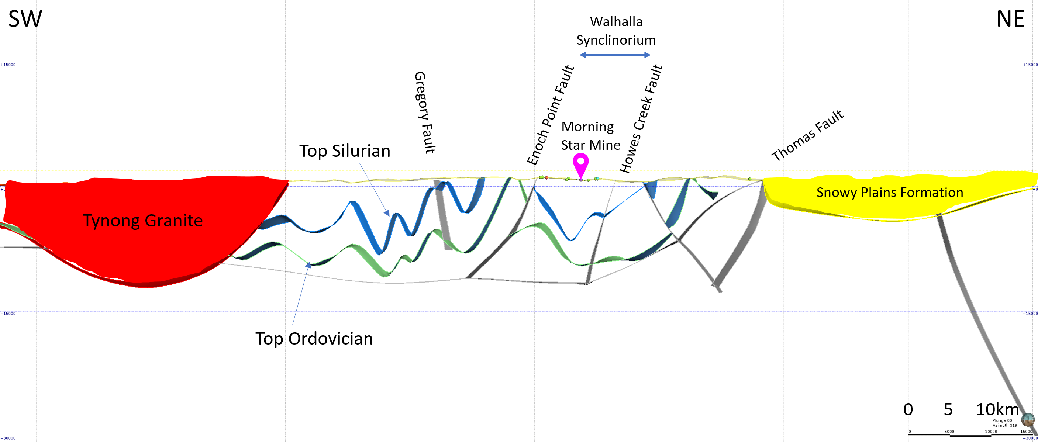

*Fig. 2. Cross section extracted from the Melbourne Zone 1:250,000 3D model of McLean et al (2010), showing the position of the Morning Star mine on the southwest-dipping limb of the Walhalla Synclinorium*

**MORNING STAR MINE**

Mineralisation at the Morning Star mine is hosted in gently dipping quartz veins which cut the intermediate composition Morning Star Dyke (Threadgold, 1958; Goodz et al, 2008). Goodz et al (2008) report a historical gold production of approximately 825,000 ounces at a grade of approximately 25g/t, though more recent review of historical production records suggests a figure closer to 600,000 ounces at similar grades.

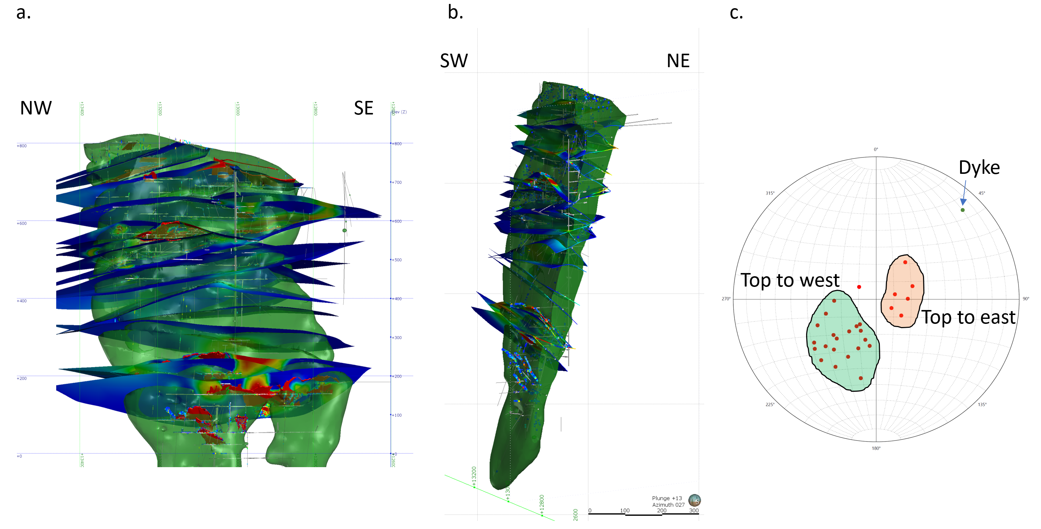

*Fig. 3. a. Long section view of Morning Star dyke and reefs (coloured by m-g/t thickness-grade product from drilling and underground sampling). b. Oblique section cut at the main shaft, showing the northeast and southwest dipping reef sets. c. Stereonet showing poles to reefs and to the dyke*

The Morning Star dyke has a northwest strike length of approximately 575m; a thickness of up to 100m; and a down-plunge extent of at least 1100m. The body dips approximately 75° to the southwest, and pitches approximately 75° to the southeast. Mineralisation is hosted in a series of gently to moderately dipping composite fault/vein structures with relatively small reverse displacements (Threadgold, 1958). Vein thicknesses vary from less than 10cm to up to 1.5m. There are two main populations of quartz reefs in the Morning Star Mine (Figure 2c). The majority of past-producing reefs in the mine dip to the northeast and have a top-to-southwest reverse displacement. A smaller though significant population of reefs dip more gently to the west and have a top-to-east displacement. These observed displacements are consistent with a strain regime of NE-SW shortening and vertical extension at the time of mineralisation.

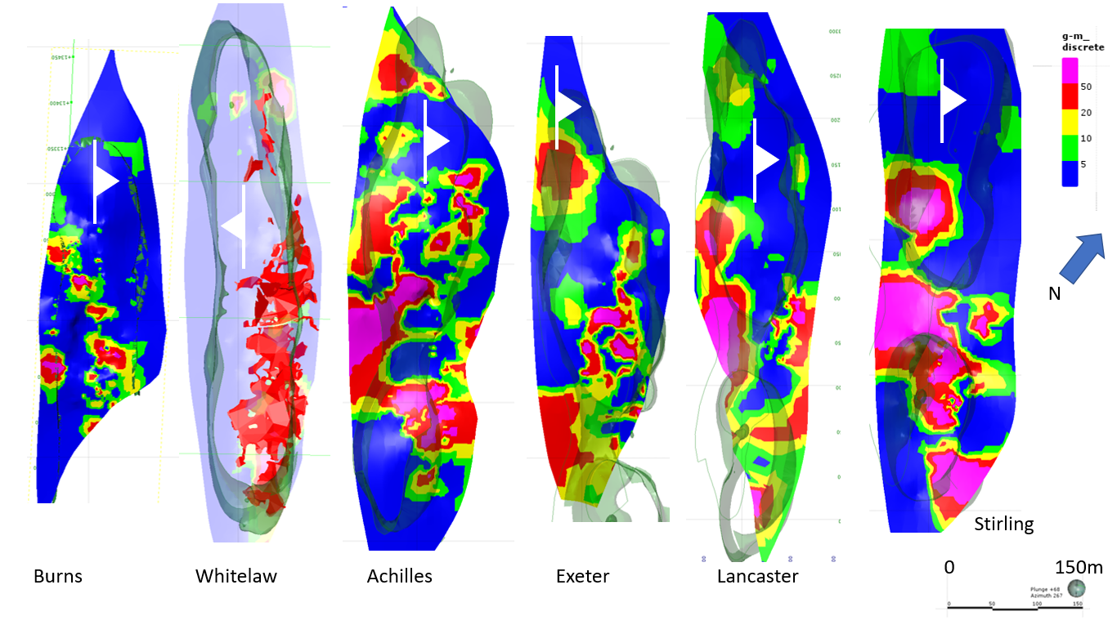

*Fig. 4. Longitudinal projections of selected veins showing contours of the grade (g/t Au) – thickness product from drilling and underground sampling in gram-metres. In the case of Whitelaw reef, the red zone indicates the stoped area of the vein, as there is a relative lack of underground sampling information. The thrust symbol indicates the dip of the vein in each case, and dyke margins from the 3D model are shown in green. Higher grade zones are generally concentrated near the updip side of the reef near the dyke-metasediment contact, but there are notable exceptions to this pattern at Burns, Achilles and Exeter. See text for further discussion.*

Of the numerous reefs occurring at Morning Star (Fig 3), a relatively small number account for a large proportion of the historical production. Descriptions of the distribution of gold at Morning Star often refer to a preferential localisation of high grade zones on the updip side of structures in zones where reverse displacement has placed dyke material in structural juxtaposition with metasediments (eg Threadgold, 1958). The Whitelaw and Stirling reefs show this pattern quite clearly (Fig 4). In other reefs, the distribution of gold is not as clearly controlled by the dyke margin. In both the Burns and Achilles reefs, for example, high grade zones are oriented obliquely to the dyke margins (Fig 4). In the case of the Burns reef, the high grade zone is associated with a zone where the reef steepens on the north limb of an east-west trending anticlinal flexure in the reef. High grade zones are also known to occur where reefs intersect (Threadgold, 1958).

The veins hosting mineralisation are predominantly quartz with minor carbonate (Goodz et al 2008), with a variable content of sulphide minerals including pyrite, arsenopyrite, pyrrhotite, chalcopyrite, sphalerite, tetrahedrite, bournonite, boulangerite and galena (Threadgold, 1958). Texturally, the veins can be massive or laminated, and in some cases, can be clast or matrix-supported hydrothermal breccias with a significant amount of altered dyke material. Brecccias tend to display lower gold grades than clast-poor vein varieties.

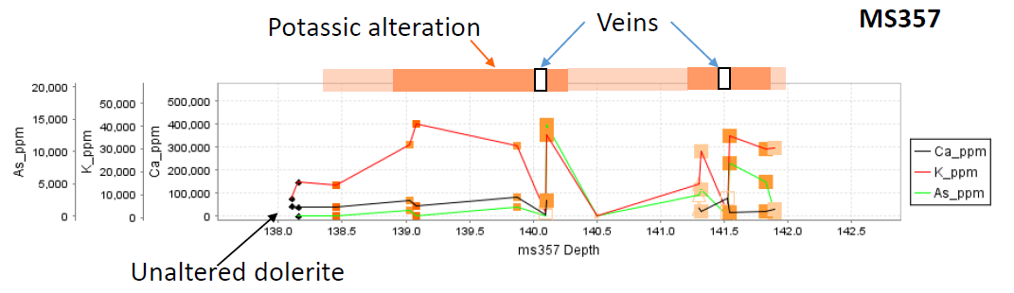

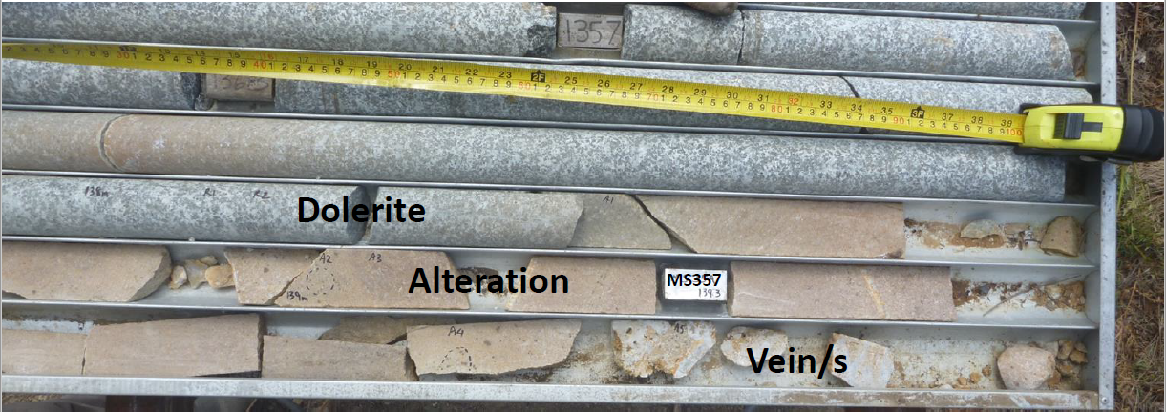

*Fig. 5. Portable XRF traverse from unaltered dyke to veins, showing an increase in K and As in the alteration halo – photograph shows core from the traverse.*

Veins at Morning Star typically have cream to red coloured alteration zones which vary from about 5 to 30 times the width of the associated vein, and which sometimes carry elevated gold grades in the 1-3 g/t range. In portable XRF transects through veins and alteration, the alteration shows increases in K, Rb, and As, with less regular increases in Ca, and common slight depletion in Fe. Cream-coloured alteration in drill core is formed by enrichment in K (K-feldspar), and slight enrichment in Ca, likely related to carbonates. When visible sulphides are present, As values are elevated and this is likely to be the residence of the disseminated gold around the veins. Red coloured alteration in drillcore does not appear to cause major elemental changes other than small increases in Fe, and much of this alteration appears a weak chemical overprint on the earlier cream alteration. This alteration formed by preferential replacement of amphiboles in the dyke by sulphides, and by conversion of plagioclase to K-feldspar, in some cases pseudomorphically preserving the earlier minerals. Veins show lowered Ti, Zr and Y consistent with these immobile elements not significantly entering the fluid-filled fractures. Veins also show highly variable As and Ca, with some gold-rich intervals being dominated by disseminated sulphide in wall rock rather than gold being restricted to veins.

Geochronology reported in VandenBerg et al (2006) and Fu et al (2009) places the timing of dyke emplacement and mineralisation within error of each other at approximately 375Ma. It appears that the dykes were faulted and hydrothermally altered very soon after their emplacement. The dykes appear to have acted both as structural and chemical traps for mineralisation. Competency contrast between the dyke and the surrounding rocks appears to have concentrated fracturing in the dykes, and the broad envelopes of sulphidisation and potassium alteration of dykes suggests that fluid-rock interaction may have played an important role in causing gold precipitation.

**ROSE OF DENMARK MINE**

Mineralisation at the Rose of Denmark Mine is also hosted in a northwest-trending dyke, but the mineralised zones show some significant differences to Morning Star. The dyke at the Rose of Denmark is relatively narrow, varying from 1-2 metres in width up to 20-30 metres in the wides dyke bulges. Mineralisation occurs in association with northwest-pitching sheeted veins, which overall define a series of 45° northwest-pitching bodies from which approximately 30,000 ounces of gold were mined in the late 1800’s.

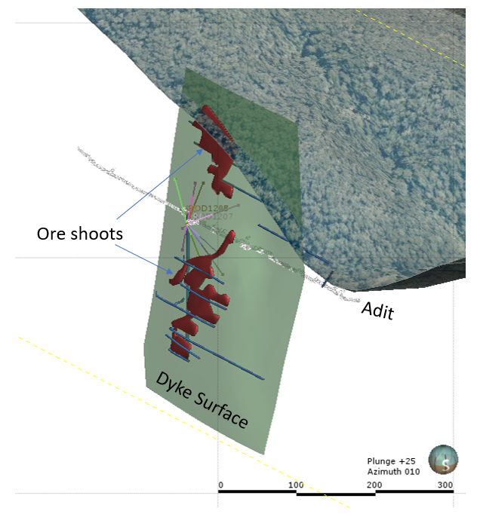

*Fig. 6. Oblique view looking NNE, showing the geometry of the dyke at the Rose of Denmark, as well as the NW-plunging shoots within the dyke.*

**CONCLUSIONS**

Gold mineralisation in the Woods Point region occurs in association with a regionally extensive dyke swarm. Mineralisation formed within fault/vein arrays which formed in a strain environment related to NE-SW shortening and vertical extension. High competency dyke bodies appear to have fractured differentially and focused the flow of gold-bearing hydrothermal fluid, and sulphidisation of the dykes appears to have promoted the precipitation of gold from a chemical point of view. Regional gravity and magnetic data suggest that both the dyke swarms and gold occurrences are underlain by a regionally extensive NW-trending granitoid batholith. There is a possibility that emplacement of this granitoid, the dykes, and gold mineralisation all took place within a very short space of time around 375Ma. The underlying granitoid may have played a significant role in driving the hydrothermal system at the time of mineralisation.

**REFERENCES**

Fu, B., Fairmaid, A. and Phillips, D. 2009 New 40Ar/39Ar geochronology of gold deposits in Central Victoria: final report. Geoscience Victoria Gold Undercover Report 19, Department of Primary Industries.

Goodz, M.D., Rea, J., and Jackson,P., 2008. Resource Estimation and Grade Assignment – A Comparison Between Historical Production and Current Maxwell Mining Validation Case Study at Morning Star Gold Mine,Woods Point. AUSIMM Narrow Vein Mining Conference, Ballarat 2008. 51-57

McLean, M.A., Morand, V.J. & Cayley, R.A., 2010. Melbourne Zone 1:250 000 scale 3D geological model report. GeoScience Victoria 3D Victoria Report 12. Department of Primary Industries.

Threadgold, I.M., 1958. Mineralisation at the Morning Star gold mine, Woods Point, Victoria. Proceedings of the Australasian Institute of Mining and Metallurgy 185, pp. 1–27.

VandenBerg, A.H.M., Cayley, R.A., Willman, C.E., Morand, V.J., Seymon, A.R., Osborne, C.R., Taylor, D.H., Haydon, S.J., McLean, M., Quinn, C., Jackson, P. & Sandford, A.C., 2006. Walhalla - Woods Point - Tallangallook special map area geological report. Geological Survey of Victoria Report 127. Geological Survey of Victoria. Department of Primary Industries.