TURBIDITE-HOSTED INTRUSION-RELATED MINERALISATION IN THE COBAR BASIN: NEW INSIGHTS FROM THE SOUTH

J.A. Fitzherbert¹, P.L. Blevin¹ & A.R. McKinnon²

¹ Geological Survey of New South Wales, Maitland, New South Wales, 2320 joel.fitzherbert@industry.nsw.gov.au
² Aurelia Metals Limited, Orange, New South Wales, 2800 adam.mckinnon@aureliametals.com.au

ABSTRACT
A recently developed metamorphic map of the Siluro-Devonian Cobar Basin highlights zones of skarn alteration and mineralisation with very high heat flow (T ≥ 500°C; pyroxene hornfels facies) hosted within relatively cool (T~250°C; anchizone, sub-greenschist facies) southern Cobar Basin sequences. Contrary to current models for Cobar-type mineralisation, which involve metal-bearing fluids derived from basement during regional metamorphism and basin inversion, these zones of localised, large thermal contrast reflect proximal, albeit, commonly blind magmatic heat source(s). The Hera and Nymagee orebodies of the southeastern Cobar mining field typify these zones of ‘orphaned’ high temperature alteration and preserve a complex alteration/gangue mineralogy that reflects siliciclastic-hosted calc-silicate veins/skarn and remnant carbonate skarn that is broadly stratabound (manto-like) within discrete allochthonous horizons. Skarn at the Hera Au–Pb–Zn–Ag orebody displays a broad south to north zonation from garnet–pyroxene-bearing to garnet–pyroxene-absent associations in siliciclastic rocks and remnant carbonate blocks/clasts. High-T associations are pervasively retrogressed to actinolite/tremolite-rich, hydrous retrograde skarn, which is associated with the main phase of sulfide mineralisation. Skarn mineralogy of the nearby Nymagee orebody is less well understood, but a high-T gangue assemblage rich in garnet and anorthite is locally preserved in association with Zn–Pb–Cu-rich lodes, while unusual ferro-hastingsite–stilpnomelane-bearing, calcic Fe-skarn is associated with Fe-oxide–Cu lodes. High-T skarn mineralogy at Nymagee is pervasively retrogressed to tremolite–chlorite-rich associations and hydrous retrograde mineral assemblages are again associated with the main phase of sulfide mineralisation. Petrographic relationships and mineral chemical data of alteration minerals is consistent with a calcic Zn–W skarn at the Hera orebody and calcic Zn–Cu to Fe–Cu-skarn at the Nymagee orebody, with sulfur, hydrogen and oxygen isotopic data suggesting a magmatic (water–sulfur) input to mineralisation and hydrous retrograde skarn formation. The Hera–Nymagee skarns are intrusion-distal (i.e. not comingled with known intrusive phases), although Devonian I-type granodiorite plutons associated with extensive Fe–Ca alteration systems have been intersected in drilling directly to the south (e.g. Fountaindale). Skarn mineralisation is not restricted to the southeastern Cobar Basin, at Norma Vale prospect. On the western basin-margin, calcic Fe-(Cu) skarn mineralisation has been intersected in drillcore within allochthonous limestone-bearing conglomerate. Here pyroxene ± garnet-rich skarn is strongly retrogressed in zones of intense stilpnomelane–actinolite–carbonate–epidote-rich alteration associated with sulfide (pyrrhotite-rich) mineralisation. At Norma Vale both mafic (diorite) to felsic I-type intrusive rocks share a close spatial relationship with mineralisation. In addition to the well-documented importance of structural pathways for Cobar Basin mineralisation, the emergence of a skarn-related mineral system highlights the role of reactive host sequences as metal traps (stratigraphic traps) and helps to bring clarity to the often-inferred magmatic source for metal-bearing fluids. The broad-scale relationship between exposure level of I-type intrusions, high-T hydrothermal zones and skarn/manto mineralisation in the southeast and southwest of the Cobar Basin has important implications for the origin of lower-T (?intrusion-distal), broadly stratabound, ‘sister’ orebodies in the central basin and to the north in the main Cobar mineral field.

GEOLOGICAL BACKGROUND
The c.420 Ma Cobar Basin is a major mining province in central New South Wales with an estimated metal endowment exceeding 134.9 t Au, 1.91 Mt Cu, 3.46 Mt Zn, 1.8 Mt Pb and 3832 t Ag. The basin sequences were deposited over Ordovician basement during the Siluro-Devonian. Deep-water parts of the basin interfinger (now mostly fault-bound) with two volcanogenic troughs to the south (Rast Trough) and west (Mount Hope Trough) and are flanked by limestone-bearing shelf sequences to the east (Kopyje Shelf) and west (Winduck Shelf). The eastern shelf also hosts a number of syn-rift volcanic sequences (Mineral Hill–Canbelego volcanic belt) (Figure 1). The lower stratigraphic levels of the southeastern deep-water basin, shelf sequences and Ordovician basement are intruded by syn-rift I-type plutons along the southeast margin of the basin and eastern shelf sequences (Figure 1). Volcanogenic sequences of the Mount Hope Trough, and parts of the interfingering siliciclastic basin to the north, are intruded by A-, I- and S-type intrusive rocks.

The Cobar Basin was inverted and deformed between 405 and 380 Ma (Perkins et al. 1994; Glen et al. 1992, 1996). Basin inversion was associated with reactivation of major, orogen-parallel basin/trough margin faults or near-margin faults. Cobar-type Cu–Au (Pb–Zn–Ag) deposits occur in a belt along the eastern margin of the deep-water Cobar Basin (Figure 1). Mineralisation is mostly associated with zones of faulting, shear zone development and epizone hydrous metamorphism, although the effects of deformation are diminished to the south and the grade of localised hydrous metamorphism increases to pyroxene hornfels facies. The deposits have been variously classified through time as reactivated/remobilised syndepositional subhalative/exhalative (Suppel 1984), epithermal and volcanogenic massive sulfide deposits (David 2005, 2006), but in recent years a structurally controlled mineral system model with metals derived from metamorphism of basement and basin has remained in vogue (e.g. Lawrie & Hinman 1998; Stegman 2001). Despite this, a magmatic source for metal-bearing fluids has been suggested (e.g. Cleverley & Barnicoat 2007; Berthelsen 2010).

Deposits/prospects classified as Cobar-type on the southeastern margin of the basin are hosted within siliciclastic-dominant turbidite sequences of the lower Amphitheatre Group and to a lesser extent early-rift siliciclastic to shelf carbonate-bearing sequences of the Mouramba Group (Figure 1). Mineralisation in the form of massive sulfide breccia and vein systems is associated with calc-silicate to calc-potassic skarn alteration. The deposits are spatially associated with a major basin margin fault, the Rookery Fault, although the orebodies are located west of this fault system and coincide with a horizon(s) of mixed allochthonous carbonate (now skarn)-bearing sandstone/gritstone packages and finer-grained basin sequences. Interestingly allochthonous packages occur at similar and higher stratigraphic levels (Shume Formation) at number of locations throughout the basin and lower temperature mineralisation is associated (e.g. Mallee Bull; Brown et al. 2013, 2015). Skarn mineralisation is also present within these higher-level allochthonous packages at the Norma Vale prospect north of the Mount Hope Trough.

METAMORPHIC GRADE IN THE COBAR BASIN
Fitzherbert et al. (2017) describe the distribution of metamorphic grade in the Cobar Basin based on a petrographic reassessment, in conjunction with new CAI (Conodont Alteration Index) determinations, and a vast library of previous thermometry studies from both proximal and distal to mineralisation. Figure 2 is a revised version of the metamorphic map (after Fitzherbert et al 2017). The important features of the map are:
Western shelf sequences
- Late diagenetic zone burial metamorphism.
- Eastern shelf and volcanic belt
- Predominantly low-anchizone burial and zeolite facies ocean-floor metamorphism in the north
- Biotite-zone greenschist hydrothermal/contact metamorphism in the southwest
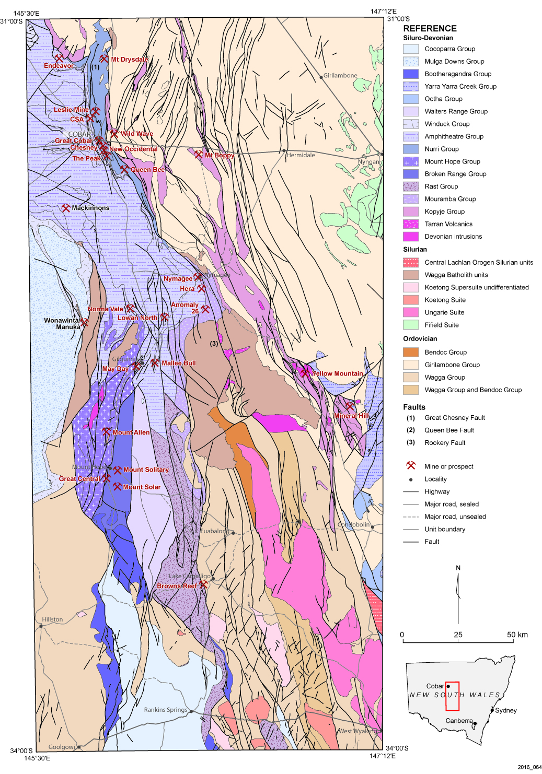
Figure 1. Group level distribution of the Cobar Basin and basement with mineral deposits/prospects referred to in the text (after Fitzherbert et al. 2017). Undercover interpretation based on Fitzherbert et al. 2016.
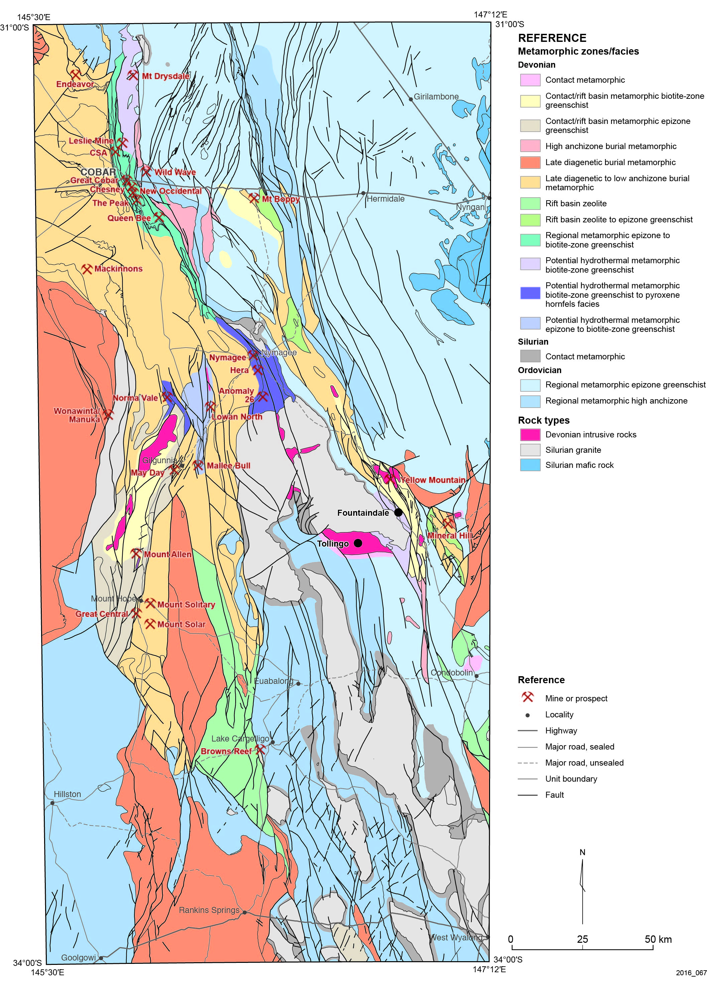
Figure 2. Metamorphic map of the Cobar Basin after Fitzherbert et al. (2017) with mineral deposits/prospects referred to in the text. Devonian intrusive rocks are highlighted in red.

- Late diagenetic in the southeast with local lower greenschist facies thermal perturbation
- A distinct thermal perturbation associated with Early Devonian intrusions in the south and unexposed sources to the east
- Volcanic Troughs
- Mount Hope Trough - lower to biotite-zone greenschist contact/hydrothermal metamorphism extending into the northern deep-water basin sequences
- Ural Volcanics (Rast Trough) - zeolite facies ocean-floor metamorphism.
- Deep water Cobar Basin
- Northwestern basin – anchizone burial metamorphism
- Central basin – anchizone with zones (particularly southern central) of lower greenschist and potentially biotite-zone (e.g Mallee Bull prospect) hydrothermal metamorphism
- Southwestern basin – immediately north of Mount Hope Trough, zone of potential pyroxene hornfels facies hydrothermal metamorphism
- Southeastern basin – immediately north of Erimeran Granite, zone of potential pyroxene hornfels facies hydrothermal metamorphism
- Northeastern basin – epizonal regional orogenic metamorphic grade, local preservation of pre-deformation biotite-zone hydrothermal metamorphism.
- Basin/shelves predominantly experienced late diagenetic to anchizone burial metamorphism.

Exposed and shallowly buried I-type intrusions are confined to the southern Cobar Basin and are exclusively associated with broad zones of contact and hydrothermal metamorphism up to pyroxene hornfels facies that affect basin, volcanic tough, shelf and basement sequences.

Epizone, hydrous greenschist facies metamorphic grades are associated with foliation development in the vicinity of interpreted basin margin and near-margin faults that accommodated significant shearing during basin inversion, particularly in the northeastern Cobar mineral field.

HERA–NYMAGEE OREBODIES
Hera–Nymagee orebodies are located on the eastern margin of the Cobar Basin at the boundary between the Mouramba and lower Amphitheatre groups (Figure 1). A quartzose sandstone-dominant unit, the Rosetta Sandstone Member, was mapped by McRae (1987) at the base of the lower Amphitheatre Group here. The deposits are situated on the western side of the Rookery Fault, a major orogene-parallel, near-margin basin fault (and likely pre-existing basement fault) that was reactivated during basin inversion.

Hera orebody
The Hera orebody is interpreted as a single broadly stratabound mineralised horizon that has been assembled into a series of steeply west-stepping, steeply west-dipping ore lenses (Figure 3). Mineralisation occurs in vein/breccia zones predominantly hosted in intensely silicified, carbonaceous siliciclastic sequences. A halo of porphyroblastic biotite is within the siliciclastic sedimentary rocks surrounding the orebody and is locally retrogressed within a chlorite–muscovite foliation. Skarn at Hera is expressed as siliciclastic-hosted veins and breccia fill, remnant high-T skarn and sulfide phase, moderate-T hydrous-mineral rich skarn. In general siliciclastic host rock and clasts are intensely silicified and enveloped by sulfide-rich breccia-fill/veins, but commonly contain quartz-rich calc-silicate veins hosting garnet–zoisite–titanite–tremolite ± scheelite proximal to, and within, the sulfide orebody (Figure 4a), while a biotite-rich mineralogy is present distal to the orebody. Garnet is absent from North Pod siliciclastic-hosted calc-silicate veins and tremolite–biotite–anorthite (± scheelite) dominate the alteration assemblage there (Figure 4b).

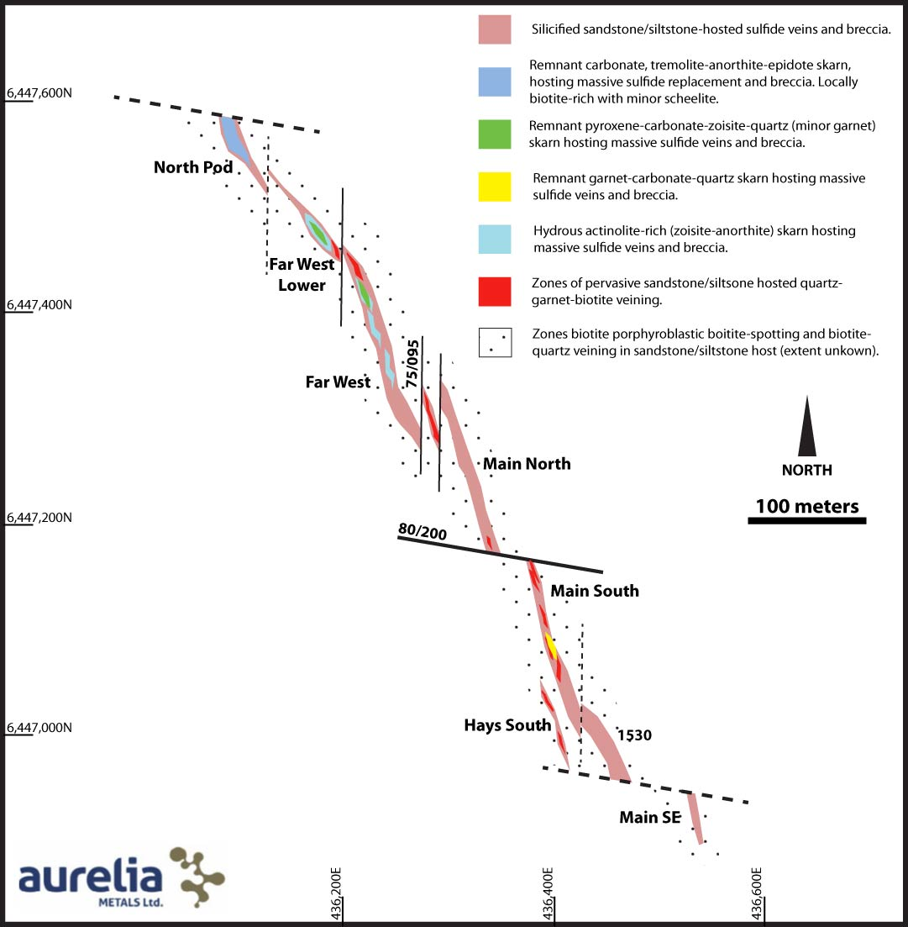

Figure 3. Interpretive, projected plan-view of the Hera orebody. Variations in skarn mineralogy discussed in the text are depicted from north to south along the strike of the orebody.

Remnant zones of retrograded high-T skarn/carbonate blocks/clasts within the mineralised sequence predominantly comprise garnet–diopside–quartz–zoisite–anorthite±carbonate (Figure 4c, d). High-T remnant skarn bodies display a broad mineralogical zonation along the entire strike of the orebody, from garnet-rich in the southern lenses through pyroxene-rich (+/-garnet) in the Far West lenses, and tremolite ± biotite, anorthite-rich (Figure 4e) (with some preserved carbonate clasts; Figure 4f) mineralogy in the North Pod.

Hydrous retrograde skarn is ubiquitous, enveloping and replacing peak, high-T skarn mineralogy. Hydrous skarn is sulfide-rich (sphalerite–galena–pyrrhotite±pyrite–chalcopyrite) and dominated by tremolite–biotite±garnet (Figure 4c). Sphalerite-rich mineralisation associated with nuggety gold in the Far West lens is associated with a very localised calc-potassic K-feldspar–tremolite–zoisite alteration (Figure 4g). Hydrous skarn within the lower-T North Pod is in many places monominerallic tremolite with abundant sulfide mineralisation.
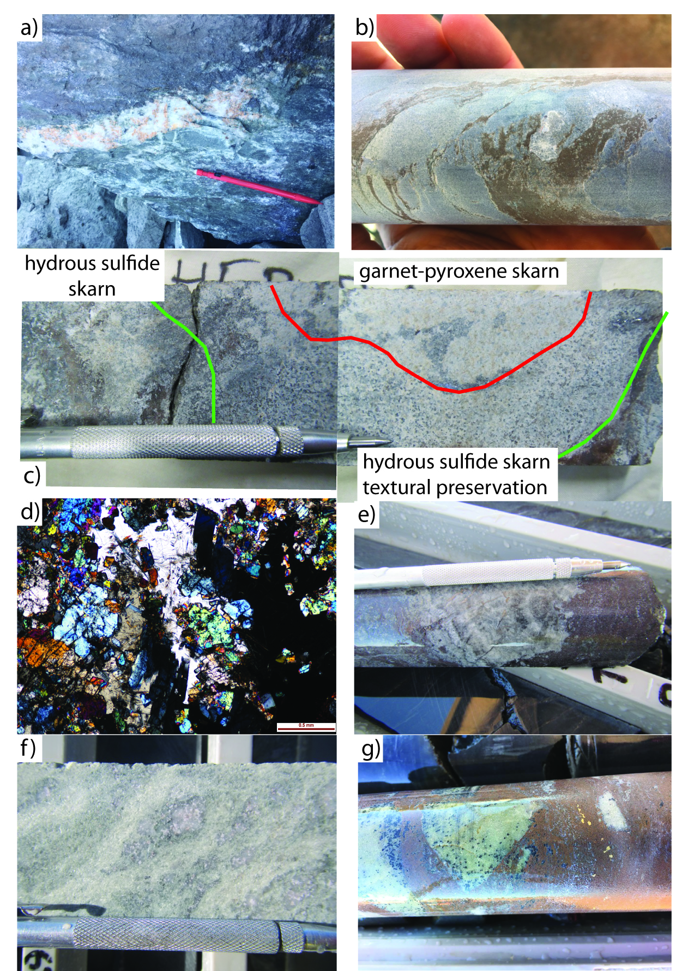

Figure 4 a) Siliciclastic -hosted garnet-rich, calc-silicate vein from southern Hera orebody. Massive sphalerite above vein and chlorite-rich silicified siltstone below; b) Siliciclastic-hosted biotite–scheelite veins. North Pod, Hera orebody; c) Remnant garnet–pyroxene skarn, enveloped by a rind of hydrous retrograde sulfide–tremolite skarn. Far west lode, Hera orebody; d) Cross-polarised photomicrograph of diopside–grossular (black) skarn, Far West lode, Hera orebody; e) Remnant, laminated carbonate clast enveloped by pervasive sphalerite-rich replacement. North Pod, Hera orebody; f) Anorthite skarn enveloped by tremolite-rich hydrous skarn zone (pale green). North Pod, Hera orebody; g) Tremolite-rich skarn blocks (pale white) enveloped by sphalerite–gold-rich mineralisation. Back spots in skarn are radiating, fibrous intergrowths of galena and tremolite. Far west lode, Hera orebody.

Tremolite from both Hera and the Nymagee orebodies has a tight range of δD (‰) of −60 to −84 and δ18O (‰) 8 to 8.5, consistent with magmatic waters, while biotite from the wall rocks displays lower δ18O (‰) and higher δD (‰), consistent with formational water input. Downes et al. (2016b) describe similar trends in δ34S (‰), ranging from values consistent with magmatic sulfur δ34S (‰) ~3 to values up to 10, consistent with formational waters.

Nymagee orebody
The Nymagee orebody is approximately 5 km along strike to the north-northwest of Hera and comprises three main ore lenses (western, main and eastern) that extend over 750 m in strike length (Figure 5; Suppel & Gilligan 1993).

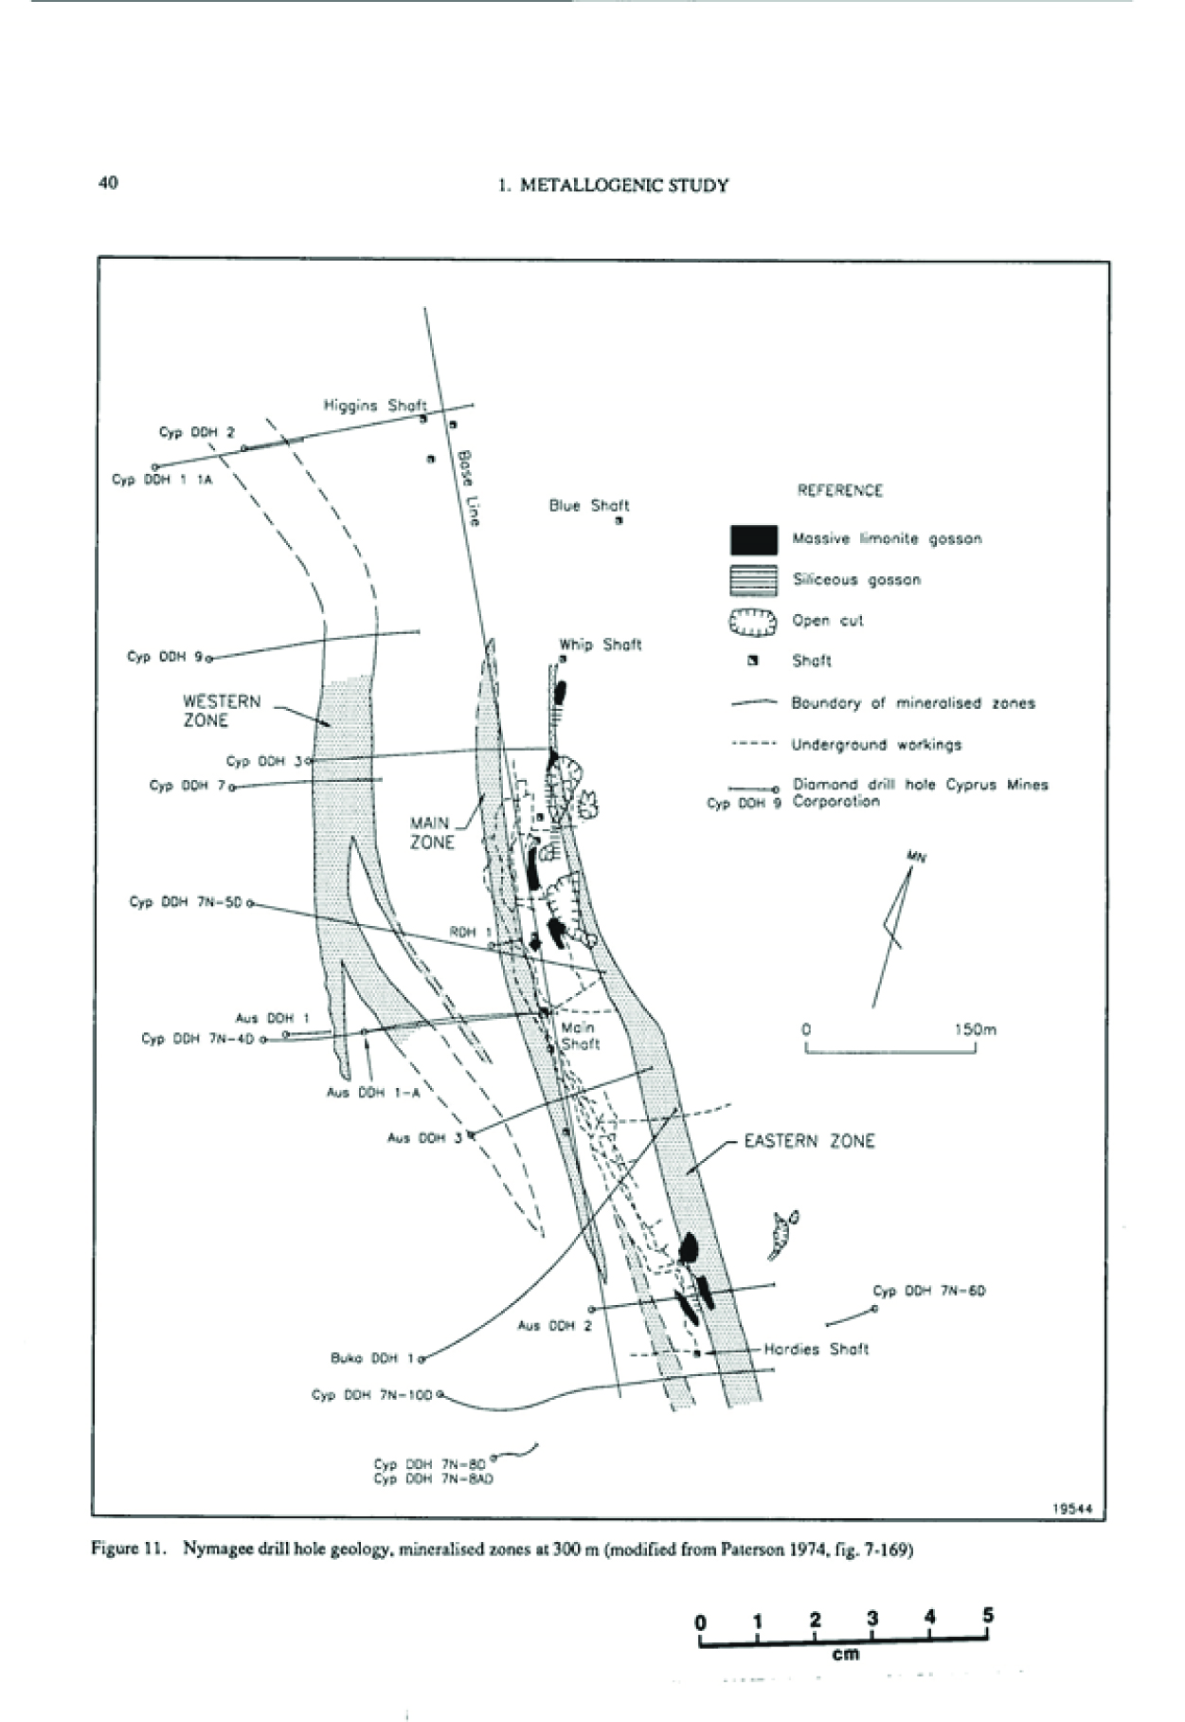
Figure 5. Nymagee orebody at 300 m depth (from Suppel & Gilligan 1993).

The metallogeny of the three main lenses is variable; western lode dominated by Pb–Zn sulfide and the eastern lode dominated by Cu-sulfide and lesser Fe-oxide. The gross zonation of gangue mineralogy at Nymagee is less well constrained than Hera and is here simply described as skarn associated with Pb–Zn–(Cu)-rich mineralisation and skarn associated with Fe-oxide, Cu-rich mineralisation. Like Hera, the Nymagee deposit is predominantly hosted within siliciclastic turbidites, with localised zones of intense calc-silicate alteration. The porphyroblastic biotite halo within the siliciclastic rocks surrounding the Nymagee orebody is more widely developed than that around Hera. The majority of mineralisation at Nymagee is hosted within retrograde gangue dominated by quartz–chlorite–muscovite–illite, although quartz may be absent (Downes et al. 2016a). Quartz–calc-silicate veins within the siliciclastic sequences are similar to the proximal veins at the Hera orebody and are dominated by garnet and tremolite, although tremolite here commonly pseudomorphs ex-pyroxene porphyroblasts. Proximal–distal relationships between alteration and the orebody have not been established at Nymagee.

Remnant high-T calc-silicate gangue comprises coarse-grained garnet–anorthite–zoisite–titanite–tremolite (after clinopyroxene) and sphalerite–pyrrhotite±galena commonly pseudomorph garnet (Figure 6a, b). This high-T association is mostly retrogressed to talc–chlorite and illite–muscovite. Skarn associated with Fe-oxide–Cu lodes is very different and comprises aluminous Fe-rich silicates including acicular ferro-hastingsite, Fe-rich biotite and epidote, which are mostly associated with the earliest Fe-oxide-rich phase of mineralisation (Figure 6c). Stilpnomelane is locally abundant, particularly in association with chalcopyrite (Figure 6d). Fe-rich chlorite and stilpnomelane are abundant as a retrograde phase throughout the ore lenses. Strong retrogression (Figure 6e) and limited exposure through drillcore means variability along strike and individual lenses have not been established.

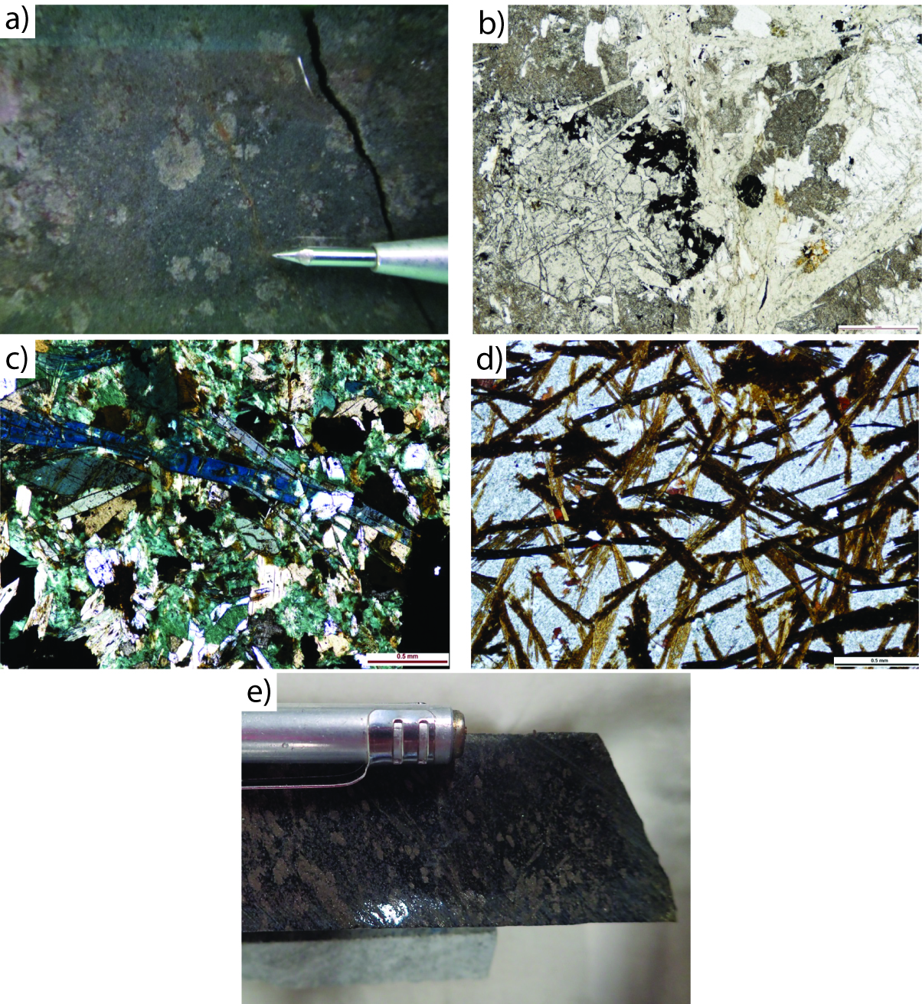
Figure 6 a) Garnet–anorthite–zoisite skarn in drillcore. Nymagee orebody. Garnet at Nymagee is commonly pale cream in colour; b) Plane-polarised light photomicrograph of garnet–anorthite–zoisite skarn. Nymagee orebody. The high-T skarn is being replaced by a chlorite sphalerite-rich retrograde assemblage (garnet is commonly replaced by sulfides); c) Ferro-hastingsite–biotite–epidote–magnetite skarn. Fe-oxide–Cu lode, Nymagee orebody; d) Acicular stilpnomelane-rich alteration peripheral to the ferro-hastingsite skarn. Nymagee orebody; e) Pervasively retrogressed high-T skarn, now talc–chlorite–pyrrhotite-rich. Pyrrohotite replaces garnet and acicular tremolite (note the textural preservation).

Devonian intrusive rocks of the Hera–Nymagee region
Devonian (c.420 Ma) I-type granodiorite has been intersected in drillcore along the line of the Rookery Fault to the south of the Nymagee–Hera orebodies (Figure 2). Blevin and Jones (2004) described granodiorite at Fountaindale and Tollingo as weakly to moderately oxidised, plotting compositionally within in the Zn–Cu–W fields of Blevin et al. (1996). These intrusions are responsible for wide zones of calcic (epidote–actinolite–prehnite) magnetite-rich alteration and would be fertile causative intrusions for skarn deposits such as Hera and Nymagee.

NORMA VALE PROSPECT
The Norma Vale prospect is located close to the western basin margin, between the upper and lower Amphitheatre Group, in an area mapped as Shume Formation (MacRae 1987). The Shume Formation intersected in drillcore at Norma Vale is lithologically distinct from its quartzose sandstone-rich exposure elsewhere in the Cobar Basin (MacRae 1987), but lithologically similar to parts of the Shume Formation described by Brown et al. (2015) at the Mallee Bull prospect to the east (Figures 1, 2). The unit at Norma Vale is dominated by a pebble to cobble conglomerate (Figure 7). Conglomerate clasts range from intrabasinal siltstone, sandstone and coherent volcanics, to shelf-derived limestone blocks. Importantly, a compositionally complex, high-level, linear, I-type intrusive stock of dioritic, granodioritic and local mairolitic leuco-syenogranite has intruded the conglomerate along a north-northeast oriented fault in the southeast of the area (Figure 7). Diamond drillhole DD09NV0005 intersected well-developed calcic Fe–(Cu) skarn and pyrrhotite–chalcopyrite mineralisation at the contact between basinal siltstone and a large allochthonous limestone block within the conglomerate package (Figure 7). The Norma Vale skarn is predominantly a fine-grained epidote-rich — and in the highest-T parts hedenbergite–(±garnet)-rich — skarn (Figure 8a) after former siltstone and fine-grained sandstone. A number of generations of carbonate-rich skarn veins transect the skarnified host.

Vein assemblages include high-T, anhydrous calcite–hedenbergite–pyrrhotite veins (Figure 8b) that are often extensively retrogressed by later veins systems comprising abundant Fe-rich epidote, calcite and actinolite (Figure 8c). The host rock adjacent to veins is pervasively altered to green and brown stilpnomelane, with an outermost selvage rich in actinolite and epidote. Pyrrhotite is abundant in the hydrous, retrograde veins. Interestingly pyrrhotite often has a cubic form, possibly suggesting initial pyrite or magnetite (initial oxidised fluids). Limestone overlying the skarn is riddled with stylolitic fluid escape structures and secondary carbonate +/- magnetite veins.

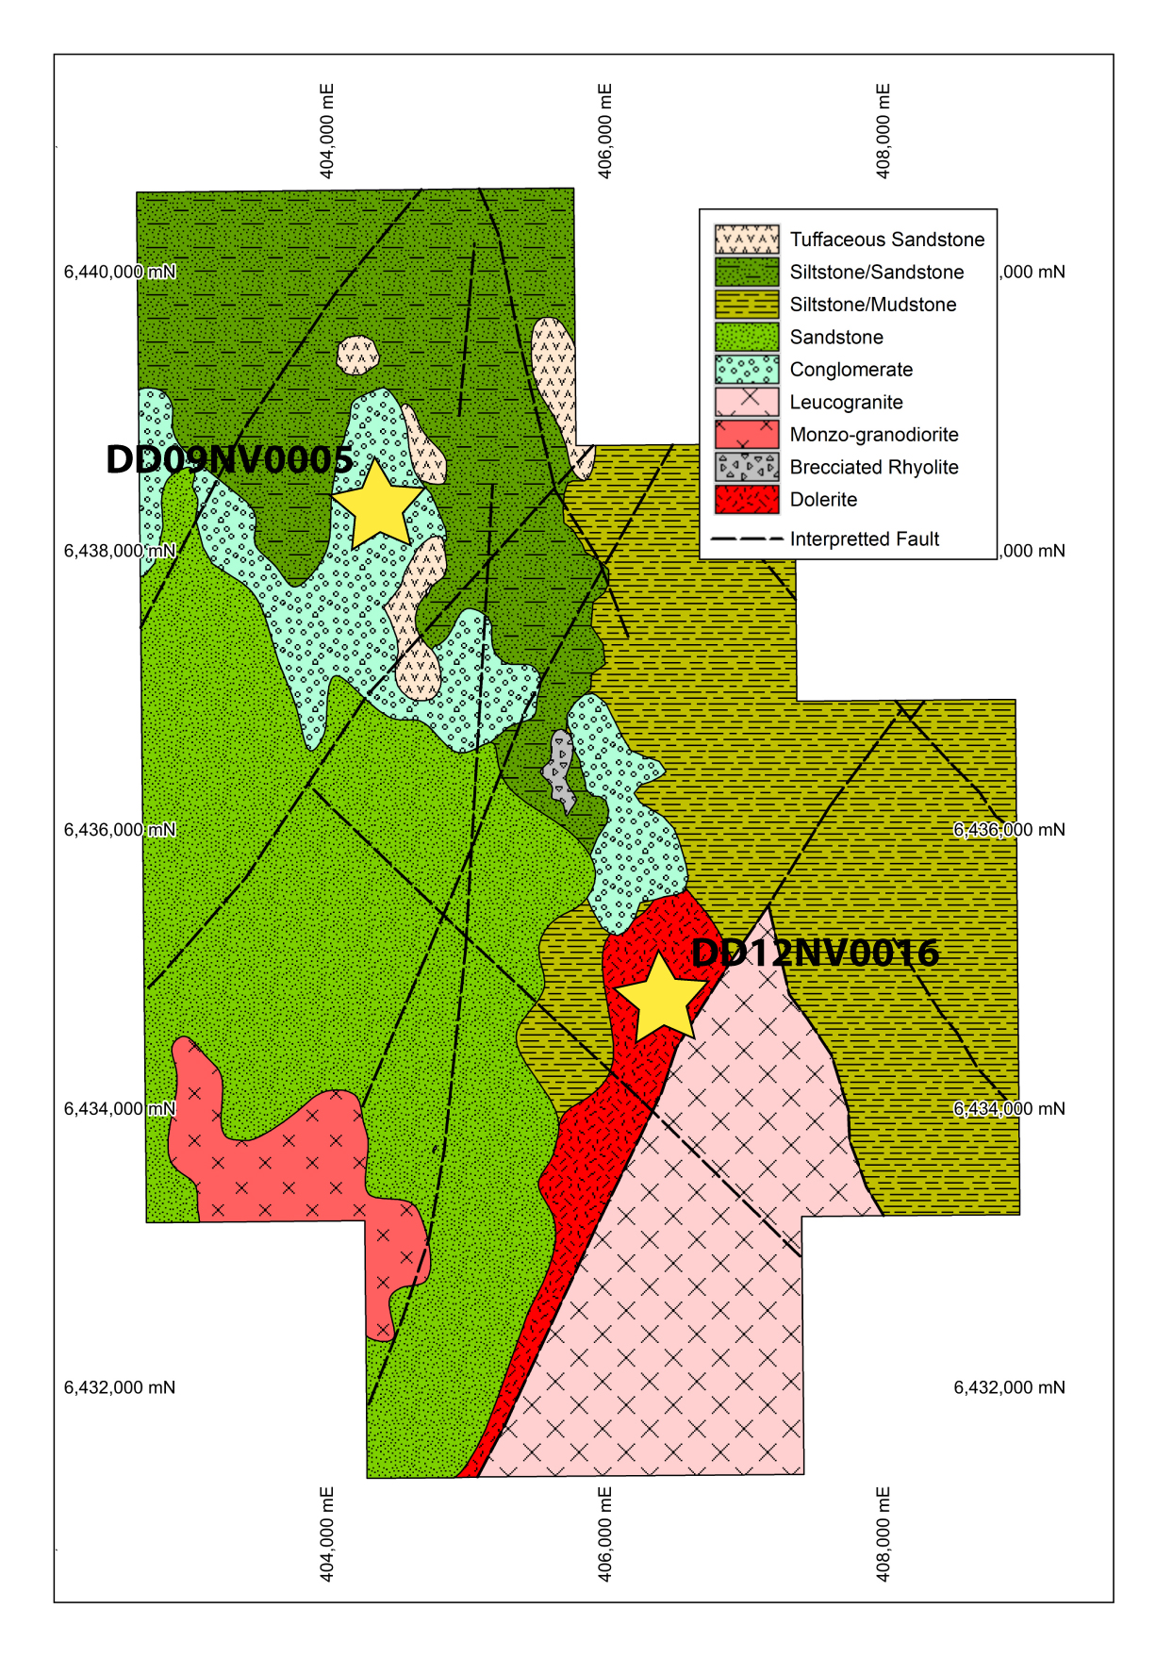
Figure 7. Basement interpretation of the Norma Vale area, showing drillholes mentioned in text. Courtesy of Peak Mines.

The Norma Vale skarn is a calcic Fe–(Cu) skarn consistent with a causative pluton(s) of dioritic composition, such as those that intrude the conglomerate horizon to the southeast (Figure 8d). S-type granite of c.420 Ma age (Downes et al. 2016b) also intrudes the Norma Vale area, but likely bears no genetic relationship to skarn alteration. S-type granites are associated with very localised zoning of biotite–cordierite hornfels and tourmalinisation of host sequences, with local scheelite-bearing veins.

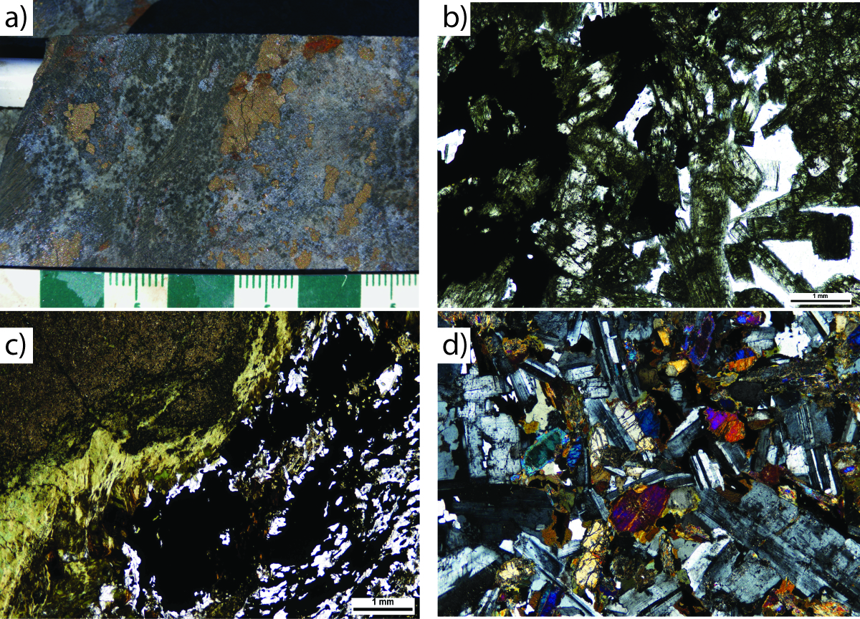

Figure 8 a) Hedenbergite-rich skarn in core (DD09NV0005). Norma Vale prospect; b) Plane polarised light photomicrograph of hedenbergite–calcite-rich skarn vein, Norma Vale prospect; c) Hydrous, retrograde epidote–calcite–pyrrhotite–chalcopyrite vein. Top left is a fine-grained epidote skarn, while alteration adjacent to the sulfide vein is rich in brown and pale green stilpnomelane; d) Cross-polarised photomicrograph of two-pyroxene, quartz diorite. Norma Vale prospect (DD12NV0016).

RECIPE FOR A SOUTHERN COBAR SKARN… & WHAT’S COOKING IN THE NORTH?
The Hera orebody is complex. It is a strongly reduced, low X(CO₂) pelitic rock-rich, magnesian–calcic Au–Zn–Pb–Ag(W) skarn. While containing similar calcic skarn-hosted ore lenses to Hera orebody, the nearby Nymagee orebody is further complicated by the presence of a spatially separated calcic Fe–Cu skarn. Skarn at Norma Vale is a reduced, relatively high X(CO₂), calcic Fe(Cu) skarn, although the presence of cubic pyrrhotite pseudomorphs implies a least an initial oxidised hydrothermal fluid.

Devonian I-type intrusions to the south of Hera–Nymagee, at Fountaindale and Tollingo, are chemically compatible with the formation of Zn–W–Cu-rich skarn and are described as weakly to moderately oxidised and moderately fractionated. Carbonaceous basin sequences would be expected to strongly reduce any weakly oxidised magmatic fluids. Calcic Fe(Cu) skarn at Norma Vale is entirely consistent with the nearby I-type diorite–granodiorite intrusions.

In all cases probable causative plutons have exploited long-lived, basin-forming fault systems, which have acted as magma and ultimately magmatic-derived fluid conduits. At several levels within the Cobar Basin, fault intersections with permeable, allochthonous packages have aided the ingress of magmatically derived fluids to produce skarn, breccia and manto bodies. The use of permeable stratigraphy by metal-bearing fluids has also been suggested for some lower-T central basin (e.g Mallee Bull; Brown et al. 2013, 2015) and number of the northeastern orebodies (Berthelsen 2006, 2010). The juxtaposition of permeable carbonate-hosting (dolomite-rich at Hera–Nymagee and calcite-rich at Norma Vale) allochthonous horizons within a package of reduced carbonaceous basin sequences provides the ideal chemical trap, with a neutralising sequence (carbonate) adjacent to a strong reductant (carbonaceous sequence). Such a scenario could easily explain the juxtaposition of calcic Zn–Pb-rich skarn lenses (carbonate-hosted) and aluminous–calcic Fe–Cu skarn (boundary between calcareous and carbonaceous sequences) at the Nymagee orebody. Given the lithological reactivity of the permeable horizons in southern Cobar, there is no requirement for mixing of basement-derived and basinal fluids for ore precipitation, although mixing between magmatic and formational waters would be expected and is observed.

The metallogeny and geometry of the CSA orebody in the northeastern Cobar mineral field (recently studied by Kyne 2014) bears many similarities to the Nymagee orebody to the south, including spatially separated Pb–Zn-rich and Cu (locally Fe-oxide-rich) ore lenses, similar lens morphology (short strike length steep plunging and vertically extensive), location in the hanging wall to a parallel, long-lived near-margin fault system and a broadly stratabound character. The similarities are so striking that Nymagee orebody has been termed ‘CSA of the south’. Is it time for the sisterhood to split? Alteration assemblages proximal to mineralisation at CSA are undoubtedly lower-T comprising chlorite (±biotite) and stilpnomelane. The orebody is hosted in the CSA siltstone, described as carbonaceous, with quartzose sandstone, although recent samples taken from Pink Panther prospect, just to the south on the same structure as the QTS south lenses at CSA, contain abundant medium- to coarse-grained calcarenite, rich in bioclastic carbonate fragments (commonly shelly; Figure 9a). Samples from the QTS north orebody contain small, spatially separated sphalerite–galena–pyrite-rich carbonate-replacement lenses alternating with copper-rich mineralisation (Figure 9b). The northern extension of these horizons hosts chalcopyrite-rich mineralisation that is cored by an early-phase, massive magnetite (plus carbonate) replacement horizon (Figure 9c). Magnetite there is often acicular in form, displaying mushketovitic texture. Fe-oxide rich lenses of the CSA orebody are very similar to the massive replacement style magnetite horizons and peripheral quartz mushketovite-rich (Figure 9d) FeO–Cu–Au body at Great Cobar to the east. In fact, many of the northeastern Cobar deposits share striking similarities with intrusion-related IOCG (iron-oxide–copper gold), replacement-style or manto-type deposits elsewhere, for example the Chillan, Mantoverde and IOCG deposits, which are also associated with major basin axial fault systems (Chen 2009; Rieger et al. 2010).

CONCLUSIONS
High-T skarn mineralisation in the southeastern and southwestern Cobar Basin is hosted in broad, thermally perturbed zones where the intrusion level, or near-intrusion level of Devonian I-type plutons has been exposed in basin, shelf and basement (Figure 2). This includes the epithermal Mineral Hill orebody (Morrison et al. 2004). Faults and permeable, chemically reactive horizons have played an important role in metal transport and trapping. Mineralised zones in the central (e.g. Mallee Bull) and northeast (e.g. CSA) Cobar Basin are lower-T, display similar metallogeny, morphology, proximity to important basin-axial, margin and near-margin fault systems, and are hosted in similar sequences, but Devonian I-type intrusions have yet to be encountered. The southern skarns, central basin and northern, distal replacement-style IOCG deposits are parts of a single Devonian I-type intrusion-related mineral system.

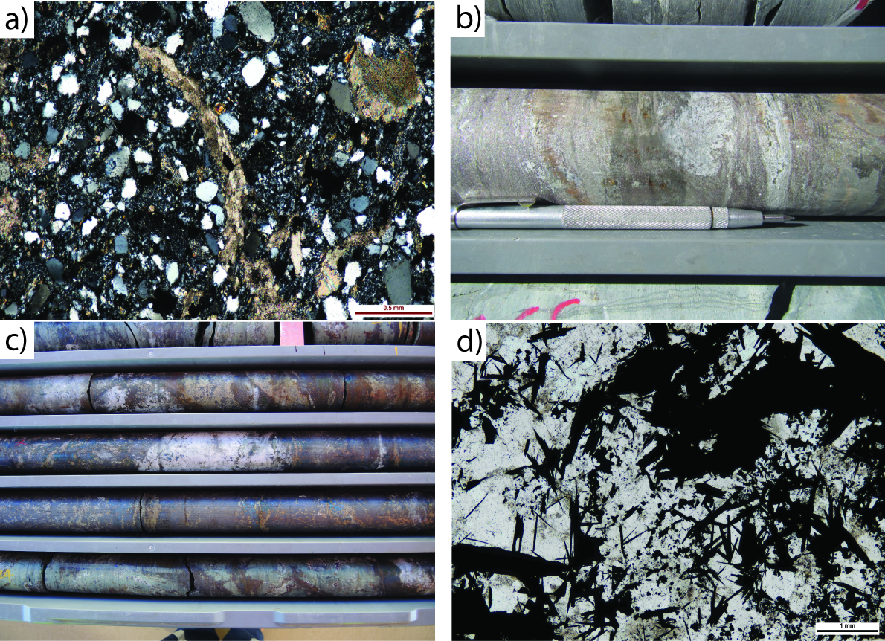

Figure 9 a) Cross-polarised photomicrograph of calcarenite, with shell fragment in the centre. Pink Panther prospect; b) Pyrite–sphalerite-rich carbonate replacement horizon, pale areas are remnant carbonate. CSA mine; c) Core interval through massive magnetite–quartz–carbonate horizon. Oxide phase is overprinted by a chalcopyrite–pyrrhotite-rich breccia. CSA mine; d) Mushketavite-textured magnetite–quartz. Magnetite in the top right is strongly replaced by chalcopyrite. Great Cobar orebody.

Higher overall intrusion-levels in the south have exposed intrusion-proximal orebodies, while in the central and northeastern basin intrusion-distal deposits are exposed, with the magmatic ‘bowels’ of the system remaining deeply buried. The timing of the intrusive event that led to mineralisation is still questionable and may be diachronous across the basin. Most igneous isotopic dates from the Mount Hope Trough area fall in the range of 415–422 Ma (Downes et al. 2016b). However, the mafic rocks that are likely to be responsible for skarn mineralisation at Norma Vale are yet to be dated (currently being processed for U–Pb SHRIMP dating). I-type intrusive rocks in the Nymagee–Hera region fall between the age range 415–420 Ma (Downes et al. 2016b). However there is the possibility of a younger phase of intrusions, so the dating from the Norma Vale mafic intrusive rocks is of great interest. Intrusive rocks of this composition are known to be related to IOCG-replacement style mineralisation (e.g. Sillitoe, 2003; Oliver et al. 2009; Tornos & Velasco 2009) and Fe–Cu–Au-skarn (e.g. Einaudi et al. 1981).

Ultimately all mineral deposits of the Cobar Basin are intimately related to major long-lived fault systems and have a strong structural control, but an intrusion-related heat, metal and fluid input is indisputable in the southern basin, as is the importance of permeable, reactive host sequences. Further work needs to focus on timing the early-stage (often oxide-rich) mineralisation in the northeastern Cobar mineral field, along with systematic characterisation of fluid and metal source for these early mineralising stages. A reassessment of some of the host stratigraphy, particularly unaltered/mineralised drillholes along strike from orebodies, would also be useful for understanding metal trapping in the region.

ACKNOWLEDGEMENTS
Fitzherbert and Blevin would like to thank the mine and exploration geologists from the Cobar region for their help and input. These include CSA mine: Eliseo Apaza, Robert Neumayr, Tristan Kay and Martin Scott; Newgold (Peak Mines): Lize Stander, John Heavey, Thomas Wall and Matthew Green. The authors acknowledge the petrographic work of Jane Barron, including prior descriptions (over many years) of high temperature alteration and sulfide mineralogy in the Cobar region.

REFERENCES
Berthelsen, R. 2006. The Cobar Goldfield — variations on a theme. In: Lewis P.C. ed. 2006. Mineral Exploration Geoscience in New South Wales Extended Abstracts, pp. 71-78. Mines and Wines Conference, Cessnock, NSW, SMEDG (Sydney Mineral Exploration Discussion Group).

Berthelsen, R. 2010. Cobar goldfield mineral deposits. Abstracts; Giant ore deposits down-under, 13th Quadrennial IAGOD symposium, Adelaide, Australia.

Blevin, P.L and Jones, M. 2004. Chemistry, age and metallogeny of the granites and related rocks of the Nymagee region, NSW. In: McQueen K.G. & Scott K.M. eds. Proceedings of the Exploration Field Workshop, Cobar Region, 2004, pp. 15–19, CRC LEME publication.

Blevin, P.L., Chappell, B.W. and Allen, C.M. 1996. Intrusive metallogenic provinces in eastern Australia based on granite source and composition. Transactions of the Royal Society of Edinburgh: Earth Sciences 87:281–290.

Brown, R.E., Chapman, N. and Oates, M. 2013. The Mallee Bull discovery and exploration in the central Cobar Basin. In: Lewis P.C. ed. 2013. Mines and Wines 2013, pp. 5–12. Australian Institute of Geoscientists Bulletin 55.

Brown, B., Ashley, P., Vickery, N., Tyson, R. and Oates, M. 2015. Significant recent developments and research at the Mallee Bull deposit, Cobar Basin, NSW. In: P.C. Lewis ed. 2015, Australian Institute of Geoscientists Bulletin 62.

Chen, Huanyong. 2009. External Fluid in the Major Mesozoic Central Andean
IOCG Deposits. Proceedings of the Tenth Biennial SGA Meeting, Townsville.

Cleverley, J.S. and Barnicoat, A.C. 2007. Fluids, sources and reservoirs. In: van der Wielen. S. & Korsch. R. eds. 2007. 3D Architecture and Predictive Mineral System Analysis of the Central Lachlan Subprovince and Cobar Basin, New South Wales. Final Report for the pmd*CRC T11 project, pp. 117–121. Geoscience Australia, Canberra.

David, V. 2005. Structural setting of mineral deposits in the Cobar Basin. PhD thesis, University of New England, Armidale (unpubl.).

David, V. 2006 Cobar Superbasin System metallogenesis. In: Lewis P.C. ed. Mineral Exploration Geoscience in New South Wales, Extended Abstracts, pp. 39–51. Mines and Wines Conference 2006, Cessnock NSW, SMEDG (Sydney Mineral Exploration Discussion Group).

Downes, P.M., Tilley, D.B., Fitzherbert, J.A., and Clissold, M.S. 2016a. Regional metamorphism and the alteration response of selected Silurian to Devonian mineral systems in the Nymagee area, Central Lachlan Orogen, New South Wales — a HyLogger™ case study. Australian Journal of Earth Sciences, 63 (8), 1027–1052.

Downes, P. M., Blevin, P., Armstrong, R., Simpson, C.J., Sherwin, L., Tilley, D.B. & Burton, G.R. 2016b. Outcomes of the Nymagee mineral system study — an improved understanding of the timing of events and prospectivity of the Central Lachlan Orogen. Quarterly Notes of the Geological Survey of New South Wales 147.

Einaudi, M.T., Meinert, L.D. and Newberry, R.J., 1981. Skarn deposits: Economic Geology 75th Anniversary Volume, pp. 317–391.

Fitzherbert, J.A., Downes, P.M., and Blevin, P.L. 2016. Cobar Special 1:500 000 Metallogenic Map. Geological Survey of New South Wales, Maitland, Australia.

Fitzherbert, J.A., Mawson, R., Mathieson, D., Simpson, A.J., Simpson, C.J., and Nelson, M.J. 2017. Metamorphism in the Cobar Basin: Current state of understanding and implications for mineralisation. Quarterly Notes of the Geological Survey of New South Wales 148.

Glen, R.A., Clare, A. and Spencer, R. 1996. Extrapolating the Cobar Basin model to the regional scale: Devonian basin-formation and inversion in western New South Wales. In: Cook W. G., Ford A. J. H., McDermott J. J., Standish P. N., Stegman C. L. & Stegman T. M. eds. The Cobar Mineral Field - A 1996 Perspective, pp.43–83. Australasian Institute of Mining and Metallurgy, Melbourne, 3/96.

Glen, R.A., Dallmeyer, R.D. and Black, L.P. 1992. Isotopic dating of basin inversion — the Palaeozoic Cobar Basin, Lachlan Orogen, Australia. Tectonophysics 214, 249–268.

Kyne, R. 2014. Genesis and structural architecture of the CSA Cu–Ag (Pb–Zn) Mine, Cobar, New South Wales. PhD thesis, University of Tasmania.

Lawrie, K.C. and Hinman ,M.C. 1998. Cobar-style polymetallic Au–Cu–Ag–Pb–Zn deposits. AGSO Journal of Australian Geology and Geophysics 17(4), 169–187.

MacRae, G.P. 1987. Geology of the Nymagee 1:100 000 sheet 8133. Geological Survey of New South Wales, Sydney.

Morrison, G., Blevin, P.L., Miller, C., Hill, P. and Mackenzie, I. 2004. Age and setting of the Mineral Hill Au–base metal deposits. In: Bierlein F.P & Hough M.A. eds. Tectonics to mineral discovery — deconstructing the Lachlan Orogen, pp.83–93. Geological Society of Australia Abstracts 74.

Oliver, N.H.S, Rubenach, M.J. and Predictive Mineral Discovery Cooperative Research Centre. 2009. Distinguishing Basinal- and Magmatic–Hydrothermal IOCG deposits, Cloncurry District, Northern Australia. Proceedings of the Tenth Biennial SGA Meeting, Townsville.

Perkins, C., Hinman, M.C. & Walshe, J. L. 1994. Timing of mineralisation and deformation, Peak Au mine, Cobar, New South Wales. Australian Journal of Earth Sciences 41(5), 509–522.

Rieger, A. A., Marschik, R., Diaz, M., Holzl, S., Chiaradia, M., Akker, B., and Spangenberg, J. 2010. The Hypogene Iron Oxide Copper–Gold Mineralization in the Mantoverde District, Northern Chile . Economic Geology 105, pp. 1271–1299.

Sillitoe, R.H. 2003. Iron oxide–copper–gold deposits: an Andean View. Mineralium Deposita 38(7), 787–812.

Stegman, C. L. 2001. Cobar deposits: still defining classification. Society of Economic Geologists Newsletter 44, 15–25.

Suppel, D.W. 1984. A study of mineral deposits in the Cobar Supergroup, Cobar region, New South Wales. MSc thesis, University of New South Wales, Sydney (unpubl.).

Suppel, D.W. and Gilligan, L.B. 1993. Nymagee 1:250 000 Metallogenic Map SI/55-2: Metallogenic Study and Mineral Deposit Data Sheets. 171 pp. Geological Survey of New South Wales, Sydney.

Tornos, F., and Velasco, F. 2009. Magmatic–hydrothermal Evolution of the IOCG Deposits
of Central Chile. Proceedings of the Tenth Biennial SGA Meeting, Townsville.

