NEW DEVELOPMENTS AT THE HERA AU-PB-ZN-AG MINE, NYMAGEE,
NEW SOUTH WALES
A.R. McKinnon¹ & J.A Fitzherbert²
¹Aurelia Metals Limited, Orange, NSW, 2800. adam.mckinnon@aureliametals.com
²Geological Survey of New South Wales, Maitland, New South Wales, 2320. joel.fitzherbert@industry.nsw.gov.au
Key Words: Hera, skarn, wall rock geochemistry, alteration, ore mineralogy, Nymagee, Cobar Basin, HyLoggerTM.

INTRODUCTION
The Hera Au-Pb-Zn-Ag Mine is located five kilometres south-southeast of the historic copper mining town of Nymagee in central western New South Wales (Figure 1). Hera was identified as a prospect in 1974 when an airborne EM survey was flown over the area. Sub-economic mineralisation was drilled in 1984 although high grade mineralisation was not intersected until 2000 when Pasminco drilled below a strong lead soil anomaly (Skirka and David, 2005). Significant subsequent exploration and delineation drilling by Triako Resources, CBH Resources and finally Aurelia Metals (previously YTC Resources) has established economic mineralisation over a strike length exceeding 800 metres.
The orebody occurs near the eastern edge of the Palaeozoic-age Cobar Basin, hosted in steeply dipping turbiditic sandstones and siltstones of the Mouramba and Lower Amphitheatre Groups. The rocks have been metamorphosed to low-middle greenschist facies and display a well-developed, near vertical cleavage (Downes et al., 2016a; Skirka and David, 2005). The deposit has a strong structural control, with mineralisation occurring as steeply-dipping sulfide vein/breccia zones, similar to other Cobar-style deposits (David, 2006).
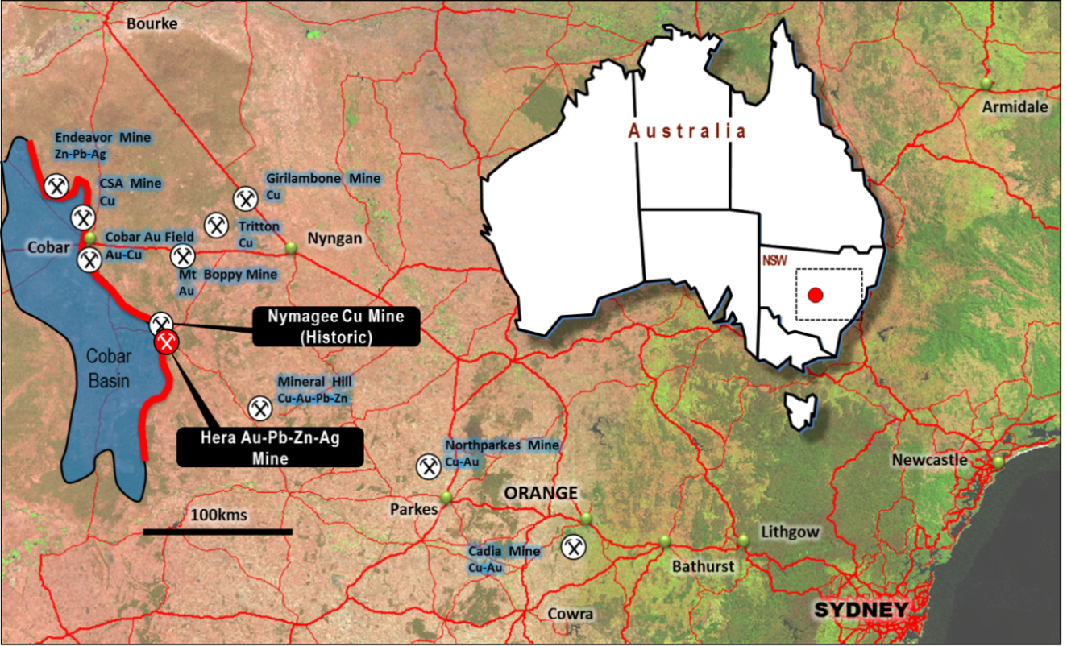
Figure 1. Location of the Hera Mine and other major deposits in central western NSW.
Mineralisation is arranged into a number of structurally offset, steeply west-dipping, NNW-striking lodes. The orebody does not have a physical surface expression, with economic mineralisation commencing nearly 200 metres below surface. Five major lode zones have been identified, which display an overall shallow plunge to the north (Figure 2). Economic mineralisation has been defined to at least 630 metres below surface and the deposit remains open at depth to the north.
Development and construction at the mine began in January 2013 and production was commenced in September 2014. Ore from the mine is currently processed at a rate of 380-400,000 tonnes per annum, producing gold and silver as doré, and lead, zinc and silver as a bulk concentrate. Resources at Hera have recently been updated, with the remaining global estimate at the end of June 2017 totalling 2.9Mt at 2.8g/t Au, 2.6% Pb, 3.8% Zn and 24g/t Ag, based on a $120 Net Smelter Return (NSR) cut-off. An expanded underground diamond drilling campaign during the last year has resulted in nearly 80% of this resource being upgraded to the Measured and Indicated categories. A new Probable Reserve of 1.5Mt at 3.5g/t Au, 2.7% Pb, 4.0% Zn and 21g/t Ag extends the mine life until at least mid-2021.
Most of the early development and production has focussed of the siliciclastic-dominant Main North and Main South Lodes. Recent exploration in and around the North Pod and Far West lodes, along with continuing development into the lower levels of the mine, have led to a number of significant discoveries about the geometry of the orebodies, geochemistry of the wall rocks and gangue and ore mineralogy.

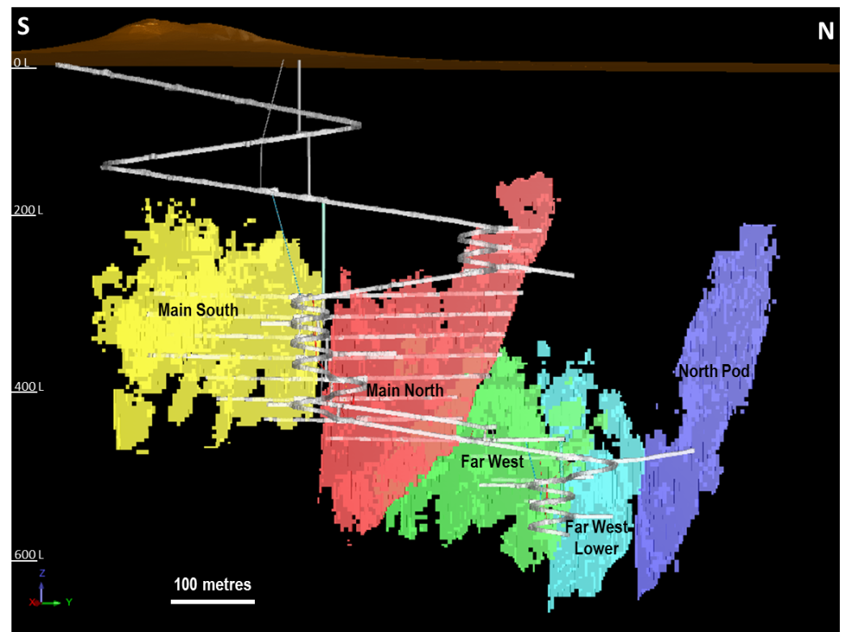
Figure 2. Long section of the Hera deposit looking west showing the major lodes and current mine development
NEW DEVELOPMENTS AT HERA
Orebody Geometry
Detailed underground mapping and infill drilling has led to a revised interpretation for the Hera orebody as a single broadly stratabound mineralised horizon that has been offset into a series of steeply west-dipping ore lenses (Figure 3). The orebody has an overall NNW-SSE strike, broadly parallel to the basin margin a short distance to the east. Two major orientations appear to control the internal geometry of the lenses: steeply south-dipping, east-west structures with apparent sinistral displacement; and steeply east-dipping, north-south structures with apparent dextral displacement. The latter structures in particular are associated with late, laminated and massive quartz veining. Titanite derived from these veins on the 460 Level give a U-Pb date of 380Ma, indicating the latest possible timing for the major mineralising event. The new interpretation confirms the areas to the northwest of the North Pod and southeast of Main SE as high priority exploration targets, with drilling plans being developed for the coming year.

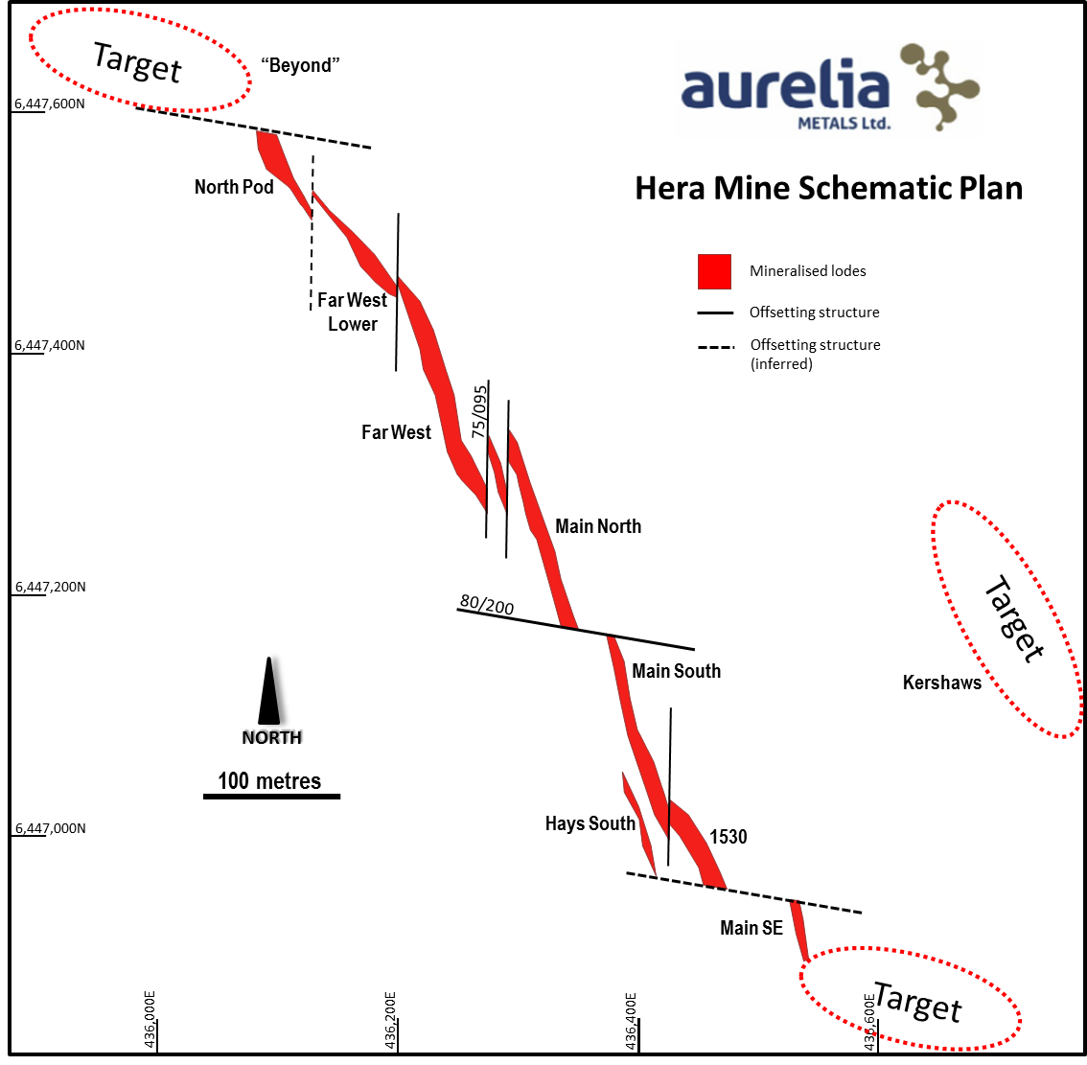
Figure 3. Schematic plan showing the geometry of the mineralised lodes at Hera.
Identification of skarn assemblages at Hera
A major recent discovery at Hera is the widespread presence of skarn assemblages. A number of the skarn-associated species are shown in Figure 5. The occurrence of the skarn and its zonation is detailed by Fitzherbert et al. (2017a), and summarised here. Siliciclastic host rocks and clasts at Hera are intensely silicified and enveloped by sulfide-rich breccia-fill/veins, and frequently contain quartz-rich calc-silicate veins proximal to and within the sulfide orebody, while a biotite-rich mineralogy is present distal to the orebody. The major skarn types that are represented are as follows:

- A retrograded high temperature assemblage variably comprising garnet-diopside-quartz-zoisite-anorthite±carbonate. These show considerable variation along strike from garnet-rich in Main South, to pyroxene-rich in the Far West lodes and tremolite±anorthite±biotie-rich (with preserved carbonate clasts) in North Pod.
- Hydrous retrograde skarn replaces the high temperature skarn mineralogy and is ubiquitous across the orebody. The hydrous skarn is sulfide-rich (pyrrhotite-sphalerite-galena±chalcopyrite-pyrite) and dominated by tremolite-biotite±garnet.

While many individual species such as garnet, tremolite, scheelite and tourmaline were known from various drill holes and early development, it was not until mining advanced into the Far West lodes in late 2016 that the widespread high temperature calc-silicate assemblages were definitively confirmed. Recent exploration drilling in the North Pod has also revealed some of the original laminated dolomitic carbonates preserved as clasts in massive sulfides (Figure 5a), frequently partially or totally altered to tremolite (Figure 4). The high temperatures required for the formation of some of these assemblages, and high thermal contrast (>200°C) to the lower temperature basin rocks, is consistent with a magmatic mineral system (Fitzherbert et al., 2017b). Measured Hera tremolite δD and δ¹⁸O values are also consistent with formation from magmatic fluids (Fitzherbert et al., 2017a).

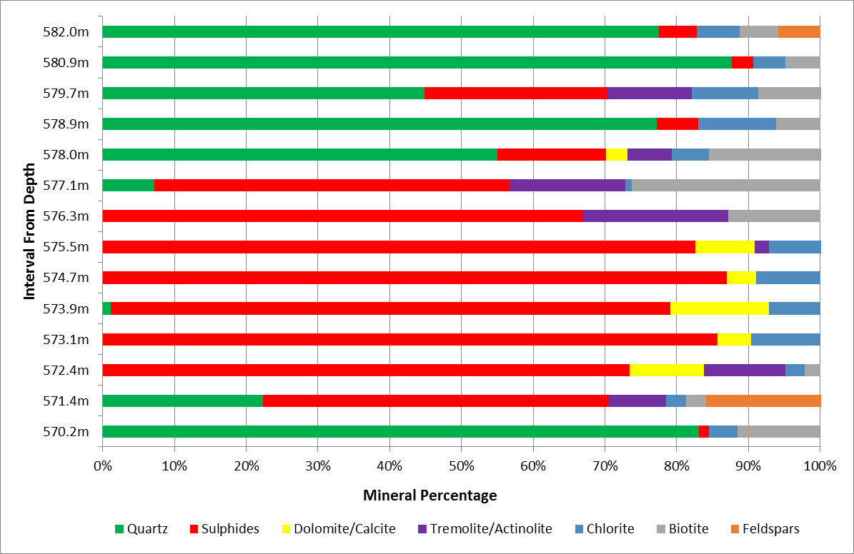
Figure 4. Simplified mineralogical profile of the ore intersection in North Pod hole HRD061, with relative percentages established by quantitative XRD. The massive sulphides zones are quartz-poor and closely associated with remnant carbonates and tremolite/actinolite.
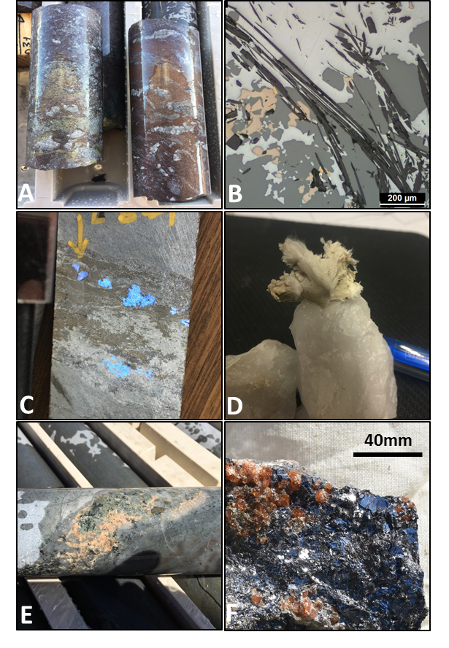
Figure 5. A) Remnant carbonate clasts within massive sulphide breccias, North Pod. B) Petrographic image of acicular tremolite intimately intergrown with sphalerite (dark grey), galena (light grey) and pyrrhotite (orange), North Pod. C) Sphalerite-galena-tremolite-zoisite vein with abundant scheelite (highlighted under short wave UV light), Far West Lower. D) Unusual fibrous dravite tourmaline on quartz (pen in background for scale), Main South. E) Quartz-garnet-actinolite-pyrrhotite vein within strongly silica-biotite altered host, Main North. F) Euhedral and subhedral garnet crystals in massive galena, Main South. All drill core is 48mm diameter.
Recent exploration at North Pod
At the last resource update in April 2016, North Pod was a wholly Inferred part of Hera’s resource base, considered to be lead-zinc dominant with little high grade gold. Following the establishment of a drill platform on the 490 Level, an extensive diamond drilling campaign targeting the lower half of North Pod was commenced. Drilling densities for the programme were increased to a nominal 25x12.5 metre offset pattern, and resulted in the discovery of several new features unique to the North Pod mineralisation.
The first of these discoveries was that the thick, high grade Pb-Zn±Ag mineralisation that was previously intercepted in certain surface holes was actually restricted to a relatively narrow “pipe-like” trend (Figure 6). The zone plunges to the south at 70-75° and comprises massive sulphide breccias and replacement zones with abundant remnant carbonate-tremolite±anorthite±epidote skarn. Gold is typically low to moderate in this style of mineralisation. Significant intercepts from this zone include 16.2 metres at 2.4g/t Au and 21.6% Pb+Zn in HRUD374 and 20 metres at 0.3g/t Au and 14.8% Pb+Zn in HRUD411.
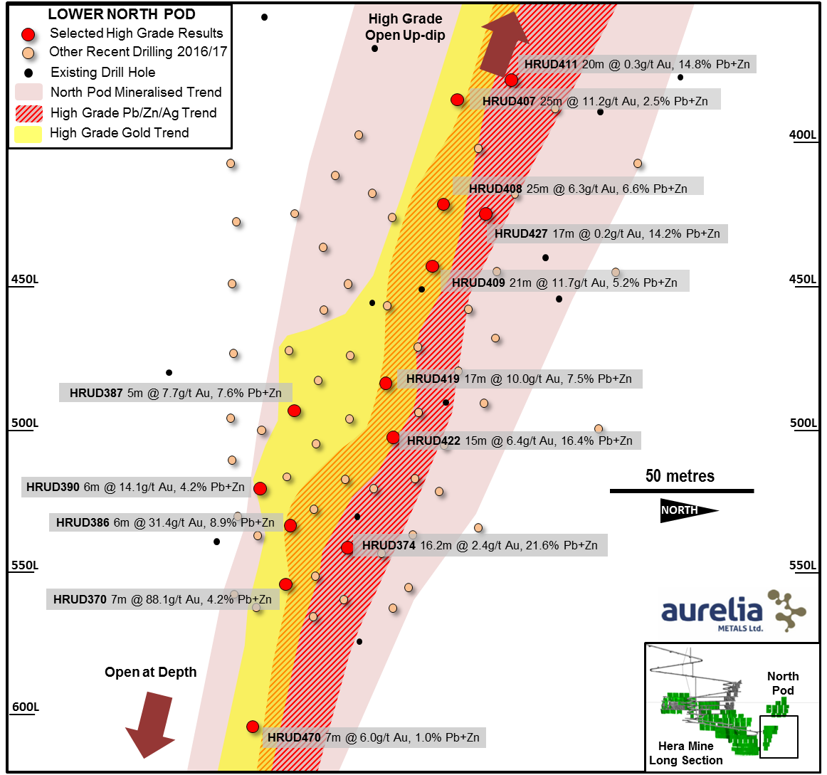
Figure 6. Long section of the lower half of North Pod and displaying selected results from recent drilling.
Sitting on the southern (upper) portion of this zone, and slightly overlapping it in places, is a second zone with typically lower base metals but moderate to very high gold. Drill intersections in this area were dominated by biotite-altered siliciclastic rocks, with remnant skarn less common. Highest grades intercepted in this zone to date include 7 metres at 88.1g/t Au and 4.2% Pb+Zn in HRUD370 and 25 metres at 11.2g/t Au and 2.5% Pb+Zn in HRUD407. Drilled from a separate location, hole HRUD470 intercepted 7 metres at 6.0g/t Au and 1.0% Pb+Zn just below the 600 Level, showing that this zone remains open at depth.
Lastly, a newly identified, narrow shear zone displaying extremely high silver grades was intercepted on several sections in the hangingwall of North Pod (Figure 7). This mineralisation is notable in that silver is not necessarily associated with the highest grade base metals as it is elsewhere at Hera. Intersections from this zone include 3 metres at 4.3g/t Au, 6.5% Pb+Zn & 640g/t Ag in HRUD403 and 3 metres at 0.2g/t Au, 2.5% Pb+Zn & 313g/t Ag in HRUD409.
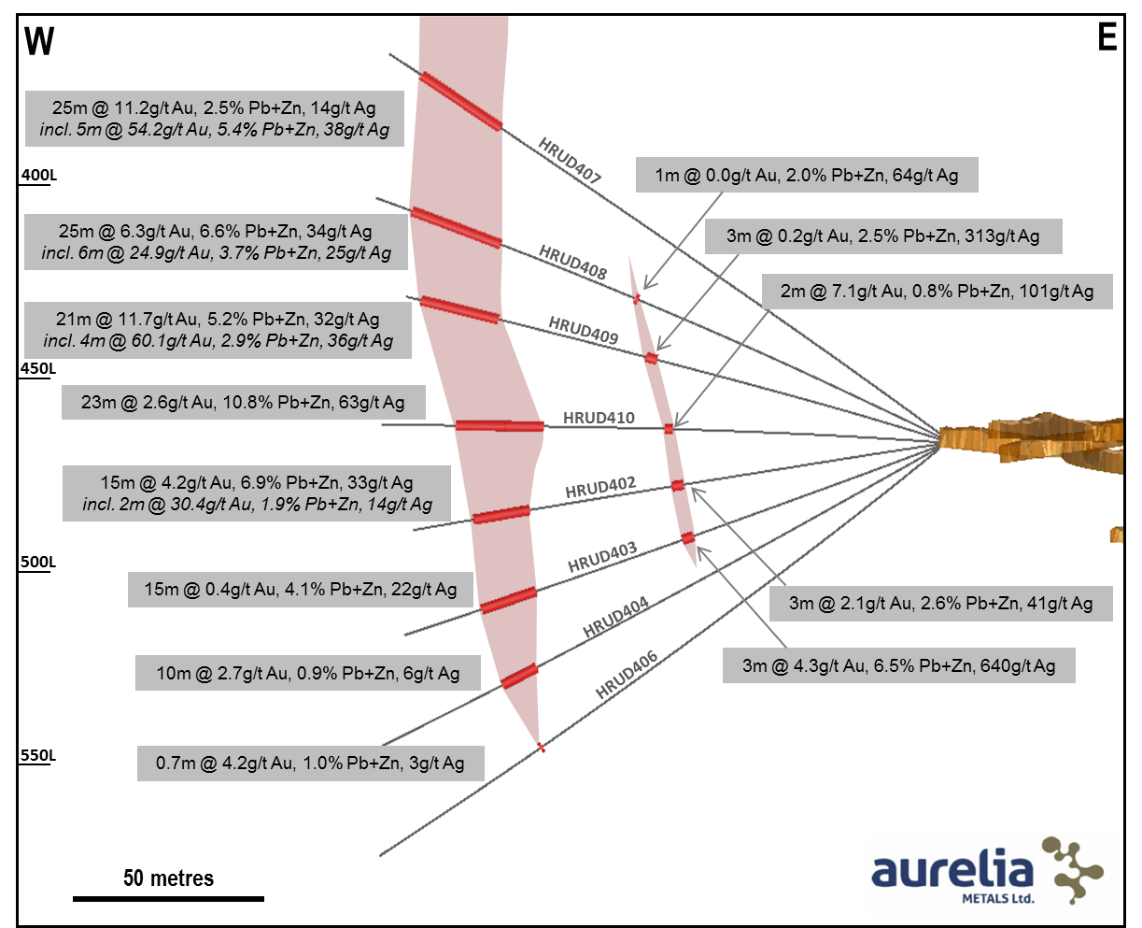
Figure 7. Oblique section through the North Pod showing recent high grade results. A newly identified, narrow high grade silver zone is also shown to the east of the main mineralised zone.

Ore Mineralogy Studies
Ore mineralogy at Hera has been extensively studied although very little has been published in the open literature. A number of detailed studies have been conducted during metallurgical test work, and more recently a comparative study of the differences in ore and gangue mineralogy across the different lodes has commenced. Table 1 lists the 24 ore species identified to date, with mineralogical work currently ongoing.
Table 1. List of ore minerals identified in samples from the Hera deposit, with relative abundance.
Ore Mineral | Formula | Abundance | Ore Mineral | Formula | Abundance
Acanthite | Ag₂S | Trace | Gudmundite | FeSbS | Trace
Antimony | Sb | Trace | Marcasite | FeS₂ | Trace
Arsenopyrite | FeAsS | Minor | Pentlandite | (Fe,Ni)₉S₈ | Trace
Bismuth | Bi | Trace | Pyrite | FeS₂ | Minor
Bismuthinite | Bi₂S₃ | Trace | Pyrrhotite | Fe_{(1-x)}S | Major
Bornite | Cu₅FeS₄ | Trace | Scheelite | CaWO₄ | Trace
Chalcocite | Cu₂S | Trace | Silver | Ag | Trace
Chalcopyrite | CuFeS₂ | Minor | Sphalerite | (Zn,Fe)S | Major
Cubanite | CuFe₂S₃ | Trace | Stibnite | Sb₂S₃ | Trace
Dyscrasite | Ag₃Sb | Trace | Tennantite | (Cu,Ag)₁₂As₄S₁₃ | Trace
Galena | PbS | Major | Tetrahedrite | (Cu,Ag)₁₂Sb₄S₁₃ | Trace
Gold | Au | Minor | Troilite | FeS | Minor

The three most common sulfides in the ores at Hera are pyrrhotite, iron rich-sphalerite and galena, with ratios of each varying strongly across the deposit. Pyrite is much less abundant than pyrrhotite but the two species often occur together and locally pyrite can become dominant. Chalcopyrite is also ubiquitous in all ore types but occurs in smaller quantities and copper is not currently considered economically recoverable.
Although the basis for the relative distribution of the major sulfides is not well understood, some large scale mineralogical trends are apparent. Figure 8 shows two long sections of the Main Lodes with contoured “heat maps” of sulfur assays (left) and pyrrhotite (right). The pyrrhotite has been calculated from the assay data for each drill hole using a normative method developed on site (McKinnon, in press). The sulfur map is relatively unstructured, with no trends obvious in the highest grades. The calculated pyrrhotite map shows a distinct shallow south-plunging trend in the south, focussed on the upper periphery of the lode. The pattern is not as well resolved to the north but a shallow south plunge is still evident.
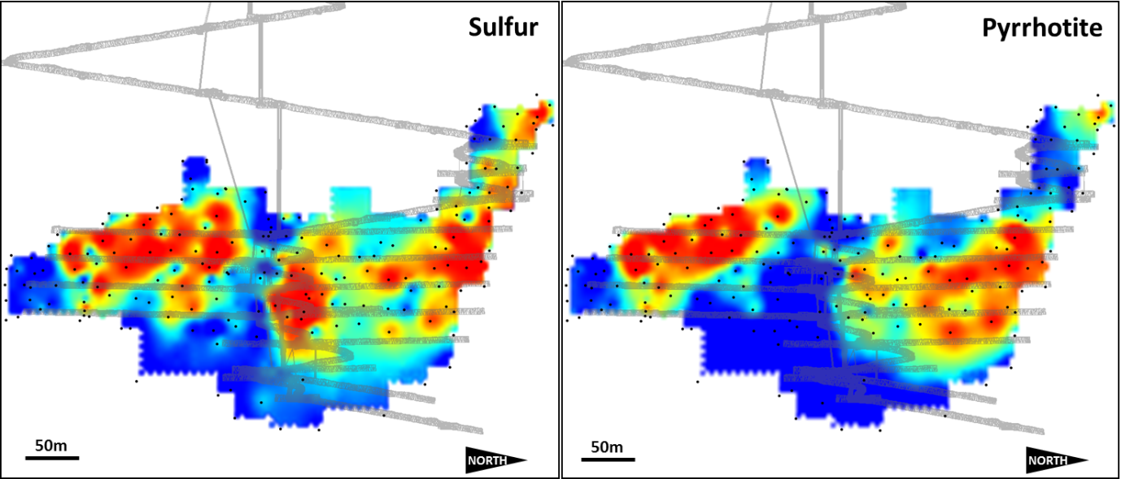
Figure 8. Long section of the Main Lodes at Hera showing an interpolated “heat map” of composited raw sulfur assay values (left) and calculated pyrrhotite values (right).

The gold at Hera has an extremely irregular or “nuggetty” distribution, spatially associated with the major sulfides but not necessarily hosted within them. Crosscutting relationships indicate the gold deposition is one of the latest paragenetic events. Coarse visible gold is often observed in hand specimens and drill core (Figure 9), occasionally occurring in patches and veinlets greater than 10mm across. The coarse nature of the gold allows more than 60% Au recovery by gravity methods.
All other sulfides listed in Table 1 are uncommon to rare, mostly identified as sub-millimetre inclusions in polished sections or by XRD/SEM microanalysis. The mineralisation at North Pod has been shown to be much more silver-, antimony- and arsenic-rich than the other lodes, with native silver and phases such as gudmundite and tetrahedrite common. Euhedral arsenopyrite crystals to 8mm in size are also common in the hangingwall of this lode, with arsenic assays occasionally exceeding 1%.

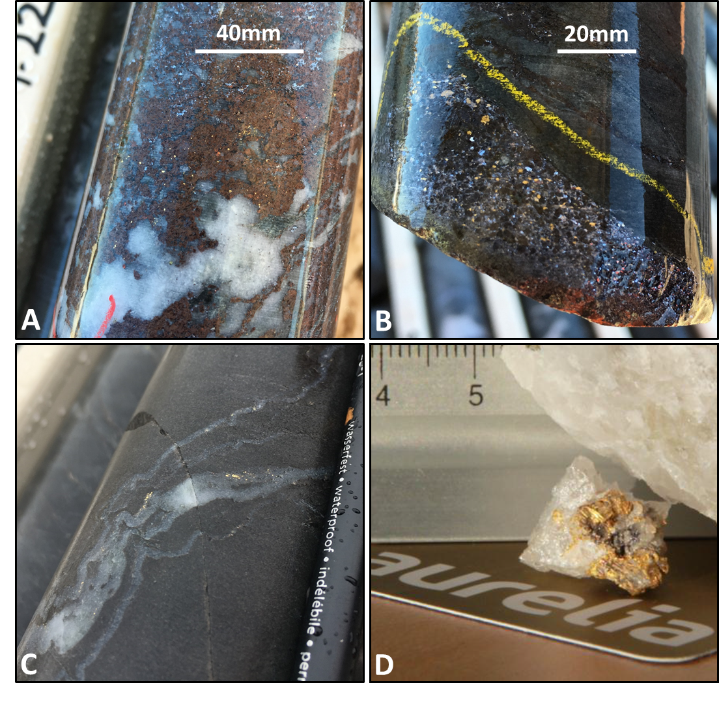
Figure 9. Visible gold from the Hera Mine in different hosts: A) scattered grains of gold to 2mm in a sphalerite-rich breccia, Far West lode; B) galena vein hosting abundant gold grains to 3mm, Main North lode; C) visible gold in small, folded quartz veins from Far West (pencil for scale on RHS); and D) nuggetty gold in massive milky quartz from Main North.
Preliminary wall rock geochemistry and alteration studies
Previous studies on the CSA orebody at Cobar have shown that systematic changes in the wall rock geochemistry and alteration may be detected a significant distance from mineralisation (Kynes, 2014; Robertson & Taylor, 1987). Such observations can be important in an exploration context, as they dramatically increase the “footprint” of the mineralised lode. In order to test whether any systematic changes occur at Hera, underground diamond hole HRUD165 was submitted for whole rock geochemical analysis. This hole was considered ideal for this purpose as it is relatively flat (-10°), starts at the edge of the high grade Main Lodes on the 310 Level and has been drilled away from the known ore zones towards the west for 360 metres (Figure 10). As the hole is not completely perpendicular to the ore zones, the end of hole is at least 215 metres from known mineralisation.
The results for selected elements are shown down hole in Figure 10. The SiO₂ displayed has a lower limit of 60% to better show the downhole trend. Silica is strongly enriched close to the mineralisation, but drops away quickly with distance. To account for the effect of pervasive silicification and/or quartz veining in some parts of the hole, Mn, Na and Sr levels here are normalised against a base SiO₂ level of 60%.
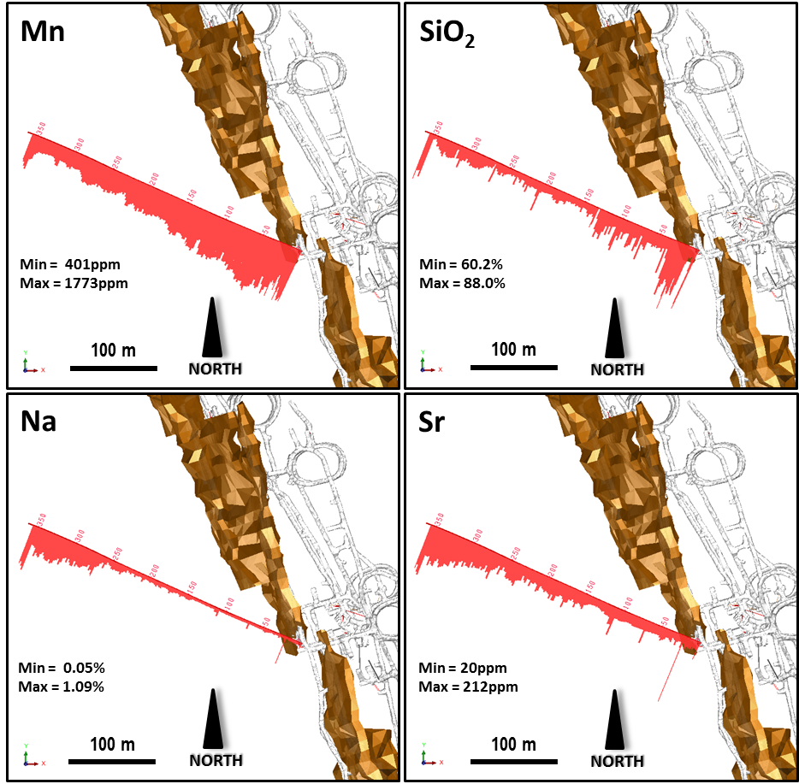
Figure 10. Plan view of Mn, SiO₂, Na and Sr responses away from the orebody (brown) in diamond hole HRUD165. The Mn, Na and Sr have been normalised against silica levels, whilst the SiO₂ has been displayed with a base level of 60%.
Manganese shows a distinct negative correlation with distance from ore, with levels peaking around 2,000ppm and dropping away to 400ppm towards the end of the hole. Sodium and strontium (and to a lesser extent calcium, which is not displayed) show the reverse trend, with significant depletion close to the orebody. Sodium in particular displays very strong depletion (<0.15%) out to at least 135 metres away from mineralisation, consistent with observations in the CSA deposit (Robertson & Taylor, 1987).
The relatively linear trend for decreasing manganese at increasing distances from the ore zone makes this element a useful candidate as a geochemical vector for “Hera-Type” mineralisation. Using the relationship of normalised Mn to perpendicular distance from ore in HRUD165 (Figure 11a), an estimated minimum distance from ore was calculated from the manganese assays in exploration holes HRUD399 and HRUD405 (Figure 11b). Both these holes were drilled immediately to the North of North Pod but neither intersected mineralisation. When plotted downhole, the calculated distances appear to very accurately reflect the presence of North Pod for both holes (Figures 11c,d).
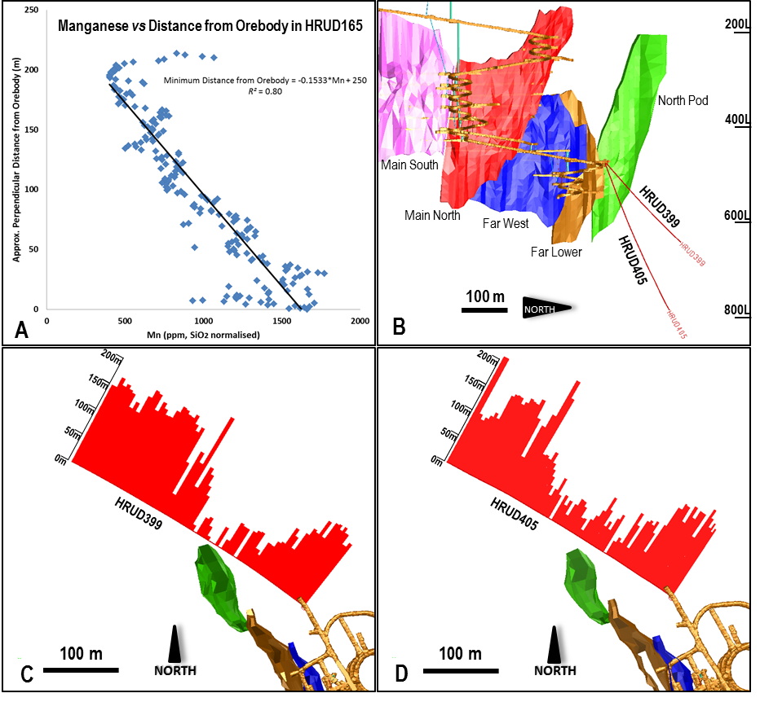
Figure 11. A) Relationship between silica-normalised Mn and perpendical distance from the Hera orebodies. B) Long section showing the locations of exploration holes HRUD399 and HRUD405 north of North Pod. C) Level plan showing HRUD399 with calculated minimum distance to orebody using the relationship in A. D) Plan showing calculated minimum distance to orebody in hole HRUD405.
Hole HRUD165 was also scanned using the HyLoggerTM spectral scanner at the WB Clarke Geoscience Centre in Londonderry, NSW. Previous studies on scanned surface diamond holes from the Hera project have established that systematic changes in mineral abundance and chemistry can be detected in the spectral data (Downes et al., 2016a,b).
Selected results from this survey are shown in Figure 12 and appear to be consistent with the systematic changes noted in the geochemistry. The shortwave infrared (SWIR) data shows a strong chlorite response to 120 metres down hole before dropping away quickly. The muscovite/phengite response drops away gradually to at least 270 metres down hole and is replaced by an aspectral response. The cause of the apsectral response is currently being investigated but may be due to an increased carbonaceous component in the rocks. While slightly harder to interpret, the Thermal Infrared (TIR) response indicates an increase in feldspar abundance down hole. The Illite Spectral Maturity (ISM) index, which uses the white mica SWIR response to infer metamorphic thermal gradient (Doublier, 2010), also shows a systematic decrease with increasing distance down hole and may provide another useful vector to mineralisation.

CONCLUSIONS AND FURTHER WORK
The new developments at Hera have shown that mineralisation has both structural and stratigraphic controls. The recognition of the skarn assemblages associated with the latter control may prove to be particularly useful in targeting near-mine and regional exploration for “Hera-style” mineralisation. Predictable changes in wall rock geochemistry and alteration at distance from the ore zones serves to significantly increase the exploration “footprint”. Further work is planned to understand the geochemical and alteration responses in additional holes around the Hera orebodies, with potential to develop a multi-element vectoring index.

ACKNOWLEDGEMENTS
The authors would like to thank Aurelia Metals for permission to publish data related to the Hera Project. The authors would also like to thank Ian Graham and Angela Lay at the School of Biological, Earth and Environmental Sciences, University of NSW, for provision of some of the mineralogical data and images published here. Joel Fitzherbert publishes with the permission of the Executive Director of the Geological Survey of New South Wales.

REFERENCES
DAVID V. 2006. Cobar Superbasin Metallogenesis. In: Mines and Wines - Mineral Exploration Geosciences in NSW. Extended Abstracts, pp 39-51.
DOUBLIER M. P., ROACHE T. & POTEL, S. 2010. Short-wavelength infrared spectroscopy: A new petrological tool in low-grade to very low-grade pelites. Geology 38(11), 1031-1034.
DOWNES P.M., TILLEY D.B., FITZHERBERT J.A., & CLISSOLD M.E. 2016a. Regional metamorphism and the alteration response of selected Silurian to Devonian mineral systems in the Nymagee area, Central Lachlan Orogen, New South Wales — a HyLogger™ case study. Australian Journal of Earth Sciences. 63 (8), 1027-1052.

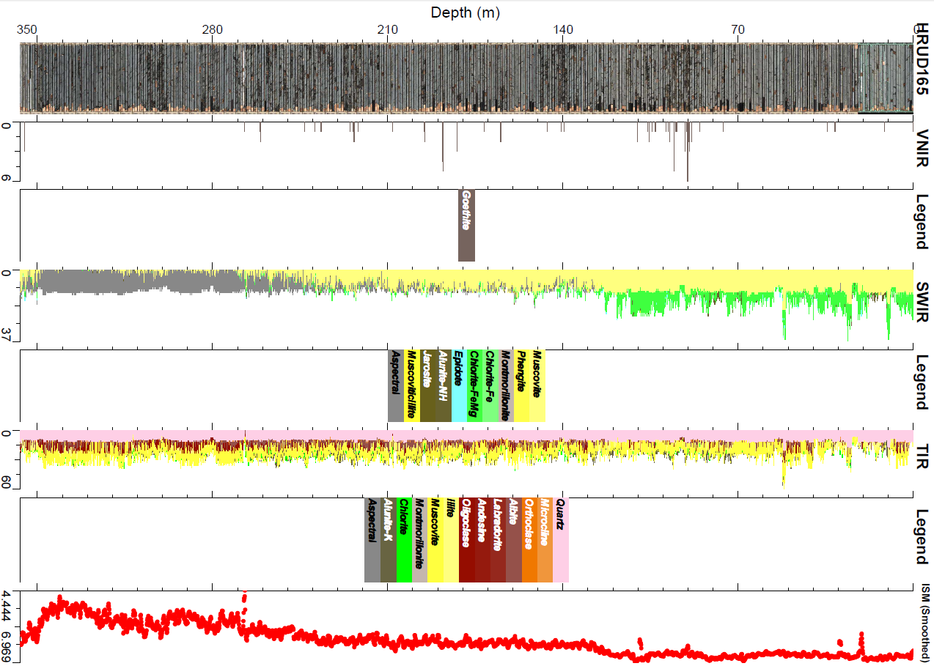
Figure 12. Selected SWIR, TIR and calculated ISM results from a HyLoggerTM survey of hole HRUD165.

DOWNES P. M., BLEVIN P., ARMSTRONG R., SIMPSON C.J., SHERWIN L., TILLEY D.B. & BURTON G.R. 2016b. Outcomes of the Nymagee mineral system study — an improved understanding of the timing of events and prospectivity of the Central Lachlan Orogen. Quarterly Notes of the Geological Survey of New South Wales 147.
FITZHERBERT J.A., BLEVIN P.L. & MCKINNON A. M. 2017a Turbidite-hosted intrusion-related mineralisation in the Cobar Basin: new insights from the south. Mines and Wines - Discoveries in the Tasmanides 2017. Extended Abstracts.
FITZHERBERT J. A., MAWSON R., MATHIESON D., SIMPSON A. J., SIMPSON C. J., and NELSON M. J. 2017b. Metamorphism in the Cobar Basin: Current state of understanding and implications for mineralisation. Quarterly Notes of the Geological Survey of New South Wales 148.
KYNE R. 2014. Genesis and structural architecture of the CSA Cu-Ag (Pb-Zn) Mine, Cobar, New South Wales. PhD thesis, University of Tasmania.
MCKINNON A. R. (in press) Application of normative ore mineralogy to geological and metallurgical datasets at the Hera Au-Pb-Zn-Ag Mine, New South Wales, Australia. In: Tenth International Mining Geology Proceedings. Australian Institute of Mining and Metallurgy, Melbourne.
ROBERTSON I.D.M. & TAYLOR, G.F. 1987. Depletion haloes in fresh rocks surrounding the Cobar ore bodies, NSW, Australia: implica-tions for exploration and ore genesis. Journal of Geochemical Exploration. 27, 77-101.
SKIRKA, M. & DAVID, V. 2005. Hera Au-Cu-Zn-Pb-Ag Prospect, Nymagee, New South Wales. In Butt, C.R.M., Robertson, I.D.M., Scott, K.M & Cornelius, M. (eds). Regolith Expression of Australian Ore Systems, pp 262-263. CRC LEME, Perth.

