Woodlawn zinc–copper–lead–silver–(gold) deposit

Steven A Jones2, Peter Downes1 and David A von Perger3

# introduction

# The Woodlawn zinc–copper–lead–silver–(gold) deposit, 210 km southwest of Sydney and 50 km east-northeast of Canberra (latitude -35.0644, longitude 149.5717), is a VMS-type deposit hosted by the late Silurian to Early Devonian basins in eastern Australia. The deposit was discovered in 1970; the mine commenced production in 1977 and closed in March 1998. Two satellite deposits — Cowley Hills, 1 km north and Currawang (also known as Currawang East), 10 km to the north-west were also mined. Following recent exploration success, the focus is on redeveloping an underground mining operation.

# EXPLORATION AND MINING HISTORY

# The discovery hole (W02) was completed in January 1970, following up soil geochemistry and IP anomalies, by Jododex Australia Proprietary Limited. Currawang was discovered in 1973. Open cut mining commenced in 1977, with underground mining starting in 1985. Denehurst Limited acquired the mine in 1987 and operated it until closure in March 1998. Past production from the Woodlawn area is summarised in Table 1. Tri Origin Australia NL acquired the tenement in 1999 and completed a feasibility study on retreating the tailings resource. Heron Resources Ltd acquired the project in 2014 and completed a feasibility study in 2016 on a combined underground and tailings retreatment project. Current resources for the project are summarised in Table 2.

# Previously published work on the deposit

# Much of the information on Woodlawn is contained in unpublished theses and company reports, a special issue of the Journal of the Geological Society of Australia (1979 vol 3–4) and a volume summarising the geophysical response of the deposit (Whiteley 1981). Early studies focussed on the main “C or 1 Lens” at Woodlawn. Furthermore, the CSIRO carried out a series of studies on Currawang (1982–1985) summaries of which are included in the CSIRO Division of Mineralogy and Geochemistry Research Review series. Downes (2012) and Downes and Forster (in press) summarise studies for the Woodlawn base metal district.

**TABLE 1 Woodlawn open-pit and underground historical production**

|  |  |  |  |  |  |  |
| --- | --- | --- | --- | --- | --- | --- |
| Ore type | Tonnes  (Mt) | Zn Grade (%) | Cu Grade (%) | Pb Grade (%) | Ag Grade (g/t) | Au Grade (g/t) |
| Open-pit | 8.0 | 8.3 | 1.6 | 3.1 | 62 | -2 |
| Underground1 | 5.3 | 9.9 | 1.6 | 3.1 | 95 | 0.5 |
| Total Woodlawn | 13.3 | 8.9 | 1.6 | 3.1 | 75 | - |
| Satellite deposits |  |  |  |  |  |  |
| Currawang1 | 0.53 | 12.4 | 1.6 | 2.1 | 34 | - |
| Cowley Hills3 | 0.035 | 4.7 | 1.8 | 2.9 | 118 | 1.9 |

Notes: 1) compilation from annual reports, 2) Au not recorded for open-pit and Currawang deposits, 3) Bouffler 1998 ore was blended with other ore and so production grades not available, reserve grades are shown here.

**TABLE 2 Mineral Resources and Ore Reserves estimate at 27th June 2016 (Ebbles 2016).**

|  |  |  |  |  |  |  |
| --- | --- | --- | --- | --- | --- | --- |
| Classification | Tonnage (Mt) | Zn Grade (%) | Cu Grade (%) | Pb Grade (%) | Ag Grade (%) | Au Grade (%) |
| MINERAL RESOURCES1 |  |  |  |  |  |  |
| Polymetallic — Inferred + Indicated + Measured | 4.6 | 9.3 | 1.5 | 3.5 | 69 | 0.71 |
| Copper — Inferred + Indicated + Measured | 2.0 | 0.8 | 2.8 | 0.2 | 15 | 0.19 |
| **Total Mineral Resource** | **6.6** | **6.7** | **1.9** | **2.5** | **52** | **0.56** |
| **ORE RESERVES2** |  |  |  |  |  |  |
| Polymetallic — Probable | 1.8 | 8.1 | 1.2 | 2.9 | 57 | 0.56 |
| Copper — Probable | 0.96 | 0.61 | 2.4 | 0.13 | 14 | 0.23 |
| **Total – Probable** | **2.8** | **5.5** | **1.6** | **1.9** | **42** | **0.45** |

Notes1) Mineral Resources are reported inclusive of Ore Reserves, and exclude remnant mineralisation considered to be unrecoverable from previous mine workings. 2) Ore Reserves are reported inclusive of forecast mining dilution and recovery factors. 3)Mineral Resources are reported at lower cut-off grade of 7% zinc equivalent. 4) Mineral Reserves are reported from the 2016 Feasibility Report (Ebbles 2016).

# GEOLOGical Setting

The Woodlawn base-metal district is located in the central part of the mid Silurian to Early Devonian Goulburn Basin — a deep water back arc basin, developed on a substrate of Ordovician to earliest Silurian siliciclastic turbidites and black shales. The late Silurian to earliest Devonian Mount Fairy Group includes the Woodlawn Volcanics and the Currawang Basalt, both of which host VMS-type mineralisation. The Woodlawn Volcanics are late Silurian (Ludlow) in age. The area was folded, faulted and metamorphosed to lower greenschist facies during the Middle Devonian Tabberabberan Orogeny (Deyssing & Fitzherbert in press). Woodlawn lies within the east limb of the north plunging Woodlawn syncline with a pervasive west dipping slaty cleavage developed throughout.

Within the Woodlawn mine area, the Woodlawn Volcanics comprise a lower sequence of medium to coarse-grained silica and sericite altered volcaniclastic quartz-phyric rhyolitic rocks with siltstone, mudstones and minor basalt overlain by strongly silica and sericite altered rhyodacitic to intermediate volcaniclastic mudstones, sandstones and debris flow units that host the massive sulfide lenses.

The host mudstones inter-finger to the south with a large (greater than 500m thick) strongly silica/sericite to sericite/chlorite altered hyaloclastite of rhyolitic composition. The hyaloclastite unit contains occasional stringers and patchy fine disseminations of base metal sulphides of sub economic grade throughout. The contact between rhyolite and the host mudstones is geometrically complex, often lobate at the meter scale. In drill core the contact is typically faulted or fractured, however rare peperitic textures have been noted in some drill core. This unit was referred to in the GSA 1975 papers as the central volcanic pile.

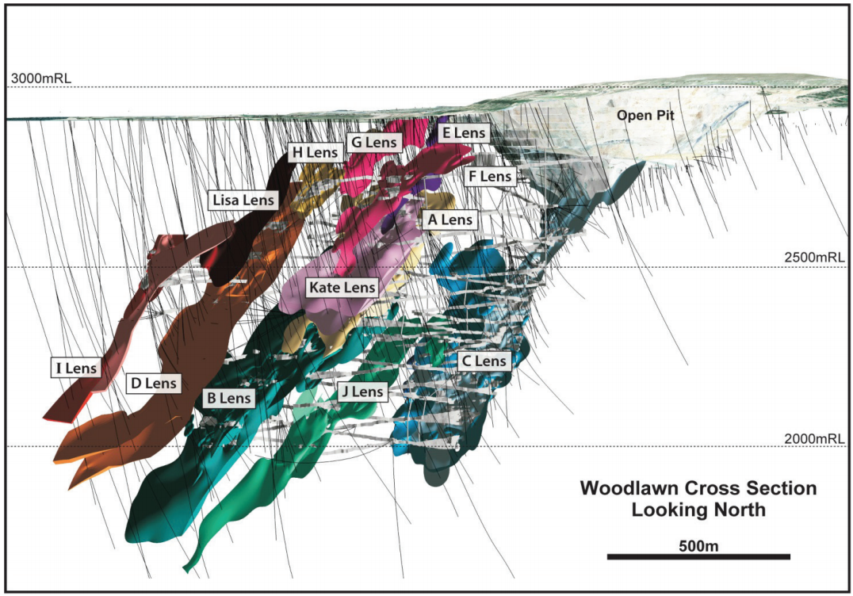

FIG 1 – 3D model of the Woodlawn deposit showing the extent of underground workings, exploration drilling to December 2015, historic (A-J) and newly identified (Kate, Lisa) massive sulfide zones.

Overlying the mineralised sequence is a less altered massive, coherent, flow banded, quartz–feldspar phyric rhyolite. The lower contact with the mudstones is peperitic and rarely faulted.

The Woodlawn Volcanics have been intruded by a number of less altered rhyolite sills and dykes, as well as tholeiitic dolerites (McKay & Hazeldene 1987) related to the Currawang Basalt. The dolerites postdate hydrothermal alteration and mineralisation at Woodlawn and are boudinaged (along with mineralisation) indicating that they were emplaced prior to deformation. Mapping suggests that at least some of the dolerite sills were emplaced into wet sediments, with clear evidence of peperite textures and contact alteration of mudstones.

# ore deposit features

**Woodlawn**

Three mineralised horizons hosting twelve known massive sulfide lenses occur within a 400 by 600m wide and 900m+ long northwest plunging envelope at Woodlawn (Figure 1). Each horizon has distinctive differences in mineralogy, geochemistry, metal ratios, alteration, isotope geochemistry and geophysical characteristics which reflect evolving ore-forming processes. Two major mineralisation types are recognised: a “copper-rich” assemblage and a “polymetallic” assemblage (McKay & Hazeldene 1987; Glen *et al*. 1995). The “polymetallic” assemblage includes fine- to medium grained, banded to massive pyrite–sphalerite–galena–chalcopyrite with the gangue mineralogy including talc, quartz, chlorite, phlogopite, muscovite and barite. The copper-rich assemblage includes pyrite–chalcopyrite, as well as distinctive black Mg rich chlorite, quartz and calcite as massive sulfide and stockwork veins.

The deposit geometry has been modified by both brittle and ductile deformation. The deformation is heterogeneous, with deformation strongest in phyllosilicate dominated units.

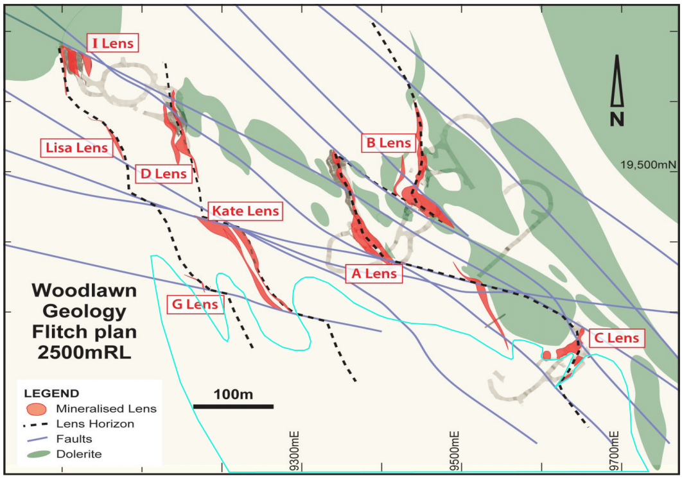

FIG2 – 2500mRL flitch plan showing underground workings, massive sulfide lenses, dolerite sills, major brittle faults and lens horizons.

The ductile deformation is preserved as a prominent foliation with minor rodding concentrated along the margins of dolerites, rhyolites and phyllosilicate altered zones. The dolerites and mineralised lenses display stretching to the northwest in the plane of foliation. Stretching is compartmentalised, and often identified adjacent to major faults and lithological contacts.

The entire rock package is cut by lens-parallel and sub-parallel anastomosing brittle faults (Figure 2). Some of the major faults appear geometrically related to chlorite alteration associated with copper rich mineralisation.

Silica dominated alteration zones, flow banded rhyolites, significant portions of the massive sulphide mineralisation and thicker dolerite sills often show excellent preservation of primary textures, with no foliation overprint or stretching lineation evident. Brittle faulting is present in these less deformed domains, in particular along major lithological contacts.

Strong hydrothermal alteration associated with mineralising fluids has resulted in textural destruction of primary features in both the immediate hanging wall and foot wall of many lenses.

**The lower horizon** is a single massive sulfide body faulted into four lenses (A, B, C and J). Massive sulfides include both “polymetallic” and “copper-rich” assemblages. The boundary between these two is discrete and usually mappable. The “copper-rich” zones are concentrated along the footwall and southern edges of individual lenses and grade into Mg-chlorite rich stringer mineralisation — interpreted to be fossil feeder zones.

Unaltered dolerite sills intrude the footwall and hanging wall of the A, B and upper portions of the C lens, distorting lens geometry and truncating the alteration envelope (see Figure 2). Intense, talc-chlorite alteration occurs in the footwall and along strike to the south of the massive sulfides, with chloritic alteration often associated with copper-stringer mineralisation. Massive barite is present within the massive sulfides, at the peripheries of individual lenses. The lenses are overlain by unaltered rhyodacitic mudstone.

**The middle horizon** lies some 170-190m in the hanging wall to the lower horizon and is offset to the northwest. This horizon is hosted by an interpreted mass flow unit and contains the D, E, F and Kate lenses. Massive sulfides often occur as multiple stacked lenses. Lenses are usually thinner and have a slightly smaller surface area than the lower horizon. This horizon has a symmetrical alteration halo, with chlorite alteration immediately adjacent to and between sulfide lenses surrounded by silica-sericite-pyrite halo with pseudoclastic textures that occurs up to 100m either side of the sulfide lenses. Massive barite is absent from the lenses, but barium is recorded in the alteration envelope. There is a strong symmetry in sulfide zonation, from outer lower temperature (sphalerite–galena-dominant) to inner higher temperature (chalcopyrite–pyrite-dominant) assemblages. Higher temperature assemblages also occur towards the southern edges of the lenses.

**The upper horizon** is 70 to 90 m in the hanging wall to the middle horizon and offset to the northwest. It parallels the middle horizon and hosts the G, H, I and Lisa lenses. Individual lenses are smaller, both in thickness and in strike extent, may be stacked, but usually only a single lens has sufficient grade/dimension to be of economic interest. Individual lenses are less pyritic than in the other horizons and have elevated precious metals.

The alteration around the lenses is asymmetrical with chlorite in the immediate footwall and extending to the south, but largely absent in the hanging wall. Some lenses have a pattern of chalcopyrite-rich stringers to the south and below that grade into polymetallic massive sulfides above and to the north. The chalcopyrite mineralisation is associated with black Mg rich chlorite alteration, and the polymetallic mineralisation is associated with silica and silica-sericite alteration. Polymetallic massive sulphides are hosted in mudstone units. At the southern end of the lens horizon polymetallic stringer sulphide mineralisation is hosted in a distinctive debris flow unit as replacement style mineralisation.

**Ore Genesis**

Many workers suggest that mineralisation at Woodlawn formed contemporaneously with volcanism, in a submarine setting, with sulfides being deposited on- or sub-seafloor (i.e. a VMS model); although, Glen *et al*. (1995) emphasises syntectonic and post-tectonic mineralising events.

At Woodlawn the three mineralised horizons formed under differing conditions. All of the mineralised horizons appear to lie along strike to the north of a large, strongly altered, weakly mineralised rhyolitic, hyaloclastite dominated unit, which interfingers the fine grained sediments hosting the massive sulphide lenses to the north.

It is proposed that the lower mineralised horizon formed at or very near the sea floor, during a period of dominantly pelagic sedimentation prior to being buried by fine grained tuffs and debris flows, likely sourced from the adjacent rhyolite to the south.

The upper horizons represent the continuation or reactivation of hydrothermal fluid flow with sulfide deposition occurring in permeable units sub-seafloor (middle horizon), and at the top of the mass flow units in the overlying fine grained pelagic/volcaniclastic sediments (upper horizon). Later rhyolite and basaltic coherent lavas without strong hydrothermal alteration overly the fine grained sediments at the Woodlawn deposit.

Based on the available data, it is suggested that the mineralisation formed synchronous with volcanism in the late Silurian. The deposit was intruded by dolerites and then deformed during both the Tabberabberan and Kanimblan orogenies.

# REFERENCES

Andrew, A S, and Binns, R A, 1984. Petrographic, geochemical and sulfur isotope studies on massive sulfide ores from Currawang East, New South Wales. *Geological Society of Australia, Abstracts* 12, 34–36.

Andrew, A S, Vaasjoki, M, and Binns, R A, 1985. Isotopic studies on massive sulfide ores and wallrocks at Currawang East, N.S.W. *CSIRO Division of Mineralogy and Geochemistry, Research Review* **1985**, 16–17.

Appleyard, E C, and Binns, R A, 1983. Wall-rock alteration and geochemical haloes at the Currawang East base metal deposit, New South Wales*. CSIRO Division of Mineralogy and Geochemistry, Research Review* 1983, 11–12.

Bouffler, M, 1998. Summary Report on Exploration of SML20 Woodlawn NSW for the period June 1987 to December 1998. Unpublished company report.

Ayres, D E, Burns, M S, and Smith, J W, 1979. Sulfur-isotope study of the massive sulfide orebody at Woodlawn, New South Wales. *Journal of the Geological Society of Australia* **26**, 197–201.

Carr, G R, Dean, J A, Suppel, D W, and Heithersay, P S, 1995. Precise lead isotope fingerprinting of hydrothermal activity associated with Ordovician to Carboniferous metallogenic events in the Lachlan Fold Belt of New South Wales. *Economic Geology* **90**, 1467–1505.

Deyssing, L, & Fitzherbert, J A, (compilers) in press. Braidwood 1:100 000 Geological Sheet 8827, 2nd edition, Explanatory notes. Geological Survey of New South Wales, Maitland.

Downes, P M, 2012. Metallic mineral systems. pp 148–225. *In* Thomas O & Pogson D.J. (compilers), *Goulburn 1:250,000 Geological Sheet SI/55-12, 2rd edition. Explanatory Notes*. Geological Survey of New South Wales, Maitland.

Downes, P M, and Forster, D B, in press. Mineralisation in the Braidwood project area. *In* Deyssing, L, & Fitzherbert, J A, (compilers) in press. Braidwood 1:100 000 Geological Sheet 8827, 2nd edition, Explanatory notes. Geological Survey of New South Wales, Maitland.

Ebbles A, Brown R, Allen P, 2016. Feasibility Study for the Woodlawn Project, New South Wales Australia pp 22-27.

Glen, R A, Walshe, J L, Bouffler, M, Ho, T, and Dean, J A, 1995. Syn and post-tectonic mineralisation in the Woodlawn deposit, New South Wales, Australia. *Economic Geology* **90**, 1857–1864.

McKay, W J, and Hazeldene, R K, 1987. Woodlawn Zn–Pb–Cu sulfide deposit, New South Wales, Australia: an interpretation of ore formation from field observations and metal zoning. *Economic Geology***82**, 141–164.

Whiteley, R J, (ed) 1981. Geophysical case study of the Woodlawn orebody New South Wales, Australia. Pergamon Press, Sydney 588 pp, ISBN 0-08-023996-X.