# Kempfield VHMS Deposit – Discovering rich new horizons

# C. T. McGilvray - Argent Minerals Limited

The Kempfield Ag-Pb-Zn-Au-Cu Deposit is located 45km SSW of Blayney and 8km west of Trunkey Creek in New South Wales. The Kempfield area first became known for barite mining which commenced in 1918 and continued periodically until the Geological Survey of NSW undertook mapping from 1971, and International Nickel Australia Ltd. began exploration drilling in 1972. The Shell Company of Australia conducted exploration drilling and both EM and IP surveys in the area from 1979 and Jones Mining Ltd. furthered drilling from 1982 and initiated a pre-feasibility study.

Golden Cross Resources conducted further drilling and a high resolution airborne magnetic survey from 1998 followed by metallurgical test work, geochemical sampling and regional mapping. Argent Minerals took ownership of the project in 2007 and has conducted extensive drilling, a VTEM survey, pole-dipole IP survey and a ground gravity survey until 2015.

In recent years, Argent Minerals has drilled numerous diamond drill holes and undertaken a geological, structural and geochemical review in order to identify key geological, structural, petrological and geochemical features of the deposit and improve the understanding of lithological controls and structural controls on mineralisation.

## **Regional Geology**

The Kempfield VHMS Deposit is located in the Hill End Trough in the eastern province of the Lachlan Orogen within the Neoproterozoic to Mesozoic Tasmanides. The Lachlan Orogen developed along the Pacific margin of the Australian craton during Palaeozoic time and is composed of deformed deep-marine turbiditic rocks, cherts, mafic/felsic volcanic rocks of Cambrian to Devonian age and younger continental cover sequences (Cas 1983; Gray & Foster 1997).

The regional geology is described in the Blayney 1:100K map sheet (Wyborn and Henderson, 1997), and the Bathurst 1:250K map sheet (Raymond and Pogson 1998). Revisions have been made by Timms and David (2011) and are included below (Figure 1).

## **Local Geology**

The local geology of the Kempfield area was last compiled by Timms and David (2011). Three main stratigraphic divisions were identified, consisting of the Ordovician Coombing Formation of the Kenilworth Group, and the Kangaloolah Volcanics and Campbell Formation of the Silurian East Mumbil Group. The Kangaloolah Volcanics host the Kempfield Deposit and have been further sub-divided into three main stratigraphic sequences (Timms and David 2011):

1. A sequence of fine-grained and quartz-phyric tuffaceous rocks faulted against;
2. Volcaniclastic sedimentary rocks with a minor allochthonous crinoidal limestone/dolomite grading into;
3. Unaltered siltstone

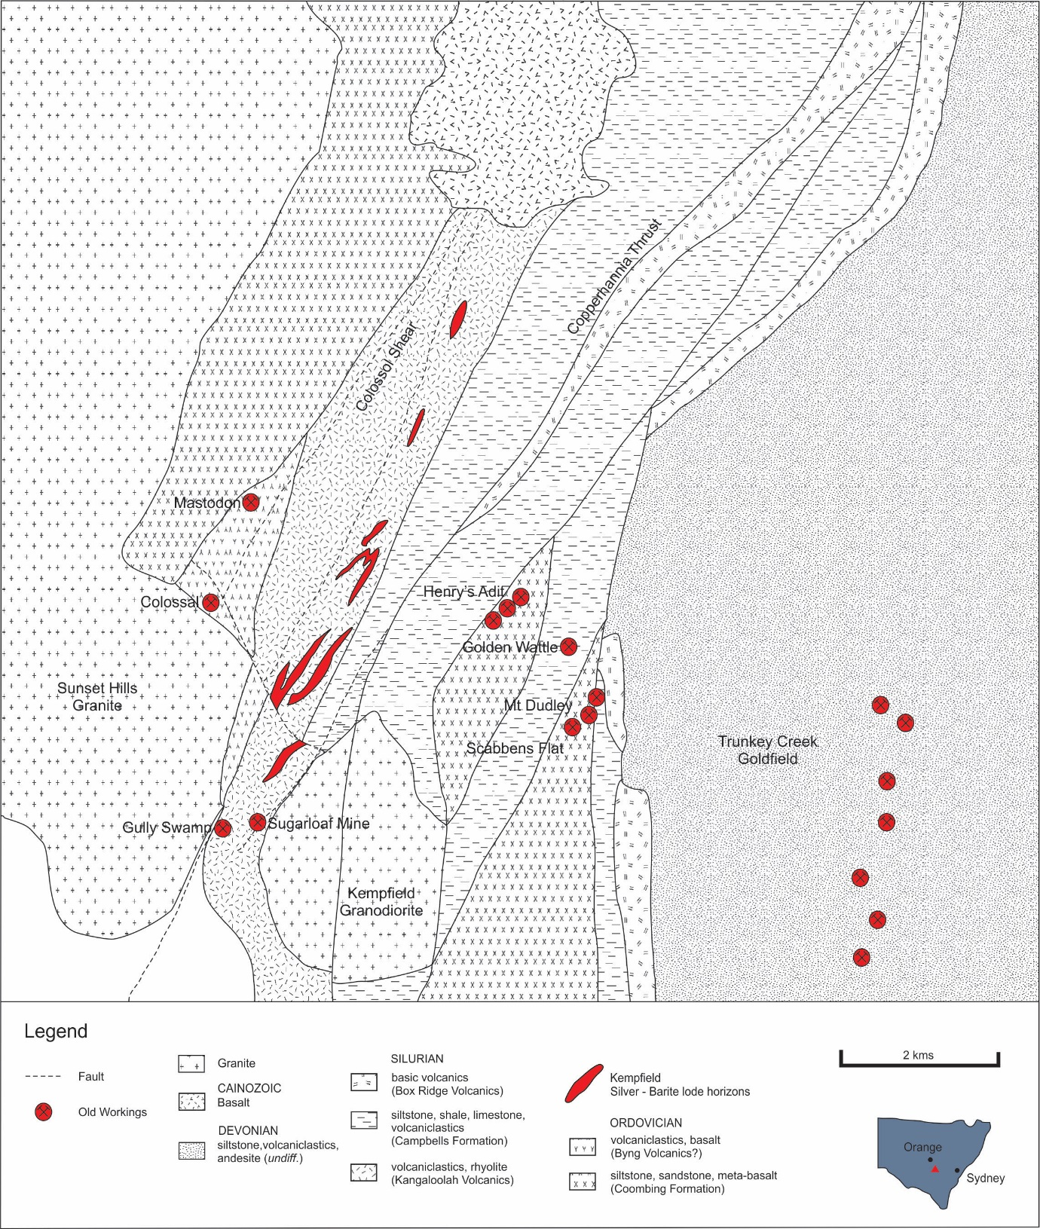

Figure 1: Regional Geological Map – Kempfield Deposit (modified after Timms and David 2011)

A stratigraphic review of historic and new drill core and a regional 1:10K mapping campaign of the northern Kempfield area was initiated in 2015 conducted by McGilvray and Herrmann (2015), complemented by petrographic assessments of drill core by Crawford (2015). The following revisions to the local geology are included below (Figure 2 and 3).

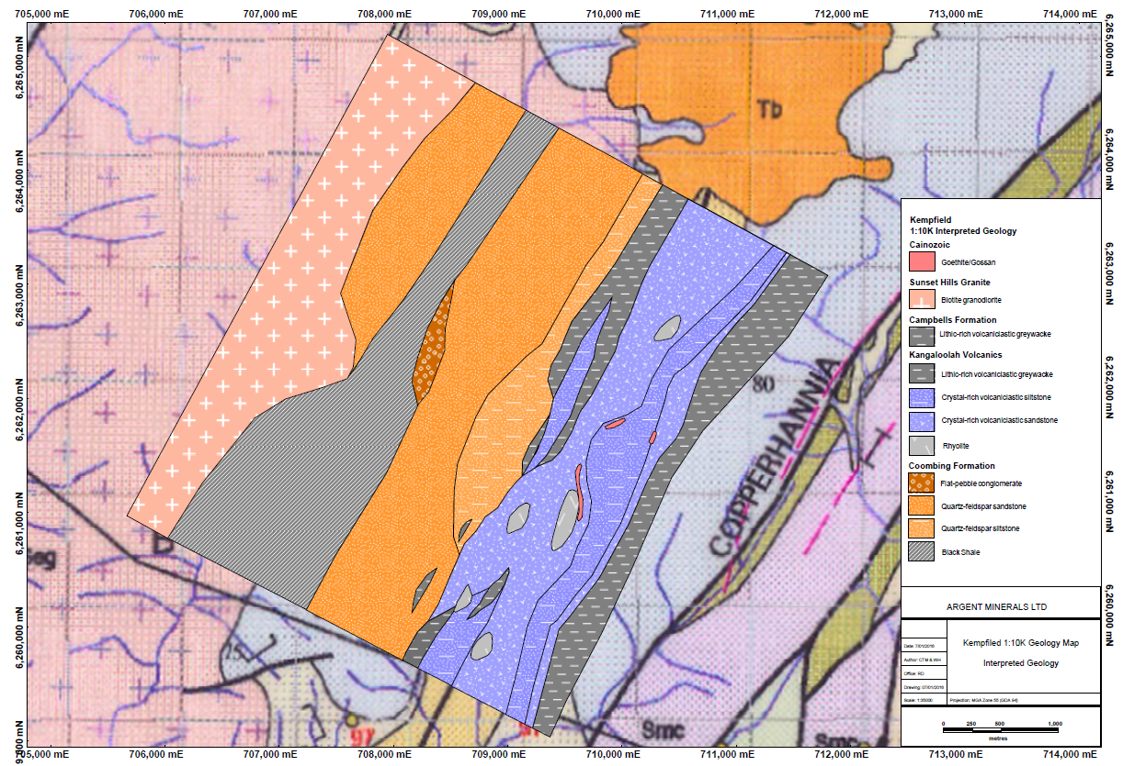

Figure 2 – Kempfield North 1:10K geological map

Oa – Adaminaby Group –

Although previous mapping suggested that a slice of Adaminaby Group turbidites was present adjacent to the Sunset Hills Granite, and in the hangingwall position of the Kempfield Deposit, this has not been confirmed by our mapping, and the rocks are considered to be Coombing Formation metasediments of the Ordovician Macquarie Arc.

Oko – Coombing Formation (Kenilworth Group) –

Rocks within the Coombing Formation have been described by Timms and David (2011) as tremolite schists, biotite hornfels, a porphyritic andesite and black carbonaceous slate. McGilvray and Herrmann (2015) mapped equivalent unaltered sequences to the north in a distal setting from the Sunset Hills Granite. The stratigraphy of the Coombing Formation consists of a basal medium-grained, massive, mature, impure, quartzo-feldspathic sandstone grading into a fine-grained, mature, clean, quartzo-feldspathic sandstone, a fissile, grey, argillic siltstone and grey-black fissile shale.

The upper Coombing Formation in this area consists of a basal matrix-supported, flat-pebble conglomerate with monomictic sandstone clast composition grading into a white, quartz-rich, mature, well-sorted sandstone and siltstone sequence. The basal boundary of this sequence to the lower Coombing Formation was not observed.

An unnamed shear that runs north-south through the mapped area transecting the lower Coombing Formation is characterised by proximal, intensely deformed, pelitic rocks with penetrative, steep southeasterly dipping cleavage and boudinaged, ptygmatic, and transposed poddy quartz veins (Herrmann 2015). Herrmann (2015) also noted a 30m wide unit of strongly chloritized mafic schist which is potentially a meta-basalt.

Crawford (2015) refined the descriptions of Timms and David (2011) via petrographic review to provide equivalent unit descriptions from those seen in the north during the mapping campaign. A thermally metamorphosed quartz-feldspar-biotite-muscovite hornfels intersected in AKDD179 at 125.9m was likely a feldspathic siltstone. A fine grained actinolite-epidote andesitic or basaltic breccia with former augite phenocrysts replaced by actinolite seen in AKDD179 at 134.7m is likely a basal volcanic unit of the Coombing Formation like that seen in mapping further north.

?Ocy – Byng Volcanics (Cabonne Group) –

Petrographic analyses conducted by Crawford (2015) on drillhole AKDD178 and AKDD179 drilled in Kempfield West note the basal section of the apparent Kangaloolah Volcanics, consisted of unambiguous meta-volcanic and meta-volcaniclastic rocks of mainly intermediate to mafic compositions. The observed hornfelses were derived from feldspathic siltstones, occasional volcaniclastic conglomerates with clasts of augite-phyric and aphyric basaltic to andesitic lavas with few examples of aphyric felsic lavas. Examples now almost entirely composed of actinolite and subordinate biotite are likely derived from plagioclase-free, largely glassy primitive mafic to ultramafic lavas almost identical to those that characterise the Byng Volcanics (Crawford 2011).

Whilst the lithologies have undergone varying degrees of metamorphism to intense alteration and silicification, it would still be likely that any quartz phenocrysts would be preserved. The Kangaloolah Volcanics in contrast is generally strongly quartz-phyric and mainly rhyolitic or rhyodacitic in composition. Crawford (2015) has proposed that this sequence is closer in composition and range in lithologies to the Middle Ordovician Byng Volcanics, or possibly the Blayney Volcanics.

This intermediate to mafic volcanic sequence was not encountered in Kempfield North although Blayney Volcanics have been mapped by Wyborn and Henderson (1997) 7 km further north again. Available evidence of the structural architecture at Kempfield is a half-graben, and the current evidence suggests the half-graben would have commenced development during the Middle Ordovician and progressed through to the Late Silurian. Age dating will be conducted on the lower volcanic sequence to test this hypothesis.

If proven, the tight isoclinal syncline in the Kempfield area is unlikely to exist and is more likely a stratigraphic progression with associated periodic breaks from Middle Ordovician to Late Silurian younging east.

Smk – Kangaloolah Volcanics

The passage from Coombing Formation metasediments to Kangaloolah Volcanics in Kempfield North is gradational and characterised by a progressive increase up section in ash and lithic components at the expense of probably craton-derived detrital quartz with a notable increase in fine matrix material. A prominent unconformity was expected however was not observed due to limited exposure Basal volcaniclastic greywacke occurs in lenticular parcels to 100m in length contained within a crystal-rich, quartz-phyric volcaniclastic sandstone sequence that fines upward into a volcaniclastic siltstone sequence. Five separate rhyolite domes were mapped in the area with associated proximal intense sericite alteration, sulphide mineralisation and barite sand occurrences.

The distal section of the Kangaloolah Volcanics can be viewed in exposures 2km along strike north of Kempfield although the exposure is dominantly subcrop and reaches a maximum apparent thickness of 800m, compared to 1.4km apparent thickness in the main Kempfield area.

Recent core drilling has enabled the construction of a robust stratigraphic column in the mine sequence vicinity, although the basal section is yet to be merged with the possible Byng Volcanics to the west. Seven members have been defined and four mineralisation horizons have been identified (Figure 3):

Smk7 – Volcaniclastic Greywacke – Fine grained, thinly bedded, well-sorted, lithic rich volcaniclastic greywacke with domainal chlorite alteration interbedded with ash-rich volcaniclastic siltstone with domainal sericite alteration.

Smk6 – Volcaniclastic Conglomerate/ Barite Sand – Normally graded, moderately to poorly sorted, clast- to matrix-supported, pebble conglomerate with intensely silicified, rounded to sub-rounded clasts hosted within a sandy, baritic and calcareous matrix grading into volcaniclastic sandstone and siltstone units.

Smk5 – Volcaniclastic Greywacke – Fine grained, thinly bedded, well-sorted, lithic rich volcaniclastic greywacke with domainal chlorite alteration interbedded with ash-rich volcaniclastic siltstone with domainal sericite alteration

Smk4 – Volcaniclastic Conglomerate/ Barite Sand – Normally graded, moderately to poorly sorted, clast- to matrix-supported, pebble conglomerate with intensely silicified, rounded to sub-rounded clasts hosted within a sandy, baritic and calcareous matrix grading into volcaniclastic sandstone and siltstone units.

Smk3 – Epiclastic Breccia – Normally graded, poorly to well sorted, mass flow epiclastic breccia composed of framework to dominantly matrix supported sub-angular to sub-rounded clasts of volcaniclastic mudstone to sandstone, quartzite and rhyolite hosted within a sandy to silty matrix.

Smk2 – Volcanic tuff – Fine-grained, entirely recrystallised mafic amphibolite composed of ragged intergrowths of actinolite and subordinate chlorite and quartz with minor titanite. Kempfield South sections provide lesser altered examples consisting of fine-grained, amphibole- and magnetite-phyric ash and lithic rich, pervasive chlorite altered mafic tuff and basalt flows.

Smk1 – Volcanic Breccia – Poorly sorted, matrix-supported volcaniclastic sedimentary rocks ranging from sandstone to pebble-breccia with a silty to sandy matrix and angular to sub-angular polymictic clasts. The detrital grain population was originally dominated by lithic clasts of formerly glassy felsic lava with common quartz and feldspar phenocryst detritus. The silty matrix is interpreted as comminuted glassy, vitroclastic material, however intense hydrothermal alteration has obliterated shard or bubble-wall textures. Strongly foliated, formerly glassy, quartz- and feldspar-phyric rhyolite or rhyodacitic lavas/domes are encompassed within this member.

Smkl – Kangaloolah Volcanics

Drillhole AKDD187 was completed in 2016 and shows a gradational progression from volcaniclastic greywacke and mineralised conglomerate (Smk7) into volcaniclastic sandstone with subordinate mudstone and siltstone interbeds with localised surge deposits, into bio-micrites, dolo-micrites and bio-sparites with isolated dacite clasts and intrusions. Timms and David (2011) describe this carbonate sequence as the upper part of the volcanic sequence which contains minor allochthonous crinoidal limestone/dolomite. The age of the limestone sequence is yet to be determined, however it is apparent that the sequence is not allochthonous, but gradational from the upper volcanic sequence. A significant north-south trending two metre wide reverse fault occurs at 161.0m in AKDD187 and appears to have truncated C Horizon at depth and uplifted D Horizon to appear in the C Horizon position. The positioning of the limestone sequence indicates it is either the upper part of the Kangaloolah Volcanics or may be part of the Kildrummie member of the Campbells Formation.

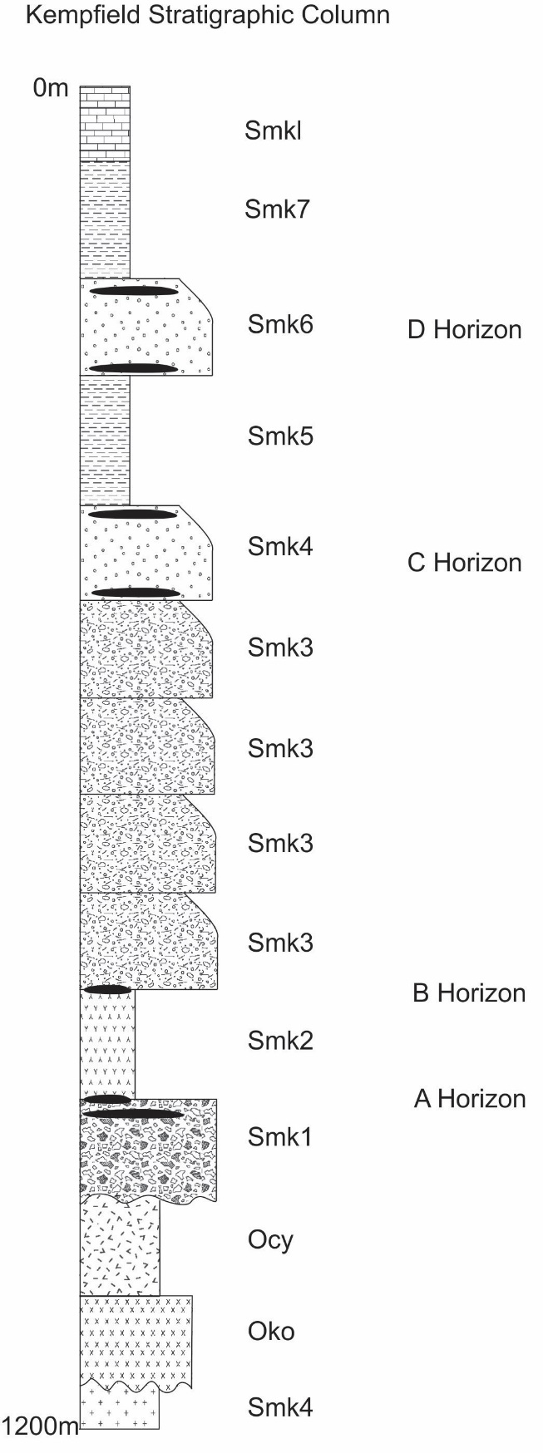

Figure 3: Kempfield Stratigraphic Column 2017

Smc – Campbells Formation

The uppermost lithology of the Kangaloolah Volcanics in Kempfield North consists of lithic-rich volcaniclastic greywacke and shale which grades into massive, argillaceous slaty siltstones of the Campbells Formation (Herrmann 2015). Wyborn and Henderson (1997) assigned this sequence in the southern part to the Coombing Formation, and in the northern part to the Adaminaby Group, however mapping by McGilvray and Herrmann (2015) could detect no visual difference.

Timms and David (2011) described this sequence as siltstone, shale and volcaniclastics of the Campbells Formation which is in faulted contact with the Kangaloolah Volcanics to the west. Elsewhere in the paper is a reference to the upper part of the Kangaloolah Volcanic sequence grading up into unaltered barren siltstone which seems at odds with the faulted contact depicted in their plans, and is more consistent with Wyborn and Henderson’s (1997) interpretation that the Kangaloolah Volcanics immediately precede, and probably interfinger with Late Silurian Campbells Formation in the Trunkey area. Herrmann (2015) suggested that the eastern slaty siltstone package is probably semi-conformable with the volcanics based on mapping. Core drilling conducted during 2016 (McGilvray 2016) has shown a progression in AKDD184 and AKDD185 from lithic-rich greywacke through to siltstone with a gradual decrease in lithic content. This sequence is visually similar to outcrop seen at Kempfield North and indicates that a gradational boundary exists between the Kangaloolah Volcanics and the Campbells Formation in the mine area that extends 4 km north of Kempfield.

Seg – Sunset Hills Granite

Herrmann (2015) described outcropping granite at Kempfield North as pink-grey, fine to medium grained, equigranular, feldspar-quartz-biotite granite with 2-3mm crystal groundmass. Crawford (2015a) provided petrographic descriptions of examples from AKDD179 at 121.9m as a medium-grained, granitic rock with all feldspars entirely replaced by sericite charged with tiny epidote prisms. Brown biotite varies from fresh to chloritized and all quartz is strained with common sub-grain recrystallised quartz.

## **Mineralisation**

The Kempfield Ore Deposit has been sub-divided into 7 separate zones and two geometallurgical domains, an oxide domain and primary sulphide domain (Timms and David 2011). A revision of existing mineralisation was conducted during 2015/2016 along with core drilling to focus on positioning of mineralisation at key stratigraphic intervals to identify further exploration potential along strike and at depth. It became apparent that two main controls on mineralisation existed, lenses in Kempfield West are positioned on specific stratigraphic boundaries, and lenses in Kempfield East are stratabound in nature.

The existing zones have become redundant due to confusion arising from representation of several lenses and conflicting designations across adjacent zones. The zones have been simplified into main areas, and the lenses have been designated as horizons (Figure 4).

The identification of seven main lithological members at Kempfield then allowed for identification of stratigraphic positioning, and identification of lenses at horizons that were consistent along the entire strike length of the deposit (Figure 3). This aided exploration considerably and resulted in discovery of new lenses during the 2016 core drilling program.

D Horizon – Stratbound throughout Smk6

C Horizon – Stratabound throughout Smk4

B Horizon – Located at the upper boundary between Smk2 and Smk3

A Horizon – Located in the upper portion of Smk1 proximal to the upper boundary with Smk2

The nature of mineralisation at Kempfield has been described by Timms and David (2011) with petrographic support from Ashley (2009). The oxide zone is typically composed of chlorargyrite, native silver and argentite with varying development of goethite and jarosite depending on the degree of weathering. Anomalous silver and lead enrichment is associated with jarosite. The main gangue mineralogy is barite with lesser quartz, sericite and a variety of clay minerals resulting from decomposition of feldspars.

The primary sulphide zone is composed of mineral assemblages including pyrite, sphalerite, galena, chalcopyrite, argentite, tetrahedrite, native silver and pyrargyrite. Pyrite is the dominant sulphide mineral and the most widespread. Ore zones are typically composed of iron-poor sphalerite, silver sulphosalts, galena and chalcopyrite with galena commonly associated with silver phases pearcite-polybasite and proustite-pyrargyrite and tetrahedrite. Gangue mineralogy is primarily barite and lesser quartz and sericite.

Recent LA-ICPMS work conducted on pyrite by CODES (Steadman 2016) has shown that the Kempfield system is multi-phase. Pyrite associated with stringer ore is marked by high Co and Ni, and free gold, indicating precipitation from a high T hydrothermal fluid. Disseminated, fine grained pyrite in volcaniclastic units contains cores with low overall trace element contents and rims of high Tl-Sb-Hg-As which typifies a high T initial phase of mineralisation followed by a low T mineralising phase. Coarse grained pyrite in highly deformed shale units are characterised by Au-As-Ag-Te-bearing cores and are likely the result of orogenic processes after formation of the main Kempfield Deposit, as observed in nearby shale-hosted orogenic gold deposits.

## **Alteration**

The alteration assemblages at Kempfield have been described by Timms and David (2011). The volcanic-volcaniclastic rock was initially fragmented and subsequently hydrothermally altered with replacement by dominant microcline and minor sericite/muscovite, quartz, barite, rutile, sphalerite and pyrite (Ashley 2009). Grain fragments were enclosed with interstitial material replaced with aggregates of sericite/muscovite, with a medium-grained infill of quartz and barite and minor microcline and sulphides. Thin veins are common throughout the deposit area and are generally composed of quartz and quartz-carbonate, and minor barite, sulphides and rare albite. Subsequent deformation resulted in the development of a moderate to strong sericite/muscovite foliation that wraps around altered fragments resulting in an anastomosing fabric.

Planar zones of schistose psammite up to 20m wide occur in north-south bands cross-cutting the deposit and are characterised by greenschist facies mineral assemblages dominated by biotite. These zones are believed to be associated with regional movement along the Copperhannia Thrust to the east

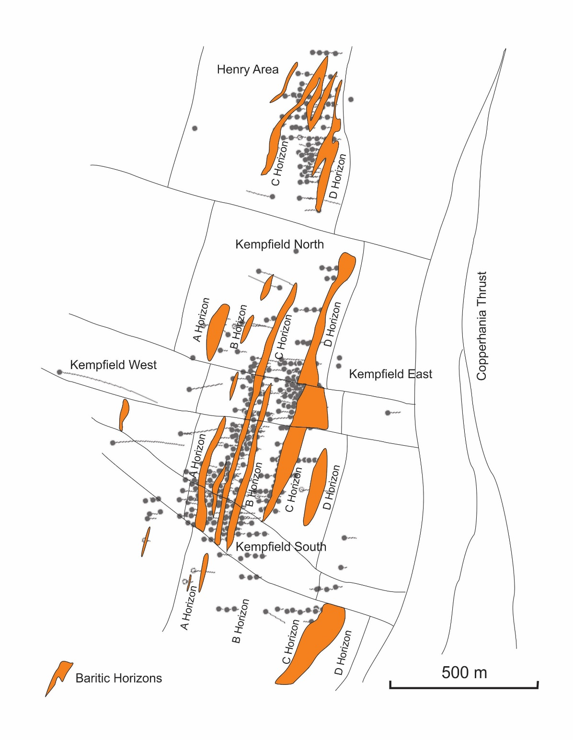

Figure 4: Kempfield Deposit – Ore Horizons with baritic horizons (*modified from Timms and David 2011*)

.

## **Resource Estimate**

The current reported mineral resource at Kempfield is included in Table 1:

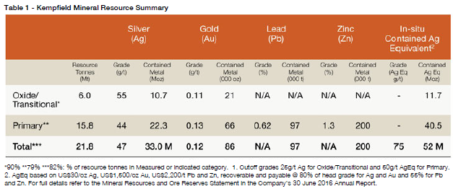

## **Further Exploration**

The Kempfield deposit has seen intensive activity over the last two years in an effort to define the geology and characterise the mineralisation. This has been relatively successful and resulted in discovery of several new mineralised areas which are yet to be incorporated into the mineral resource. The deposit is believed to represent a typical low temperature VHMS deposit analogous to a barite sand type deposit similar to the Wetar Deposit in Indonesia, which was a white smoker field with concentrated black smokers occurring on main growth fault lines. A common feature at Wetar is a stockwork chalcopyrite zone and concentrated gold occurrences around intensely silicified rhyolite domes. This feature has been observed at Kempfield (AKDD197), and footwall chalcopyrite mineralisation is yet to be tested.

Mapping will be conducted in Kempfield South after discovery that the mafic tuff unit (Smk2) previously thought to be part of the Coombing Formation is a conformable unit within the Kangaloolah Volcanics, and therefore felsic volcanics are believed to extend much further south. The Gully Swamp Cu Mine, and Sugarloaf Barite Mine 800m south along strike are potentially a distal expression of the Kempfield Deposit.

Resource infill drilling activities will be initiated this year to provide a revised resource estimate in the coming year.

## **References**

Ashley, P. M., 2009. Petrographic report on eleven drill core samples from the Kempfield barite-polymetallic deposit, central western NSW. *Internal Unpublished Report.*

Cas, R. A. F., 1983. Timing of deformation, plutonism and cooling in the western Lachlan fold belt, southeastern Australia. PhD thesis. La Trobe Univ. Melbourne, Australia.

Crawford, A. J., 2015a. Petrographic Report – 46 Rocks from Drillholes AKDD178 and AKDD179 on the Kempfield Ag-Barite Deposit, NSW, for Argent Minerals Ltd (Sydney) 24/06/2015. *Internal Unpublished Report.*

Crawford, A. J., 2015b. Petrographic Report – 17 Rocks from Drillholes AKDD177, AKDD178 and AKDD159, Kempfield Ag-Barite Deposit, NSW, for Argent Minerals Ltd (Sydney) 26/09/2015. *Internal Unpublished Report.*

Gray, D. R., and Foster, D. A., 1997. Orogenic concepts – application and definition: Lachlan fold belt, eastern Australia. *Am. J. Sci.* 297:859-91.

Herrmann, W., 2015. Notes on reconnaissance geological mapping north of Kempfield Quarry Zone – 28/10/2015. *Internal Unpublished Report*

McGilvray, C. T., and Herrmann, W., 2015. North Kempfield 1:10k Geological Mapping 2015. *Internal Unpublished Report.*

McGilvray, C. T., 2016. Joint Annual Report to 27/06/2016 – Exploration Licences 5748-7134 and PLL 517-519-727-728 – Kempfield / Trunkey, NSW.

Raymond, O.L., and Pogson, D.J., et al. 1998. Bathurst Geology Second Edition, 1:250 000 geological map SI55-08), Australian Geolgical Survey Organisation, Canberra / Geological Survey of New South Wales, Sydney.

Timms, D., and David, V., 2011. Kempfield Silver, Barite and Base Metal (Pb-Zn) Deposit, Lachlan Orogen, Eastern Australia. Eighth International Mining Geology Conference – Queenstown, New Zealand, 22-24 August 2011.

Wyborn, D., Henderson, G.A.M., 1997. Blayney First Edition (1:100 000 geological map 8730) Geological Survey of New South Wales, Sydney / Australian Geological Survey Organisation, Canberra.