# THE WAGGA TANK DEPOSIT - FULL TO THE BRIM WITH POTENTIAL

R.E. Brown and N.M. Vickery

## Abstract

The Wagga Tank deposit is a complex, multi-stage Zn-Pb-Ag-Cu- Au deposit within the Mount Hope Trough of the Cobar Basin. Following its discovery in the mid 1970s, the deposit underwent extensive exploration until 1989, at which time an indicated (non-JORC) resource of 1.25Mt at 0.66g/t Au, 68.84g/t Ag, 0.81% Cu, 1.76% Pb and 3.29% Zn was estimated. Following this, no significant exploration was undertaken until Peel Mining acquired the tenement in 2016. Peel’s work has comprised drilling, 3D model development, surface EM, IP, gravity and an aeromagnetic survey. This has enhanced the deposit toward producing a new resource estimate. The deposit is hosted by the Silurian Mount Kennan Volcanics. These locally consist of low energy, mudstone-dominant turbidites (the informal Wagga Tank mudstone) which are underlain by a package of mass flow, intermixed sandstones, breccias, conglomerates and volcaniclastics (informal Vivigani Formation). These are underlain by sandier turbidites, the informal Eastern Formation. Mineralisation is largely hosted by the Vivigani Formation as up to four discontinuous, massive and semi-massive sulphide lenses, and vein-hosted sulphides developed close to, and along, the Wagga Tank-Vivigani stratigraphic boundary. The strongest mineralisation occupies a discontinuous, vertically-plunging shoot-like domain in the centre of the deposit. A broad zone of fine-grained, low-grade, disseminated mineralisation envelopes the richest mineralisation, straddling the stratigraphic boundary. Sulphides are dominated by pyrite, with abundant sphalerite and galena, minor chalcopyrite and rare cubanite and pyrrhotite. There are evidently two episodes of mineralisation at Wagga Tank, a low temperature Zn-Pb system and possible later, higher temperature Cu-rich system. A lens-like zone of Zn-Pb-Ag oxide mineralisation passes upward from the main sulphide lenses, grading into rich supergene Cu-Pb-Ag-Au. A separate Cu-Au supergene lens is developed at shallow depths to the east. The deposit has been cut by a number of steeply-dipping faults and probable low angle, west-dipping thrusts. Faulting has overturned the strata at depth by rotating and offsetting bedding and mineralisation eastward. The deposit remains open at depth and to the north and south.

## Introduction

The Wagga Tank deposit is located approximately 130km south of Cobar (Figure 1) in western New South Wales. It comprises sediment-hosted, zinc-lead-silver-copper- gold mineralisation with substantial, shallow oxide and supergene components. A non-JORC compliant indicated resource estimate of 1.25 million tonnes @ 0.66g/t gold, 68.84g/t silver, 0.81% copper, 1.76% lead and 3.29% zinc was calculated by Homestake Australia Ltd., (Rabone and Krcmarov, 1989).

Focussed exploration interest in the Wagga Tank area commenced with a Newmont - Kennco Explorations – Texasgulf joint venture during the early 1970s. This resulted in the discovery of an outcropping gossan at Wagga Tank, where outcrop otherwise comprises a small area of strongly silicified sandstones. Limited geological mapping, rock chip sampling, an aeromagnetic survey, followed by diamond and RC drilling encountered encouraging lead and zinc mineralisation (Kennco Explorations (Aust) Pty Ltd, 1977a,b).

More substantial work followed in a joint venture between Amoco Minerals Australia (subsequently Cyprus Gold) and Homestake Australia Ltd during 1983-1989 (Amoco Minerals Australia Co, 1982; Rabone & Krcmarov 1989; Poltock & Ferris 1990). A broad lead, gold and arsenic anomaly identified by extensive shallow RAB drilling was tested by 17 diamond and 16 RC holes. This identified near-surface gold-silver mineralisation grading into zinc-lead-silver sulphide mineralisation at depth. Down hole EM was undertaken on many drill holes. BLEG soil sampling and a structural review were completed. Geological and mineralisation models were compiled from the approximately 3000m of drill hole data and a resource estimate produced (see above).

Ryan (1987) completed an honours study of the Wagga Tank deposit using drill hole data. His research included petrographic description of host rocks and mineralisation, fluid inclusion studies, sulphur isotope analysis, geothermometry, and metamorphism.

No significant work was undertaken at Wagga Tank following the Cyprus-Homestake tenure. A succession of explorers, including Arimco NL/ CRA Exploration Pty Ltd – 1991-92; Golden Cross Operations Pty Ltd/Pasminco Exploration – 1997; and subsequently Golden Cross Operations Pty Ltd/MMG Australia Ltd- 2004-2016; have focussed on other local prospects.

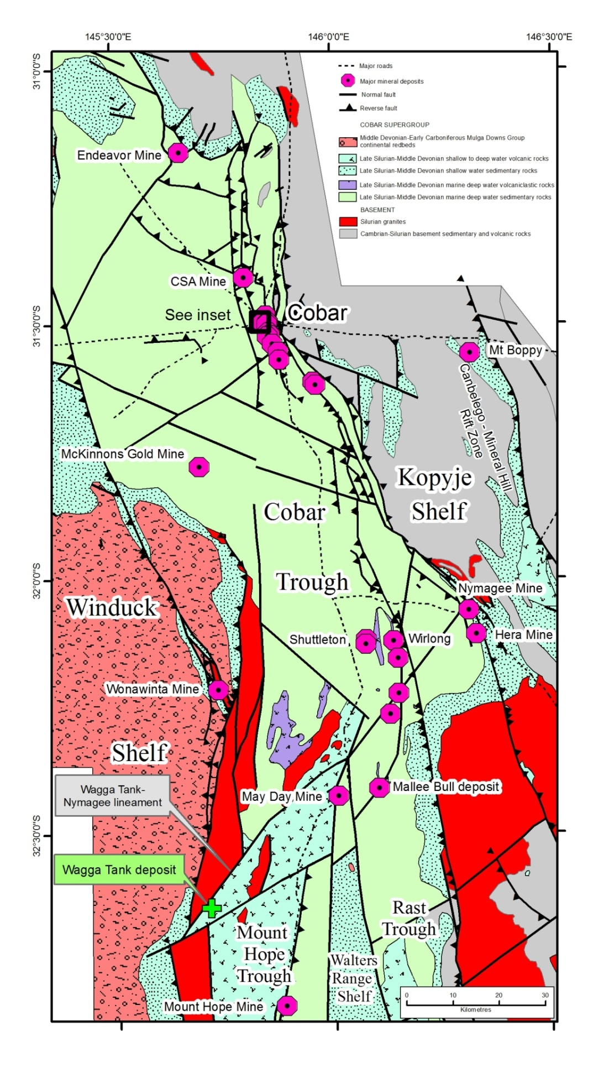Peel Mining Ltd acquired the prospect in 2016. Initial drilling by Peel included 18 RC holes (for 4,315m), 5 of which were extended with diamond tails (for 473m). The program confirming the presence of high grade base and precious metal mineralisation between the lines of the historic drilling grid. This has been followed up with surface EM, IP, gravity and a high resolution aeromagnetic survey. Subsequent 3D geological and deposit modelling and re-examination of historic core was completed to produce an exploration model and to evaluate the previous resource estimate.

## Geological Setting

The Wagga Tank deposit is hosted by rocks of the Mount Hope Trough within the southern Cobar Basin (Figure 1), an intracratonic rift basin which was active during the Late Silurian to Middle Devonian. Deposition within this trough took place during the rift-phase as the Mount Hope Group. This is represented by early subaerial volcanism followed by widespread turbidites and mass flow deposits of volcaniclastic detritus, breccias and conglomerates, and possible local submarine felsic volcanism.

The Mount Hope Group in the Wagga Tank area is represented by the Mount Kennan Volcanics. These were described by Scheibner (1987) and the NSW Geological Survey (Chisholm et al 2014; Simpson, 2014, Downes et. al., 2016) as felsic, A-type volcanics interbedded with sediments (Scheibner, 1987). In the Wagga Tank region, non-tuffaceous sediments are more prevalent than volcanics, comprising a basal sequence of coarse grit and sandstone with pebbly horizons, overlain

*Figure 1. Simplified architecture and major mineral deposits of the Cobar Basin with the location of the Wagga Tank prospect. Compiled from Geological Survey data.*

by muddy lithic sandstone, muddy siltstone, and mudstone. The basal sequence is succeeded by rhyolitic, rhyodacitic and dacitic lavas, volcaniclastics and sediments, with turbidites present higher up the sequence. In places the formation is intruded by the Boolahbone Granite forming thermal aureoles characterised by hornfelsing and cordierite development with accompanying local felsic porphyry dykes.

Scheibner (1987) divided the Mount Hope Trough into a number of fault-bounded structural blocks (Figure 1). The Wagga Tank deposit lies to the east of an interpreted and unnamed fault which probably corresponds with the regional-scale Wagga Tank - Nymagee lineament. Numerous mineral occurrences are developed within short distances of this structure.

Within the Mount Hope Trough the Cobar Supergroup has been deformed into open, concentric, meridionally-oriented regional and mesoscopic folds with shallow-plunging, undulating fold axes across a regional synclinorium.

## Local Geology

The Wagga Tank deposit area is characterised by poor outcrop bordering an alluvial flat along the west of a low topographic rise (Figure 2). Most exposures at the prospect site comprise intensely silicified quartz-rich sandstones and siltstones hosting common quartz veinlets and abundant goethitic veinlets and joint-fills. A small outcropping goethitic gossan exhibiting strongly anomalous base metal assays (>3% Pb) is exposed on the western edge of the outcrop area.

The geology of the deposit has been determined largely from drill hole data. The informal stratigraphy proposed for the deposit area is illustrated in Table 1.

*Figure 2. Outcrop and shallow subcrop in the Wagga Tank area showing drill hole traces and the 3 major sulphide lenses projected to surface. Major subvertical faults and the dominant anticlinal axis are illustrated with the outline of the Wagga Tank Mudstone-Vivigani Formation contact at 200m depth.*

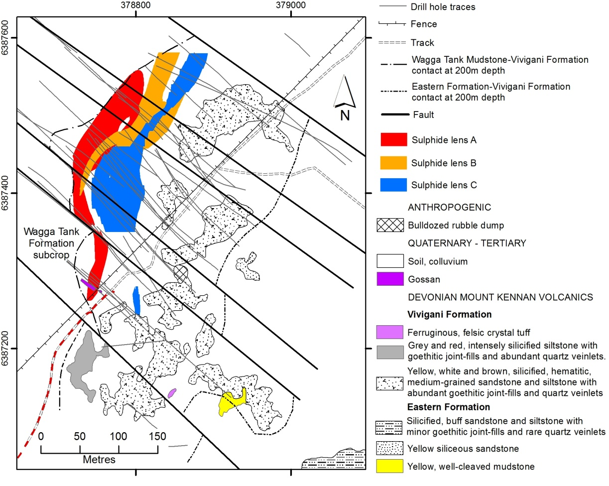

|  |  |  |
| --- | --- | --- |
| **Age** | **Stratigraphic unit** | **Description** |
| Quaternary | Unnamed | Soil, colluviums, alluvium |
| Tertiary | Unnamed | Semi-lithified conglomerate, sandstone, claystone, ferricrete, gossan |
| Late Silurian | Mount Kennan Volcanics – Wagga Tank mudstone | Low energy, mudstone-dominant turbidites, with thin, fine-grained graded sandstone-siltstone. Rare volcaniclastic detritus. Non-outcropping |
| Mount Kennan Volcanics – Vivigani Formation | Medium to coarse-grained, massive, quartzo-feldspathic and quartz-lithic sandstones, massive sedimentary breccia, conglomerate, interbedded mudstone-dominant graded bedded units, massive felsic volcaniclastics, local felsic lavas. |
| Mount Kennan Volcanics – Eastern Formation | Low energy sandstone and siltstone dominant turbidites with rare volcaniclastic lenses. Very minor outcrop |

The Wagga Tank mudstone dominantly comprises low energy turbidites, consisting of massive to weakly laminated mudstone hosting thin, fine-grained graded sandstone-siltstone beds. Graded bedding confirms that the sequence is upright, although a domain of local overturning is present at depth, probably due to drag folding along thrust faults. Minor poorly stratified volcaniclastic debris is present locally within the mudstone. Local zones of intense silicification are present throughout. Disseminated polymetallic mineralisation is hosted by the mudstone to about 200m from its contact with the Vivigani Formation. Local semi-massive pyrite aggregates occur to within 60m of the stratigraphic contact.

*Table 1. Local, informal stratigraphic succession at the Wagga Tank deposit.*

The Vivigani Formation is dominated by quartz-rich, massive, medium- to coarse-grained sandstones, with various amounts of volcanogenic feldspar and lithic clasts. The sandstones occur with various amounts of polymictic sedimentary breccia comprising felsic volcanic and sedimentary clasts and rare silica-replaced crinoidal fragments. Most breccia clasts are angular, but well rounded clasts with a high degree of sphericity are locally common. Unbedded polymictic conglomerates with a similar clast population as the breccias occur locally. Strongly altered felsic volcanics comprising massive, amygdaloidal and autobrecciated rhyodacite are present sparsely throughout the package. The volcanics range in thickness from less than 1m to about 5m. Local intervals of mudstone-dominated graded bedded units occur in places. The Vivigani Formation shows significant lateral and vertical facies variation, with limited lateral persistence of individual distinctive lithologies between drill holes. Disseminated polymetallic mineralisation is pervasive, and massive sulphide bodies and siliceous quartz vein-hosted and stringery mineralisation are common near the contact with the Wagga Tank mudstone. Silicification is pervasive, and many mudstone and siltstone clasts and beds have been altered to “elvan”, the chert-like lithology common to most Cobar-style deposits.

The Vivigani Formation exhibits many similarities to the mass flow, volcaniclastic-dominated, bioclastic limestone-bearing allochthonous package in the Mallee Bull deposit (Brown et al. 2013, 2015) 50km to the north. A similar, mass flow origin is proposed for most of the Vivigani Formation, with lavas representing olistoliths. Intervening mudstone-dominated turbidites represent a return to the quiescent, deep water marine environment which prevailed following the periods of seismicity which produced the mass flow deposits. Multiple sediment sources are indicated by the presence and intermixing of unsorted and unabraded detritus (proximal volcaniclastic debris?), high sphericity clasts (high energy fluvial environment) and crinoidal remains (shallow marine).

The Eastern Formation comprises fine-grained graded sandstone to mudstone, with sandstone generally predominating. Rare tuffaceous lenses are present locally. Minor disseminated sulphides are present in places.

## Mineralisation

The characteristics of mineralisation at Wagga Tank have been described in previous exploration reports (e.g. Rabone & Krcmarov, 1989; Poltock & Ferris 1990) and in research by Ryan (1987). The various styles of mineralisation present are summarised in Table 2.

|  |  |  |
| --- | --- | --- |
| **Mineralisation style** | **Minerals** | **Characteristics** |
| Massive to semi-massive sulphides | Pyrite, lesser sphalerite, galena, minor chalcopyrite | Fine-grained, massive to weakly laminated, stratiform. Laminae defined by diffuse alteration of mineral aggregates. Typically vughy, silica-siderite alteration of host rocks. |
| Disseminated sulphides | Pyrite, lesser sphalerite, galena, minor chalcopyrite | Very fine-grained, pervasive throughout deposit. Hosted by both stratigraphic units. |
| Stringer zone sulphides | Sphalerite, galena, pyrite | Narrow sulphide±quartz-siderite veinlets throughout mineralised zone |
| Vein-hosted sulphides | 1. Sphalerite, galena, pyrite rare cubanite and pyrrhotite  2. Pyrite-chalcopyrite | 1. Banded, colloform, complexly zoned  2. Medium to coarse-grained sulphides forming semi-massive to massive aggregates within quartz- and quartz-siderite veins. |
| Oxide zone | Haematite, goethite, jarosite with secondary Zn, Pb, and Ag species, and enriched Au | A vertical extension of the richest sulphide zone extending from about 75m depth to surface |
| Supergene zone | Malachite, azurite, digenite, chalcocite, cerussite, Au, secondary Ag | From 35 to 125m below surface in moderately east-dipping lens |

*Table 2. The characteristics of mineralisation styles in the Wagga Tank deposit*.

The most intense mineralisation at Wagga Tank can be grouped within a number of laterally persistent to discontinuous lenses. These are developed within the Vivigani Formation, close to its contact with the Wagga Tank mudstone. Oxide and supergene mineralisation occurs within both stratigraphic units.

Three major sulphide lenses were identified by Homestake (Rabone & Krcmarov, 1989) and have been substantiated by our modelling (Figures 2, 3). Drilling to date has identified a strike extent of about 360m, and shows continuity to about 400m below surface. Mineralisation diminishes to the north and south, where it becomes thinner and increasingly pyritic. Down-dip mineralisation remains open in the central, and richest part of the deposit, supporting observations by previous workers that the central portion of the deposit represents one or more steeply dipping shoots. Significant intercepts within the central zone include:

|  |  |
| --- | --- |
| 5.3m @ 2.09 g/t Au, 1164 g/t Ag, 9.36% Cu, 0.78% Pb from 119.8m in HD-9 | Historic drill holes |
| 15.4m @ 133 g/t Ag, 0.4% Cu, 4.5% Pb, 12.5% Zn from 140.1m in HD-11 |
| 7.5m @ 99.4 g/t Ag, 7.25% Pb, 18.0% Zn from 215.6m in HD-12 |
| 2.5m @ 0.24 g/t Au, 100 g/t Ag, 0.25% Cu, 8.59% Pb, 11.6% Zn from 216.2m in HD-14 |
| 15m @ 8.49% Zn, 4.11% Pb, 114 g/t Ag, 1.57 g/t Au, 0.31% Cu from 280m in WTRCDD004 | Peel drill holes |
| 13m @ 5.02% Zn, 3.51% Pb, 46 g/t Ag, 0.29 g/t Au from 240m in WTRC003 |
| 13m @ 3.73% Zn, 2.14% Pb, 29 g/t Ag, 0.30% Cu, 0.21 g/t Au from 225m (incl. 7m @ 5.75% Zn, 3.32% Pb, 43 g/t Ag, 0.40% Cu, 0.24 g/t Au from 230m) |

*Table 3. Significant drill hole intercepts at Wagga Tank.*

The sulphide lenses are enveloped within a broad zone of disseminated, very fine-grained sulphides. A combined 0.1% Zn-Pb-Cu geochemically anomalous shell of disseminated mineralisation extends up to 200m above the Vivigani-Wagga Tank stratigraphic boundary, and for 600m below this surface, totally encompassing the high grade lenses.

Two mineralised systems are apparent at Wagga Tank. They are spatially and temporally discrete and hosted in different lithologies within the Vivigani Formation. Due to the spatial dislocation, their relationship to one another is unclear. Copper mineralisation is associated with massive bucky quartz

(siderite) veins that may include entrainments of chloritised mudstone. Ore mineralogy is simple, dominated by medium to coarse-grained pyrite and chalcopyrite. The latter commonly post-dates the former. Zinc and lead mineralisation is associated with complex, narrow, high density colloform-banded quartz/chalcedony veins in strongly altered, weakly brecciated, coarser clastic rocks, dominantly pebble conglomerate and sandstone. Veins contain alternate bands of quartz and sphalerite with subordinate galena. Sphalerite commonly occurs with siderite and galena in the cores of these complex veins. Disseminated sphalerite and narrow sulphide stringers are abundant in the matrix of host rocks proximal to the veins. An overall increase in temperature of the system is interpreted, with early low temperature lead-zinc mineralisation followed by higher temperature copper. This is indicated by pale brown sphalerite cores commonly rimmed by a darker, higher temperature variant, consistent with observations by Ryan (1987). Additionally, chalcopyrite rarely rims and appears to post-date sphalerite grains.

## Alteration

The Vivigani Formation host rocks are pervasively weakly to intensely silicified and chloritised. Hydrothermal alteration associated with zinc-lead mineralisation is dominated by sporadically developed black chlorite, silicification and patches of intense pyrite and siderite replacement. Spotty and locally pervasive siderite is common in host rocks within the mineralised zones. It also occurs in veinlets and in quartz ± sulphide veins. Sericitic alteration is variable but common within the mineralised zone. Iron-rich chlorite is more abundant in the copper-bearing mineralisation. A variant of the alteration associated with zinc-lead mineralisation features intense vughy silica, siderite and kaolinite replacement. This is consistent with the interpreted lower temperatures of formation of the zinc-lead system.

Hydrothermal alteration associated with copper mineralisation is characterised by green chlorite, siderite, pyrite and variable silicification.

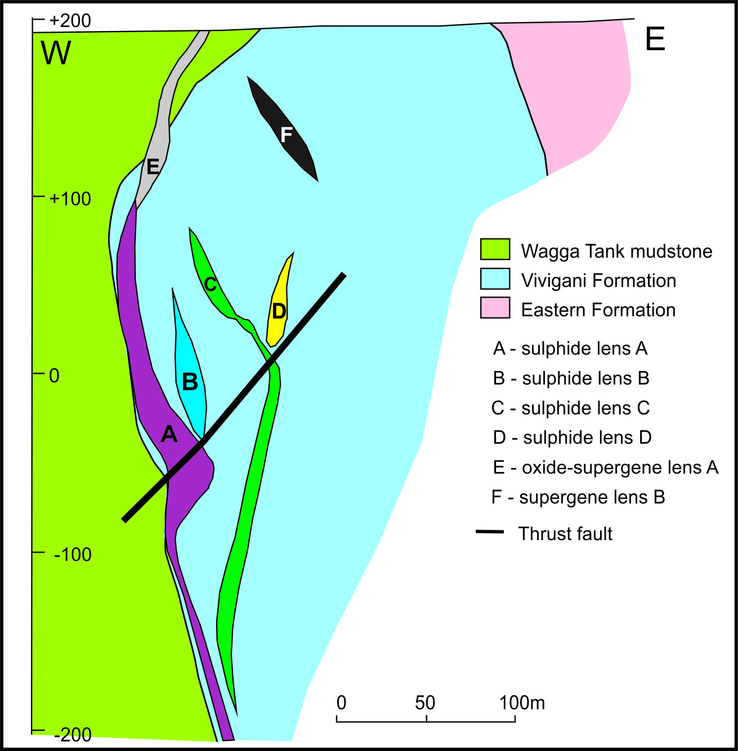Hylogger data produced from diamond drill hole HWTD-09 confirms significant kaolinite associated with the strongest mineralised massive sulphide zone at 125m. Muscovite (as sericite) is present throughout, and both Fe- and Fe-Mg chlorite and siderite are present below 200m associated with Zn-Pb dominant disseminated sulphide lenses.

## Structure

The deposit occurs along the irregular stratigraphic boundary between the Wagga Tank mudstone and Vivigani Formation (Figure 3). Domains of overturned strata occur at depths below 100m where the contact generally dips easterly (Figure 3). Local bedding rotation has taken place here about drag folds associated with vertical (Figure 2) and thrust faults throughout the deposit.

A number of steeply dipping, northwest-trending faults or fault pairs have been interpreted based on stratigraphic offsets and the presence of fracture zones and brecciation (Figure 2). The northern-most fault pair show mainly graben-like vertical displacement of tens of metres with no significant displacement of the mineralised lenses. The southern fault pair are associated with sinistral lateral offset with significant displacement of mineralisation.

*Figure 3. Schematic east-west cross section through the Wagga Tank deposit viewed north.*

Shallowly west-dipping breccia zones with associated quartz-sulphide veining and lateral displacement were reported by Poltock & Ferris (1990). This apparent thrust fault has offset stratigraphy and mineralisation lenses up to 20m (Figure 3).

Previous workers have described a zone of tectonic brecciation associated with a flexure along the Wagga Tank-Vivigani stratigraphic boundary (e.g. Rabone 1987; Ryan 1987). This would be in accord with the gross rheological contrasts between the two formations resulting in differential deformation along the stratigraphic contact during folding. Alternatively, the presence of significant faults proximal to the mineralised zones may be responsible for producing fault breccias in this area.

## Geochemistry

Two distinct metal associations are apparent at Wagga Tank:

1. Base metal Pb, Zn (Ag, Sb, Cu, Bi)-rich mineralisation characterised by discrete high grade lodes, and

2. Broader, lower grade, Cu (Ag)-rich horizons which partially overprint earlier Pb-Zn mineralisation.

Four high grade (>2% combined Pb, Zn and Cu) hypogene lenses are identified from modelling of recent and historic drilling data. These lenses are separated by regions of lower grade, but highly anomalous metal values. Lenses have distinct metal relationships indicating possible multiple ore fluid generations; Ag for example, is enriched with both Pb/ Zn and Cu-rich horizons.

Metal zonation is recognised within the deposit. A broad Cu-rich region is apparent on the stratigraphically lower eastern side of the system grading to Pb and Zn-rich to the west and at depth. A shallow high grade oxide lens from surface is characterised by higher gold and lower zinc grades compared to the hypogene lenses. The latter is possibly the result of zinc mobility (depletion) in the oxide zone.

## Geophysics

Recent 100m line spacing aeromagnetic data acquired by Peel confirms that the strongly altered Vivigani Formation exhibits a low magnetic response. This contrasts markedly with the Wagga Tank mudstone which displays a low-order, but significantly higher response. The mineralised lenses are distributed along the boundary between these two magnetic domains. The domains are regionally extensive, particularly southward.

Newly acquired IP and gravity data have confirmed anomalies associated with, and local to Wagga Tank. Significant coincident IP and gravity anomalies are present for up to 3.5km south of Wagga Tank along the same magnetic domains as those associated with Wagga Tank. One anomaly corresponds with an historic bedrock Pb anomaly (Anomaly G of Rabone & Krcmarov 1989) which was partly explored by limited drilling and ground magnetics. As expected, IP data show a strong correlation with the broadly disseminated mineralisation at Wagga Tank, but do not highlight the massive sulphide-rich zones of sulphide lens A.

Down hole EM has been used at Wagga Tank by earlier explorers to assist with targeting the massive sulphide zones. This technique is also used by Peel for trialled surface EM.

## Isotopic and Fluid Inclusion Determinations

Ryan (1997) undertook fluid inclusion and sulphur isotope studies on Wagga Tank mineralisation. He concluded that there were two distinct temperature populations of mineralising fluids of about 200⁰ C and 325⁰ C. Chlorite geothermometry indicated a temperature of 228⁰ to 302⁰ C for massive sulphide mineralisation. Sulphur isotope compositions indicate that most sulphur originated from seawater.

## Deposit Origin

Most previous workers (e.g. Kerne & Buckland, 1985; Rabone, 1987) have proposed a volcanogenic origin for the deposit, based on the presence of volcanics amongst the host rocks, local laminar textures within some massive sulphides, the general stratabound geometry of the deposit and "cherts" which were assumed to be exhalites. Poltock & Ferris (1990) considered that the sulphide-bearing quartz veins proximal to the Wagga Tank-Vivigani boundary were attributed to localised remobilisation of nearby massive sulphides.

Ryan (1987) interpreted the mineralisation as Cobar-style, syn-deformational, citing the conclusions of Glen (1987) and Binns et al. (1986) for deposits in the Cobar area, and using the similar characteristics of deposits from that area as analogies. Sulphur isotope data suggest that the mineralising fluids were derived from circulating seawater. Ryan concluded that the deposit formed during folding in a zone of brecciation formed by a competency contrast between the two stratigraphic units.

We concur partly with Ryan’s model for deposit genesis. However, drill logging, geochemistry and petrography indicate a more complex, multiphase genesis for the deposit. The massive and semi-massive sulphides exhibit textures and relationships indicative of sediment-replacement, and show an affinity for coarse sandstone layers, which is supportive of an epigenetic origin. The deposit also shares similarities in host rocks, alteration, structural setting, syn-deformational sulphide precipitation textures and sulphur isotope data with the Mallee Bull deposit which has been confirmed as Cobar-style. However, abundance of low temperature features such as colloform banding, low temperature sphalerite (compared with many other Cobar-style deposits) and low temperature alteration including kaolinite, suggest an epithermal-type episode of zinc-lead mineralisation. The copper mineralisation is more typical of Cobar-style deposits, is spatially removed from the zinc-lead system and tentatively post-dates it.

## Wagga Tank Prospectivity

Recently acquired IP data at Wagga Tank has identified a strong, continuous chargeability anomaly extending up to 2km south of the major identified mineralisation. 3D inversion modelling suggests that this anomaly possibly represents mineralisation developed on the eastern flank of the Vivigani Formation in an area of structural complexity. No previous drill holes have penetrated this area. New drilling by Peel at Wagga Tank is currently investigating the potential of this IP target. Exploration southward along the low magnetic corridor which hosts Wagga Tank has identified geological, geophysical and geochemical anomalies which will be the subject of future exploration.

## Acknowledgements

The authors are indebted to Rob Tyson, Mick Oates, Angus Hornabrook and Jason Bryan for their constructive input into this document.

## References

Amoco Minerals Australia Co., 1982. Prospecting reports, PL 600, Wagga Tank area. *Geological Survey of New South Wales, File GS1980/423, R00015590 unpublished*.

Binns R.A., and Appleyard, E. C. 1986. Wallrock alteration at the Western System of the CSA Mine, Cobar, New South Wales, Australia. *Applied Geochemistry*, **1**, 211 - 225.

Brown R.E, Chapman N., and Oates M., 2013. The Mallee Bull discovery and exploration in the central Cobar Basin. *In*: Lewis P.C. Ed., AIG Bulletin 55, *Mines and Wines 2013*, pp5-12.

Brown R.E, Ashley P.M, Vickery N.M, Tyson, R., and Oates M., 2015. Significant recent developments and research at the Mallee Bull deposit, Cobar Basin, NSW. *In*: Lewis P.C. Ed. 2015. Mines and Wines 2015.

Chisholm E.I., Blevin P.L., Downes P.M. & Simpson C.J. 2014. New SHRIMP U–Pb zircon ages from the central Lachlan Orogen and Thomson Orogen, New South Wales: July 2011–June 2012. *Geoscience Australia: Canberra Record 2014/32, Geological Survey of New South Wales, Report GS 2013/1837.*

Downes P.M., Blevin P.L., Armstrong R., Simpson C.J., Sherwin L., Tilley D.B, and Burton G.R., 2016. Outcomes of the Nymagee mineral system study — an improved understanding of the timing of events and prospectivity of the central Lachlan Orogen. *Geological Survey of New South Wales, Quarterly Notes 147, 38pp.*

Glen R.A., 1987. Copper- and gold - rich deposit s in deformed turbidites at Cobar , Australia. Their structural and hydrothermal origin. *Economic Geology,* **82,** 124 - 140.

Kennco Explorations (Aust) Pty Ltd 1977a. Exploration report, EL 768, Wagga Tank - Mt Allen area. *Geological Survey of New South Wales, File GS1976/143, R00022124 unpublished*

Kennco Explorations (Aust) Pty Ltd 1977b. Exploration report, EL 768, Wagga Tank - Mt Allen area. *Geological Survey of New South Wales, File GS1976/143, R00022125 unpublished*

Kern R.R., and Buckland R. 1985. Progress report January 1985 to July 1985, EL 2031, New South Wales. *Geological Survey of New South Wales, File GS1984/219, R00014380 unpublished*

Poltock R, and Ferris B., 1990. Progress report for the 12 months to January 4, 1990, EL2031, Mt Hope New South Wales. *Geological Survey of New South Wales, File GS1990/155, R00003810 unpublished.*

Rabone G., 1987. Progress report on EL 2031 (Mount Hope) for sixth month period ending January 6, 1987. *Geological Survey of New South Wales, File GS1987/029, R00006610 unpublished.*

Rabone G and Krcmarov R., 1989. Progress report on Exploration Licence 2031 (Mount Hope) for Six Month Period ending January 4, 1989. *Geological Survey of New South Wales, File GS1989/135, R00006075 unpublished.*

Ryan S.J., 1987. The geology and genesis of the polymetallic Wagga Tank prospect, Mount Hope, N.S.W. *The University of Adelaide, B.Sc. Hons. Thesis, unpublished.*

Scheibner E. 1987. Geology of the Mount Allen 1:100,000 Sheet 8032, 220 pp. *Geological Survey of New South Wales, Sydney*.

Simpson C. 2014. Nymagee Project: Petrographic re-assessment of the Mount Halfway Volcanics and other formations in the Mount Hope Group. *Geological Survey of New South Wales, Report, unpublished*.