**Great Cobar – A Re-Introduction, 148 years from the initial discovery.**

John Heavey

New Gold Inc. - Peak Gold Mines, Cobar, NSW, Australia.

**Summary**

“Great Cobar”, a copper-gold deposit located in Cobar, NSW, holds a significant place in Australian mining history, primarily worked from 1871-1919,when underground mining operations largely concluded following the end of the First World War. It was the original copper discovery in the Cobar district and until recently the consensus from the community and mineral explorers alike was that the deposit was “all mined out”. Little did anyone know, that for 94 years, a new orebody was waiting to be discovered right on the edge of town, 200m south from the historic workings. Exploration during the past four years has resulted in the discovery of additional copper-gold and lead-zinc resources that offer significant promise for Cobar to hold its place as an important mining centre well into the future. The Great Cobar deposit is owned by Peak Gold Mines P/L (PGM), a wholly owned subsidiary of New Gold Inc.

A new lens adjacent to the historic workings was discovered for New Gold in 2013. Defining the lenses at Great Cobar and testing the economic potential of the system has been an ongoing focus for the exploration team since 2014.

Drilling Great Cobar from surface poses many challenges. Holes are deep, drill pad locations are limited, cleavage changes cause unpredictable hole deviation, and there is magnetic interference effecting down hole conventional camera shots well outside the ore zone from the magnetite mineralization. Target zones are approximately 800-1000m down hole and a slight deviation of azimuth or dip can lead to holes ending up far off target.

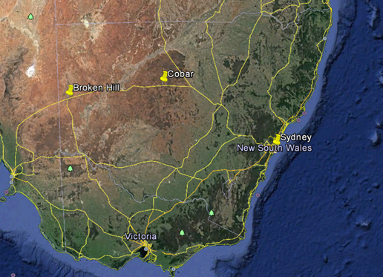These challenges were overcome by an in-house understanding and use of navigational drilling and other directional drilling techniques developed by the drillers, which many would see as unorthodox. Combining these, with a measure of chance, produced a rare exploration success that has good prospects for the future of mining in the area and for the township of Cobar itself.

**Introduction**

The PGM properties are situated near Cobar which is located at 31°34′S 145°53′E (6,515,000N, 390,000E in UTM Zone 55J), approximately 600km northwest of Sydney, New South Wales, Australia as shown in Figure 1. The Cobar gold field is defined as the 10km long belt of operating and historic mines that extend northwards from the Perseverance – Peak gold mine area to the Tharsis workings, immediately 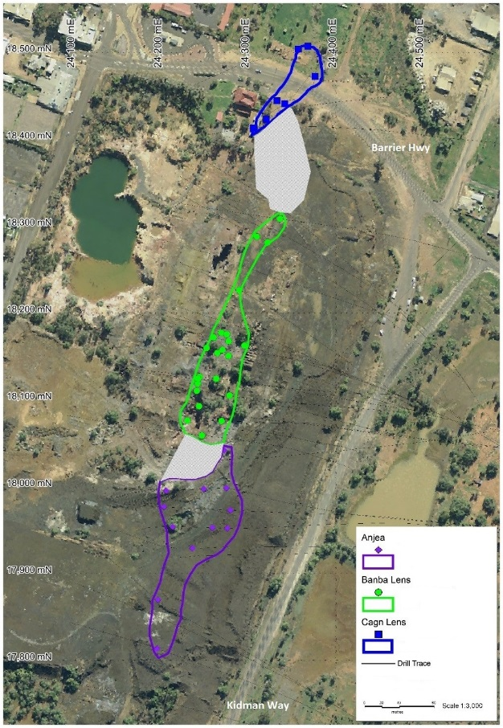north of the township of Cobar. The Great Cobar mine site is situated toward the northern end of the Cobar Gold Field, on the eastern edge of the township, at the intersection of the Barrier Highway and the Kidman Way.

Figure 1: Location of Cobar within NSW (2016, Google Earth).

Overall, the Great Cobar system represents a considerable mineralization environment, one of the most important of the Cobar Gold Field. The umbrella prospect called Great Cobar is composed of several distinct lenses, each of which would be individually significant in exploration terms, in a well-defined, highly prospective shear zone.

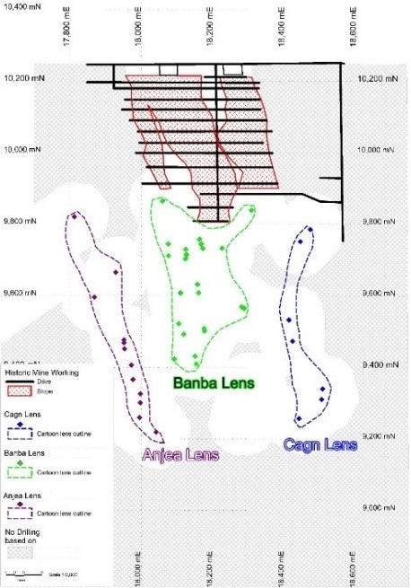The Great Cobar system is a polymetallic prospect, with occurrences of both copper-gold and lead-zinc mineralisation. Three lenses have been identified since 2015, namely: Anjea, Banba and Cagn, Figures 2 & 3. This should not be confused with previous work where historically there was reference to three lenses - Northern, Central, and Southern - within the historic mine workings, which are flattened pipe or carrot-like developments in long sections of the old workings. The project has a strike length of approximately 800m and depth of >1,200m, open to depth. Additionally, there is potential for more blind lodes along strike beyond the current project area. There is approximately 300m of strike extent to the north of the highway where traces of shearing and iron rich alteration can be found, which remains largely unexplored. To the south the shear zone extends to the Dapville prospect area, some 800m away.

Figure 2: Plan view of Great Cobar showing conceptual lenses

Of the recently named conceptual lenses, Banba and Cagn are associated with historic mining activity. Banba covers what were the narrow Southern and extensive Central lenses of the historic mine and the potential down dip depth extent beneath. Cagn is associated with the historic Northern lens and its along strike north and down dip potential. The Anjea lens represents a new discovery, separate from historic workings. The focal point for recent exploration success has been on the southern Anjea lens and toward the central Banba lens.

Data from underground drilling at the end of Great Cobar’s working years has been lost. There are indications in historical notes of the success of introducing diamond drilling to the mine. The mine closed due to economic difficulties, with crashing copper prices after World War One, rather than depleted reserves, with all indications that economic mineralization persisted to depth.

Figure 3: Long Section looking west of Great Cobar conceptual lenses.

Drilling in the 1950s was designed to test continuation of the mineral system at depth, and these holes did indeed discover that the shear was mineralized at much greater depths than previously known.

Following 35 years of no exploration activity PGM began exploring under Great Cobar with three small drilling campaigns in 2004, 2010 & 2013. The early campaigns were encouraging but the turning point came with the last southernmost hole of the 2013 program which intersected significant gold and massive sulphide from a prospect previously regarded as being gold poor. Excitement prompted further drilling, the discovery of the southern lens, separate from historic workings, which raised the status of the deposit for inclusion in the company’s inferred mineral resource/reserve estimate in 2016.

**Geology and Mineralization**

The Great Cobar Fault is part of a complex architecture of faults that has developed on the eastern margin of the Devonian Cobar Basin, schematically shown in Figure 4. Much has been published on the basin synthesis and architecture (Drummond *et al.*, 1992; Fitzherbert *et al.*, 2016; Glen, 1987; Glen, 1991; Glen, 1995; Glen, 1996) and this is not the scope of this paper.

The basin lies in the north region of the Central Belt of the Lachlan Orogen. The Central Belt formed as a back-arc basin in the Cambrian between the Precambrian metamorphic rocks of the Broken Hill Block, to the west. To the east lies the Macquarie Arc subduction complex.

Throughout the region multiple deposits and mineral occurrences have been discovered, with a wide variety of styles of mineralisation (Fitzherbert *et al.*, 2016).

Figure 4: Schematic cross-section through the Cobar Gold Field, eastern margin of the Cobar Basin (Modified from Glen et al., 1994).

The region is probably underlain by a Precambrian basement extending at depth eastwards from Broken Hill. Ancient structures in blocks of this basement have probably been loci initiating or influencing the trend of later structures now seen affecting the superimposed sedimentary groups (Rayner, 1969). The copper and gold-copper lodes of the Cobar mining field are contained in a series of echeloned and overlapping shear zones which collectively form a major tecto-lineament along the western limb of a south-pitching anticlinorial belt (Rayner, 1969).

The main ore bodies of the Cobar field are known for their great vertical persistence. Their depth may be many times the horizontal length along the shear strike. Their length in turn is usually greater than the worked width. The ore bodies have the shape of a flattened pipe or carrot. It is considered that this shape results from the attenuation and shattering of cylindrical columns of rock, particularly of slate, by tensional rotation, forming between overlapping thrust planes moving relatively under the action of wrench couples. The general sense of coupling movement, in the horizontal component is east block northwards (Rayner, 1969).

Briefly, the Great Cobar deposit occurs in an anastomosing shear zone within the beds of the Cobar Slate formation (Cobar Group). The strike of the mineralized zone is approximately north-south. The dip of the lodes is almost vertical, with local variation favouring east or west in parts, resembling pinch, and swell. The pitch is steeply to the north.

Drilling of the deposit at depth has been from east to west, and as such we cannot discount the possibility of additional complexity or parallel mineralisation west of the lodes we have focused on. Similarly, to the east, there are indications in shallow drill core, well before the target zone, of further potential for parallel mineralisation, which have not been tested.

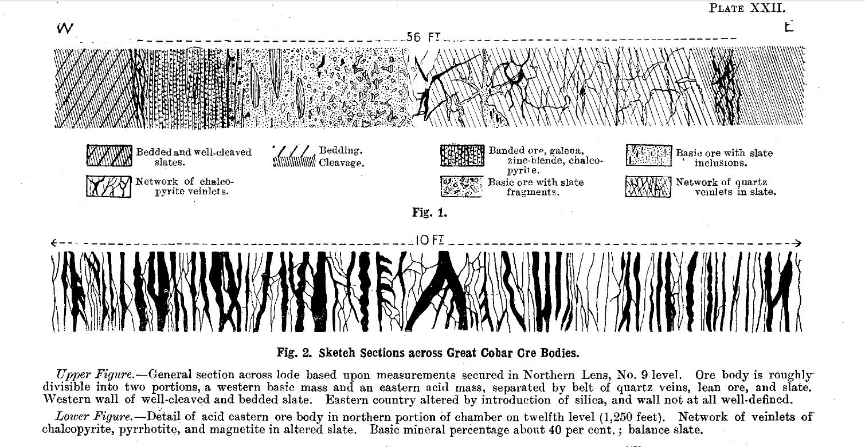The earliest sketches of the mineralisation remain some of the best, Figures 5 & 6 (Andrews, 1913). The width of the mineralised zone is more sharply contained on the western side than the east. The footwall on the west is distinctly less altered, with black chlorite and even carbonate nodules in parts. The mineralised zone can be very thick, with zones of very intense mineralisation, alteration, and veining. Moving east the intensity of a stock work like spaced vein complex of chalcopyrite, pyrrhotite, magnetite and quartz in a distinct green chlorite altered Great Cobar Slate gradually weakens and fizzles out.

Figure 5: Schematic representing a west-east cross section of shear hosted mineralisation at Great Cobar, recent drilling has shown that the cross section can be much wider, with the eastern edge poorly confined (from Andrews, 1913).

The lead/zinc lode on the western edge of the shear can vary in thickness considerably, from centimetre scale wisps to metre scale massive sulphide. Broadly speaking there is an apparent zonation where the lead/zinc is more dominant at the upper levels of the Anjea lens, however more data points are needed to say this conclusively. There is also an apparent zonation from north to south, with more development of lead/zinc on the southern end of the lenses. Again, there are not enough data points in the overall system to be conclusive. The assemblage is dominantly galena-sphalerite-pyrrhotite, with lesser chalcopyrite. Gangue includes quartz, chlorite, carbonate, and some stilpnomelane. The lead/zinc is usually a marker indicating the end of the copper-gold primary target zone.

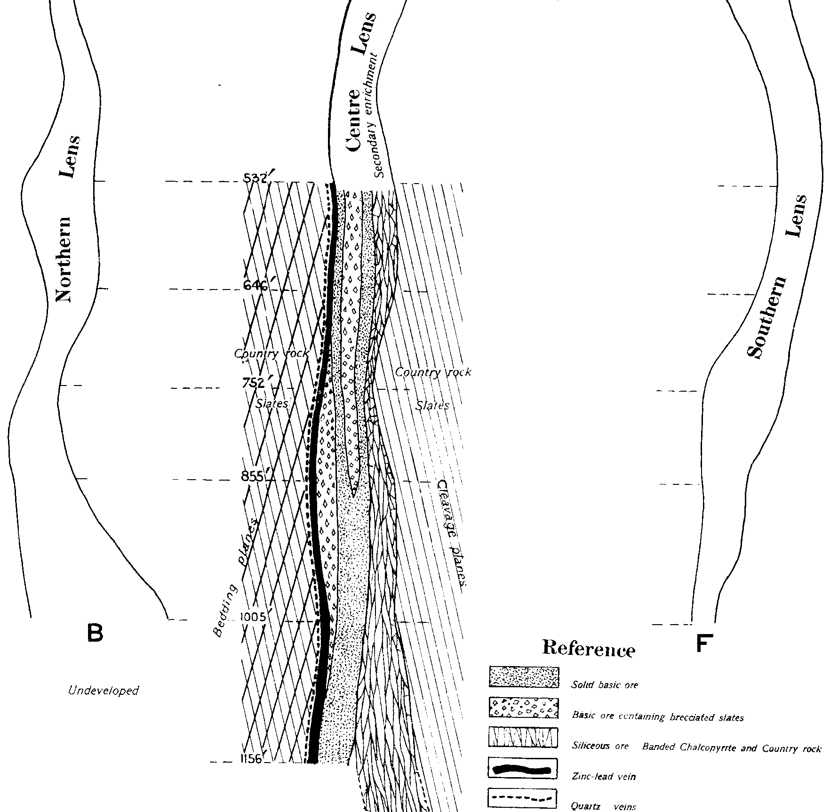The copper zone broadly extends eastward from the lead/zinc horizon. An eastern edge does not have a well-defined or sharp contact. The mineralisation can consist of zones of massive mineralisation or stock work space veins. The assemblage consists mainly of chalcopyrite-magnetite-pyrrhotite. Gangue includes quartz, chlorite, and stilpnomelane.

Figure 6: A cross section, west-east, representing mineralization style in the central lens of the historic workings. Note: Cleavage remains similar both sides of the mineralised zone and the lens pinches and swells in the vertical plane. This is also true in plan view along strike (from Andrews, 1913).

The occurrence of thicker zones of stockwork style and narrower semi-massive to massive mineralisation can lead to en echelon lodes within the copper zone. This could be a product of the anastomosing shearing, resulting in lozenge like ground preparation with pinch points and broader shattered zones. The influence of fold hinges, stratigraphic horizons, and cross cutting major structures in localising the economic core of the deposit are not completely understood.

Observations in drill core have been supplemented with detailed thin section analyses, focusing on the broad mineralised zone. In the highly altered mineralised zones sampled, little diagnostic relict material from a protolith has been recognised. Gangue phases show small aggregates and individual grains of gangue minerals hosted within sulphides ± magnetite, and locally it could be speculated that the larger included gangue aggregates might represent small remnants of intensely altered host rock (Ashley, 2015; Ashley, 2016).

Given the occurrence of the deposit within the Great Cobar Slate, original host rocks were typical of the of pelite-psammopelite (shale-siltstone) type. The implications are that there were major element transfers during hydrothermal fluid flux. Where sulphide-rich, there were large influxes of S, Fe and Cu (and locally Zn and other metals). Whereas in adjacent altered host rocks, there was probable Mg-metasomatism, as well as local increases in Fe, S and CO2. To accommodate these additions, there must have been large losses of silica and implied mobility of Al, K and probably other components. Silica loss and mobility could be represented in the patchily abundant syn-tectonic quartz veining and hydrothermal breccia infillings (Ashley, 2015; Ashley, 2016).

Current interpretation suggests the host rock material has undergone two main types of intense alteration: (a) silicification, i.e. replacement by quartz (and in places with minor chlorite, stilpnomelane, magnetite and sulphides) and (b) replacement by foliated, fine grained chlorite, but with varying proportions of magnetite, stilpnomelane, quartz and sulphides. Alteration of host rock, hydrothermal infill and mineralisation developed syn-tectonically. This is indicated by strong foliation in remnant chlorite-rich domains, by development of a hydrothermal breccia containing deformed fragments and with deformation textures in hydrothermal infill, in the widespread occurrence of strain and recrystallisation phenomena in quartz, and locally within magnetite-rich aggregates (e.g. aligned fractures filled with cross-fibre stilpnomelane) and local foliation shown in stilpnomelane aggregates. Although chalcopyrite and pyrrhotite have textures indicative that they are paragenetically later than magnetite, they are commonly intergrown with stilpnomelane (which can be foliated), and the probability is that sulphides also initially crystallised syn-tectonically, but due to their ductility, were considerably recrystallised and locally mobilised into veinlike masses (Ashley, 2015; Ashley, 2016).

The overall paragenetic sequence recognised is that magnetite and pyrite (with trace arsenopyrite) were deposited early, followed by pyrrhotite, and then apparently by chalcopyrite, sphalerite, and galena (with associated bismuth), with valleriite (a soft, bronze-yellow iron-copper hydroxysulfide mineral, occurs as minor encrustations) being a later retrograde alteration product, mainly of chalcopyrite. The paragenetic sequence does not necessarily mean more than one phase of mineralisation; it is simply reflecting the depositional sequence, e.g., from higher to lower temperature, as well as reflecting differences in rheology (and recrystallisation behaviour) during continued deformation, e.g, harder magnetite and pyrite showing fracturing and being enclosed in, and apparently replaced by, the base metal sulphides. Drill hole intercepts also appear to have demonstrated broad scale zonation from east to west, i.e. from an essentially Fe-Cu association, to a Fe (pyrrhotite-dominated) zone and then a Zn-Fe (-Cu-Pb) association. Most magnetite is associated with pyrrhotite-chalcopyrite (-pyrite) in the Fe-Cu zone (Ashley, 2015; Ashley, 2016).

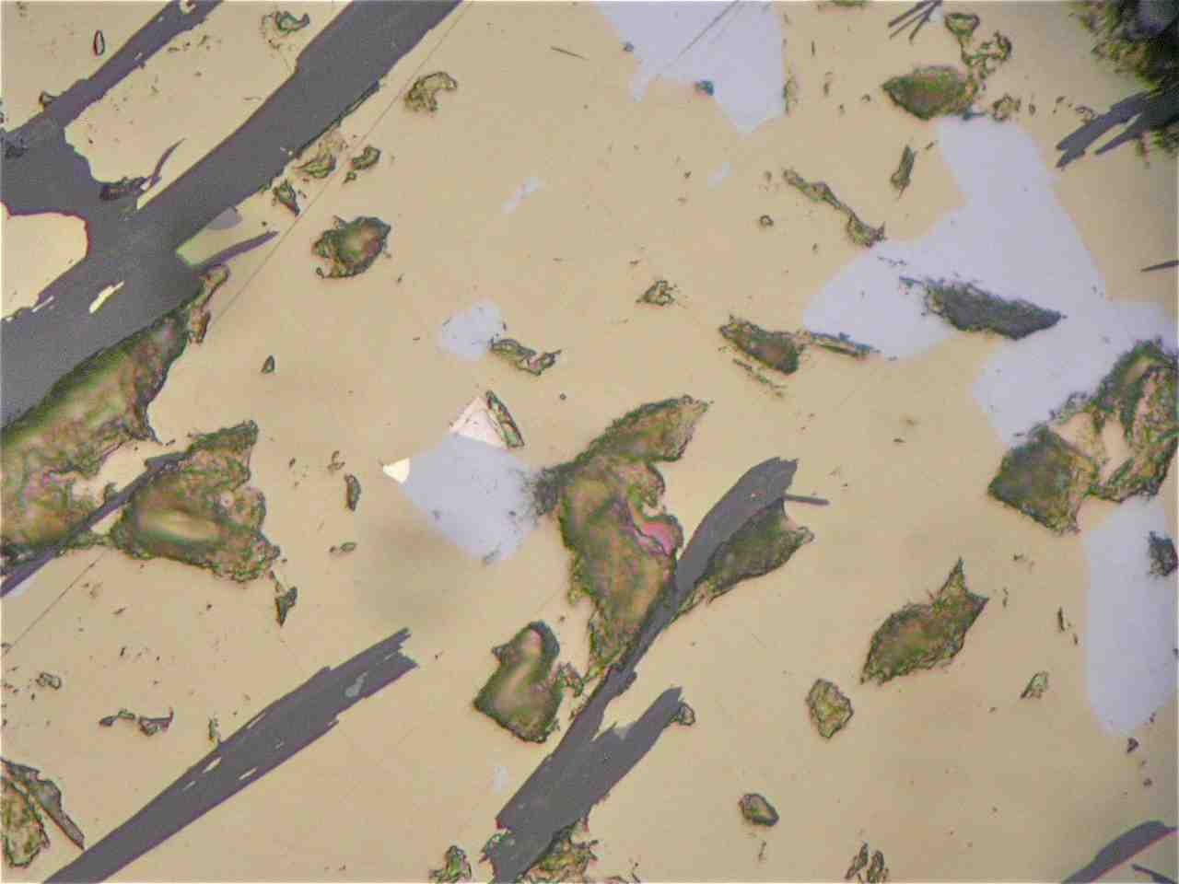Small grains of electrum have been observed, typically hosted in chalcopyrite and pyrrhotite (can also be associated with sphalerite). Bi phases occur in the same paragenesis as electrum, Figure 7 (Ashley, 2016).

Overall, the intersections are typical of Cobar-type mineralisation. The mineralisation occurs syn-tectonically in a well-developed shear zone which focused hydrothermal fluids. There are similarities to other major deposits in the district, New Cobar, CSA, New Occidental, and Peak. Occurrence of subtle indicator such as Bi minerals, cubanite, stipnomelane, and valleriite differentiate this style of mineralisation from alternatives, such as volcanic-associated massive sulphide deposits in Silurian sequences in the Lachlan Fold Belt (Ashley, 2015; Ashley, 2016).

Figure 7: Grain of interpreted Bi telluride phase (creamy, just left of centre) and electrum (bright creamy white, further left) attached to galena (pale bluish grey) and hosted in chalcopyrite (yellow) that is intergrown with a few flakes of stilpnomelane (dark grey). Note intergrowth of sulphides with finely acicular stilpnomelane. Plane polarised reflected light, field of view 0.25 mm across (Ashley, 2016).

**Mineral Resources**

In November 2015, New Gold announced the discovery of Anjea. Anjea is a zone of copper-gold and silver-lead-zinc mineralization located adjacent to the historic Great Cobar mine and approximately nine kilometres north of the Peak mill. The Anjea lens is located approximately 200 metres to the south of the historic Great Cobar mine. Beginning at a depth of less than 100 metres from surface, the Anjea zone has been delineated over dimensions measuring approximately 1,000 metres vertically, 150 to 200 metres along strike and 30 to 80 metres in width. The Anjea lens appears to be made up of a series of sub-parallel vertically-oriented lodes. Two high-grade copper lodes were identified, with associated gold mineralization, similar to what was mined historically at Great Cobar. A third lode is located approximately 40 metres to the west, with near surface mineralization, hosting primarily silver, lead and zinc mineralization, remains open along strike and below a vertical depth of 900 metres. Highlights of the 2015 intersections are contained in Table 1 (New Gold, 2015).

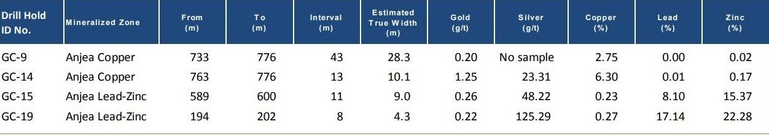

Table 1: Some of the highlight intersects at Great Cobar, both copper and lead/zinc lodes are represented (New Gold, 2015).

New Gold’s objective in 2016 has been to further delineate the Anjea mineral resources for incorporation into the company’s 2016 year-end mineral reserve and resource estimates. While both copper lodes consist predominantly of copper mineralization with subordinate amounts of gold, a localized zone of higher gold grades has also been intercepted during the 2016 drilling of Anjea. Some highlights of the 2016 intersects which were released are contained in Table 2 (New Gold, 2016).

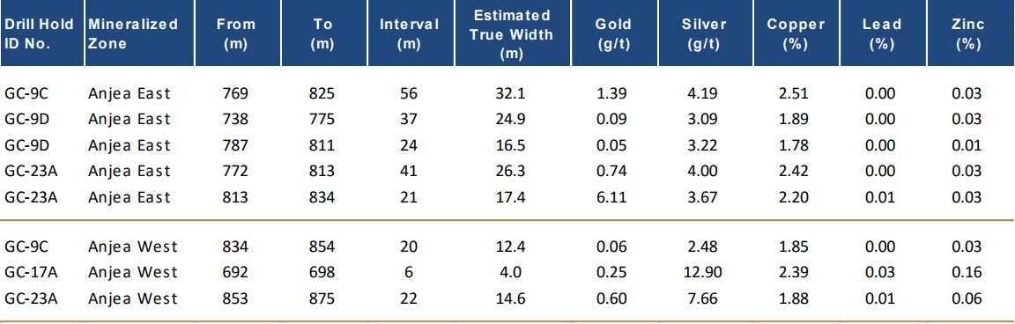New Gold’s published summary of mineral reserve and mineral resource estimates does not differentiate between Great Cobar and other parts of the northern mine corridor. As such, no estimate for tonnage and grade for the Anjea lens is included in this paper (New Gold, 2017).

Table 2: Some of the highlight intersects at Great Cobar, both copper and lead/zinc lodes are represented (New Gold, 2016).

**Exploration and Drilling Challenges**

The most prominent feature of the Great Cobar historic mine site is the large amount of iron rich slag remaining on the site. From the road, it looks like the entire site is covered in a mound of slag. This masks the reality that, like all the mines in the mine corridor, there is a prominent hill associated with the mineralisation. There is outcropping red stained and quartz veined deformed slate at the top of the hill where the old mine infrastructure was built. The slag was essentially poured down the edges slowly building the topography out and eventually masking the natural hill.

The slag has some interesting properties that hamper some exploration techniques. It is dense, conductive, and magnetic in parts. It weathers unevenly, creating cavities on the centimetre and metre scale which are unpredictable. It contains many vesicle like bubbles. It can be solid sheets, pot shaped lumps or loose gravelly material. Its thickness is not uniform and it is impossible to model accurately with current data. This all makes interpretation of gravity, electromagnetic and magnetic data localised to the centre of the deposit difficult. Being a refining product, it contains higher than background quantities of prospective metals, hampering local surface geochemistry. This becomes more of a problem when it is encountered further afield than the mine site where it has been used as road base or fill.

Having said that, it is old wisdom that the best place to find mineralisation is near an old mine, and what better indication of the significance of historic workings than such a large pile of slag?

The Great Cobar Slate (GCS) has a well-developed cleavage. It is the principle fabric in the area and it generally strikes close to parallel to the major shear direction. The beds of the GCS are transected by the Great Cobar Fault (GCF), which appears to be an anastomosing shear. In areas of intense strain, the cleavage can be warped. It is suspected that some intersections of faults sub-parallel to the main trend also warp cleavage locally. The bedding on the east of the GCF is not well understood now but is certainly folded on both a large region anticlinorial and local parasitic scale. This results in the potential for developing unpredictable lineations and fabrics approaching the main shear zone.

The challenge with drilling this project is primarily due to the cleavage and its local variations. A secondary difficulty is the tendency for drilling to encounter very hard patches of ground followed by softer rock, especially true in the quartz veined skirts of the eastern side of the target zones.

The thickness of the target zone can be 100m or more, when considering the various economic lodes encountered and the usual precursor of weaker stock work. There is a significant halo of magnetic interference down hole. Magnetic susceptibility has been measured and can be extremely high with significant magnetite mineralisation. This can influence a standard magnetic survey camera from 50-100m horizontally away from the hole.

Drill pad selection also has an influence on how difficult it is to drill at Great Cobar. The drill rig cannot be put on the road, so it must be placed in the paddock to the east. Locations for drill pads are limited by the presence of seasonal pools near the road which fill when heavy rain occurs. There is also consideration taken in not putting a drill rig too close to town, limiting the northern drill pad selection. It cannot be put much further east or drill strings would be too long and drilling would be expensive. Placing a pad on the slag would only allow testing of shallower targets.

To mitigate the unpredictable swings that occur in the holes, previous survey traces were analysed. When we drill at close to perpendicular to the cleavage the hole can swing either with or against rod rotation, which is generally not too strong, but not always. When holes were drilled sub perpendicular to cleavage, then the holes tended to swing back toward cleavage, but not always.

Navigational drilling was used extensively during exploration at Great Cobar due to the difficulty in controlling holes. It is a useful tool but expensive and even itself can be unpredictable at times. Over time the drillers working at the project became very familiar with how the rock behaved when drilled. They developed methods for steering the holes without navigational drilling intervention. This is a delicate process and requires constant communication between the geologist and the drillers working in partnership when making decisions on how to manage the holes. The Great Cobar drilling broke the rules that usually apply in other places. Specifics of the drilling methods employed are sensitive competitive information. The results of the collaboration were better, cheaper results.

**Further Work**

The Great Cobar deposit is a major deposit in the district. There are no detailed studies conducted on the deposit in modern times. A critical analysis of the structural, mineralogical, chronological and alteration controls and styles at the deposit would significantly enhance future exploration in the district.

For an operating mine, the focus is not to thoroughly understand the mineral system but to know enough to continue successfully exploring. Some of our questions will yield high impact answers for future prospecting, others will be subtler and are more something to consider for those willing to pursue the academic answers.

Some studies have begun to examine assay information and spectroscopic core logging data to develop a picture of the alteration around the mineralisation. The transition from Mg-chlorite to Fe-chlorite, for example, in this iron rich system is of interest as it may help with future target generation.

There are several broad questions about the occurrence of mineralisation in economic lodes at Great Cobar that remain unanswered with reasonable scientific certainty:

* How is the deposit structurally controlled? Is there an intersection of shears at play? Are large scale folds within the slate influencing lode development, i.e. fold hinges and faults on limbs and/or maximum extensional direction?
* How big of an influence are stratigraphic units, possible hereto undefined, within the sequence on ore deposition? Are carbonates and talcs stratigraphically controlled and are they impacting mineralisation?
* Are there different orientations to the different mineral assemblages? i.e. is the gold on a cross structure and on a different trend? Same for Cu and Pb.
* Geochemically, what size of a halo in enriched or depleted elements can be established around the deposit? Can we use this information to pursue similar targets in future exploration?
* Are the mineralising fluids from a magmatic source? Are there signs of a large-scale feature that could indicate deep magmatic sources in the area that is not discovered when we step back and look at the big picture?

Great Cobar, like many other exploration projects and scientific endeavours, raises more questions and reveals more surprises each time a new piece of the puzzle is seen. Like most mines it will probably keep surprising us until it has been mined and exhausted.

**Acknowledgements**

The author would like to thank New Gold and the Peak Gold Mines operational team for permission to publish and present this paper. All the Peak Mines staff and contractors, past and present that have contributed to discussions, data collection and processing, especially the geology, drilling and core yard teams. The Peak Exploration Team. Paul Ashley for his invaluable work on petrography. The geologists from the Geological survey of New South Wales who have given us plenty to think about and new insights through their work. Mark Petersen and Ian Mackenzie for reviewing. Katrina Virgoe, Angela Dimond and Aoife Lyons for support writing, valuable comments, and editing. Jeremy Frost, “Bluey” Pfeiffer and Marcus Sherrin whose drilling expertise ensured we hit our targets accurately. Particularly, Barry Taylor for the modern discovery and for his continued mentorship and exploration wisdom throughout this exploration story. The opinions expressed in this paper are those of the author only.

**References**

Andrews, E.C., 1913. Report on the Cobar Copper and Gold-field. Part I. Mineral Resources 17. (New South Wales Department of Mines, Sydney).

Ashley, P.M., 2016. Petrographic Report on three rock samples from Nymagee and ten drill core samples from Cobar, Peak Mine Area, Cobar Central-Western NSW (unpublished).

Ashley, P.M., 2015. Petrographic Report on twelve drill core samples from Great Cobar Mine area, Cobar Central-Western NSW (unpublished).

Drummond, B.J., Glen, R.A., Goleby, B.R., Wake-Dyster, K.D. and Palmer, D., 1992. Deep Seismic of the Cobar Basin II: A ramp Basin Controlled by Mid-Crustal Detachment [Abs], *Geological Society of Australia Abstracts,* 32: pp44 (Geological Society of Australia, Hornsby, NSW)

Fitzherbert, J.A., Downes, P.M. & Belvin, P.L., 2016. Cobar 1:500 000 Special Metallogenic Map. (Geological Survey of New South Wales, Maitland, Australia).

Glen, R.A., 1987. Copper and Gold Deposits in Deformed Turbidites at Cobar, Australia: their Structural Control and Hydrothermal Origin, *Economic Geology,* 82 pp 124-140 (Society of Economic Geologists, Littleton, CO).

Glen, R.A., 1991. Inverted Transtensional Basin Setting for Gold and Basemetal Deposits at Cobar, New South Wales, *BMR Journal of Geology and Geophysics,* 120: pp 12-44 (Geoscience Australia, Canberra).

Glen, R.A., 1995. Thrusts and Thrust-Associated Mineralisation in the Lachlan Orogen, *Economic Geology,* 90 pp 1402-1429 (Society of Economic Geologists, Littleton, CO).

Glen, R.A., 1996. Extrapolating the Cobar Basin Model to the Regional Scale: Devonian Basin-Formation and Inversion in Western New South Wales, in *The Cobar Mineral Field – A 1996 Perspective,* (Ed Cook et al.) pp 43-83 (Australasian Institute of Mining and Metallurgy, Melbourne).

Glen, R.A., Drummond, B.J., Goleby, B.R., Wake-Dyster, K.D. and Palmer, D., 1994. Structure of the Cobar Basin, New South Wales, based on seismic reflection profiling, *Australian Journal of Earth Sciences,* 41: pp341-352 (Geological Society of Australia, Hornsby, NSW)

Rayner, E.O., 1969. Geology Memoir 10: The Copper Ores of the Cobar Region, New South Wales. A report on the geology and mineralogy of the copper deposits of the Cobar region, with special reference to the characteristics of deep-zone, high-temperature, iron-rich copper ores. R00031686 (Departmental Publications Geological Survey of New South Wales NSW Mines Department)

New Gold, 2015. An update on the company's exploration success at the Peak Mines ("Peak") [online]. Available from <http://www.newgold.com/investors/NewGoldNews/PressReleaseDetail/2015/New-Gold-has-continued-exploration-success-at-the-Peak-Mines/default.aspx>

New Gold, 2016. An update on results of the company's exploration programs at the New Afton C-zone and Peak Mines ("Peak") for the first half of 2016. [online]. Available from <http://www.newgold.com/investors/NewGoldNews/PressReleaseDetail/2016/New-Gold-has-continued-exploration-success-at-New-Afton-C-zone-and-the-Peak-Mines/default.aspx>

New Gold, 2017. Summary of Mineral Reserve and Mineral Resource Estimates. [online]. Available from <http://www.newgold.com/investors/reserves-and-resources/default.aspx>