**THE GEOLOGICAL POTENTIAL FOR MAGMATIC AND OROGENIC MINERAL SYSTEMS IN THE SOUTHERN NEW ENGLAND OROGEN**

**Phillip L. Blevin1, Katie Peters2, Greg Partington3, Peter M. Downes1, Michael Nelson4 & Bradley J. Williams1**

1 Geological Survey of NSW, Dept of Planning & Environment, PO Box 344, Hunter Region Mail Centre 2310

2 Kenex Ltd, PO Box 41136 Eastbourne, Lower Hutt, New Zealand 5013

3 Kenex Pty Ltd, PO Box 775 Dongara, WA 6525

4 ex. Geological Survey of NSW, now Regis Resources Ltd

**Key words**: Southern New England Orogen, intrusion-related tin–tungsten, intrusion-related gold, orogenic gold–antimony, mineral potential mapping, metallogeny

**INTRODUCTION**

The first edition series of 1:250,000 scale metallogenic maps for NSW was completed with release of the Warwick–Tweed Heads Metallogenic map. This concluded a thirty-year campaign of mineral occurrence mapping by the Geological Survey of NSW (GSNSW). A new generation of regional metallogenic synthesis maps seeks to reassess the basement geology and to interpret mineralisation within the time–space evolution of the respective regions (Fig. 1). These maps have been completed for Broken Hill and the Cobar–Nymagee regions, and the New England Orogen Metallogenic 1:750,000 special map is due for release in late 2017 (Downes et al., in prep.).

To go beyond mineral occurrence location mapping to prediction of the location of undiscovered mineralisation requires a more detailed holistic understanding of the components of each type of mineral system. These can be used as a guide for predicting where conditions conducive to mineralisation may occur and therefore where there is an increased chance of mineralisation. Apart from the largely answered question of “*where* are the known mineral occurrences in NSW?”, we need to address “*when* did these mineral occurrences form?” and “*why* did they form where and when they did?”. That is, to understand the process and geological circumstances that came together at that point in time and space to provide the appropriate conditions for mineralisation.

With the “where” answered by the metallogenic map series and MetIndEx-type data compilations, “when” and “why” was the focus of recent studies by the Mineral Systems group of the GSNSW. This has been achieved through the adoption of a mineral system approach, systematic geochronology of mineral deposits, ore minerals and their host rocks, and Pb–Pb, S, Nd–Sm, Rb–Sr, O and D isotope studies. Collaboration external researchers working on NSW minerals deposits and GSNSW allowed focussed studies on key systems. Hyperspectral studies of rock and drillcore by the GSNSW HyLogger™ unit have also been integrated into mineral systems studies to better understand alteration and mineralisation processes and to map these in 2D and 3D.

The “where else” is a much more complex question as it involves the distillation of existing data and the incorporation of uncertainty through predictive analysis to define geological areas of mineral potential at surface and under cover. This movement into the mineral potential space is a useful and necessary progression of the GSNSW work because of several drivers. These include:

* Land-use planning and provision of mineral potential advice to a range of stakeholders
* Technical resources for improved mineral system studies, including global endowment estimations
* Promotion of the state through the generation of targets and prospective tracts to reduce exploration risk and encourage the uptake of exploration titles, and increase exploration (drilling) expenditure.

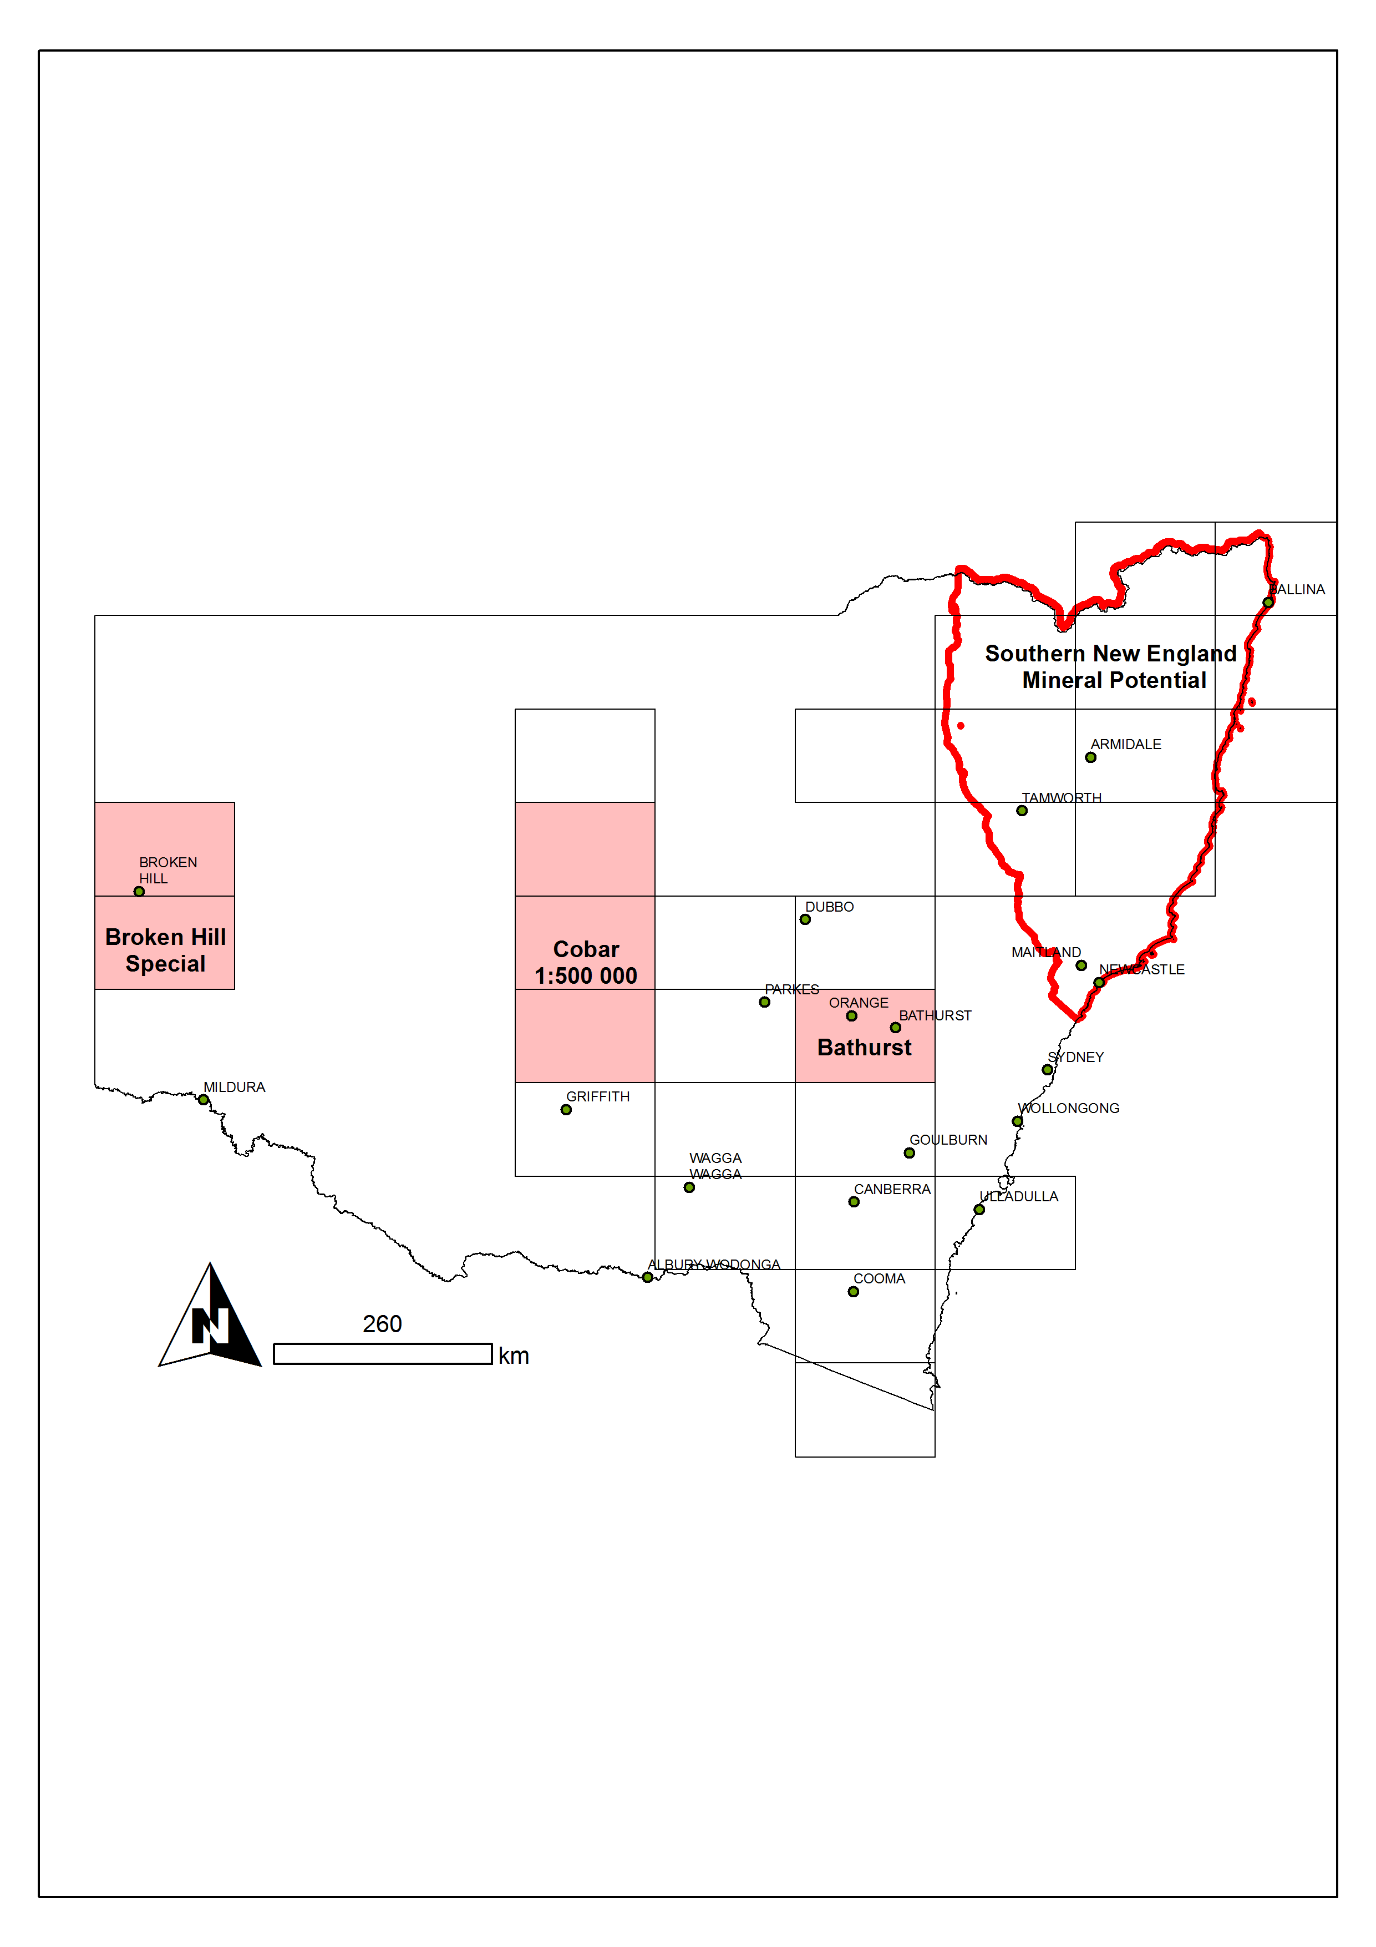

Figure 1. Map of NSW showing location of 1:250 000 metallogenic maps (black outlines) completed by GSNSW. Pink areas show the three regional metallogenic synthesis maps completed, with the New England 1:750 000 metallogenic map (Downes et al. in prep.) covering the area of the Southern New England Orogen mineral potential project (red outline).

**WHY THE SOUTHERN NEW ENGLAND OROGEN?**

The Southern New England Orogen (SNEO) was chosen as a starting point for data-driven mineral potential studies in NSW because of its perceived potential for new economic deposits of intrusion-related gold (Blevin, 2017), intrusive-related tin–tungsten (Blevin & Downes, 2017) and orogenic gold–antimony (Downes, 2017) mineral systems. Added to that, a raft of new and improved datasets and geoscientific products for SNEO have recently been generated by the GSNSW. These include:

1. The seamless geology map of Zone 56 which includes the SNEO. The aim of the NSW Seamless Geology Project is to create a geodatabase with the best-available geological data organised into layers (or time slices) that represent the major tectonic cycles of evolution of the Tasmanides in NSW. These layers include: basement geology, sedimentary basins, Mesozoic igneous provinces, and Cenozoic sedimentary and igneous units (Phillips et al., 2014).
2. A fault attribution geodatabase (Phillips, 2016) that spatially organises data which describes faults via a fully attributed polyline feature class. This product provides context with respect to the genesis and evolution of fault systems of the SNEO, including how they have defined the present architecture of the orogen.
3. A 3D geological model of the western Tamworth Belt (Robinson and Phillips, 2015). This map was developed from a series of 2 dimensional cross-sections based on surface mapping, 16 reflection seismic profiles as well as magnetic and gravity data.
4. A new geochronology and classification of the New England Batholith leading to improved metallogenic fertility indicators. Over 78 new SHRIMP dates support a new geochronology of magmatic events within the batholith (Cross & Blevin, 2013; Chisholm et al., 2014a, b; Waltenberg et al., 2016; Waltenberg in prep.). In addition, Bryant (2017) has reclassified the batholith into 16 supersuites with additional groupings at the suite and pluton level. This revision is accompanied by the editing and updating of 1500 whole-rock geochemical analyses from the SNEO, with full REE analyses from a representative subset of samples to better understand the REE potential and fractionation trends within granite suites (Bryant & Blevin, 2017a, b).
5. Metamorphic geodatabase for the SNEO. This is the first stage of a statewide product that will define metamorphic boundaries as a polyline feature class to define areas of constant metamorphic type and grade, and related data (Phillips, 2017).

Several of the products and geodatabases for Zone 56 are the first instalment of a roll out of data across the state, generally in the order Zone 56, 54 and 55. Thus the SNEO provides an ideal test bed for the usefulness of these datasets as inputs to mineral potential mapping, underpinned by the seamless geology, mineral occurrence data and region-specific mineral system models – in other words, testing that these new generation products are “fit for purpose”. Other datasets and data layers that contributed to the study include: geophysics (radiometrics, magnetics, gravity and derivatives); historical exploration titles; mineral occurrence/deposit location; geochemistry (drillhole, whole rock, stream and surface); depth to basement where available; previous mineral assessment studies (e.g. Nandewar, Brigalow); exploration data packages for New England; and digital publications from GSNSW and other sources.

**MODELLING METHODOLOGY**

Three mineral systems that occur within the SNEO were selected: intrusion-related Sn–W, intrusion-related Au, and orogenic Au–(Sb). These mineral systems were selected on the basis that they represent known metal endowment (production and identified resources) and are related to geological features that are widely distributed in the SNEO (the New England Batholith and the extensive fault systems). For each of these deposit types, a specific SNEO mineral system model was prepared using the general outline of the national mineral system models of Geoscience Australia. The intrusion-related Sn–W and Au models represent modifications of existing national models (Blevin & Downes, 2017, Blevin, 2017), while the orogenic Au and Au–(Sb) model is substantially new (Downes, 2017).

The weights-of-evidence technique was used to perform detailed spatial analysis of the data and produce the mineral potential maps. This technique allows the prediction of the location of features based on the presence or absence of a characteristic or pattern and the occurrence of an event. It is ideally suited for spatial data systems and takes best advantage of the analysis and combination of a variety of datasets. This spatial analysis process allows for a non-biased assessment of large numbers of predictive variables to determine their relevance to the individual mineral system. The spatial analysis and mineral potential mapping has been carried out using Arc-SDM (Peters et al. 2017, Peters et al. in press).

A second advantage of the weights-of-evidence methodology, from the mineral system perspective, is it that it requires training data to determine spatial correlations and weights for each predictive map tested. This enables an estimate of the probability of the occurrence of a training point to be present or absent to be calculated for each area being assessed.

A variety of training data points (i.e. mineral deposits/occurrences) were selected for each mineral system. These were chosen to capture the variety of deposit styles present within each system and cover a wide geographical spread. The training data for this study included: 13 intrusion-related Sn–W deposits; 13 intrusion-related Au zones; and 28 orogenic Au and Au–(Sb) zones.

The source data were converted into maps that represent each of the key elements of the mineral system being studied (source, transport/migration, trap/deposition). The relative importance of these varies between mineral systems. For example, while the sources for intrusion-related Sn–W and Au are relatively straightforward, being granites for which metallogenic fertilities can be assigned, source criteria for orogenic Au are generally unexposed and contentious. However, the nature of ore-forming fluids transporting metals and structural controls in orogenic Au systems can be readily determined.

The spatial correlation of a mapped feature is calculated by using the relationship of the area covered by the feature and the number of training data points that fall within that area, compared with the number of points in the rest of the study area. The spatial analysis process resulted in the creation of between 71 and 101 predictive maps for each model. The overall percentage of these maps that correlated well with the training data was high. Based on the spatial analysis between the predictive maps and the training data, the most important variables for predicting intrusion-related Sn–W, intrusion-related Au and orogenic Au and Au–(Sb) mineralisation in the SNEO were identified.

**MINERAL POTENTIAL MAPS**

Mineral potential maps were developed for each mineral system, using a selection of 18 predictive maps that represent all stages of the mineral system model defined for each mineralisation style (Figs 2–4; also see Peters et al., 2017). Predictive maps were chosen from those that had the best regional coverage, a significant spatial association with the mineral system model being considered, and minimal duplication of predictive map patterns. In the mineral potential maps (Figs 2–4), areas that are from blue to red have geological potential that is higher than that calculated before any evidence for mineralisation was applied. Red areas have the highest geological potential. The mineral potential maps were validated by calculating the efficiency of classification, a measure of how well the training sites were classified by the model. If less than 10% are not well classified, the model is considered acceptable.

For the intrusion-related Sn–W and intrusion-related Au mineral potential maps the area considered prospective covers only 6% and 8% of the study area (respectively). For the intrusion-related Sn–W model all the training points fall within the highly prospective area (Fig. 2). Similarly, all but one intrusion-related Au training points fall within the highly prospective area (Fig. 3). The efficiency of classification for both mineralisation styles is 99.5%, confirming the validity of these models. For the orogenic Au and Au–(Sb) mineral potential map the area considered to be prospective covers only 4.5% of the study area. Two training points fall outside of the prospective area and 20 of the 28 training points fall within the highly prospective area (Fig. 4). The efficiency of classification is 97.6%, confirming the validity of the model.

**OUTPUTS AND DISCUSSION**

The key output of the SNEO mineral potential project is the SNEO Mineral Potential Atlas. This atlas contains all the GIS files used to produce the mineral potential maps for each mineralisation style. This includes: training data points, study area grids, predictive map grids, weights tables and mineral potential grids. The atlas also contains a detailed spatial data table, which contains information relating to the various GIS files, including methods for creating predictive maps, model set up, spatial correlation statistics and predictive maps combinations used for the final mineral potential maps. The SNEO Mineral Potential Atlas can be accessed through the GSNSW website. The supporting mineral system models are available through the DIGS system.

The GSNSW is finalising a thematic 1:750,000 scale metallogenic special map of the SNEO (Downes et al., in prep.). This map will classify lithostratigraphic units according to their depositional environment, while plutonic igneous units will be classified according to their oxidation state and degree of fractionation. The map base will utilise the new GSNSW seamless geology and fault data layers, as well as new dating of the major igneous units throughout the orogen.

While the mineral potential maps have been very successful in “predicting” the occurrence of known Sn–W, intrusion-related Au and orogenic Au and Au–(Sb) systems, including those not included as training points, the maps also identify the following new areas of potential, particularly for Sn–W and intrusion-related Au mineralisation.

* Areas of identified potential for intrusion-related Sn–W deposits include the general Tooloom, and Boonoo Boonoo areas as well as the Liston region, where known alluvial and small primary Sn exist. Interestingly the Liston–Ruby Creek area also shows high potential for intrusion-related Au. No training points for either deposit types are located in this area. The Parlour Mountain Leucomonzogranite and portions of the Mount Duval Monzogranite are also indicated, although the latter is otherwise not obviously geochemically conducive for Sn–W mineralisation. The Mole Granite and contact environs are (not unexpectedly) indicated as having a high potential. Closer examination or further gathering of information on metamorphic grades in the host volcanic rocks to the south (biotite isograd) and additional gravity data may extend this zone of enhanced prospectivity significantly to the south.
* Areas of identified potential for intrusion-related Au are much more extensive than expected. They include the extensive region along the main axis of felsic I-types from Tenterfield and Timbarra south-southwest through Kingsgate, Oban River and the Red Range granites. Interestingly, areas of potential were also identified around the contact margins of the Mole Granite, the Mount Mackenzie/Nonnington mass to the west of Tenterfield, the margins of the Bolivia Range Leucomonzogranite (which is also associated with minor Mo showings) and the southeastern zone of the Gilgai–Tingha complex. There are minor occurrences of Au along the contact between the Mole Granite and its roof pendant and, as a surface, the contact zone between the roof of the pluton and its wallrocks would re-intersect the present topography at the outer margins of this pluton. In the Tingha–Gilgai complex, small Au–Mo–Bi occurrences have been reported, and a zone of elevated intrusion-related Au potential extends to the southeast towards the Uralla–Rocky River goldfield. This zone includes the Gwydir River Monzogranite and follows the north-northwest trend of the “Regional Felsic Dyke Swarm”.
* Elevated potential for intrusion-related Au is also shown around the margins of the Moonbi–Attunga–Inlet granites north and northwest of Tamworth, where minor Mo and Au–Cu vein and skarns are recorded. Finally, the large Walcha Road Monzogranite pluton south of Uralla has no recorded mineralisation associated, despite its K-rich, modestly oxidised and compositionally zoned character. The largely unexposed Dumboy–Gragin Granite near Delunga also has elevated potential, previously worked only for Sn–W veins and alluvial Sn. Exploration for intrusion-related Au in most of these areas away from the Timbarra district has been minimal.
* Areas of unexpected elevated potential for orogenic Au and/or Au–(Sb) mineralisation include the Tooloom–Paddys Flat–Lunatic area and Lionsville. Although orogenic and possible epithermal mineralisation has been recorded from these areas, their high prospectivity status from the analysis undertaken in this study suggests that a re-examination of known occurrences, possible structural traps and fluid transport pathways should be undertaken. The area abuts the onlap of the Clarence–Moreton Basin, so further potential is likely to exist under relatively shallow cover immediately to the east of the indicated areas of high potential. The elevated potential in the Mole Granite and environs may be a reflection of the recorded vein and fracture density.

**CONCLUSIONS**

This project represents a highly successful collaboration between the GSNSW and Kenex Ltd that has defined areas of mineral potential in SNEO for three mineral systems. The mapped geological potential for these mineral deposits is statistically valid and is ideal for application to land-use planning decision-making and area selection for mineral exploration. The keys to the success of the models are the robust spatial analysis by Kenex Ltd and the quality of existing and new generation datasets that have been developed by GSNSW for the SNEO and are being further developed across the state. The SNEO Mineral Potential Atlas is a significant new resource for those wishing to undertake more specialised analysis of mineral potential at the regional to camp scale.

The SNEO mineral potential project marks the start of a new chapter for GSNSW mineral systems work, with similar studies planned for key geological provinces across the state over the coming years.

**REFERENCES**

BLEVIN P. L. 2017. A mineral system model for intrusion–related gold deposits of the southern New England Orogen. Geological Survey of New South Wales GS2017/0618.

BLEVIN P. L. & DOWNES P. M. 2017. A mineral system models for Palaeozoic Sn–W deposits in the southern New England Orogen. Geological Survey of New South Wales GS2017/0617.

BRYANT C. J. 2017. A compendium of granites of the southern New England Orogen, eastern Australia: Geological Survey of NSW, Report GS2017/0408.

BRYANT C.J. & BLEVIN P. L. 2017a. Chappell–White Legacy: CHAPGRAN and associated resources. *In*: Vernacombe, J. ed., Granites: Crustal Evolution and Mineralisation, pp 21-23, AIG Bulletin 65, Perth.

BRYANT C.J. & BLEVIN P. L. 2017b. High precision REE and trace element analyses from selected samples of the Bruce Chappell (CHAPGRAN) analytical collection, southern New England Orogen. Geological Survey of New South Wales. DIGS report no: GS2017/0584.

CHISHOLM E. I., BLEVIN P. L. & SIMPSON, C. J. 2014a. New SHRIMP U–Pb zircon ages from the New England Orogen, New South Wales: July 2010–June 2012. Geoscience Australia. Record 2014/13.

CHISHOLM E. I., BLEVIN P. L. & SIMPSON, C. J. 2014b. New SHRIMP U–Pb zircon ages from the New England Orogen, New South Wales: July 2012–June 2014. Geoscience Australia. Record 2014/52.

CROSS A. J. & BLEVIN P. L. 2013. Summary of results for the joint GSNSW–GA geochronology project: New England Orogen 2009–2010. Geoscience Australia. Record 2013/27.

Downes P.M. 2017. A mineral system model for orogenic Au and Au -Sb in the southern New England Orogen. Geological Survey of New South Wales GS2017/0619

DOWNES P. M., WILLIAMS B. J., BLEVIN P. L., NELSON M., VEGA FAUNDEZ M. & BALLARD J. in prep. New England Orogen 1:750 000 Special Metallogenic Map. Geological Survey of New South Wales, Maitland, Australia.

PETERS K. J., PARTINGTON G. A., GREENFIELD, J.E., BLEVIN P. L., & DOWNES P. M. 2017. Southern New England Orogen Mineral Potential Report. Geological Survey of New South Wales. DIGS report no: GS2017/0624 49pp.

PETERS K. J., PARTINGTON G. A., BLEVIN P. L., DOWNES P. M. & NELSON M. D. (in press). The Southern New England Orogen Mineral Potential Project. AusIMM New Zealand Branch Conference, 10-13 September, Christchurch.

PHILLIPS G., COLQUHOUN G., HUGHES K., DEYSSING L. & FITZHERBERT J. A. 2014. Seamless geology of New South Wales (poster). Geological Survey of New South Wales. DIGS report no: GS2014/0940.

PHILLIPS G. 2016. Fault Attribution Geodatabase for the southern New England Orogen, eastern Australia. Geological Survey of New South Wales. DIGS report no: GS2016/0967.

PHILLIPS G. 2017. Documentation for the GSNSW Metamorphic Geodatabase. Geological Survey of New South Wales. DIGS report no: GS2017/0030 20pp.

ROBINSON J. & PHILLIPS G., 2015. 3D Geological Map of the southern New England Orogen: western Tamworth Belt. Geological Survey of New South Wales. DIGS report no: GS2015/1144 59pp.

WALTENBERG K., BLEVIN P. L., BULL K. F., CRONIN D. E. & ARMISTEAD S.E. 2016. New SHRIMP U–Pb zircon ages from the Lachlan Orogen and the New England Orogen, New South Wales: Mineral Systems Projects, July 2015–June 2016. Geoscience Australia, Canberra. Record 2016/28

WALTENBERG K., BLEVIN P. L., HUGHES K. S., BULL K. F., FITZHERBERT J. A. & CRONIN D. (in prep). New SHRIMP U–Pb zircon ages from the Lachlan Orogen and the New England Orogen, New South Wales: Mineral Systems Projects, July 2016–June 2017. Geoscience Australia.

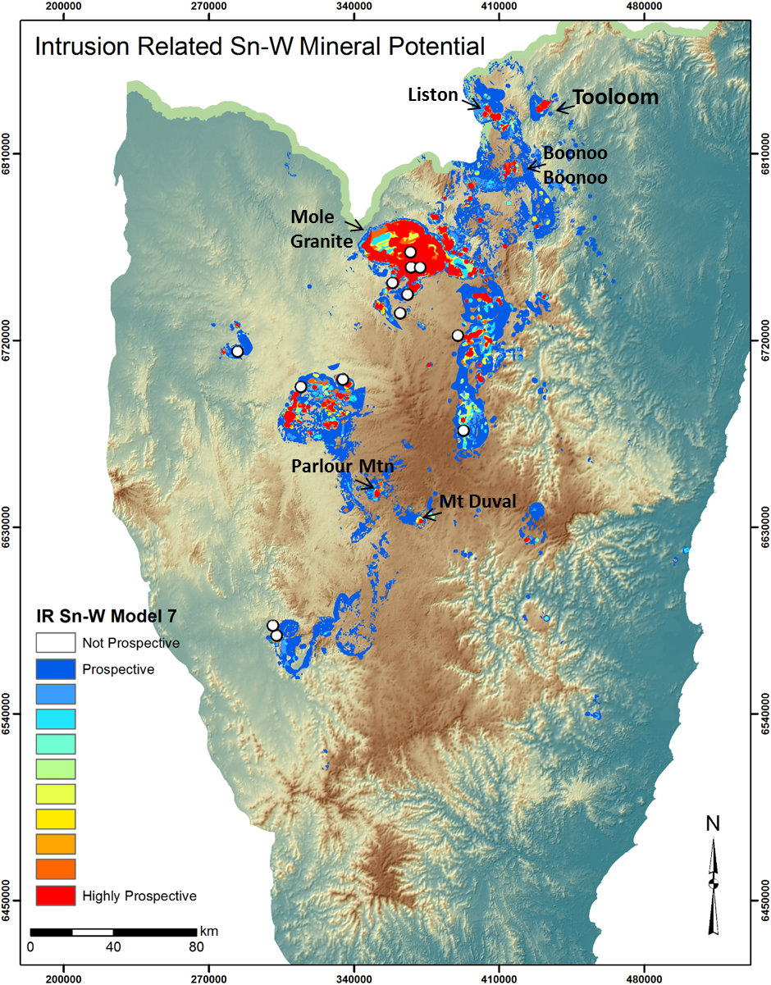

Figure 2. Intrusion-related Sn-W mineral potential results for the Southern New England Orogen. Training data are shown as white dots. Locations and/or intrusive units mentioned in the text are indicated.

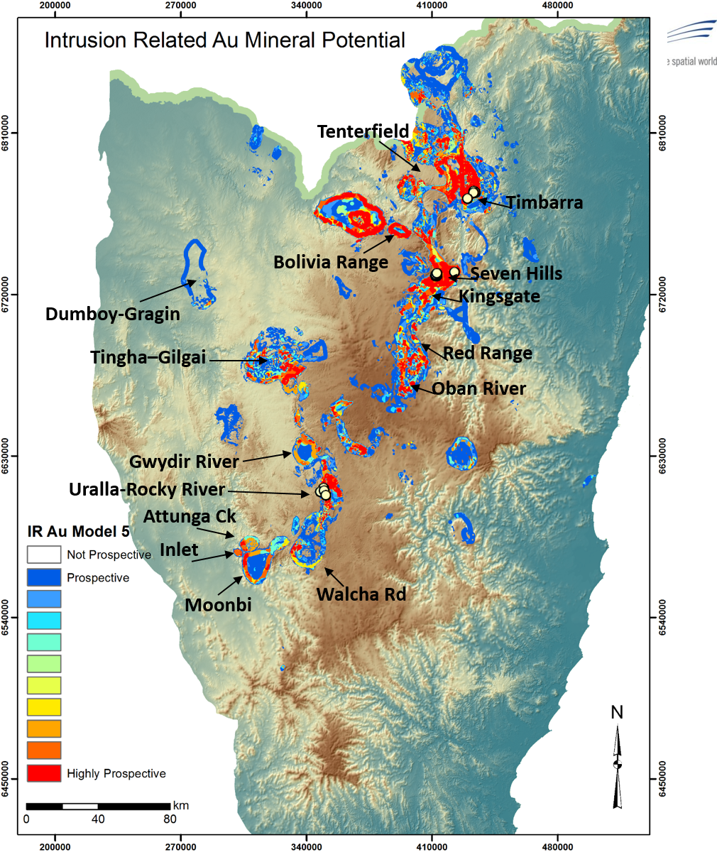

Figure 3. Intrusion-related Au mineral potential results for the Southern New England Orogen. Training data are shown as white dots. Locations and/or intrusive units mentioned in the text are indicated.

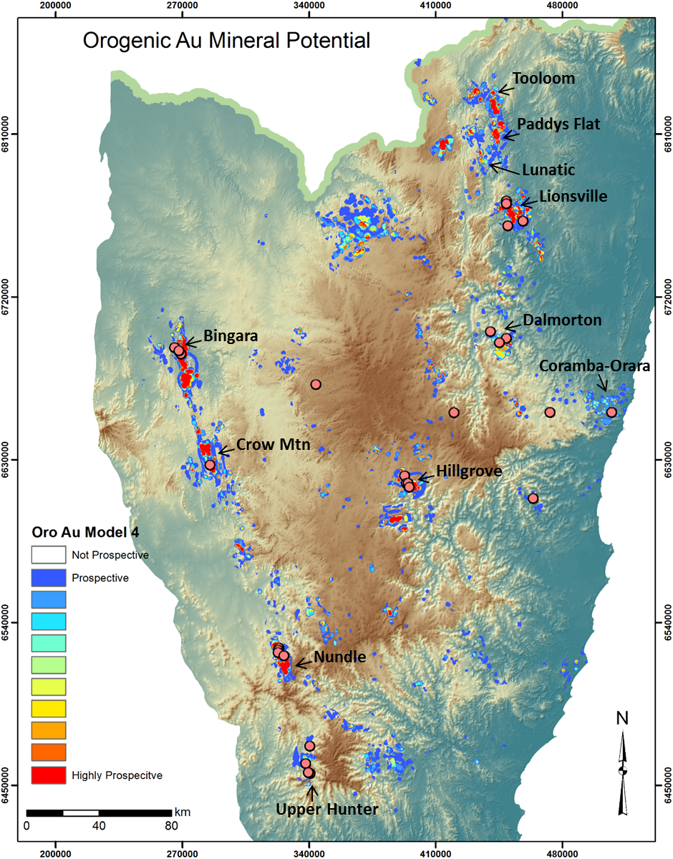

Figure 4. Orogenic Au(–Sb) mineral potential results for the Southern New England Orogen. Training data are shown as pink dots. Key locations and/or gold districts with training data points are indicated.