Polymetallic gold, silver and base metal mineralisation at Paupong, NSW: a new intrusion-related system
Helen S Degeling, Thomas Klein & Russell J Fountain

Key Words: Paupong, Gold, Silver, Southern New South Wales, Lachlan Orogen, Intrusion-Related Gold System, IRGS, Polymetallic Mineralisation.
INTRODUCTION
The Paupong gold and silver project is located 20km south-east of Jindabyne, in southern NSW. The project represents a newly discovered IRG mineral field in the southern Lachlan Orocline. Its presence increases the significance of the region, with neighbouring IRG deposits at Mt Adrah and Dargues Reef.
Gold and silver anomalism at Paupong has been identified over an area of 8 x 4 km, with up to 14 g/t Au and 451 g/t Ag in rock chips. Bismuth and base metal anomalism is also locally developed, with Cu up to 3.8 %, Pb up to 4.1 %, Zn up to 1 % and Bi up to 1.4 % in surface and drillhole sampling. Gold and other metals are hosted in quartz vein systems with associated complexly zoned Au-Bi-Cu-Ag-As-Pb-Zn-Te anomalous geochemistry. This geochemistry, together with proximity to, and association with local mineralised intrusives supports an intrusion-related model for the system.
Within the project area at least 14 separate small intrusive bodies have been mapped, ranging in surface area from a few hundred square metres to around 1 square km. These have been tenuously classified into two main groupings; the Paupong Intrusive Suite and the Blind Gabbro Suite. The Paupong Intrusive Suite transects the project area, forming a north-east/south-west linear trend of weakly deformed and anomalously Au-Ag-Cu mineralised, I-type granitoids. These rocks are older than the Blind Gabbro Suite, and may be comparable in age to, or slightly younger than, the neighbouring Kosciuszko and Berridale Batholiths.
A diatreme breccia and with intensely pyrite-sericite altered diorite was recently intersected in drilling. The pyrite-rich diorite is non-outcropping, and forms the matrix of the diatreme breccia. Whilst sulphide-rich, it is barren of Au-Ag-Cu mineralisation, and shows a different trace element signature to the Paupong Intrusive Suite, and different magnetic character to the Blind Gabbro Suite.
Geological Setting
The Paupong Project lies within the south-eastern Lachlan Orocline, in far southern New South Wales. The Lachlan Orocline is host to a number of intrusive-associated deposits, including the world-class porphyry systems at Cadia and Northparkes, and developing regions in the south such as the Unicorn Porphyry. IRG systems are well-defined in southern NSW at Dargues Reef and Mount Adrah.
In the Paupong prospect area, deep water sediments, comprising impure sandstones, siltstone, black shale and minor chert of the Ordovician Adaminaby Group, are tightly folded about a near north-south axis. The sedimentary package is bounded to the west by the Kosciusko Batholith and the east by the Berridale Batholith and intruded by a swarm of small intrusive stocks.
Small-scale, localised prospecting has occurred historically throughout the region, extracting gold, copper, tin and tungsten, with anomalous silver, lead and zinc also reported. At Paupong, gold (+silver ± copper ± lead ± zinc ± bismuth) has been identified in sediment-hosted quartz vein systems over an area of 8 x 4 km. A variety of large (2m wide) continuous veins, extensive stockwork zones and areas of sheeted veining have been mapped. Spot grades from these vein systems, both at surface in rock chips and from drilling, have revealed up to 14 g/t Au and 451 g/t Ag, 3.8 % Cu, 4.1 % Pb, 1 % Zn and 1.4 % Bi across the Paupong system.
Paupong Intrusive Suite
A suite of previously un-identified porphyritic granitoids and granodiorites have intruded along a linear trend, somewhat coincident with the Barney’s Range Fault. Whilst a number of these bodies have been identified previously during mapping by the NSW Geological Survey (Lewis and Glen, 1995), exploration mapping by Alt Resources has outlined the existence of additional small bodies, reliably defining the linear intrusive trend (Figure 1). The Paupong Intrusive Suite is more deformed than nearby intrusives (such as the Koscziusko Batholith, Berridale Batholith and Blind Gabbro Suite), with pervasive fracturing and a weak shear fabric associated with regional north-east trending faults, and weak pyrite mineralisation throughout. Anomalous Au-Ag mineralisation is detected in the Paupong suite of deformed granitoids, which contrasts strongly with the neighbouring, massive and barren Koscziusko and Berridale Batholiths.
U-Pb zircon geochronology on an I-type, amphibole-bearing granodiorite of the Paupong intrusive suite, the Middle Creek granodiorite, was performed by the NSW Geological Survey in 2017 (Waltenberg et al, in prep). The sample was a pyrite-bearing, fractionated, amphibole-bearing and weakly deformed I-type granodiorite. The derived age of 430.9 ± 2.1 Ma is older than previous published ages for the Blind Gabbro Suite (414.6 ± 4.1 Ma; Ickert and Williams, 2011), and also the nearby I-type Jindabyne pluton (424.1 ± 4.2 Ma; Ickert and Williams, 2011), west of the project area. It is younger than the Dalgety pluton (Berridale Batholith) which has an age of 435.1 ± 4.4 Ma (Ickert and Williams, 2011).
Sheeted veining, weak but ubiquitous sulphide mineralisation, pervasive fracturing and a weak shear foliation typify the Paupong intrusive suite. Figure 2 shows a deformed and veined porphyritic granite west of Windy Hill. Sampling of the porphyritic granite revealed anomalous values for almost all intrusion-related gold indicator elements, including gold, silver, arsenic, copper, bismuth and lead.
Mineralised granites tend to be those that are strongly fractionated (e.g. Blevin, 2004). At Paupong, a wide range in the degree of fractional crystallisation is evident in the deformed intrusive suite. The more evolved compositions at Paupong tend to be associated with elevated gold concentrations, whilst the less evolved intrusions seem to be strongly associated with elevated copper and lead.
At Windy Hill, central north of the Paupong Project, recent drilling identified a diatreme breccia with strong sulphide (pyrite) mineralisation and diorite intrusive matrix. The diorite melt matrix suggests the presence of a buried intrusive body beneath the Windy Hill breccia. The sulphide rich diorite has not been observed anywhere in outcrop. The existence of a large, buried intrusive complex is also suggested in magnetic data (outline shown in Figure 1).

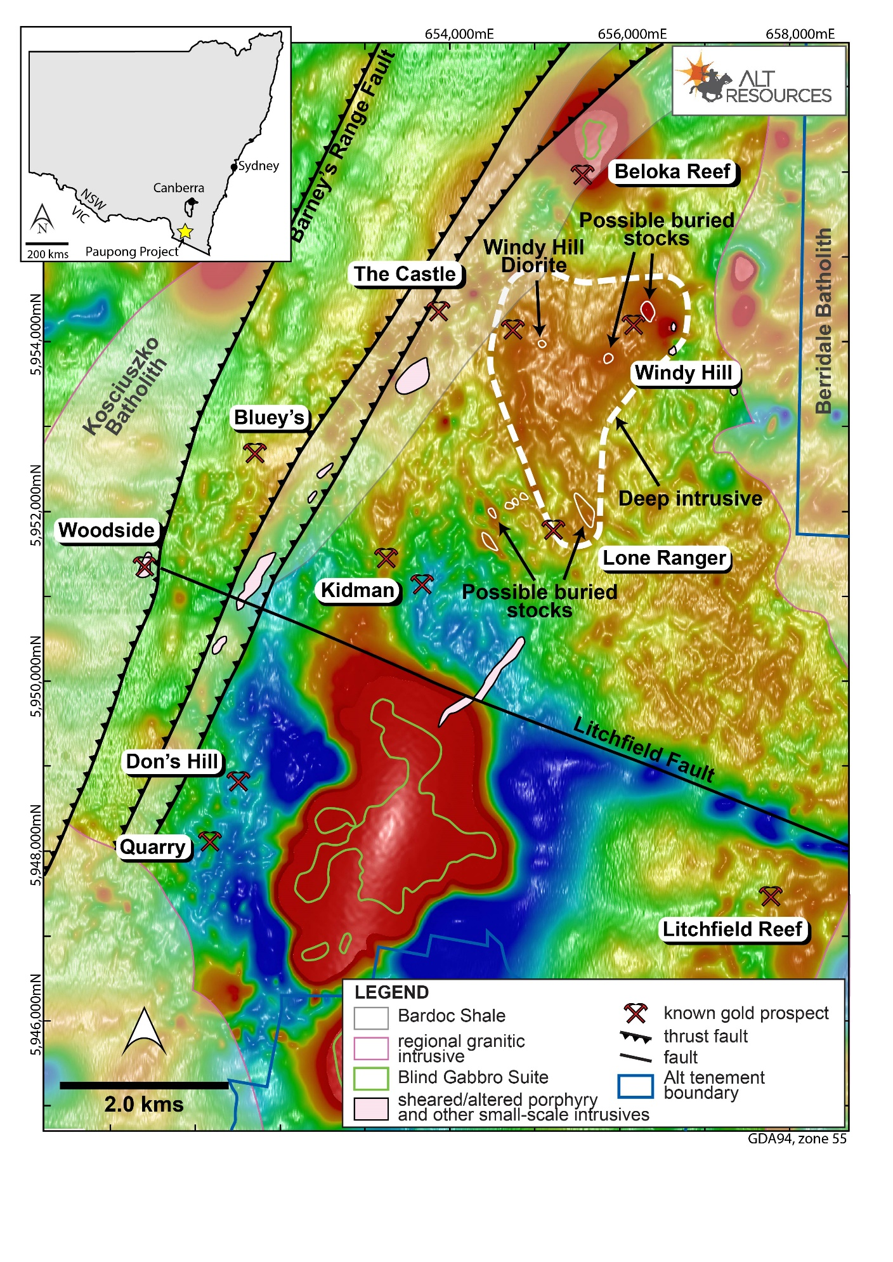
Figure 1. Distribution of mapped granitic bodies at the Paupong Project relative to known gold mineralisation, large-scale structures and regional RTP magnetic response. The background image is Alt Resources' aeromagnetic data flown in January 2016, whilst the broad-scale geology outlines are from the Bega-Mallacoota 1:250,000 Sheet (Lewis and Glen, 1995). Local-scale sheared/altered porphyry intrusions and other small-scale intrusions have been mapped by Alt Resources. The location of buried (non-outcropping) intrusions and stocks are shown in the Windy Hill and Lone Ranger areas, based on drill results and magnetic modelling.
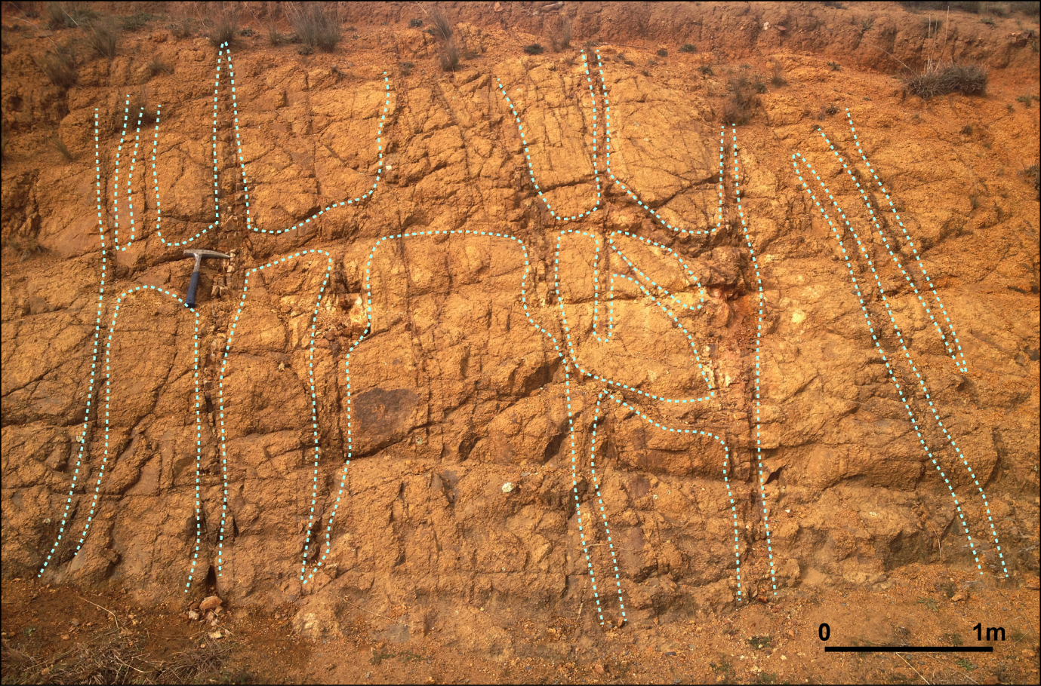
Figure 2. Porphyritic granite at Paupong with anomalously mineralised quartz veins and stockwork throughout (outlined in pale blue).
Magnetic Data
In 2016, Alt Resources completed a 5,000 line kilometre high resolution aeromagnetic and radiometric survey across the Paupong Project area. A number of magnetic features were revealed which were not visible in the coarser regional magnetic data set. These were interpreted as late stage stocks intruding to shallow depths. The magnetic features occur as a cluster, and appear to postdate and penetrate a larger intrusive body located at a depth of about 400m below surface (Figure 1). The magnetic anomalies occur beneath zones of known quartz-sulphide and quartz stockwork veining, and associated breccia zones mapped at surface (the Windy Hill prospect).
IP Data
Areas of magnetic anomalism at Windy Hill were also tested by Dipole-Dipole Induced Polarisation (IP) geophysics, over an area of 3 km². The resulting 3D IP model shows very strong anomalies (~35 mv/V) associated with the strongest magnetic anomalies (M1, M2 and M3 on Figure 3). The strongest IP responses form a partial doughnut around the M1 and M2 magnetic anomalies, and include both chargeability and resistivity. These areas have been interpreted as zones of quartz stockwork or sheeted quartz veins forming an envelope around and above the interpreted buried intrusions. Figure 3 shows the relationship between the magnetic and IP responses in 3D.
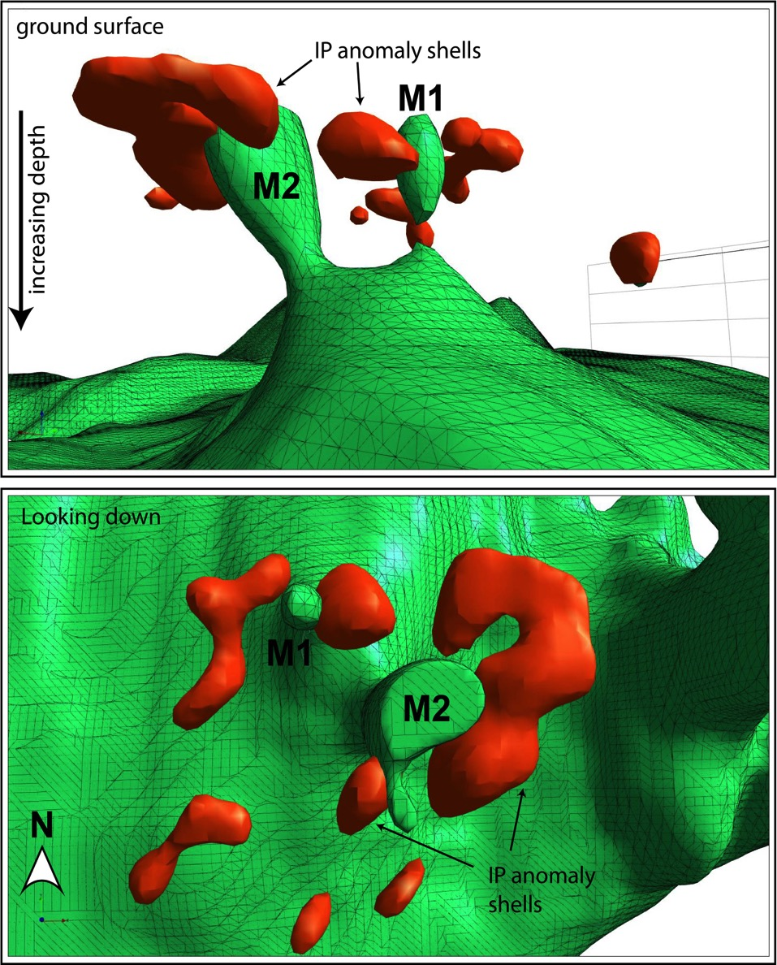
Figure 3. 3D image of the magnetic model (green shell at 143 Si units) and IP model (red shells at 37 mv/V). The view in the top image is to the south-west, looking obliquely upwards towards the ground surface. The bottom image is looking directly down. These images clearly demonstrate the close relationship between the M1 and M2 magnetic anomalies and enveloping IP anomalism.
Geochemical Zonation
Data from 1,300 soil samples, rock chip samples, mapping and diamond drilling at Windy Hill have defined a profound mineralogical and geochemical alteration halo associated with magnetic and IP targets. Zonation is apparent in Au, Ag Cu and Zn, with an outer polymetallic zone of Zn + Ag (± Cu ± Pb), transitioning to and inner zone of Au + Cu (± Zn ± Pb). These zones are interpreted as halos above a cluster of buried intrusions and represent the influx of substantial sulphide-bearing, albeit low-gold fluids into the country rock. A pyrite-mineralised diatreme breccia, interpreted as a venting structure associated with cooling and de-gassing of the intrusion, was also intersected in recent drilling. This hole (PDD018) revealed a 235m downhole width of pyrite-rich breccia with pyrite-rich diorite matrix.
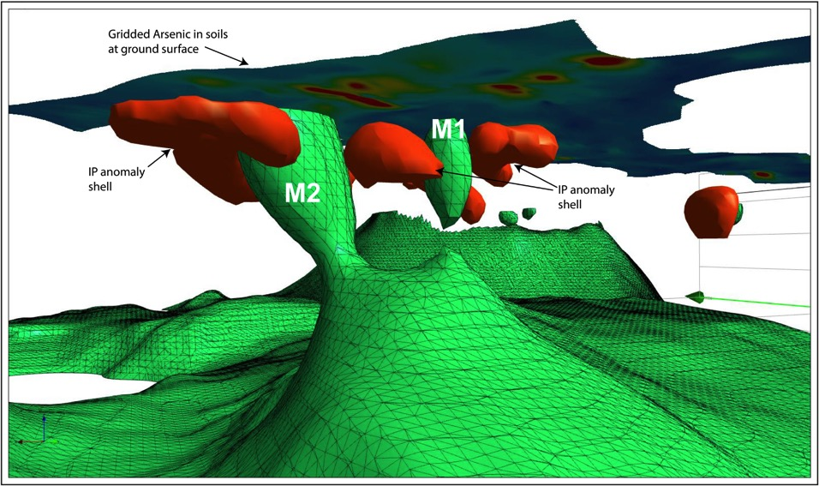
Figure 4. 3D image of the magnetic model (green shell at 143 Si units), IP model (red shell at 37 mv/V) and gridded arsenic anomalism in soils at surface. The view is to the south-west, looking obliquely upwards towards the ground surface. This image clearly demonstrates the close relationship between the M1 and M2 magnetic anomalies, and IP anomalism, as well as anomalous arsenic in soils at surface.
Figure 4 shows the complete data set (geophysical and geochemical) in 3D, focusing on the M1 and M2 anomalies. The relationship between geophysical features, both magnetic and IP, and surface geochemistry is clearly illustrated. In this case, the gridded arsenic surface is shown.

In addition to As, zoned Cu, Pb and Zn anomalies were identified over the Windy Hill magnetic and IP anomalies (Figure 4). Over the strongest of the magnetic and IP anomalies, surface geochemical anomalism has a diameter of ~850m, and displays a distinct pattern of zonation. An As-rich core is present, with a Pb-rich western margin, and Cu+Zn-rich eastern margin; (Figure 4 and Figure 9).
Drilling of the geophysical anomalies revealed pervasive magnetite and pyrrhotite alteration of the host sediments (turbiditic sandstones and siltstones). Minor mineralised zones were associated with sheeted and stockwork quartz veins. No significant intrusive body was intersected however several minor dykes were encountered downhole. The sediments in drillhole PDD015, in particular, also revealed a strong contact metamorphic overprint. This is related to intrusion of the nearby, voluminous (barren) Berridale Batholith.
Detailed petrographic analysis of the magnetite-pyrrhotite alteration zone revealed that propylitic alteration affects the host sandstone, while pyrrhotite, arsenopyrite, chalcopyrite, sphalerite and rare galena, native bismuth and bismuthinite occur as part of the mineralisation assemblage. Therefore, alteration and mineralisation are interpreted to be co-genetic. Furthermore, these sulphides (pyrrhotite and arsenopyrite) record a relatively reduced assemblage, consistent with global IRGS models. A small, non-magnetic granitic dyke within the alteration system shows propylitic to greisen-style alteration, forming in direct association with granite emplacement and associated fluid discharge. This is consistent with an intrusion-related gold model. The propylitic-greisen alteration postdates contact metamorphism associated with intrusion of the nearby (barren) Berridale Batholith. The Dalgety pluton of the Berridale Batholith has a U-Pb zircon age of 435.1 ± 4.4 Ma (Ickert and Williams, 2011).
A number of key timing relationships can be derived from these observations:
- Regional, large scale and barren intrusions (such as the Berridale Batholith) pre-date alteration and mineralisation at the Paupong IRG system.
- Hydrothermal, granite-related alteration is associated with polymetallic sulphide mineralisation, and the two features were therefore introduced into the host rocks as part of the same event.
The 3D model for magnetic anomalies M1 and M2 in Figure 6 shows the paired magnetic (green) and IP (brown) anomalies with interpretation confirmed by drilling. Sheeted quartz-sulphide veins are interpreted to have produced the IP chargeability response, whilst the strong presence of magnetite + pyrrhotite is responsible for the observed magnetic response. Fluids responsible for producing these discrete, spherical anomalies are interpreted to be sourced from buried intrusive stocks. The whole system has been overprinted by contact metamorphism from the nearby younger Berridale Batholith
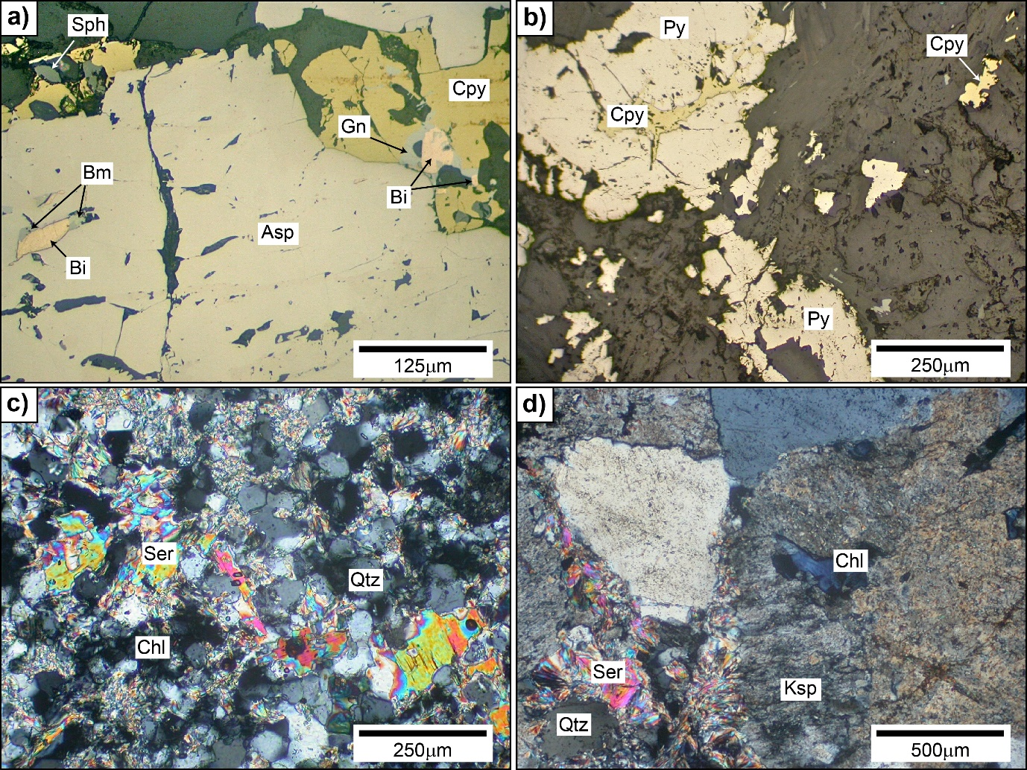
Figure 5. Photomicrographs of thin section samples from Windy Hill drillcore; a) PDD015 191 m, Arsenopyrite (off-white) hosting a small composite of bismuth (creamy-pink) and pale grey bismuthinite at left. Adjacent chalcopyrite (yellow) hosts a composite of bismuth and galena at right, and a small grey sphalerite grain at upper left. Host rock is a metamorphosed pelitic rock. Plane polarised reflected light; b) PDD016 86.7 m, pyrite aggregates (pale creamy) in metamorphosed quartz-rich sandstone. Pyrite probably formed by retrograde replacement of former pyrrhotite, with a couple of associated aggregates of chalcopyrite (yellow). Plane polarised reflected light; c) PDD015 394 m, granular, recrystallised metasiltstone showing abundant quartz, and overprinted by strong development of sericite-muscovite and chlorite (dark). Transmitted light, crossed polarisers; d) PDD015 394 m, altered granite from vein showing interlocking grains of K-feldspar (slightly turbid) and quartz, with local replacement of feldspar by sericite-muscovite (bright colours) and minor chlorite (dark bluish). Transmitted light, crossed polarisers. Mineral abbreviations are: Asp = arsenopyrite, Bi = bismuth, Bm = bismuthinite, Chl = chlorite, Cpy = chalcopyrite, Gn = galena, Ksp = K-feldspar, Po = pyrrhotite, Py = pyrite, Qtz = quartz, Ser = sericite.

.
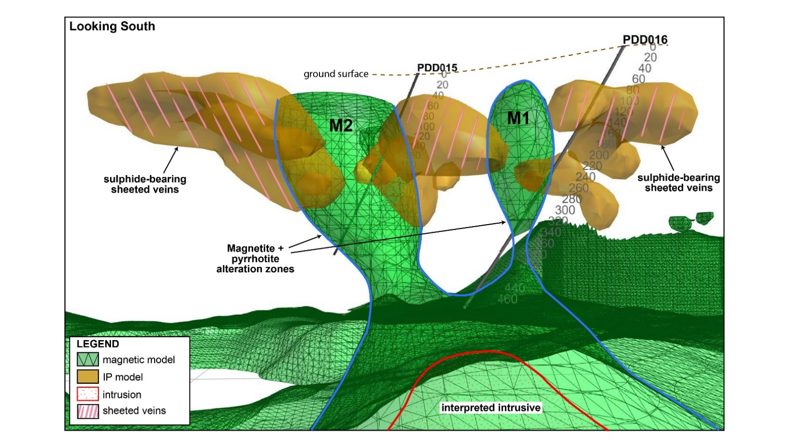
Figure 6. 3D image of PDD015 and PDD016 showing the path of the drillholes through IP (brown) and magnetic (green) anomaly shells. The interpreted geological features that produced these geophysical responses is shown as sulphide-bearing quartz veins for the IP anomaly, and magnetite + pyrrhotite alteration zones for the magnetic anomaly. The source intrusive for these paired circular anomalies is shown at the bottom of the image in an estimated position based on magnetic response at depth. The cut-off for the green magnetic model shell is 143 Si units, whilst the cut-off for the brown IP model shell is 37 mv/V.
Diatreme Breccia
A prominent gossanous breccia mapped in the western part of the Windy Hill prospect was tested by diamond drilling in 2017. The breccia was intersected from 114m and occurred over a downhole width of 235m (Figure 7). At surface, the breccia has a gossanous or quartz-dominated matrix. However, from 110m vertical depth, the breccia in drill core was revealed to have a pyrite-rich diorite matrix. The diorite matrix is homogeneously and pervasively speckled with round pyrite clots (Figure 8).
Thin section analysis reveals the breccia matrix to be a sparsely porphyritic quartz microdiorite with strong, pervasive sodic to greisen type hydrothermal alteration. Pyrite forms local porphyroblastic aggregates and is part of the greisen-alteration assemblage. Trace galena and pyrrhotite were also identified as inclusions in pyrite. The breccia clasts are medium-grained sandstone with strong greisen alteration and veining. Where the breccia has a quartz vein matrix, irregular scattered masses of coarse pyrite also occur. Pyrite is poikiloblastic and intergrown with the alteration silicates.
The relationship between the microdiorite and other intrusives throughout the project area is unclear at this stage. The diorite does not lie on the same structural trend as other rocks of the Paupong Intrusive Suite, and has a distinctly different trace element signature. The magnetic response is subtle, and quite unlike the very strong magnetic character of the Blind Gabbro Suite. The abundant and pervasive pyrite alteration suggests a relationship with mineralisation, however the diorite is barren in assay for all precious and base metals.
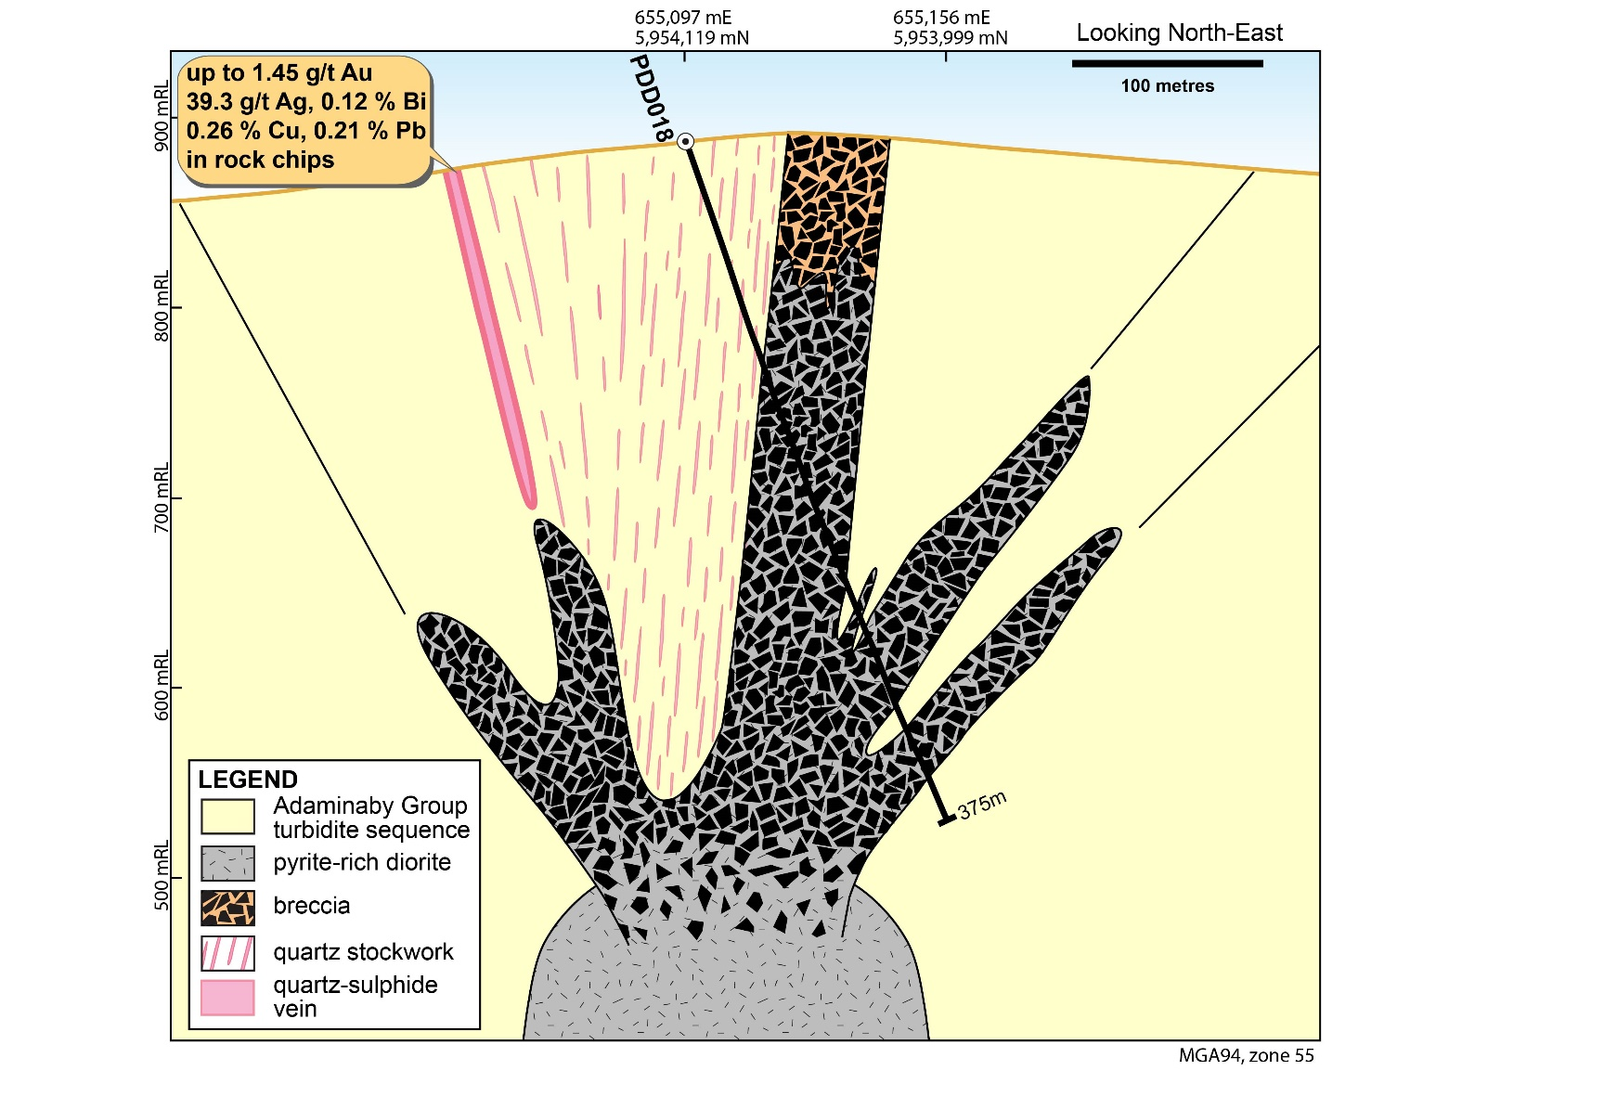
Figure 7. Cross-section of PDD018 showing interpreted diatreme breccia with associated stockwork zone and peripheral quartz-sulphide veins (pink), with source intrusive interpreted at depth. The pyrite-rich diorite forms the matrix of the breccia downhole in PDD018, but is not evident in the matrix of the breccia in surface outcrop.
The breccia in PDD018 is interpreted as a late stage hydrothermal structure associated with cooling and de-gassing of the buried diorite intrusion shown in Figure 7. A semi-circular ring of outcropping breccia has been mapped at surface, associated with a subtle magnetic anomaly which appears to form a donut shape. The breccias are situated over the outer ring of the donut, with an interior magnetic low and a second subtle magnetic high at the core.

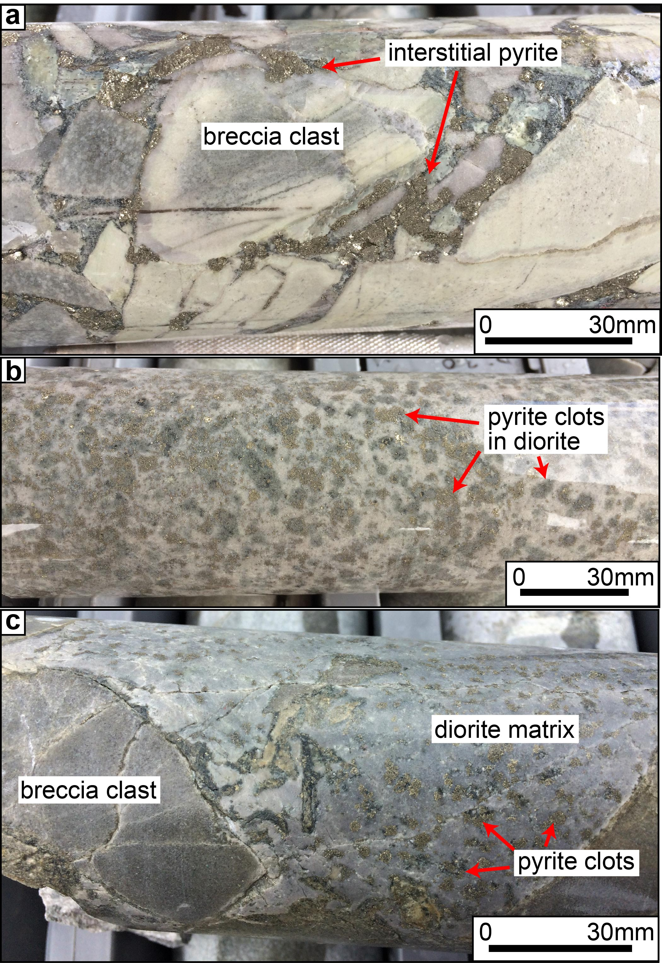
Figure 8. Photos of drillcore from PDD018; a) pyrite-bearing diatreme breccia at approximately 120m downhole. The coarse pyrite forms part of the matrix between breccia clasts; b) Pyrite-rich diorite intrusive associated with breccia in (a), also at approximately 120m downhole. Pyrite aggregates up to 1cm wide are visible as abundant, homogeneously distributed bronze-coloured patches within the white/grey matrix; c) breccia with pyrite-rich diorite matrix at approximately 198m downhole, demonstrating the intimate relationship between the two rock types, and the abundance of pyrite throughout.

Paupong IRG system
The new, combined exploration results at Paupong appear to demonstrate that gold and associated mineralisation form part of an Intrusion-Related Gold System (IRGS). An IRGS is a mineralised magmatic-hydrothermal system, with gold as the dominant commodity, in which there is a demonstrable genetic link to an intrusive body (Morrison and Beams, 2015). IRG systems in Eastern Australia tend to show unusually abundant polymetallic mineral associations (Blevin, 2006, 2009), consistent with observations at the Paupong Project. Other examples include Dargues Reef and Mount Adrah in southern NSW, Timbarra in the New England Orogen, and Kidston, Mt Leyshon and Ravenswood in Queensland.

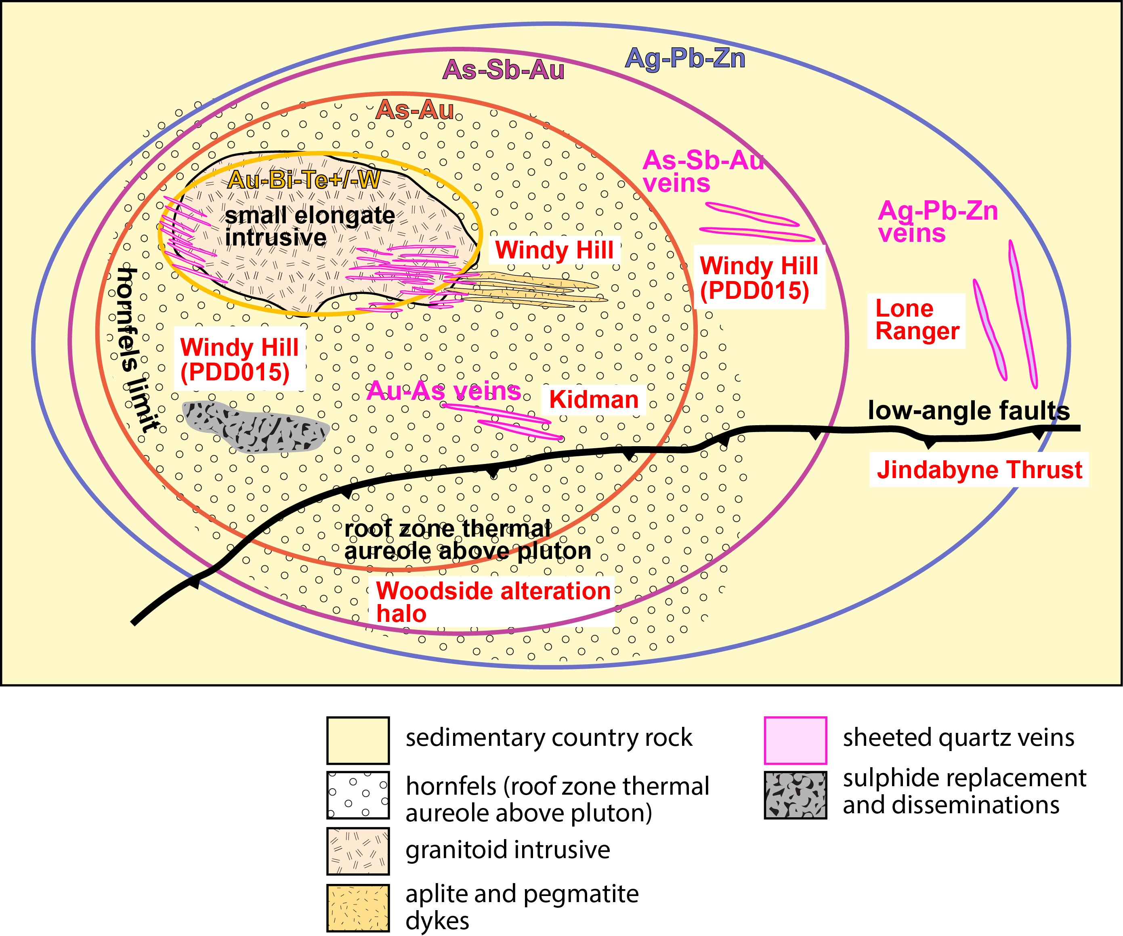
Figure 9. Conceptualised model of a representative Intrusion-Related Gold System, showing geological, mineralogical and geochemical zonation features. Modified from Hart (2005) and based on Intrusion-Related Gold Systems in the Tintina Gold Province, Alaska and the Yukon.
Surface vein sampling and drilling by Alt Resources have shown a very strong association between gold and arsenic, copper, bismuth, tellurium and lead. The project area contains an abundance of outcropping intrusive bodies, identified by geological mapping, with confirmation of the existence of at least one blind intrusive at Windy Hill. Additional non-outcropping intrusions may also be present based on interpretation of aeromagnetic data. Intrusion of the Paupong Suite appears to have driven greisen-style alteration coincident with the introduction of polymetallic sulphide mineralisation.
Intrusion-related gold deposits can display distinct zonation in both geochemistry and alteration mineralogy. These features show a progression from distal to proximal, and tend to be quite predictable in their pattern of zonation. For comparison with the Paupong system, Figure 9 shows a conceptual geochemical and geological zonation map typical of deposits in the 2000 km long Tintina gold belt in the Yukon and Alaska. On this image, the various components of the Paupong gold system are shown for comparison. Most features of mineralisation in the Paupong Project area strongly support an IRGS conceptual model, and provide vectors that indicate a cluster of buried but shallow intrusive sources. A number of differences between Paupong and the conceptual Tintina deposits do exist, however this schematic map, applied to a system in Alaska, has not previously been applied to this degree in the Lachlan Orogen of southern New South Wales.

References
BLEVIN P. L. 2004. Redox and compositional parameters for interpreting the granitoid metallogeny of Eastern Australia: Implications for gold-rich ore systems. Resource Geology, 54, 241-252.
BLEVIN P. L. 2006. Granite-associated mineralisation in New South Wales: Data, models and opportunities for the future. Mines and Wines 2006 Mineral exploration in New South Wales – SMEDG & DPI Geological Survey.
BLEVIN P. L. 2009. Granites and mineral deposits in NSW. SMEDG presentation April 2009.
HART C. J. R. 2005. Classifying, distinguishing and exploring for intrusion-related gold systems. The Gangue, 87, 1-9.
ICKERT R. B. & WILLIAMS I. S. 2011. U-Pb zircon geochronology of Silurian-Devonian granites in South Eastern Australia: implications for the timing of the Benambran Orogeny and the I-S dichotomy. Australian Journal of Earth Sciences, 58, 501-516.
LEWIS P.C. & GLEN R. A. 1995. Bega-Mallacoota 1:250,000 Geological Sheet ST/55-4, SJ/55-8. Second edition. Geological Survey of New South Wales.
MORRISON G. & BEAMS S. 2015. Intrusion-Related Gold Systems of the Charters Towers Province, North Queensland. AIG Bulletin, 62, 193-208.
WALTENBERG K., BLEVIN P. L., HUGHES K. S., BULL K. F., FITZHERBERT J. A. & ISAACS D; (in prep). New SHRIMP U–Pb zircon ages from the Lachlan Orogen and the New England Orogen, New South Wales: Mineral Systems Projects, July 2016–June 2017. Geoscience Australia Record, Geological Survey of New South Wales Report.

See ARS Announcement, 24th May 2016: http://www.altresources.com.au/wp-content/uploads/2016/11/Major-New-Gold-Targets-24-May16.pdf

