**East Riverina mapping project: laying the foundation for resource discovery**

Phil Gilmore, Kate Bull, Lorraine Campbell, Daniel Cronin, Mark Eastlake, Steven Trigg and Brad Williams

Geological Survey of New South Wales

**Key words:** East Riverina, Lachlan Orogen, porphyry, mineral systems

**Introduction**

The East Riverina Mapping Project is generating data and ideas to lay the foundation for resource discovery, and to enable informed regional land-use decisions. The aim of the 5-year project is to understand the geodynamic history of the area, including the timing, nature and pathways of heat/fluid transfer into the upper crust – the drivers of mineral systems.

Located in the central Lachlan Orogen of NSW (Figure 1), the project area is prospective for a range of deposit styles, including magmatic tin–tungsten deposits, orogenic gold, rare earth elements, intrusion-related gold, and copper–gold porphyries with associated epithermal systems.

Systematic field mapping is being integrated with specialist studies in mineral systems, geochronology, palaeontology, spectral analysis, geophysical modelling, reinterpretation of existing seismic lines, 3D modelling, and hydrogeochemistry (with CSIRO).

The new 1:100 000 scale, or better geological mapping generated from field work will be incorporated into the NSW seamless geology coverage. Field observations/measurements and analytical data are available online in the GSNSW Geoscientific Data Warehouse (<http://dwh.minerals.nsw.gov.au/CI/warehouse>). Quarterly project updates with links to project reports and products are available on the GSNSW website (<http://www.resourcesandenergy.nsw.gov.au/miners-and-explorers/geoscience-information/projects/east-riverina-mapping-project>).

The aim of this talk is to highlight some results of the project and their implications for mineral exploration.

**Regional geology**

The project area includes the Wagga part of the Wagga–Omeo metamorphic belt, and is bounded by the Gilmore and Kancoona fault zones to the east and west, respectively (Figures 1 and 2). Major units through the project area are:

* Ordovician metasedimentary rocks of the Wagga and Bendoc groups
* Early Silurian volcanic rocks (e.g. Gidginbung, Temora and Junawarra volcanics)
* Silurian S-type granites of the Koetong and Tom Groggin suites
* Siluro-Devonian sedimentary rocks such as the Ootha Group
* Early Devonian volcanic rocks (e.g. Gurragong and Walleroobie volcanics)
* Devonian I-type granites (e.g. Holbrook, Jinderra)
* Devonian quartz-rich sandstones of the Cocoparra Group

**Field mapping**

Increasing the resolution of geological mapping is a key output of the project. Existing Wagga Wagga and Narrandera 1:250 000 geological maps were released in the late 1960s, before the development of modern mapping techniques that allow interpretation below deep alluvial cover. The Cootamundra 1:250 000 geological map was published in 1996, before acquisition of high resolution geophysical data.

Field mapping began for the East Riverina project in 2014, in the Ardlethan and Barmedman 1:100 000 map sheet areas. Field work has now been completed over the northern parts of the project area, with work continuing in the central and southern parts (Figure 1). Annual field reports have been produced by the mapping team. Detailed mapping projects by post-graduate students at the University of Newcastle complement the GSNSW mapping. For example, Williams et al. (2015) constrained the timing of metamorphism and deformation in the Holbrook area by studying and dating monazite growth in different tectonic fabrics, and Bell et al. (2016) investigated kinematics and timing of movement along the Gilmore Fault Zone.

**Geochronology**

Over 60 new age dates (U–Pb dating of zircon) for the project area have been determined in conjunction with Geoscience Australia (SHRIMP) and the University of Newcastle (LA-ICP-MS). This work has led to a revised magmatic history for the area (e.g. Bull et al. 2017, Campbell et al. 2017), and provided insight into the provenance of detrital zircons in sedimentary rocks.

Two batches of samples from mylonitic zones have been submitted to the University of Melbourne for Ar–Ar isotopic analysis, to constrain the age of deformation and metamorphism in different parts of the project area (in time and space).

**Crustal architecture**

Potential field modelling, seismic interpretation and 3D modelling are unravelling the crustal architecture of the project area. Venkataramani et al. (2016) modelled the deep crustal seismic line GA-99AGS-L3 in the Barmedman area, which crosses the Gilmore Fault Zone and the Early Silurian Gidginbung Volcanics. Work by Robinson (in prep.) along the deep crustal seismic line GA-99AGS-L2 in the Lake Cowal area to the east of the Gilmore Fault Zone on associated faults such as the London–Victoria Fault, has led to detailed interpretation of fault systems at depth.

**Mineral systems**

Mineral system studies have focussed on the style, fluid source (e.g. sulfur, lead) and mineralisation age (e.g. Ar–Ar) of epithermal–porphyry systems (Cronin et al. in prep.), magmatic-related tin mineralisation (Furnass et al. 2014, Blevin et al. 2017), intrusion-related gold, orogenic gold systems and rare earth elements. Exploration models for these systems are in progress.

Postgraduate research projects with the Lachlan ARC Linkage project are currently in progress at porphyry Cu–Au/epithermal prospects at Dobroyde and Gidginbung. These projects will involve mineral geochemistry, geochronology, petrography and spectral studies, including Hylogger™ scanning of core.

**Acknowledgments**

This abstract and presentation is a summation of work by a large number of contributors since 2014: Phil Blevin, Astrid Carlton, Robert Musgrave, Kyle Hughes, John Greenfield (Geological Survey of NSW), Jamie Robinson and Glen Phillips (ex- Geological Survey of NSW), Simon Bodorkos, Kathryn Waltenberg, Phil Main (Geoscience Australia), Deepika Venkataramani, Michael Bell, Alistair Hack, and Bill Collins (University of Newcastle).

**References**

Bell, M., Hack, A.C., Boutlelier, D.A., Collins, W.J. and Phillips, G. 2016. The geodynamic significance of the Gilmore fault zone, Lachlan Orogen: structural characteristics, kinematic history and timing. Abstract for the 2016 Australian Earth Sciences Convention. Available online <http://aesc2016.gsa.org.au/assets/AESC-2016-Abstract-Book-as-at-070716-opt.pdf> (then search by author).

Blevin P. L., Kemp. A. and Bodorkos, S. (2017). Age and origins of S- and I-type magmas at the Ardlethan tin deposit, NSW. Extended abstract for the granites@Benalla 2017 conference, September 2017.

Bull K. F., Blevin P. L. and Fitzherbert J. A. (2017). Felsic volcanic rocks of the central Lachlan Orogen. Extended abstract for the granites@Benalla 2017 conference, September 2017.

Campbell, L.M., Blevin, P.L., Bodorkos, S., Bull, K.F., Eastlake, M.A., Gilmore, P.J., Trigg, S.J. and Williams, B.J. 2017. New insights into the magmatic history of the central Lachlan Orogen, New South Wales. Extended abstract for the granites@Benalla 2017 conference, September 2017.

Cronin D. E., Kitto J., Mowat, B., Munro S. and Scott M. M. (in prep.). Temora copper–gold deposits. Australian Ore Deposits (ed. Phillips G. N.). Australian Institute of Mining and Metallurgy, Melbourne.

Furnass, M., Blevin, P.L. and Hack, A. 2014. Constraining source and duration of tin mineralisation at Ardlethan, NSW: an example of multimillion year time-scales for magma-driven hydrothermal systems from U–Pb dating of cassiterite. Abstract for the 2014 Australian Earth Sciences Convention. Available online [http://www.aesc2014.gsa.org.au/assets/V arious-reg-partner-opp-workshop-summ- /AESC-Abstract-Proceedings.pdf](http://www.aesc2014.gsa.org.au/assets/V%20arious-reg-partner-opp-workshop-summ-%20/AESC-Abstract-Proceedings.pdf) (then search by author).

Robinson, J. (in prep.). Central Lachlan Orogen major fault model. Geological Survey of NSW, Maitland.

## Williams, B., Hack, A., Phillips, , G. 2015. [HTLP metamorphism & accretionary orogen geodynamics: View from the WOMB (Wagga–Omeo Metamorphic Belt)](https://uonblogs.newcastle.edu.au/earthscience/2015/10/20/htlp-metamorphism-accretionary-orogen-geodynamics-view-from-the-womb-wagga-omeo-metamorphic-belt/). University of Newcastle Honours thesis. Summary available online <https://uonblogs.newcastle.edu.au/earthscience/2015/10/20/htlp-metamorphism-accretionary-orogen-geodynamics-view-from-the-womb-wagga-omeo-metamorphic-belt/>

Venkataramani, D., Musgrave, R. and Boutelier, D. 2016. Understanding the 3D Structure of the Gilmore Fault Zone through geophysical modelling: implications for Lachlan tectonic reconstructions. Extended abstract of he Australian Society of Exploration Geophysics. Available online <http://www.publish.csiro.au/ex/ASEG2016ab236>

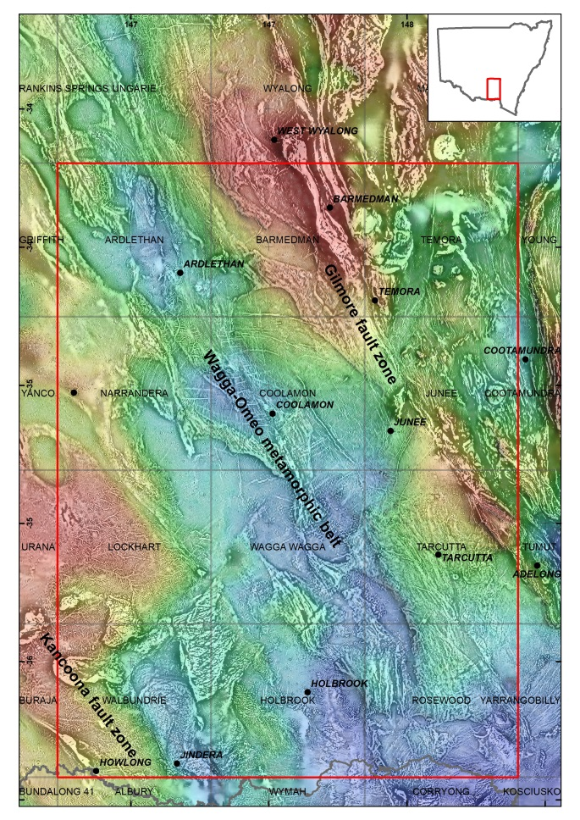

Figure 1. Location of the East Riverina project area (red box, approx. 150 km × 200 km) in southern NSW. Background image is greyscale first vertical derivative of total magnetic intensity underlain by colour Bouguer gravity. Shown are 1:100 000 map sheet names, selected towns (in italics), and the NSW–Victoria border (the Murray River in grey).

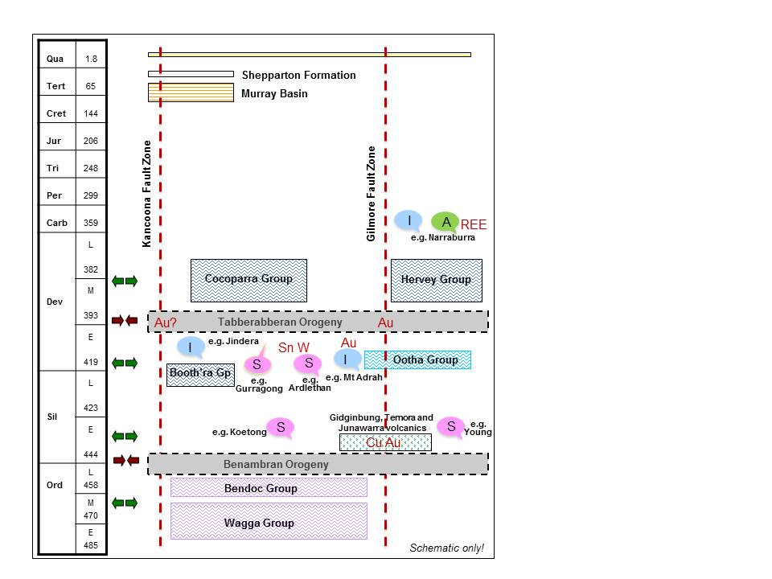

Figure 2. Schematic time–space diagram for the East Riverina project area.