**DISCOVERY OF THE BYGOO TIN DEPOSIT, CENTRAL NSW, AUSTRALIA**

**Eoin Rothery and David Ward**

Thomson Resources Ltd

**Key Words:** Bygoo, Ardlethan, tin, greisen, radar

**INTRODUCTION**

The Bygoo Tin discovery is the first significant find for many years in the Wagga tin belt of the Lachlan Orogen. The S-type granites of the Wagga tin belt stretch for over 600km from Victoria through New South Wales and contain over 330 separate, known tin deposits (Mamuse and Guj 2013). Most of these deposits are small, with only the Ardlethan deposit known so far to exceed 1,000 tonnes of contained tin. The Bygoo deposit lies within the Ardlethan tin field and some 7km north of the old Ardlethan tin mine.

**ARDLETHAN TIN MINE**

The tin mine at Ardlethan was the most productive on the Australian mainland. From its discovery in 1912 until 1986, when mining ceased following a collapse in the price of tin, it processed over 9 million tonnes of ore containing 48,000 tonnes of tin (Paterson, 1990). The total endowment at the old Ardlethan mine using the production figures; an unpublished mine report (Molina and Doran 1989) at 5,500,000 tonnes of ore at a similar grade of 0.45% Sn; and estimates of low grade material stockpiled on site (Kimber 2011) gives a pre-mining endowment in excess of 90,000 tonnes of contained metal.

Historic production peaked in 1919 when 680 tonnes of concentrate were produced and sporadic production of around 100 tons of contained tin continued until the mine was taken up by Aberfoyle (later in joint venture with Cominco as “Abminco”). Commercial production began in 1965 and continued until 1986, with peak production in 1979 of 583,000 tonnes of ore at 0.57% tin.

Three main igneous bodies occur in the Ardlethan area: the Mine granite, a garnet-bearing quartz-feldspar porphyry, and the Ardlethan Granite. At the regional scale they form part of the Late Silurian to early Devonian Koetong Supersuite (Blevin and Chappell, 1995). The Ardlethan granite is highly fractionated compared with other granites of the Koetong Granite Supersuite, including the Mine Granite, indicating potential for tin-tungsten enrichment.

Although the Ardlethan Granite is thought to be associated with the tin mineralisation, the Ardlethan tin mine lies 400m east of the surface exposure of the Ardlethan Granite (Figure 1), which is thought to dip east under the mine. The tin deposits are hosted in breccia pipes, probably sourced from the Ardlethan Granite, that intrude older rocks including the Mine Granite, porphyries, rhyolite and Ordovician sediments.

**PREVIOUS EXPLORATION AROUND ARDLETHAN**

Tin was discovered at Ardlethan in 1912 and by 1915 nearly 40 separate operations were being worked on the field (Godfrey 1915). Outside the main Ardlethan complex of breccia pipes, the vast majority of the regional tin workings were on the Ardlethan Granite itself (Figure 1). The workings stretch over a distance of 24km, distributed concentrated north-south along the eastern edge of the Ardlethan Granite. Significant production came from two areas – Little Bygoo comprising a number of separate operations including Smiths and Dumbrells, and Big Bygoo which includes the Titanic, Lone Hand and Leviathan. Recorded production until activity ceased around 1946 was about 26,000 tonnes at 1% tin from the Little Bygoo group (Mosher and Raggat 1947) and 10,640 tonnes at 1.9% tin from the Big Bygoo Group (Mines Inspectors 1967). The workings include open cut pits, shafts and drives on underground levels but did not extend to significant depths.

Between the 1960s and 1980s extensive regional exploration was undertaken carried out in the Ardlethan tin field, by the mine operator (Aberfoyle) and competitors such as Billiton (the then metal division of the Shell Company of Australia). Much of this was directed to finding further breccia-hosted deposits at some distance from the Ardlethan Granite contact (Figure 1). In fact, of the 3,300 or so exploration drilling holes recorded up to 2015 in company reports, only around 1,400 were drilled on or within 250m of the Ardlethan granite – that is 43% of the holes, or only 34% of the metres (~25,000m). These numbers largely exclude drilling on the Ardlethan Mine leases and drilling targeting alluvial deposits. The average depth of this exploration drilling was quite shallow at 18m. The other major issue for that exploration drilling was that only 35 holes (2%) are recorded as being angled, with the vast majority being drilled vertically.

The regional exploration program by Abminco was generally unrewarding with minor hard rock occurrences discovered at several locations around 2-3km distant from the Ardlethan Mine at Carrolls (North), Browns Knob, Fordes Gossan (East) and Stouts (Southeast). Several alluvial deposits were also discovered around Ardlethan including Yithan, North Road and Carrolls, as well as at Bald Hill 12km to the south.

**The Bygoo area**

The most promising location in the Abminco exploration was at Bygoo where 26 percussion holes defined a small, low-grade, pre-JORC “resource” near the Dumbrells working in the Little Bygoo area (Paterson and Yates 1977). This drilling defined a shallow east dipping quartz, sericite, muscovite, tourmaline, topaz-rich greisen or alteration zone at the contact between a fine-grained phase of the Ardlethan Granite and garnet porphyry. Within this greisen disseminated cassiterite occurs sporadically and commonly associated with tourmaline. Despite the presence of some high grades the report concluded that although the mineralisation remained open the opportunity for grade improvement appeared limited.

Exploration dried up after the closure of Ardlethan in 1986, along with many other tin mines globally, owing to the collapse of the International Tin Council support for the tin price. Very little exploration was done around Ardlethan in the years between 1986 and 2015, with one unsuccessful short drill program carried out at Dumbrells in 2011.

**EXPLORATION RATIONALE AND DEPOSIT MODEL**

Thomson Resources was set up in 2009 to explore for under cover deposits in the Thomson Fold Belt in northwestern NSW. The effort was successful with multiple large mineralised hydrothermal systems identified by deep drilling of magnetic anomalies. However, investor interest for such covered potential was lacking and so Thomson developed and acquired new projects across NSW. The first hole drilled by Thomson at Cuttaburra intersected 1m at 0.8% tin (as well as significant silver, zinc, copper, gold, lead and tungsten) which sparked a company interest in broader tin potential in NSW. Thomson acquired a tin prospect in the Wagga Tin Belt at Wilgaroon north of Cobar in 2012 and briefly held the Victory tin prospect near Wagga Wagga in 2013. In 2014, Thomson acquired the Mt Jacob intrusion-related gold project near Kempsey which also has a significant carbonate hosted tin-copper skarn deposit. After the Bygoo acquisition Thomson also acquired the Mt Paynter tin-tungsten project on the NSW-Victorian border in 2015.

However, the big prize was EL 8260 surrounding the old Ardlethan Mine leases. Thomson acquired this in a share deal in early 2015 and focussed immediately on the Little Bygoo area with its multiple workings and reported “high-grade intersections” reported by Abminco.

The large size of the Ardlethan deposit suggests very good potential to find significant deposits in the 5-40,000 tonnes range of contained tin in the Ardlethan tin field based on mineral prospectivity analysis by Mamuse and Guj 2013. Like many other deposit styles tin deposits are often clustered, suggesting the potential for multiple deposits in any one area. The extensive historical workings taken together with little modern effective exploration enhances the potential of the Ardlethan tin field.

Tin mineralisation in the Ardlethan area manifests in at least three different ways indicative of differing processes – greisen style, vein style and breccia pipes (Blevin 1998). All types are related to plutonic igneous activity involving exsolution of mineralising magmatic aqueous fluids from crystallising granites. The Ardlethan Mine deposits are prime examples of the breccia-pipe type. Explosive brecciation may be related to excess fluid pressure in the crystallising Ardlethan Granite at depth (Ren et al 1995), with multiple episodes of brecciation and intrusion of highly fractionated rock types such as the Mine Porphyry. Tin deposition from volatile fluids exploited the permeability of the brecciated zones.

The difference between the vein and greisen types is mainly size and grade, i.e. how concentrated the mineralisation is. Vein deposits tend to be low tonnage and high grade, whereas greisen deposits tend to be higher tonnage and lower grade (Blevin 1998). Both types are associated with the roof zones of granitoids, commonly in the apical parts of plutons. Background tin within the Ardlethan Granite increases markedly from west towards the eastern outcrop edge (Ren et al 1995), suggesting a spatial association with this eastern part of the granitoid.

The Bygoo deposit is not a breccia pipe, but may be part vein, part greisen. In addition multiple greisen types are observed – the greisen with abundant tourmaline is typically low grade and may represent a more typical greisen-type whereas the topaz greisen carries very high grades and may be more akin to a vein deposit.

**BYGOO NORTH EXPLORATION BY THOMSON**

The Abminco exploration had defined a shallow east dipping tabular zone of mineralisation with erratic grade distribution (Paterson and Yates 1977). However early work (Godfrey 1915, Mosher and Raggat 1947) had described the mineralisation in terms of veins and pipes at vein intersections, or in one case as occurring as an “inverted funnel”. Spectacular high grades encountered may have been in the form of “slugs or spuds of tinstone” including one “two and a half ton” mass that ran 63% tin.

Descriptions of the lodes and veins described them as having multiple strike directions and lying steep to vertical in sketches. Accordingly, a drill program was designed to test Bygoo North (Dumbrells to Corners) with angled holes of various azimuths.

The first drill program was completed in June 2015 and had immediate success. Holes BNRC3, 4 and 10 all had strong intersections with that in BNRC10 being the best at 13m at 1% tin from 66m hole depth (Figure 2). The geometry suggested a line east-west that corresponded with some of the higher grade intersections from the Abminco work. Accordingly the next program was designed to test for a steep to vertical east-west or ENE-WSW striking lode. Interestingly, the greisen appears to lie southeast of the main Dumbrells working and may not have been accessed by the historical operation.

The next program appeared to confirm this interpretation with 35m at 2.1% tin in BNRC11 and 10m at 2% tin in BNRC13. Holes BNRC10, 11 and 13 were all drilled from south to north and intersected broad mineralised alteration zones, so following programs were designed to drill from north to south to estimate true width of this steeply dipping greisen vein now termed “Bygoo North”.

North to south drilling in September 2016 confirmed and extended the ENE-WSW zone and established that the greisen had substantial true width. Intercepts included 8m at 1.7% tin from 121m depth in BNRC19 and 11m at 2.1% tin from 78m depth in BNRC20. In addition, several other greisens appeared to be intersected by the new drilling (Figure 2). The current interpretation is of a network of NE-SW and NW-SE linked greisen zones, one extending SW along the line of historic workings.

**Bygoo North Geology**

The Bygoo North greisens consist of a quartz – topaz – cassiterite alteration zone several metres wide. Petrology from the BNRC11 intercept reported a highly fractionated, siliceous hydrothermal / metasomatic pegmatoidal vein-like deposit of granular quartz and topaz that hosts significant, disseminated cassiterite and subordinate patchy tourmaline. The cassiterite forms spongy anhedral interstitial aggregates of crystals into which project subhedral terminated host crystals of earlier-formed quartz and topaz. Cassiterite has an average grain size of about 0.5 mm, ranging up to 3.2mm.

The lack of sulphides in this quartz – topaz – cassiterite mineralisation is in strong contrast to the Ardlethan Mine where pyrite, chalcopyrite and arsenopyrite were common accessories. Given the strong density contrast between cassiterite and quartz or topaz effective gravity methods of concentration may be available. The absence of significant sulphides from the main greisen also suggests that a cleaner concentrate could be produced.

Tourmaline-rich greisen alteration commonly forms either side of the quartz-topaz greisen zone and also hosts significant tin. The greisen appears to be an alteration product of the Ardlethan Granite, as the alteration passes laterally into the common and barren pink two-feldspar biotite granite. The greisen does not appear to extend upwards into the overlying unit that Abminco described as quartz-garnet porphyry. This lack of upward continuation may have contributed to the “contact greisen” interpretation of earlier work. At this stage it is not clear whether other intersections at or near the contact represent true contact greisen or whether these are additional vertical greisen zones.

Overall, the Bygoo North greisen shows good continuity with multiple wide intercepts. However in detail there are some complexities: in some holes multiple topaz greisens appear and in one or two there is a suggestion of a barren quartz rich core. This may mean there are several greisens within an overall zone; they may pinch and swell or they may thicken at joint or vein intersections. Diamond drilling is planned to answer some of these questions. The Bygoo North greisen remains open along strike and at depth and will be the focus of further drilling to establish its full extent.

**Bygoo South**

The Little Bygoo area is divided by a lot boundary, the southern section being a road reserve and Crown Land. As such access for exploration was not available until a year after the project was acquired. Initial drilling in late 2016 under the Smiths open cut resulted in a strong tin intercept of 8m at 1.5% in BNRC21. Recent drilling has added further strong intersections to this prospect with 20m at 0.9% in BNRC31.

The Bygoo South mineralisation has important differences to Bygoo North. Firstly the mineralisation is hosted well within the Ardlethan Granite, not in any “roof” or ‘contact” zone. Secondly the mineralisation is sulphide rich and has similar mineralogy to the Ardlethan deposits with accessory pyrite, chalcopyrite and arsenopyrite. Sulphides are largely absent from the quartz-topaz greisen at Bygoo North. The geometry of Bygoo South is not clear at this stage and further drilling is needed, but it does not appear to be a simple steeply dipping tabular zone.

**Geophysics**

Abminco and others tried multiple geophysical techniques during the 1970s to 1980s exploration but reported “it became apparent that there are no outstanding geophysical features of Ardlethan ore which can be easily used in grass roots exploration” (Paterson and Yates 1977). Nevertheless, Thomson conducted a high-resolution ground magnetic survey over the Little Bygoo area. Magnetic anomalies coincided with the two main open cuts at Bygoo South and were assigned to metallic waste disposal.

Thomson also conducted ground penetrating radar (GPR) surveys which appeared to detect a strong apparent fault associated with the mineralisation. Interpretation of the GPR is non-trivial as there are several parameters at play e.g. soil composition and stratification; rock crystallinity, composition and pore space (and thus density); conductivity of pore fluids and bulk rock; conductive media like wet clays and salt water that inhibit the signal; groundwater; and mineralogy. So, while geophysical techniques remain under consideration, drilling will be the main exploration tool in the short term.

**Further Afield**

The lack of sustained exploration along the eastern edge of the Ardlethan Granite, where more than 40 separate areas of historic workings have exploited tin mineralisation offers excellent potential to find additional significant deposits. In particular, mention should be made of Bald Hill, where Billiton discovered a substantial alluvial tin deposit at the foot of the hill by drilling 77 holes, but directed only three holes at hard rock source targets under the multiple historic tin workings on nearby Bald Hill itself.

**CONCLUSIONS**

The Bygoo discoveries represent the successful application of a modern exploration approach in an area with outstanding potential but neglected for many years. Thomson sees excellent potential to develop a standalone mining operation in the Bygoo area, with multiple small to medium size deposits scattered along the Ardlethan Granite contact. The different chemistry and setting of the Bygoo North discovery from its Ardlethan Mine neighbour suggests opportunities for cheaper and cleaner processing.

**REFERENCES**

BLEVIN P. 1998. Palaeozoic tin ±tungsten deposits in eastern Australia. AGSO Journal of Australian Geology & Geophysics, 75-79.

GODFREY J.R. 1915. Report on the Ardlethan tin field: New South Wales Geological Survey Mine Report 20 (No. MR02435.R00045678).

KIMBER P. 2011. Ardlethan tin mine, NSW, Summary of resources – tailings and waste dumps. Unpublished report by Reynard Australia Ltd.

MAMUSE A and GUJ P. 2013. Tin Prospectivity Mapping and Resources Assessment, Wagga Tin Belt, New South Wales. Geological Survey NSW DIGS GS2013/0833 (R00049859).

MINES INSPECTORS 1967. Mine Record No. 1600. Available from the Geological Survey of NSW as report MR01600.R00047456.

MOLINA A.B. & Doran P.M. 1989. Ardlethan Information Brochure. Unpublished Report for Aberfoyle Resources Ltd.

MOSHER K.G. & RAGGATT H.G. 1947. Little Bygoo Mine and Drumlish Hill Mines, Ardlethan. Mine Inspector’s Reports, Mine Record 2594. Available from the Geological Survey of NSW as report MR02594.R00050060.

PATERSON R.G. & YATES K.R. 1977. Final report Exploration Licence 647, Ardlethan, NSW. Unpublished report for Ardlethan Tin NL. Available from the Geological Survey of NSW as report GS1977_093.R00016502.

PATERSON R G 1990 - Ardlethan Tin deposits: in Hughes F E (Ed.), 1990 Geology of the Mineral Deposits of Australia & Papua New Guinea. The AusIMM, Melbourne. Monograph 14, v2, 1357-1364

REN S. K., WALSHE J. L., PATERSON R. G., BOTH R. A., ANDREW A. 1995. Magmatic and hydrothermal history of the Porphyry-style deposits of the Ardlethan Tin field, New South Wales, Australia. Economic Geology 90, 1620-1645.

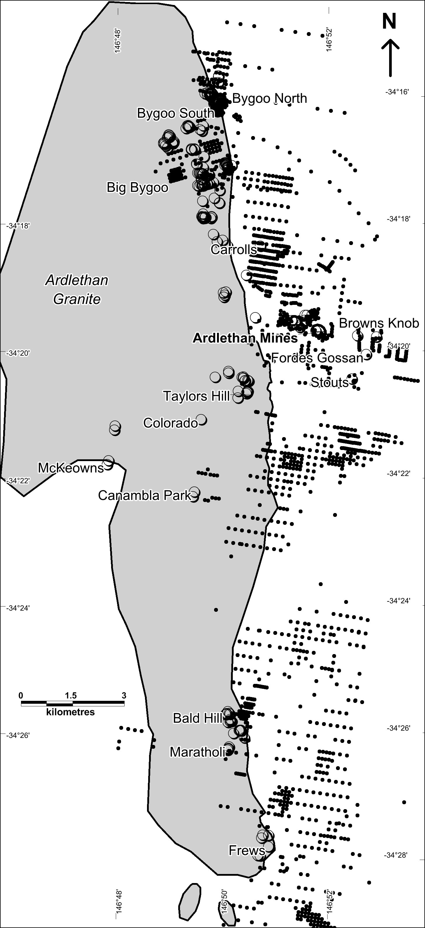

*Figure 1: Ardlethan area, showing the outcrop area of the Ardlethan Granite; historic tin workings (open circles) and exploration drillholes (closed circles: depth greater than 10m).*

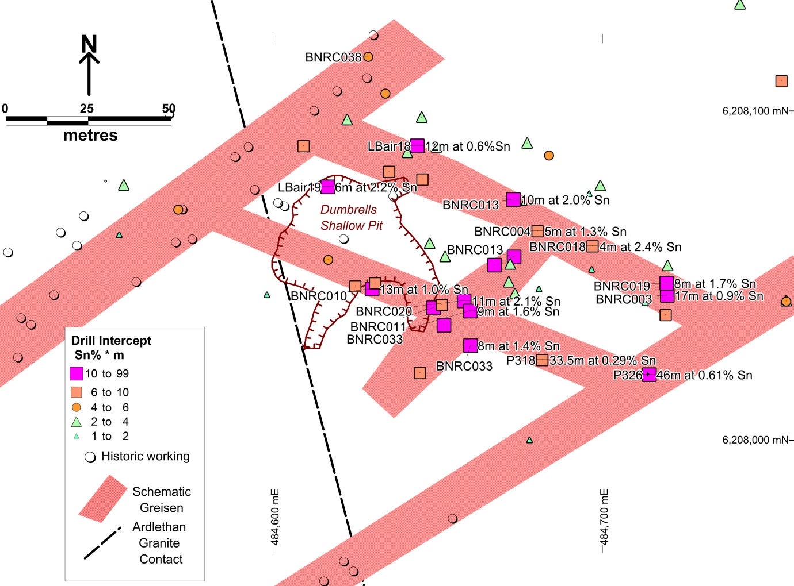

*Figure 2: Bygoo North plan view. Schematic greisen interpretations shown with intercept mid-points (vertically projected). Greisens are interpreted as steeply dipping. The Ardlethan Granite contact is shown; it outcrops to the west and dips to the east. Holes prefixed “BN” are by Thomson Resources, Holes prefixed “LB” or “P” are by Aberfoyle/Cominco.*