**Dover Castle Zn-Pb-Ag ± In Project**

**Matt Haindl (1) and Doug Menzies (2)**

(1) Dover Castle Metals (2) GeoInsite Pty Ltd

**Key Words:** Zinc, Lead, Silver, Tin, porphyry, gold, Dover Castle, Lachlan Fold Belt, Dimbulah, Muirson Rhyolite, Featherbed Volcanic Group.

**ABSTRACT**

The Dover Castle Project area (EPM10834, EPM15452 and ML20499), located 30km SW of Dimbulah in northern QLD, hosts lode-style Zn-Pb-Ag ± In ± Au mineralisation. This vein hosted low sulphidation poly-metallic epithermal Zn-Pb-Ag ± In ± Au mineralisation, which is an end member of carbonate-base metal epithermal Ag-Au mineralisation defined by Corbett and Leach (1998), is hosted within the 301 (± 9) Ma Late Carboniferous porphyritic Muirson Rhyolite of the Featherbed Volcanic Group. A large aeromagnetic and gravity low, indicative of an intrusion, is situated to the NW of the project area and interpreted to be the source of metal bearing fluids.

Zn-Pb-Ag ± In ± Au mineralisation at the Dover Castle, Midas, Comstock, Silver King and Better Luck prospects is hosted within 1-1.5m wide lode-style galena, red-brown sphalerite-carbonate-quartz bearing veins that pinch and swell. Locally elevated In values appears to be associated with elevated Zn values indicative of In substitution into sphalerite crystal structure. The NS striking Better Luck vein has a length of approximately 500m, and that the Silver King, Midas, Dover Castle and Comstock prospects also exhibit a broad NS-NNE en echelon orientation. Geological mapping and drill intercepts have defined a mineralised system over 1.5km in length. Hydrothermal alteration of the rhyolite host rocks, peripheral to lodes, is typically silica-sericite-epidote, whilst gangue minerals in the veins are carbonate and silica.Soil samples collected at 50m centres on 100m spaced E-W grid lines, and analysed with a hand-held XRF, defined zones of elevated Zn-Pb-Ag ± In ± Au associated with historically worked prospects and an untested area to north. A dipole-dipole induced polarisation survey (14 line km, 50m spaced dipole centres on 250m spaced lines) identified an area of elevated chargeability (> 12mV/V) coincident with the elevated Pb-Zn-Ag soil and rock samples collected in the northern part of the project area. This zone has a strike length of 1400m, a width of 200 m, and a depth to the source of the chargeability anomaly at 150-200m. Best intercepts from 56 reverse circulation hole bored into the project area are:

* 4m @ 24.32% Zn eq from 86m depth in DCRC0001 drilled into Better Luck prospect.
* 4m @ 14.50% Zn eq from 57m depth in DCRC0002 drilled into Better Luck prospect.
* 2m @ 11.12% Zn eq from 129m depth in DCRC0004 drilled into Better Luck prospect.
* 2m @ 9.54% Zn eq from 62m depth in DCRC0048 drilled into Better Luck prospect.
* 12m @ 6.77% Zn eq from 166m & 21m @ 1.88% Zn eq from 227m into the northern IP target.
* 14m @ 3.84% Zn eq from 146m & 29m @ 3.31% Zn eq from 187m into the northern IP target.
* 18m @ 7.15% Zn eq from 58m & 11m @ 1.85% Zn eq from 207m into the northern IP target.

A model for the structural evolution of the Dover Castle project Ag-Zn- Pb-Sn ± In ± Au bearing veins is proposed whereby dextral movement along NW trending structures has facilitated the development of NS trending dilatant fractures, which promoted fluid flow from a magmatic source at depth. This dilatant environment has also facilitated the emplacement of diorite domes, locally coincident with mineralisation in the Dover Castle EPM. It is proposed that the deposition of the Zn-Pb-Ag ± In ± Au mineralisation resulted from the mixing of rising Pb-Zn-Ag-Sn-In-Au bearing magmatic fluids with bi-carbonate waters as evidenced by high grades closely associated with carbonate and base metal bearing veins,The predominance of fine grained chalcedonic silica and fine-grained galena is indicative of rapid cooling, limited sulphide crystal growth and quenching of silica. The occurrence of bornite, chalcopyrite and red-brown sphalerite indicates that sulphides were deposited from a high temperature fluid proximal to a magmatic source.

**INTRODUCTION**

The Dover Castle project (EPM10834, EPM15452 and ML20499), located 30km SW of Dimbulah in northern QLD, hosts lode-style Zn-Pb-Ag ± In ± Au mineralisation (figure 1). It was identified and purchased by a recently graduated geologist who decided that he needed to generate work for himself (the main author).

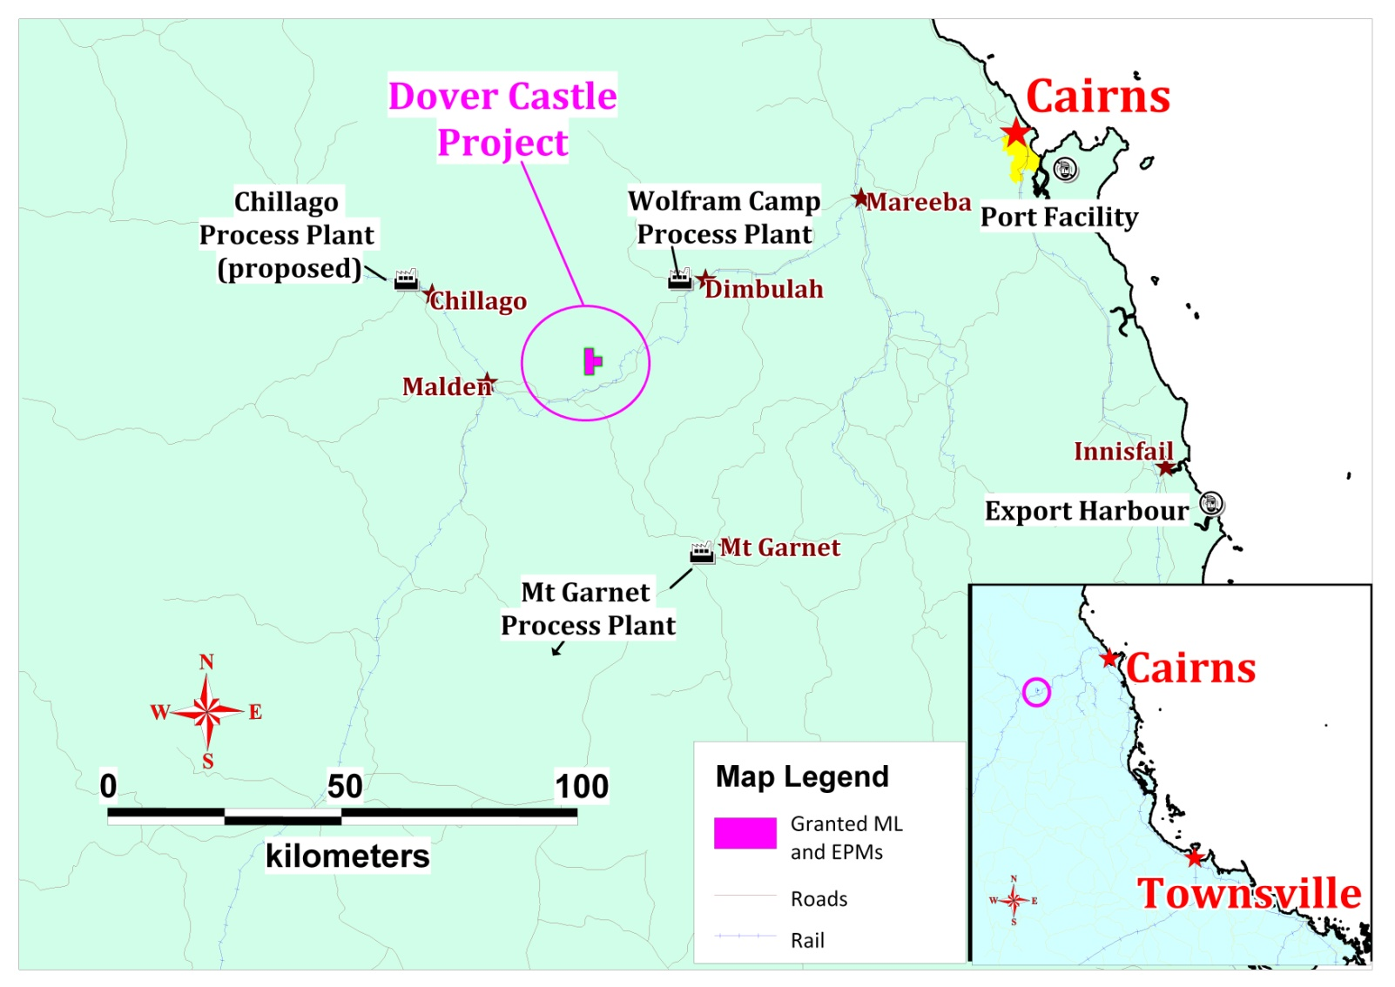

Figure 1. Dover Castle polymetallic project, north Queensland (Sheehan, 2015a)

**REGIONAL GEOLOGY**

Mineralisation in the Dover Castle area is hosted within the 301 (± 9) Ma, Late Carboniferous (Black 1978) porphyritic Muirson Rhyolite of the Featherbed Volcanic Group (Mackenzie, 1993). This unit consists of a dark grey, intensely welded, medium to coarse grained hornblende-biotite rhyolitic ignimbrite with large quartz phenocrysts. Accessory minerals are magnetite, apatite, zircon and the unit has been moderately to intensely chlorite, sericite, calcite, epidote and leucoxene altered (Mackenzie, 1993). Mackenzie (1993) estimates the Muirson Rhyolite is at least 350m and up to 750m thick. To the north of EPM 10834 the Muirson Rhyolite is overlain by the 304-306-million-year-old (Mackenzie, 1993) RockHole Rhyolite which consists of a massive pale pink crystal-rich, leucocratic biotite-bearing rhyolitic ignimbrite with weak sericite, chlorite and calcite alteration. NW of EPM 10834 is a large area mapped as the Early Permian (288 ± 17 Ma, Mackenzie, 1993) Arringunna Rhyolite which is coincident with a large aeromagnetic and gravity low described below. This area has been described as Featherbed Cauldron, one of nine nested volcano-tectonic collapse structures identified by Mackenzie (1993). The Arringunna Rhyolite consists of numerous flow units of massive crystal-rich rhyolitic ignimbrite and has been divided into a lower less mafic sub-unit and an upper more mafic sub-unit. The total thickness of this package is estimated by Mackenzie (1993) to be 150-200m in the northwest to at least 900m in the east and southeast. On the E side of EPM 10834 the sequence has been intruded by the Mid Carboniferous to Early Permian Ootann Granite Suite which is a medium to course grained biotite-hornblende bearing granite with minor mafic enclaves and sedimentary inclusions. Nerthery (2014) documents four main periods of intrusive activity within the region based on dating of the separate supergroups (Mackenzie, 1993), which are (figure 2): O’Brien’s Creek Supersuite at 315 Ma, Almaden and Ootann Supersuite at 300 Ma, Claret Creek and the Lags Supersuite at 290 Ma and 280 Ma respectively. The Dover Castle project area is bordered by the arcuate shaped younger Tennyson Ring Dyke to the east, which extends for some 30km. Three major faults in the area are the Lappa Creek Fault to the NW, the Oaky Creek Fault to the S and the Bamford Creek Fault to the E.



Figure 2. Histograms of age dates showing the four main peaks of activity (Nethery, 2014).

**Previous exploration and historical production**

Original miners worked the Comstock Ag-Pb vein between 1884 and 1893 (Hilla, 2000) dominantly with primitive mining methods, transporting ore in saddlebags by mule pack teams to the Mt Albion Silver Lead Smelting Works approximately 50km away. A collapse in the silver price in 1893 led to the abandonment of the mine. Jensen (1919) reported the Comstock lode was a steeply dipping, 1.2m wide pinch and swell vein which reported grades of 38.5 ounces of Ag/t (1192 g/t Ag) and 35.8% Pb and exhibited increased sphalerite content with depth.

The Dover Castle mine was discovered in 1890 and was worked by Irvinbank Mining Co until 1906 when it laid dormant until being sold to Bagden in 1958. Bagden worked a cassiterite lode that trended NE and dipped 55-80°SE down to a depth of 170m and reported highest grades associated with calcite. The total quantity of cassiterite processed from the Dover Castle mine in the period 1906 to 1958 was 361.5 tons (Keyser and Wolff, 1964). The Dover Castle, Midas, Better Luck, Comstock and Christmas Gift veins examined by Dover Tin Mines Ltd in the mid 1960’s who completed sampling, costeaning, mapping, geophysical surveying and drilling. No further detail of this exploration was available at the time of this review. Mareeba Mining and Exploration took out an option over the Dover Castle area in the early 1970’s (Keyser and Wolff, 1964) with no data being available for the work completed at the time of this review.

In 1978-79 Houston Oil and Minerals (Aust) Inc took out an option over the 8 hectare Dover Castle mining lease, ML 1363, from C.J Bagden as well as being granted an addition 130ha of mineral leases termed the Red Herring Leases. Houston Oil and Minerals completed 1:2000 scale geological mapping, collected 31 rock chip samples and drilled 4 holes for a total of 466m into the Dover Castle (Syvret, 1979). A review of the Comstock vein within EPM 10834 was undertaken by geologist Frank Hilla in 2000 to evaluate the potential for additional resources of Pb-Ag (Hilla, 2000). Four samples collected during this review reported an average of 9.76% Pb, 4.31 % Zn, 778 g/t Ag, 421 ppm Cd, 11.7 ppm Ga and 567 ppm In, with only one sample being analysed for Sn, which reported 3.45%. This report concluded that the Comstock vein, using a strike length of 250m x depth of 150m x 2m width and SG of 3.5, had a bulk potential ore reserve of 98000 tonnes. In 2014 a young un-employed geologist (Haindl) began prospecting in the area, realised the potential of the Dover Castle prospects, and closed a deal with the tenement holders which lead to the establishment of Dover Castle Metals Pty Ltd.

**REGIONAL GEOPHYSICAL DATA**

**Aeromagnetic data**

The regional total magnetic intensity aeromagnetic data exhibits a large, prominent low to the NW of EPM 10834, and several other lows to E and NE (figure 3). The large aeromagnetic low to the NW is coincident with a zone mapped as the Arringunna Rhyolite within the Featherbed Caldera (Mackenzie, 1993), and is rimmed by a noticeable aeromagnetic high indicative of magnetite created during a hornfels event caused by the intrusion of a granite. There is a clear cluster of Au-Cu-Pb-Ag-Sn mineral occurrences around the margins of these circular aeromagnetic lows and NW trending faults which are depicted by linear zones of magnetite depletion (figure 3). A prominent NW trending fault is evident immediately N of EPM 10834 (figure 3).

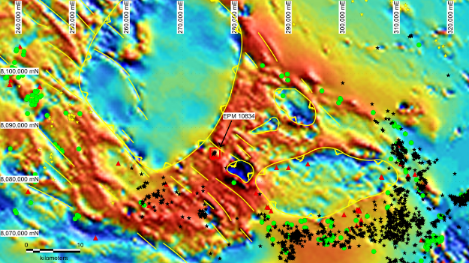

Figure 3. Total magnetic intensity aeromagnetic data (Geoscience Australia) showing a prominent low to the NW, E and NE of EPM 10834 (Dover Castle), NW trending faults (yellow lines) and mineral occurrences (yellow stars = Au, red triangles = Ag, green circles = Cu, and black stars = Sn) (Menzies, 2014b)

**Gravity data**

Regional bouguer gravity data highlights a large low coincident with the aeromagnetic low displayed in figure 3, indicative of a less dense granite intruded into the denser volcano-sedimentary pile (figure 4). A NW trending structural grain can also be seen in this gravity data (figure 4).

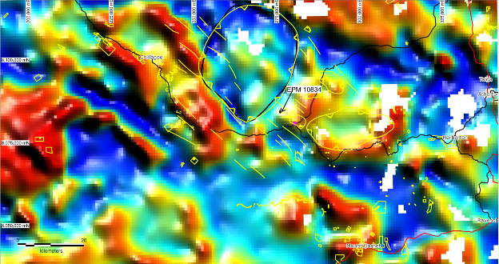

Figure 4. First vertical derivative bouguer gravity data (Geoscience Australia) overlain by aeromagnetic interpretation (yellow lines) showing the location of EPM10834 (Menzies, 2014b)

**LOCAL GEOLOGY**

**Lithology**

The dominant lithology observed within the Dover Castle project area is a quartz-eye porphyritic rhyolite which locally exhibits moderate to intense silica flooding and minor vughs after feldspar, and is interpreted to correlate with the Muirson Rhyolite as defined by Mackenzie (1993). In the south western portion of Dover Castle hill there is a minor outcrop of weakly feldspar porphyritic andesite with a chlorite-rich, aphanitic groundmass, which is interpreted to correlate with the trachyandesite unit of the Featherbed Volcanics reported by Syvret (1979). Dark grey, medium grained diorite was observed on the mullock heap at Midas mine, Dover Castle mine and in drill core believed to have been bored into the Dover Castle mine area. The diorite is believed to correlate with the Ootann Granite suite from Mackenzie (1993) and may be a heat source driving hydrothermal fluid flow.

**Hydrothermal Alteration**

Intense silicification with moderate to strong sericite alteration was observed in the quartz porphyritic rhyolite at Dover Castle hill which appears to have leached out feldspar and locally shows a vughy texture. Silicification has ensured that this unit was resistive to weathering and, as a result, has created the prominent ridgeline of Dover Castle hill. Moderate sericite alteration is also evident within the porphyritic rhyolite. Minor epidote veined feldspar porphyritic diorite was observed in the creek between Dover Castle shaft and Comstock shaft which is indicative of a high temperature environment proximal to a porphyry hydrothermal fluid-bearing source (photo 12). Galena-sphalerite-pyrite bearing veins contain minor rhodochrosite (pink Mn carbonate) which is an indication of the mixing of bi-carbonate bearing waters with metal bearing magmatic fluids as proposed by Corbett and Leach (1998) (photos 19-25). This is supported by historical petrographic studies by Huston Oil (Fander, 1979) which reported the occurrence of sericite-chlorite alteration of rhyolitic volcanic with vein gangue of carbonate, chlorite, and quartz.

**Mineralisation**

The NS trending (355-020°/55-70° E) Better Luck vein, which exhibit a strike length of approximately 500m, is 1-1.5m wide and exhibits massive galena-red brown sphalerite-chalcopyrite-bornite-pyrite ± tetrahedrite with chalcedonic silica (plates A-D figure 5). The occurrence of Fe-rich, red brown sphalerite, bornite and chalcopyrite in these samples is indicative of proximity to a high temperature fluid source. Minor carbonate-sericite and fine-grained silica gangue occur associated with veins. Flat-dipping, Fe oxide stained veins were observed adjacent to the Better Luck prospect, which appear to have been created by normal movement on NS trending structures. Abundant limonite, plumbojarosite and Mn oxide occurs around Better Luck vein. Rock samples collected returned bonanza Ag grades including two sample from Better Luck prospect that reported 5030 g/t Ag, 783 ppm As, 604 ppm Cu, 147.5 ppm In, 58.50 % Pb and 0.97% Zn (plate A, figure 5), and a second sample that reported 767 g/t Ag, 5.94 % As, 178 ppm Cu, 31.7 ppm In, 11.35 % Pb, 0.11% Zn (plate B, figure 5). Overall Sn values were of a low tenor with the maximum value of 480ppm Sn reported from Better Luck prospect.

The Comstock prospect, which contains a 7m deep shaft, comprises several pits into NE trending veins some of which exhibit a shallow dip (ie 50°SE). Mineralisation occurs as a massive galena and red-brown, Fe-rich sphalerite bearing lode (plates E & F, figure 5). Red-brown, Fe-rich sphalerite is indicative of deposition from a high temperature fluid proximal to a magmatic source. Quartz-galena veins exhibit a gangue of fine silica and orange Fe-rich carbonate (ankerite) within grey medium-grained diorite porphyry. Previous samples collected at Comstock prospect by Hilla (2000) show highly anomalous Ag-Pb-In-Zn values. The highest In grades were reported from Comstock prospect where assays returned maximum values of 423 g/t Ag, 1.43% As, 0.27% Cu, 3130 ppm In, 14.35 % Pb, and 16.90 % Zn (plate E, figure 5), and another that reported 1510 g/t Ag, 1.70 % As, 0.57% Cu, 1920 ppm In, 32.20 % Pb, and 17.05 % Zn (plate F, figure 5). The association of high In with high grade Zn supports the interpretation that In is incorporated in the sphalerite lattice.

The Midas prospect includes historical workings that exhibit a NS vein trend (355°/70° E) and are proximal to the broad zone of intense silicification associated with Dover Castle Hill. Dover Castle prospect, which includes a large disused mine shaft and demolished head-frame, has historically produced 360 tons of cassiterite. The Silver King prospect exhibits several historical shafts and pits along a NS strike. Mineralisation is dominated by fined grained galena, red-brown, high temperature Fe-rich sphalerite in chalcedonic silica bearing veins. These veins are 500m along strike from the Feldspar prospect pits which, although not inspected in this review, could represent the northern extent of the Silver King veins (figure 6). Gangue minerals seen in Silver King veins are quartz, sericite and carbonate which, along with chalcedonic silica and fine galena, are indicative of rapid cooling caused by fluid mixing resulting in limited galena crystal growth and the quenching of silica. Gossanous yellow-green plumbojarosite with red-brown limonite/Fe oxide which exhibit box-work voids after galena and sphalerite were abundant around old working.

|  |  |
| --- | --- |
| C:\Data\photos\QLD\Dover Castle - Mareeba\IMG_1701 Weathered massive galena -quartz - back argentite +- carbonate - Better Luck prospect.JPG | C:\Data\photos\QLD\Dover Castle - Mareeba\IMG_1705 Limonite + yellow Pb oxide, sample 554b, Better Luck prospect south.JPG |
| Plate A. Massive galena-quartz ± carbonate which reported 5030 g/t Ag, 783 ppm As, 604 ppm Cu, 147.5 ppm In, 58.5 % Pb, 1.0% Zn from Better Luck prospect. | Plate B. Limonite + yellow plumbojarosite which reported 767 g/t Ag, 5.9 % As, 31.7 ppm In, 11.35 % Pb, and 0.1 % Zn Better Luck prospect. |
| IMG_2972 Massive fine grained galena-sphalerite-pyrite, which reported 797 gt Ag, 154ppm In, 15.25% Pb and 8 | IMG_2977 Galena-pyrite-hematite which reported 163 gt Ag, 30.2 ppm In, 3.6% Pb, 1 |
| Plate C. Massive fine-grained galena-sphalerite-pyrite, which reported 1m at 797 g/t Ag, 154 ppm In, 15.25 % Pb and 8.2 % Zn from 87-88m in DCRC001, drilled into Better Luck prospect. | Plate D. Galena, dark brown sphalerite and pyrite mineralisation which reported 1m at 163 g/t Ag, 30.2 ppm In, 3.6 % Pb, 1.8 % Zn from 89-90m in DCRC001 drilled into Better Luck prospect. |
| C:\Data\photos\QLD\Dover Castle - Mareeba\IMG_1722 Massive galena and red-brown sphalerite, sample 562b, Comstock prospect.JPG | C:\Data\photos\QLD\Dover Castle - Mareeba\IMG_1727 Galena and red-brown sphalerite, sample 562c, Comstock prospect.JPG |
| Plate E. Massive galena and red-brown sphalerite which reported 0.12 g/t Au, 423 g/t Ag, 1.4 % As, 0.3 % Cu, 3130 ppm In, 14.4 % Pb, 16.9 % Zn Comstock prospect. | Plate F. Galena and red-brown sphalerite which reported 1510 g/t Ag, 1.65 % As, 0.6% Cu, 1920 ppm In, 32.2 % Pb, & 17.0 % Zn Comstock prospect. |

Figure 5. Ore samples from Dover Castle prospects (Menzies, 2014b, 2014c)

**STRUCTURAL MODEL FOR DOVER CASTLE MINERALISATION**

The Dover Castle Project Ag-Zn-Pb-Sn ± In ± Au lode mineralisation occurs in a series of en echelon veins at the Dover Castle, Midas, Comstock, Silver King, Feldspar and Better Luck prospects, which trend broadly NNE-SSW at approximately 355-020° dipping 55-80° E (figure 6). Old mine workings along the Better Luck vein, which strikes 355-020° and dips 56-75°E, indicate the vein has a strike length of approximately 500m in length. The Silver King veins appear to be along strike from the Feldspar prospect 500m to the N. These veins are sub parallel with regional structures identified on both the aeromagnetic data and satellite imagery, suggestive of a NS trending dilatant environment emplaced by dextral movement on NW trending faults (figure 7).

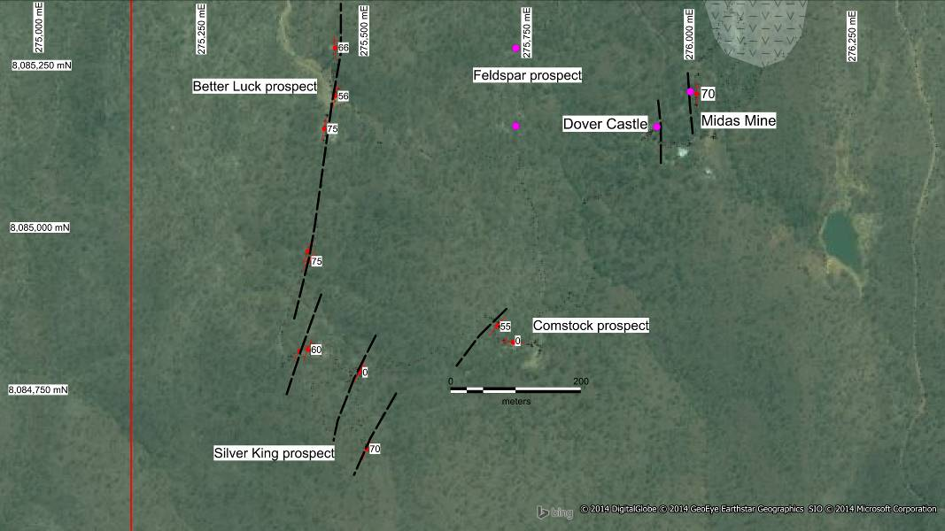

Figure 6. Prospect location with vein strike and dip measures (red symbols), interpreted vein extents (black dashed lines), track and EPM boundary (red line) (Menzies 2014b).

|  |  |
| --- | --- |
|  |  |
| Plate A. | Plate B. |

Figure 7. Plate A. Regional aeromagnetic interpretation from figure 2 (yellow lines) and drainage lineament interpretation (blue lines) with orientation of Better Luck, Silver King and Comstock veins (black lines), EPM boundary (red lines) on a satellite image, Plate B. Regional structural model showing dextural movement along NW trending faults which created dilatant NS structures and facilitated fluid flow and vein formation at Better Luck, Silver King, Comstock, Midas and Dover Castle prospects (Menzies 2014b).

**Induced Polarisation surveys results**

The data returned from a 14-line km dipole-dipole induced polarisation survey, completed with 50m spaced dipole centres on 250m spaced lines, when incorporated in the 3D geology model shows a positive correlation between elevated chargeability (> 12mV/V) and zones of known Pb-Zn-Ag mineralisation. The survey highlighted two zones to the north, coincident with historically worked pits and Zn-Pb-As in soil samples (see below), that are along strike from the Better Luck, Feldspar and Dover Castle prospects (figure 8 & 9). The approximate depth to the source of chargeability anomalies is 150-200m and exhibits a width of 200 m and strike length of 1400m. A 3-dimensional block model of these data highlights an oblate zone of elevated chargeability which trends to the NE and is coincident with historically worked pits (figure 9 & 10). A small zone which exhibits a low tenor chargeability anomaly has been delineated on the western part of the survey, 250m NW of a 5m wide quartz-Fe oxide bearing vein (figure 9).

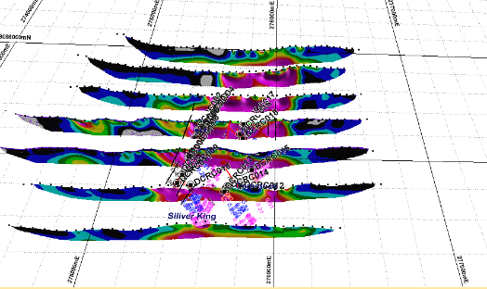

Figure 8. 3D model of induced polarisation chargeability pseudo sections (purple is >12.09 mV/V) and previous Dover Castle drill holes (Menzies 2014c).

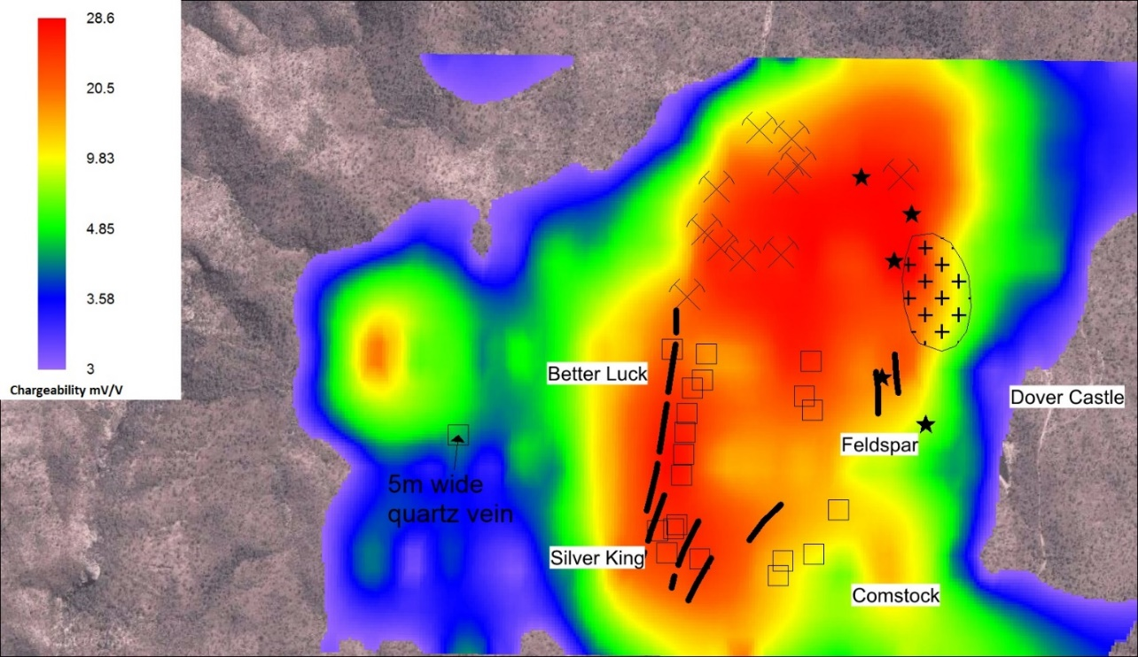

Figure 9. Plan view of chargeability data overlain by Dover Castle Metals drill holes (squares), Houston Oil and Minerals drill holes (black stars), interpreted vein orientations (black lines), historically worked pits (black crosses) and Dover Castle porphyry outcrop (cross hatch) (Menzies 2014c).

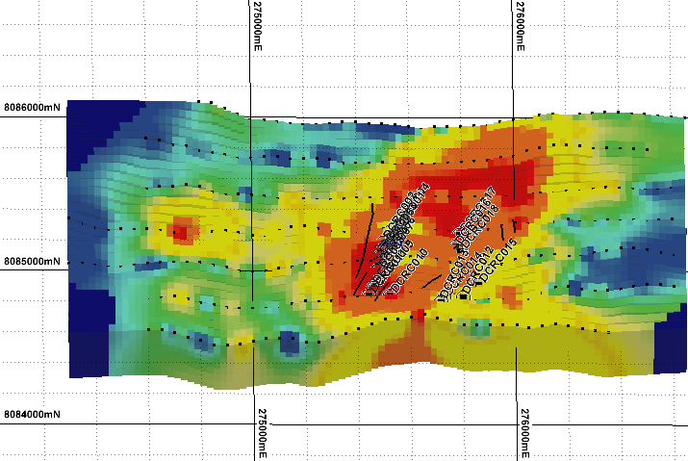

Figure 10. An oblique block model of chargeability data looking N showing drill hole locations and vein orientations (orange is > 12mV/V and red is > 18.6 mV/V) (Menzies 2014c).

**Handheld XRF supported soil sample survey**

Soil samples were collected at 50m centres on 100m spaced E-W grid lines over the project area and analysed with a hand portable XRF device (Thermo Scientific Niton XL3t Series Mining Analyzer). The analysis of these data highlights zones of elevated Pb-Zn-As ± Sn proximal to historically worked pits, and confirmed this approach was a viable technique for drill target generation across the tenement. Elevated Pb-in-soil values occur in close proximity to the Better Luck, Silver King, Feldspar, and Dover Castle prospects which indicates this element is immobile in the weathered environment and a good indicator for primary sulphide (galena) (figure 11). These data also highlight untested zones of elevated Pb between Comstock and Feldspar prospects, north of the Dover Castle porphyry outcrop and north of historically worked pits to the NW (figure 11). Zn values reported from soil analysis, while locally patchy due to this elements typical mobility in the weather environment, show a good correlation with Better Luck, Feldspar, Silver King, Comstock and Dover Castle prospects and a weak association with historically worked pits to the north (figure 12). Sporadic weakly anomalous Sn in the soil sampling data is consistent with the low Sn content in rock chips and drill core. Elevated Sn values are evident near the Dover Castle/Midas prospect and weakly elevated values occur with Pb-As-Zn north of Dover Castle at the porphyry outcrop and associated with historically worked pits to the NW (figure 13). While As in soil analyses defines low tenor anomalies over the Silver King and Feldspar prospects it does show a good correlation with Better Luck and Dover Castle prospects which highlights, along with Pb-Zn-Sn-As, the area to the NW associated with historically worked pits (figure 14). Supergene samples collected over the El Pinguino low sulphidation epithermal Ag-In-Pb-Zn in Argentina indicate that In-Sn-Pb are immobile in the oxide zone (Jovic et al, 2011 and Lopex et al, 2014) and therefore anomalous In, Sn or Pb values in soil samples should considered good indicators for the locations for primary hypogene mineralisation. Overall, a large zone of elevated Pb-Zn-As in soil samples is coincident with the zone of high chargeability (>12 mV/V) that trends towards the NNE (figures 9-15).

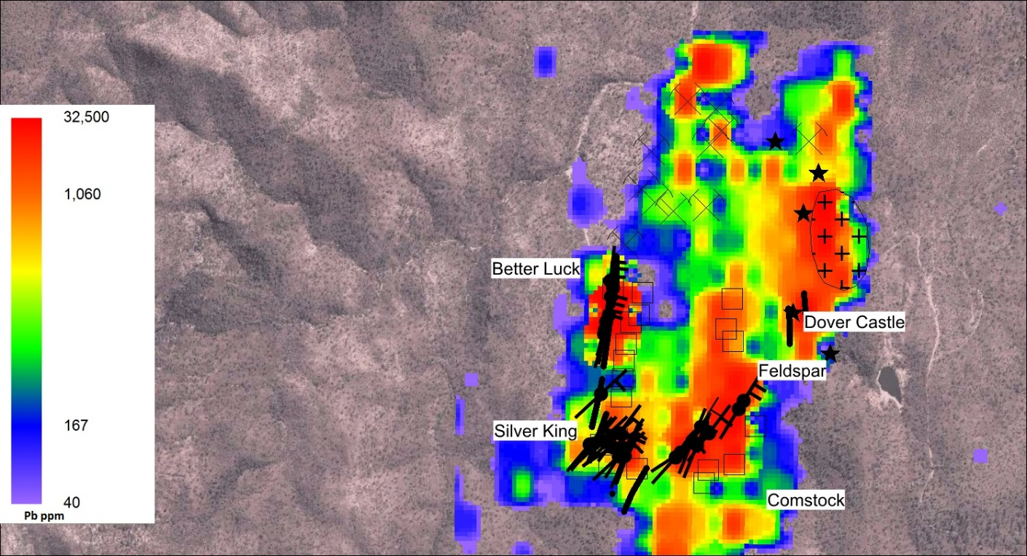

Figure 11. Gridded Pb ppm in soils on a satellite image overlain by Dover Castle Metals RC drill holes (squares), Houston Oil and Minerals drill holes (black stars), interpreted vein orientations (black lines), historically worked pits (black crosses) and Dover Castle porphyry outcrop (cross hatch) (Menzies, 2014c).

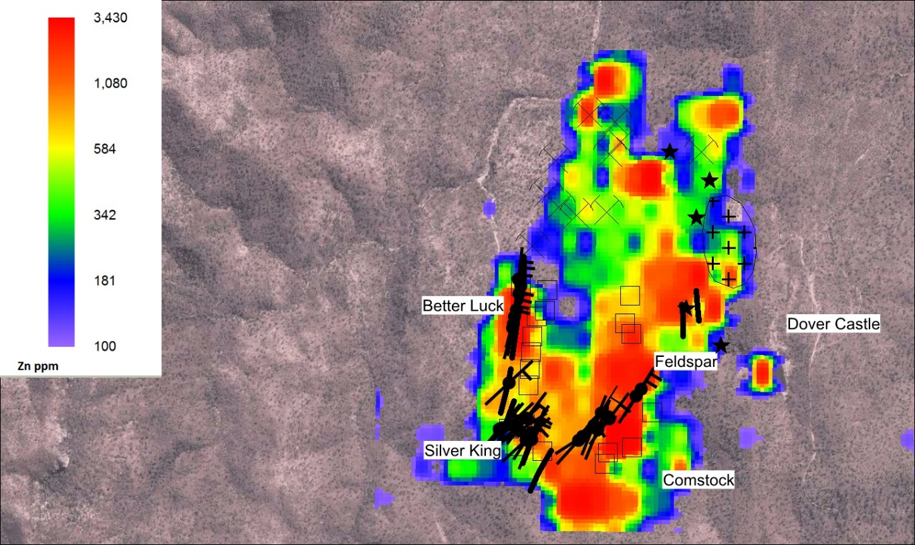

Figure 12. Gridded Zn in soils on a satellite image overlain by Dover Castle Metals RC drill holes (squares), Houston Oil and Minerals drill holes (black stars), interpreted vein orientations (black lines), historically worked pits (black crosses) and Dover Castle porphyry outcrop (cross hatch) (Menzies 2014c).

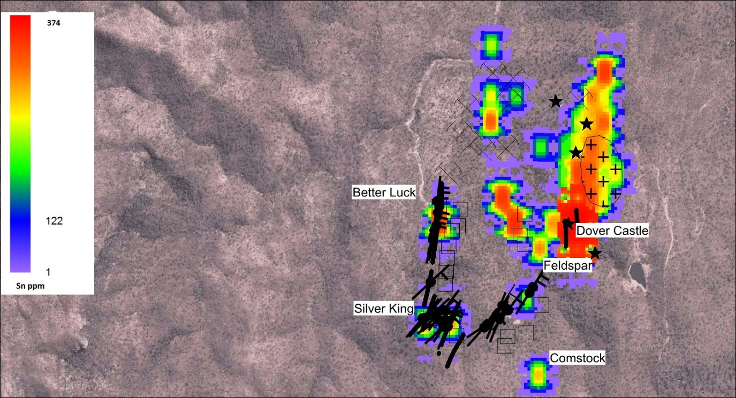

Figure 13. Gridded Sn in soils on a satellite image overlain by Dover Castle Metals RC drill holes (squares), Houston Oil and Minerals drill holes (black stars), interpreted vein orientations (black lines), historically worked pits (black crosses) and Dover Castle porphyry outcrop (cross hatch) (Menzies 2014c).

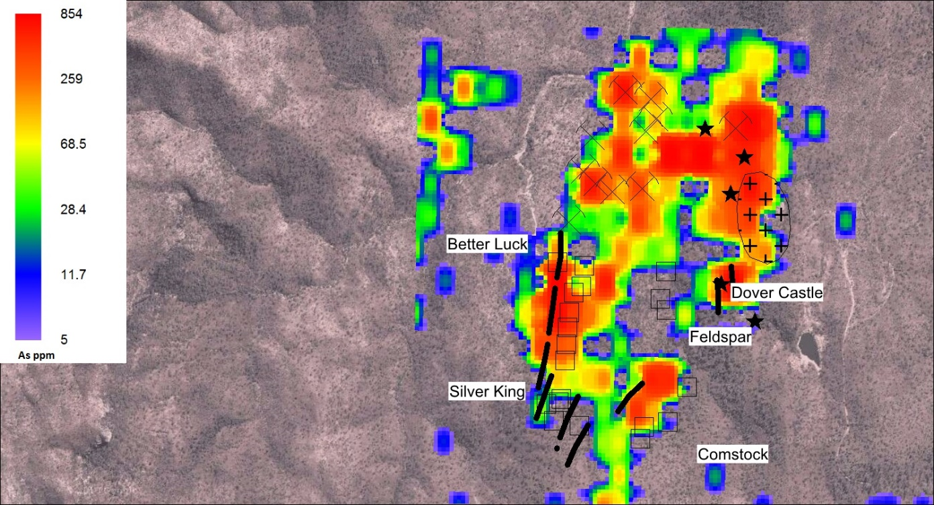

Figure 14. Gridded As in soils on a satellite image overlain by Dover Castle Metals drill holes (squares), Houston Oil and Minerals drill holes (black stars), interpreted vein orientations (black lines), historically worked pits (black crosses) and Dover Castle porphyry outcrop (cross hatch) (Menzies 2014c).

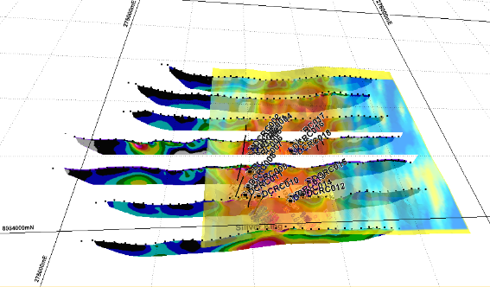

Figure 15. Gridded Pb in soil overlain on chargeability pseudo sections with orange > 329 ppm Pb (Menzies 2014c).

**Drill data**

56 reverse circulation (RC) holes, which totaled 8,257 metres, were drilled across the project area and defined a mineralised zone of over 1.5km in strike length (figure 16). Best drill intercepts reported from these drill holes were:

Better Luck prospect

* 4m @ 24.32% Zn equivalent from 86m depth in drill hole DCRC0001
* 4m @ 14.50% Zn equivalent from 57m depth in drill hole DCRC0002
* 2m @ 11.12% Zn equivalent from 129m depth in drill hole DCRC0004
* 2m @ 9.54% Zn equivalent from 62m depth in drill hole DCRC0048

North of Feldspar prospect

* 6m @ 31.20% Zn equivalent from 69m in drill hole DCRC051 located 250 metres north of Feldspar.

Silver King prospect

* 3m @ 10.63 Zn equivalent from 42m depth in drill hole DCRC011.
* 2m @ 5.73% Zn equivalent from 69m depth in drill hole DCRC009.

Large tonnage IP target - a total of 15 RC holes were drilled over a large area with the following intercepts:

* 12m @ 6.77% Zn equivalent from 166m & 21m @ 1.88% Zn equivalent from 227m in drill hole DCRC0024
* 14m @ 3.84% Zn equivalent from 146m & 29m @ 3.31% Zn equivalent from 187m in drill hole DCRC0032
* 18m @ 7.15% Zn equivalent from 58m & 11m @ 1.85% Zn equivalent from 207m in drill hole DCRC0051
* 21m @ 2.29% Zn equivalent from 220m depth in drill hole DCRC0052
* 27m @ 3.35% Zn equivalent from 162m depth & 13m @ 5.16% Zn equivalent from 212m depth 21m @ 3.75% Zn equivalent from 230m depth, & 29m @ 2.97% Zn equivalent from 265m depth in drill hole DCRC0053

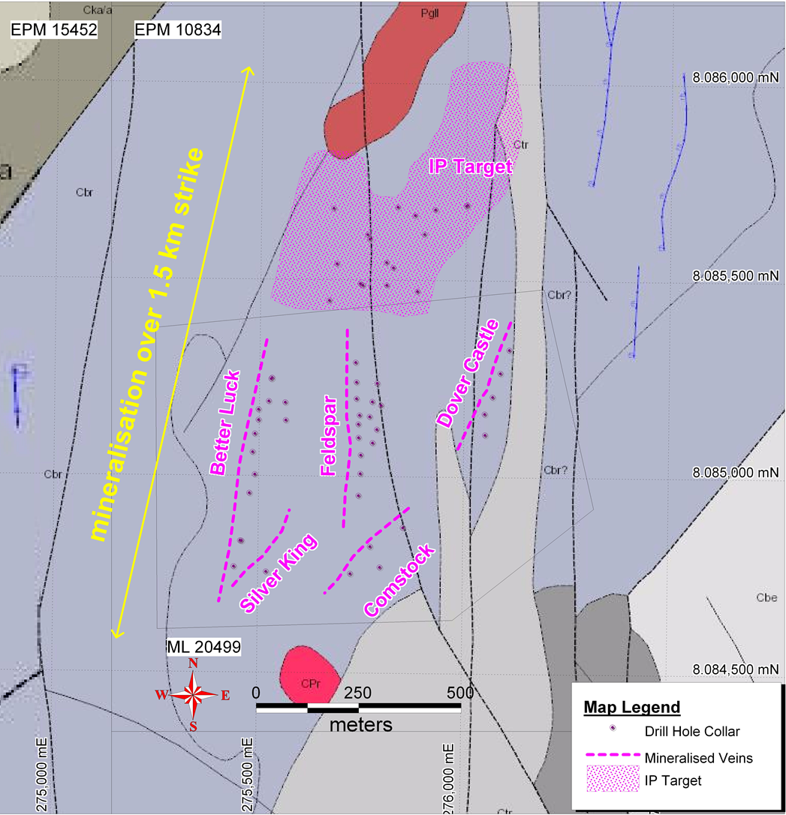

Figure 16. Dover Castle Project – geological map, prospect locations and drill holes (Sheehan, 2015b)

An analysis of RC percussion samples from holes DCRC001-DCRC003 using a Pearson Correlation matrix highlighted a positive association between Ag and Au (0.8)-As (0.6)-Ga (0.6)-Cd (0.9)-In (0.9)-Mn (0.3)-Pb (0.9)-S (0.8)-Sb (1.0)-Te (0.7)-Zn (0.9) which is a typical of a deep carbonate-base metal epithermal Au-Ag geochemical signature. The positive Ag-Mn association is indicative of the introduction of the Mn-bearing carbonate rhodochrosite by the mixing of metal-bearing magmatic fluids with bi-carbonate waters causing metal deposition as previously proposed by Menzies (2014). The association of Zn with In (1.0) –Cd (1.0) indicates that these elements are being deposited within the crystal structure of sphalerite. The negative correlation between Ag and Ba (-0.4)-K (-0.5)-Mg (-0.4)-Tl (-0.2) is suggestive that these elements are being leached out of the surrounding host rocks during the mineralisation event.

**MODEL FOR THE CONTROLS TO Pb-Zn-Ag-Sn-In±Au MINERALISATION**

The interaction of three controls have governed the development of the Pb-Zn-Ag-Sn-In±Au mineralisation within EPM 1084, namely:

1. Competent host rocks. Competent components within the rhyolite rock package, as opposed to less competent sediments or volcaniclastics, have allowed a greater amount of brittle fracturing and vein formation.
2. Structural controls. Dextral movement on NW trending structures created dilatant NS trending fractures which facilitated fluid flow from a magmatic source at depth and the formation of veins. Collapse along this NS direction produced the flat lying quartz-sulphide veins seen at Better Luck prospect. These veins are similar to those seen at the carbonate-base metal style Kelian Gold Mine in Indonesia, which occurs in a pull apart basin/negative flower structure configuration (Corbett and Leach, 1998), flat lying bedding plane shears at the Emperor Gold Mine, Fiji (Corbett, 2014), and shallow-dipping Au-bearing veins at Cowal Gold Mine, NSW (Henry et al., 2014 and Menzies, 2014a) are the main feeder structures in the Drake caldera-related Au field (Cumming et al., 2013).
3. Mechanism of base and precious metal deposition provides a major control to elevated metal grades. The mixing of rising Pb-Zn-Ag-Sn-In ± Au carrying fluids with oxidising weakly acidic bi-carbonate waters has facilitated the carbonate-base metal Pb-Zn-Ag-Sn-In±Au mineralisation (Corbett and Leach, 1998). With increasing acidity, bi-carbonate waters leached Fe, then Mn, rather than Mg from the wall rocks to provide a zonation from ankerite (Mg carbonate) to kutnahorite (Mg-Mn carbonate) to rhodochrosite (Mn carbonate) to siderite (Fe carbonate). The more acidic waters are more oxidising and, therefore, more efficient at destabilising the bi-sulphide complexes which transport Ag and Au and so there is a trend of best Ag-Au with siderite, declining with rhodochrosite, then with ankerite, and so on (Leach and Corbett, 2008). Examples of projects that exhibited high Au-Ag and base metal content with carbonate are: Wafi Link Zone carbonate base-metal epithermal Au mineralisation (Menzies et al., 2013), Cirotan carbonate-base metal epithermal Au-Ag-Pb-Zn-Sn-W mineralisation (Wagner et al., 2005), and Cowal Gold Mine (Henry, et al., 2014, Menzies 2014a).

W E

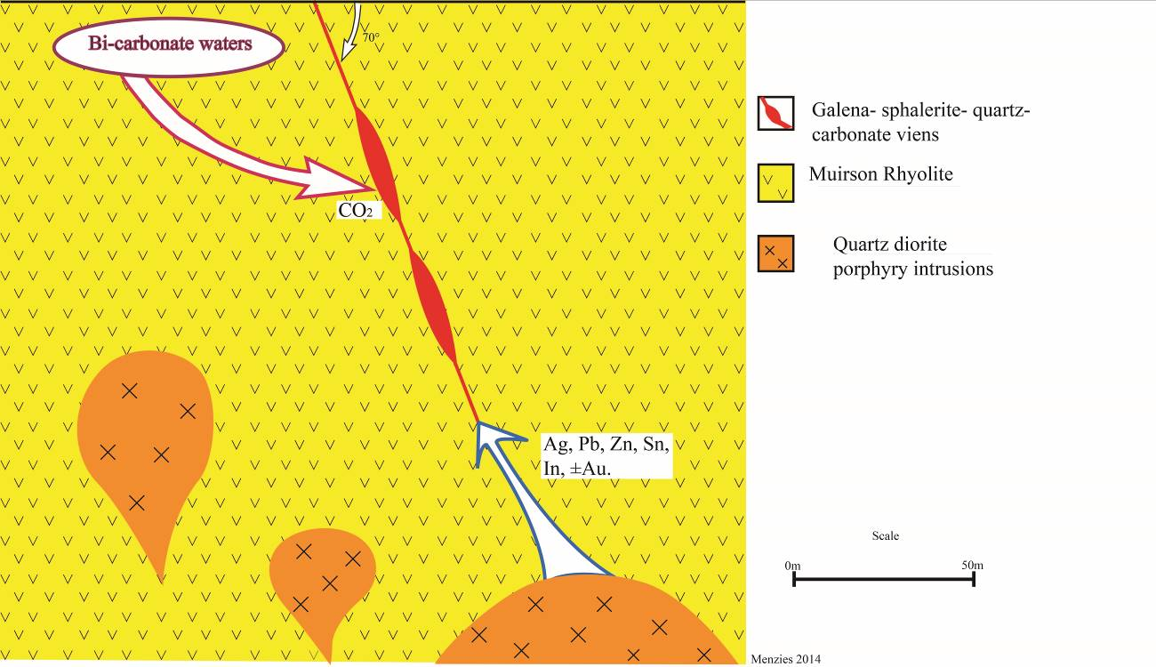

Figure 10. A schematic sectional model for the formation of Pb-Zn-Ag-Sn ± In ± Au mineralisation by the mixing of metal bearing magmatic fluid with bi-carbonate waters producing metal deposition.

**CONCLUSIONS**

The Dover Castle project carbonate-base metal Ag-Zn-Pb-Sn ± In ± Au low sulphidation mineralisation is hosted within the 301 (± 9) Ma Late Carboniferous porphyritic Muirson Rhyolite of the Featherbed Volcanic Group. A large aeromagnetic and gravity low, indicative of an intrusion, is situated to the NW of the project area and interpreted to be the source of metal bearing fluids.

Massive galena-sphalerite-pyrite-chalcopyrite ± bornite bearing veins are 1-2m wide and exhibit sericite-silica alteration selvages and quartz-carbonate gangue. RC drill intercepts, geological mapping, soil sampling and induce polarisation surveys at Dover Castle project have identified a Ag-Zn-Pb ± In-Au mineralised system that extends to the NNE for over 1.5km. Soil samples collected over the projects area report a large zone of elevated Zn-Pb-As coincident with an elevated induced polarisation chargeability signature. This zone has a strike length of 1400m, a width of 200 m, and a depth to the source of the chargeability anomaly at 150-200m.

Best intercepts from 56 reverse circulation hole bored into prospects across the project area are:

* 4m @ 24.32% Zn eq from 86m depth in DCRC0001 drilled into Better Luck prospect.
* 4m @ 14.50% Zn eq from 57m depth in DCRC0002 drilled into Better Luck prospect.
* 2m @ 11.12% Zn eq from 129m depth in DCRC0004 drilled into Better Luck prospect.
* 2m @ 9.54% Zn eq from 62m depth in DCRC0048 drilled into Better Luck prospect.
* 12m @ 6.77% Zn eq from 166m & 21m @ 1.88% Zn eq from 227m into the northern IP target.
* 14m @ 3.84% Zn eq from 146m & 29m @ 3.31% Zn eq from 187m into the northern IP target.
* 18m @ 7.15% Zn eq from 58m & 11m @ 1.85% Zn eq from 207m into the northern IP target.

It is proposed that the deposition of the Pb-Zn-Ag-Sn ± In ± Au mineralisation at the Dover Castle, Midas, Comstock, Silver King and Better Luck prospects resulted from the mixing of rising Pb-Zn-Ag-Sn-In-Au bearing magmatic fluids with bi-carbonate waters as evidenced by the close associated of appreciable grades with carbonate and base metal bearing veins.

**REFERENCES**

Black, L.P., 1978 - Isotopic ages of rocks from the Georgetown/Mount Garnet/Herberton area, north Queensland. Bureau of Mineral Resources, Australia, Report 200 (BMR Microform MF28).

Corbett, G.J., 2014, Epithermal and porphyry ore deposits: Field aspects for exploration geologists – Short course notes (unpublished).

Corbett, G.J., and Leach, T.M., 1998, Southwest Pacific Rim gold-copper systems: Structure, alteration and mineralization: Society of Economic Geologists Special Publication 6, 240 p.

Cumming, G, Worland, R, and Corbett G., 2013, The caldera collapse environment for Au-Ag mineralisation within the Drake Volcanics, New England: Implications for exploration: Mineral Exploration in the Tasmanides, AIG Bulletin 46, p. 33-40.

Fander, H. W., 1979, Petrological report on drill core from the Featherbed volcanic by Central Mineralogical Services for Huston Oil and Minerals Aust Inc.

Henry, A.D., McInnes, P., and Tosdal, R. M., 2014, Structural evolution of Auriferous veins at the Endeavour 42 Gold Deposit, Cowal Mining District, NSW, Australia: Economic Geology, V109, pp.1051-1077.

Hilla, F. I, 2000, Dover Castle project EPM No 10834: Evaluation of the “Comstock” Silver Lead Mine, DCP/2000: unpublished report for Loudon Mill Irvinebank N.Q.

Jensen, H. I., 1919, Scattered geological observations, Koorboora, Bamford and Petford areas: Unpublished report to Chief Government Geologist.

Jovic, S. M., Guido, D. M., Schalamuk, I. B., Rios, F. J. Tassinari, C. C. G. and Recio, C, 2011, Pinguino In-bearing polymetallic vein deposit, Deseado Massif, Patagonia, Argentina: characteristics of mineralisation and ore-forming fluids: Mineralium Deposita 46:257-271.

Keyser, F. D. E and Wolff, K. W., 1964, The geology and mineral resources of the Chillagoe area, Queensland: Bureau of Mineral Resource, Geology and Geophysics Bulletin No. 70.

Leach, T.C, and Corbett, G.J., 2008, Fluid mixing as a mechanism for bonanza grade epithermal gold formation: proceedings of the Terry Leach Symposium, AIG Bulletin 48.

Lopez, L. Jovic, S. M., Guido, D. M. Vidal, C. P., Paez, G. N., and Ruiz, R. 2014, Geochemical distribution and supergene behaviour of indium at the Pinguino epithermal polymetallic vein system, Patagonia, Argentina: Ore Geology Review in press.

Mackenzie, D. E, 1993, Geology of the Featherbed Cauldron Complex, North Queensland: Part 1-Eruptive Rocks and Post-Volcanic Sediments: Australian Geological Survey Organisation report 993/82.

Menzies, D. C. 2014a Controls to mineralisation at the Cowal Gold Mine and E46 prospect: Unpublished report for Barrick Gold Corporation by Corbett and Menzies Consulting Pty Ltd.

Menzies, D., 2014b, A Review of Ag-Pb-Zn-In-Sn ± Au mineralisation within EPM1083, Qld: an unpublished report by GeoInsite Pty Ltd to Peloton Capital.

Menzies, D., 2014c, Comments on Dover Castle Metals drilling program within EPM1083, Qld: an unpublished report by GeoInsite Pty Ltd to Exalt Resource.

Menzies, D., Shakesby, S., Wass, J., Finn, D., Fitzpatrick, N., Morehari, G., Tekeve, B., Alupian, B., Kur, J., Kulinasi, N., Miam, G., Larsen, J., Peter, D., Goliad, P., 2013., The Wafi-Golpu porphyry Cu-Au deposit: Mineralisation and alteration zonation, surface geochemical expression and paragenesis: Australian Institute of Geoscientists Bulletin 57, p. 60-63.

Sheehan, P, 2015a, Dover Castle Polymetallic Project – Exploration Target & Resource Drilling, unpublished memo by Newport Mining Services for Dover Castle Metals Pty Ltd.

Sheehan, P, 2015b, Better Luck & Feldspar - Resource & Met test work Drilling, unpublished memo by Newport Mining Services for Dover Castle Metals Pty Ltd.

Syvret, J. N., 1979, Report on the Red Herring Leases, Dover Castle area, Petford, north Queensland: Unpublished report to the QLD Mines Department GR11950 by Syvret and Associates.

USGS, 2014. Mineral Commodity Summaries, 2014, US Geological Survey website <http://minerals.usgs.gov/minerals/pubs/mcs/2014/mcs2014.pdf>.

Wagner, T., Williams-Jones, A. E., and Boyce, A. J., 2005, Stable isotope-based modelling of the origin and genesis of an unusual Au–Ag–Sn–W epithermal system at Cirotan, Indonesia: Chemical Geology 219, 237–260.