**AN OVERVIEW OF SN-W METALLOGENY IN NORTH EAST QUEENSLAND**

**Zhaoshan Chang, Gavin Clarke, Yanbo Cheng, Jaime Poblete, Kairan Liu, Kaylene Camuti**

Economic Geology Research Centre (EGRU) and Academic Group of Geosciences, College of Science and Engineering, James Cook University, Townsville, Queensland 4811, Australia

**Key Words:** tin, tungsten, metallogeny, cassiterite, wolframite, scheelite, Queensland,

**Introduction**

Tin (- tungsten) mineralisation in north-east Queensland was discovered in the 1880’s and, since then, there has been intermittent exploration and mining of both hard rock and alluvial resources. The north-east of Queensland is characterised by a large number (many hundreds) of Sn and W deposits, indicating geological conditions favourable for Sn-W-Mo mineralisation. While the deposits are generally small, the area has been one of Australia’s major sources of Sn and W.

Most of the Sn-W mineralised districts in north-east Queensland, and the largest known deposits, are located in the Siluro-Devonian Mossman Orogen in the east. To the south, the relatively small Sn deposits of the Kangaroo Hills district straddle the boundary between the Mossman and the Neoproterozoic–Ordovician Thomson Orogen. In the west, scattered Sn and W deposits occur within the Paleoproterozoic–Mesoproterozoic Etheridge Province of the North Australian Craton (Figure 1), with the at least the larger ones of placer type.

The North Australian Craton and the Thompson and Mossman Orogens were intruded by Carboniferous–Permian plutons of the extensive Kennedy Igneous Association (KIA), and covered by roughly coeval volcanic rocks (Figure 1). The KIA mainly comprises I-type magmatic rocks, with local S-type intrusions to the north-east of a NW trending line that passes through Atherton and Innisfail, and minor scattered A-type rocks south-west of the Atherton-Innisfail line. The Sn-W mineralisation of north-east Queensland is closely associated with these Carboniferous-Permian igneous rocks of the KIA.

**Deposit Classification**

The Sn-W-Mo deposits of north-east Queensland have different metal associations and can be classified as W-dominant, W-Mo-Bi deposits, and Sn-dominant deposits (Table 1). These subgroups have characteristic features and time-space distributions.

**W-dominant deposits**

These are represented by the Mt Carbine and Watershed deposits north-west of Cairns. Both deposits are hosted in siliclastic rocks and mineralisation occurs mainly in sheeted quartz +/- feldspar +/- muscovite veins, with local disseminated mineralisation at Watershed. Tungsten mineralisation at Mt Carbine is dominantly wolframite with minor later scheelite, while at Watershed scheelite is the only tungsten ore mineral.

Wall rock alteration around veins at Mt Carbine is mainly chlorite-illite, whereas wallrock alteration at Watershed comprises skarn assemblages (including garnet, pyroxene, clinozoisite and amphiboles).

Mineralisation in the Mt Carbine - Watershed area has been dated at 287 - 253 Ma (this project; Higgins et al., 1987).

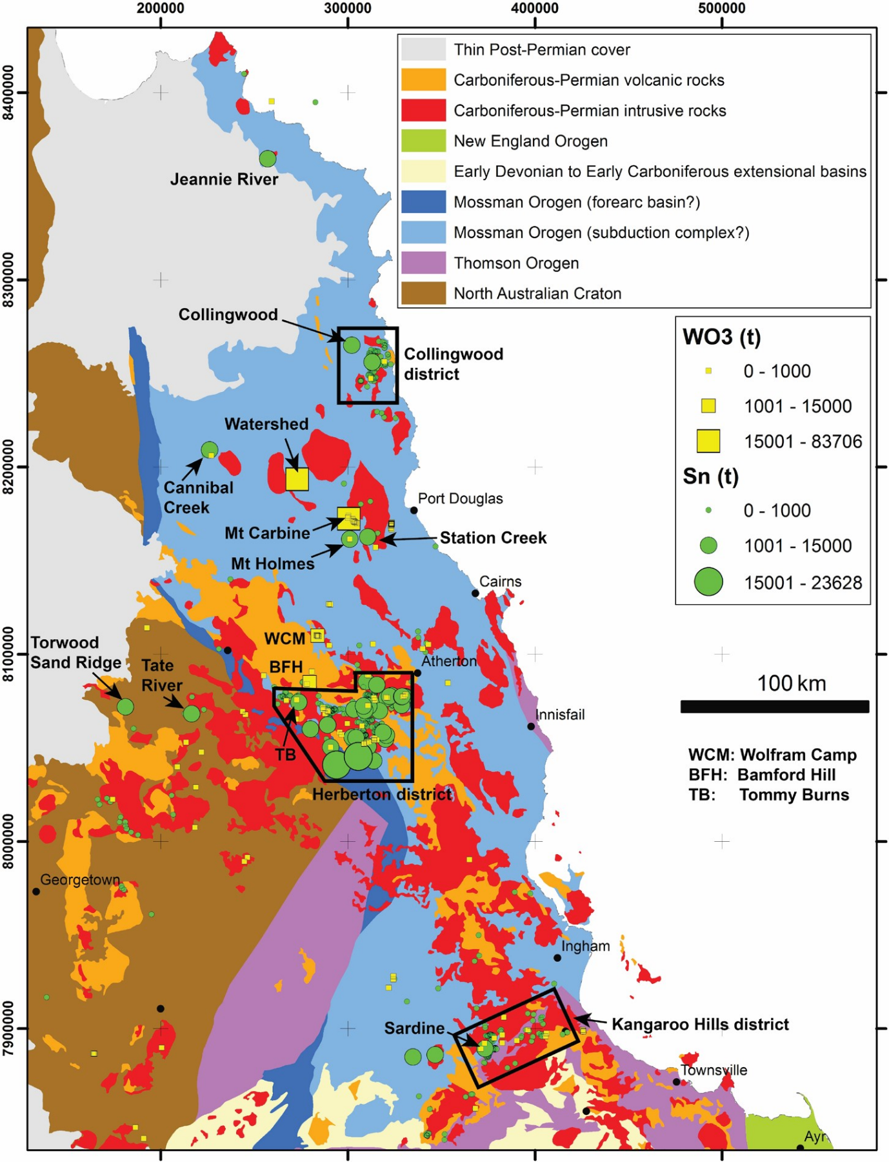

Figure 1. Geology of north-east Queensland and the distribution of W and Sn deposits. (GDA94, UTM Zone 55).

**W-Mo-Bi deposits**

This group of deposits occurs mainly in the NNE-trending Wolfram Camp - Bamford Hill corridor, and is represented by the Wolfram Camp and Bamford Hill deposits. The characteristic features of this group are:

* Mineralisation is confined to granitic intrusions.
* Ore occurs in pipe-like bodies and discontinuous pockets of quartz +/- minor calcite, which grade outwards to quartz-rich greisen. The pipes and pockets are located in the roof zone and upper side margins of plutons, and oriented parallel to intrusion margins.

The main W mineral is wolframite, with minor scheelite replacing wolframite. Molybdenite is the main Mo mineral, locally occurring intergrown with wolframite. Minor cassiterite, bismuthinite and native bismuth post-date the wolframite.

Most alteration ore minerals are coarse- to very coarse-grained (wolframite crystals can be up to 50 cm long).

Molybdenite from both Wolfram Camp and Bamford Hill has been dated at 308 - 306 Ma.

**Sn-dominant deposits**

Deposits with Sn as the dominant economic metal cluster in the Collingwood, Herberton and Kangaroo Hills districts (Figure 1). The deposits can be subdivided into two groups based on host rocks, and further subdivided based on alteration assemblages and distribution.

**Group 1** deposits are hosted in metasedimentary rocks whereas **Group 2** deposits are in fractionated microgranites and/or in coarse-grained batholithic granite adjacent to microgranites. Variations in alteration allow the two groups to be subdivided into the following sub-types:

1A Mineralisation hosted in carbonate wall rocks resulting in skarn alteration assemblages. The typical ore assemblage is cassiterite - magnetite - fluorite - wollastonite - pyroxene. The skarn Sn deposits are typically larger than other sub-types in north-east Queensland.

1B Mineralisation hosted in metabasalts with skarn alteration assemblages dominated by pyroxene or massive chlorite. The ore assemblage is typically cassiterite-magnetite.

1C Mineralisation occurring at the boundary between metabasalt and chert. Cassiterite occurrs in cordierite-cummingtonite rocks that have been altered to chlorite.

1D Mineralisation hosted in siliclastic metasedimentary rocks. Ore types include quartz-tourmaline-cassiterite veins and breccia pipes, chlorite- and/or quartz- cassiterite pipes and veins with chlorite haloes, and quartz-cassiterite veins with silicification haloes.

1E Hydrothermal breccias located in metasedimentary rocks and porphyry dykes, and transitioning to cassiterite-bearing chlorite lodes at shallower levels.

2A Feldspathic alteration: albite-altered lenses with disseminated cassiterite, and locally with quartz - fluorite - cassiterite +/- K-feldspar veinlets and veins.

2B White mica greisen: pipes and veins of quartz-cassiterite (+/- muscovite, wolframite, fluorite, topaz, sulphides) with haloes of fine-grained white mica +/- quartz.

Table 1. Major W and Sn deposits in north-east Queensland.

a. Vital Metals report, 2014. b. Carbine Tungsten annual report, 2014. c. Queensland Minerals, 2014. Please note that the resources of many deposits in this compilation were defined before JORC was established in 1989. d. Almonty Industries 43-101 report, 2015. e. Consolidated Tin Australian securities exchange (ASX) announcement 25 June 2014. f. Consolidated Tin ASX announcement 3 April 2012. g. Tin Australia prospectus,1999. h. Monto Minerals ASX announcement 12 January 2012. i. MINOCC 2017 - Qld Mineral Occurrence database.

^ Mt Carbine has also produced 8 t Sn. + Tommy Burns also produced 700 t scheelite and 670 t wolframite (1076 t WO3). * Baal Gammon also contains 2.8 Mt resources averaging 1% Cu, 40 ppm Ag and 39 ppm In. # includes both past production and current identified resources.

|  |  |  |  |  |  |  |  |
| --- | --- | --- | --- | --- | --- | --- | --- |
| **Tungsten Deposits** | **Metal Association** | **Deposit Style** | | **Resources (Mt)** | **Grade WO3 (%)** | **Production WO3 (t)** | **Total WO3 (t)** |
| Mt Carbine | W-dominant (wolframite, scheelite) | Steeply dipping veins, largely hosted in siltstone - shale | | 59.3b | 0.12b | 12,546c | 83,706 |
| Watershed | W-dominant (scheelite) | Sheeted veins and disseminations, largely hosted in skarn altered sediments | | 49.2a | 0.14a |  | 70,400 |
| Wolfram Camp - Bamford Hill | W-Mo-Bi dominant (wolframite, minor scheelite, molybdenite; bismuthinite, native bismuth) | Quartz pipes and pockets in the roof zones and margins of plutons | | 2.393d | 0.29d | 5,253c | 12,260 |
| **Tin Deposits** | **Metal Association** | **Deposit Style** | **Sub-Type** | **Resources (Mt)** | **Grade Sn (%)** | **Production Sn (t)** | **Total Sn (t)** |
| Pinnacles | Sn-dominant  (+/- base metals) | Skarn: wrigglite with cassiterite-bearing magnetite bands is common | 1A | 7.035e | 0.30e |  | 21,105 |
| Gillian | Sn-dominant  (+/- base metals) | Skarn: wrigglite with cassiterite-bearing magnetite bands is common | 1A | 2.53e | 0.78e |  | 19,734 |
| Collingwood | Sn-dominant | Sheeted quartz-tourmaline and greisen veins in granite | 2B | 0.643c | 1.19c | 5,133c | 12,793 |
| Great Nthn Gullyc  Great Nthn Eastc  Great Sthn Tinc | Sn-dominant | Veins and pipes in granitic rocks. | 2B | Combined figures for three adjacent deposits | | | 11,903 |
| Tommy Burns+ | Sn-dominant  (wolframite, scheelite +/- base metals) | Steeply dipping pipes in altered sandstone | 1C |  |  | 11,520c | 11,520 |
| Vulcan | Sn-dominant  (+/- base metals) | Pipes in siliclastic metasedimentary rocks | 1D |  |  | 10,993c | 10,993 |
| Jeannie River | Sn-dominant  (+/- base metals) | Veins in sheared sedimentsi | 1D | 2.24f | 0.47f |  | 10,583 |
| Sailor Tin | Sn-dominant | Sub-horizontal lenticular bodies of greisen in granitei | 2B | 10g | 0.08g |  | 7,874 |
| Station Creek | Sn-dominant (+ wolframite) | Placer |  | 46 M m3c | 180 g/m3c |  | 6,520 |
| Tate River | Sn-dominant | Placer |  | 9.76 M m3c | 587 g/m3c | 1,256c alluvium | 6,154 |
| Mount Holmes | Sn-dominant (+ scheelite, wolframite, bismuthinite) | Quartz-feldspar and pegmatite veins in cherti | 1D | 10c | 0.055c | 142c | 5,654 |
| Baal Gammon* | Sn-dominant  (+/- base metals) | Veins and breccia pipe | 1E | 2.8h | 0.20h |  | 5,600 |
| Windermere | Sn-dominant  (+/- base metals) | Skarn: massive magnetite-hematitei | 1A | 2.04e | 0.27e |  | 5,508 |

2C Chlorite alteration: pipes and veins of quartz-cassiterite (+/- wolframite, fluorite, topaz, sulphides) with haloes of intense chlorite alteration.

It has been speculated that the various alteration and mineralisation types listed above are related, with the pipe and vein-style mineralisation hosted in metasediments extending to lodes in granitic intrusions at depth. The associated alteration assemblages in the metasediments would transition from silicification, to chlorite, to tourmaline with depth, and to white mica greisens and feldspathic alteration in the granitic intrusions.

**Age of Mineralisation**

The age of Sn-dominant mineralisation varies from district to district, with the earliest Sn mineralisation occurring in the Kangaroo Hills district (345-339 Ma), and younger Sn mineralisation in the Herberton-Emuford-Mt Garnet district (327-317 Ma). W-Mo-Bi deposits in a north-south corridor west of the Herberton Sn field formed at 308-306 Ma.

Age dates from the W-dominant mineralisation in the Mt Carbine - Watershed area north of the Herberton District are in the range 287-253 Ma, and may be broadly synchronous with the Collingwood Sn mineralisation further north where the mineralisation age should be younger than ~276 Ma, the age of the host granite, although accurate mineralisation ages for the Collingwood district are yet to be obtained.

**Prospectivity**

The setting and style of Sn-W-Mo mineralisation in north-east Queensland suggests that:

* Carbonate rocks are the most favourable host rocks for forming larger deposits.
* In siliclastic wall rocks, extensive chlorite alteration seems to indicate higher grade Sn mineralisation.
* In granitic wall rocks, white mica greisen is more favourable to mineralisation than topaz-bearing greisen and felspathic alteration.
* Mineralisation confined within intrusions may indicate the magma did not exsolve sufficient water to rupture the carapace and such deposits may have limited tonnage potential.

Previous drilling and mining operations in the north-east Queensland Sn-W-Mo districts have generally been fairly shallow. Elsewhere in the world, vein-type W mineralisation may transition to skarn or massive greisen-related mineralisation at depth (e.g. southern Jiangxi, China - see Xu, 2008). Consequently, in north-east Queensland the potential for mineralisation at depth is considerable, and Sn and W vein and breccia style mineralisation hosted in wall rocks should be priorities in future exploration.

**ACKNOWLEGEMENTS**

This metallogenic study is part of a larger collaborative project between the Geological Survey of Queensland and the Economic Geology Research Centre (EGRU) at JCU. We appreciate the deposit owners for in-kind support and access, including Carbine Tungsten, Vital Metals, Wolfram Camp Mine, Consolidated Tin, Monto Minerals and the Herberton Mining Museum.

**References**

Black, L. P., Blake, D. H. & Olatunji, J. A., 1978. Ages of granites and associated mineralisation in the Herberton tinfield of northeast Queensland. Bureau of Mineral Resources Journal of Australia Geology and Geophysics, 3:173–180.

Blake, D. H., 1972. Regional and Economic Geology of the Herberton Tinfield, North Queensland. Bulletin 124, p 126 (Bureau of Mineral Resources: Canberra)..

Blake, D. H. & Smith, J. W., 1970. Mineralogical zoning in the Herberton tinfield, north Queensland, Australia. Economic Geology, 65:993–997.

Blevin, P. L., Chappell, B. W. & Allen, C. M., 1996. Intrusive metallogenic provinces in eastern Australia based on granite source and composition. Transactions of the Royal Society of Edinburgh, Earth Sciences, 87:281–290.

Britt, A., Summerfield, D., Whitaker, A., Kay, P., Champion, D. C., Huston, D., Senior, A. B., Sexton, M., Robert, D., Wright, S. J. & Schofield, A., 2015. Australia’s Identified Mineral Resources 2015, p 16 (Geoscience Australia: Canberra).

Brown, W. M., Kwak, T. A. P. & Askins, P. W., 1984. Geology and geochemistry of a F-Sn-W skarn system; the Hole 16 Deposit, Mt. Garnet, North Queensland, Australia. Australian Journal of Earth Sciences, 31:317–340.

Charoy, B. & Pollard, P. J., 1989. Albite-rich, silica-depleted metasomatic rocks at Emuford, northeast Queensland: mineralogical, geochemical, and fluid inclusion constraints on hydrothermal evolution and tin mineralization. Economic Geology, 84:1850–1874.

Cheng, Y., Mao, J., Chang, Z. & Pirajno, F., 2013. The origin of the world class tin-polymetallic deposits in the Gejiu district, SW China: constraints from metal zoning characteristics and 40Ar-39Ar geochronology. Ore Geology Reviews, 53:50–62.

de Roo, J. A., 1988. Structural controls on the emplacement of the vein type tungsten-tin ore at Mount Carbine, Queensland, Australia. Economic Geology, 83:1170–1180.

Elliott, J. E., 1992. Tungsten-geology and resoures of deposits in Southeastern China, in: Contributions to Commodity Geology Research (eds: J H DeYoung, Jr and J M Hammarstrom), pp 11–110 (United States Geological Survey: Res).

Forsythe, D. L. & Higgins, N. C., 1990. Mount Carbine tungsten deposit, in: Geology of the Mineral Deposits of Australia and Papua New Guinea (ed: F E Hughes), pp 1557–1560 (The Australasian Institute of Mining and Metallurgy: Melbourne).

Fraser, N., Taylor, R. G. & Cuff, C., 1981. Aspects of mineralisation at the United North Australian Mine, Watsonville, North Queensland, Australia. Transactions of the Institutions of Mining and Metallurgy, Applied Earth Science, B103–B114.

Gregory, P. W., Taylor, R. G. & White, A. H., 1980. Mineralisation in the Broken River and Hodgkinson Provinces, in: The Geology and Geophysics of Northeastern Australia (eds: R A Henderson and P J Stephenson), pp 191–200 (Geological Society of Australia, Queensland Division: Brisbane).

Henderson, R. A., Innes, B., Fergussion, C., Crawford, A. & Withnall, I., 2011. Collisional accretion of a Late Ordovician oceanic island arc, Northern Tasman Orogenic Zone, Australia. Australian Journal of Earth Science, 58:1–19.

Higgins, N. C., Forsythe, D. L., Sun, S-S. & Andrew, A. S., 1987. Fluid and metal sources in the Mt Carbine Tungsten Deposit, North Queensland, Australia, in: Proceedings Pacific Rim Congress 87, pp 173–177 (The Australasian Institute of Mining and Metallurgy: Melbourne).

Jell, P. A., 2013. Geology of Queensland, p 970 (Geological Survey of Queensland: Brisbane).

Johnston, C. & Chappell, B. W., 1992. Topaz-bearing rocks from Mt. Gibson, North Queensland, Australia. American Mineralogist, 24:15–49.

Kwak, T. A. P. & Askins, P. W., 1981. The nomenclature of carbonate replacement deposits, with emphasis on Sn-F (-Be-Zn) wrigglite skarns. Geological Society of Australia Journal, 28:123–136.

Mao, Z., Cheng, Y., Liu, J., Yuan, S., Wu, S., Xiang, X. & Luo, X., 2013. Geology and molybdenite Re-Os age of the Dahutang graniterelated veinlets – disseminated tungsten ore field in the Jiangxin Province, China. Ore Geology Reviews, 53:422–433.

Plimer, I. R., 1974. Pipe-like molybdenite-wolframite-bismuth deposits of Wolfram Camp, North Queensland, Australia. Mineralium Deposita, 9:95–104.

Plimer, I. R., 1974. Pipe-like molybdenite-wolframite-bismuth deposits of Wolfram Camp, North Queensland, Australia. Mineralium Deposita, 9:95–104.

Pollard, P. J., 1981. Hydrothermal tin-tungsten mineralization and origin of associated cordierite-anthophyllite rocks at Tommy Burns Mine, North Queensland, Australia. Transactions of the Institution of Mining and Metallurgy, Applied Earth Sciences, 90:B65–B69.

Pollard, P. J., 1988. Petrogenesis of tin-bearing granites of the Emuford District, Herberton tinfield, northeastern Queensland, Australia. Australian Journal of Earth Science, 35:39–57.

Pollard, P. J. & Taylor, R. G., 1983. Aspects of tin systems in the Herberton-Mount Garnet tinfield, Queensland, in: Permian Geology of Queensland, pp 353–356 (Geological Society of Australia, Queensland Division: Brisbane).

Taylor, R. G. & Steveson, B. G., 1972. An analysis of metal distribution and zoning in the Herberton Tinfield, North Queensland, Australia. Economic Geology, 67:1234–1240.

von Gnielinski, F., 2015. Queensland Minerals 2014: A Summary of Major Mineral Resources, Mines and Prospects, p 222 (Department of Natural Resources and Mines, Queensland: Brisbane).

Witt, W. K., 1987. Fracture-controlled feldspathic alteration in granites associated with tin mineralization in the Irvinebank – Emuford area, northeast Queensland. Australian Journal of Earth Sciences, 34:447–462.

Witt, W. K., 1988. Evolution of high temperature hydrothermal fluids associated with greisenisation and feldspathic alteration of a tin mineralised granite, northeast Queensland. Economic Geology, 83:310–334.